Part A — Practice Programs (Hour 1)
PROBLEM1 | Vending machine (VendingMachine.java, main in this file)  (a) Define an enum Coin with constants ONE, TWO, FIVE, TEN.  (b) In main, set a snack price of 15 and a running total of 0; create a Scanner.  (c) Loop: read a coin name, use a switch expression to convert the Coin to its value  (ONE→1, TWO→2, FIVE→5, TEN→10), add it to the total, and print the total so far.  (d) Stop the loop once the total reaches 15 or more.  (e) Print the change to return (total − 15).  Expected output: TEN then FIVE prints “Paid. Change: 0”; TEN then TEN prints “Paid. Change: 5”.
CODE | import java.util.Scanner;  enum Coin {  ONE, TWO, FIVE, TEN  }  public class Vending {  int price = 15;  int total = 0;  void addCoin(int value) {  total += value;  System.out.println("Total so far: " + total);  }  boolean isPaid() {  return total >= price;  }  int getChange() {  return total - price;  }  public static void main(String[] args) {  Scanner sc = new Scanner(System.in);  Vending vm = new Vending();  while (!vm.isPaid()) {  Coin coin = Coin.valueOf(sc.next().toUpperCase());  int value = switch (coin) {  case ONE -> 1;  case TWO -> 2;  case FIVE -> 5;  case TEN -> 10;  };  vm.addCoin(value);  }  System.out.println("Paid. Change: " + vm.getChange());  }  }
OUTPUT | 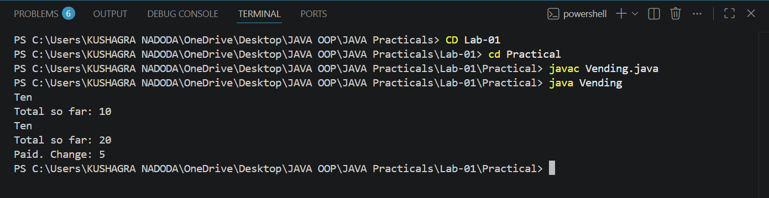
PROBLEM2 | Toll booth (TollBooth.java, main in this file)  (a) Define a record Vehicle(String number, String type).  (b) In main, keep a running toll total and three counters (bike,car,truck).  (c) Loop until the user types “done” for the number: build a Vehicle, use a switch expression on its type for the toll (bike→20, car→50, truck→150), add to the total,and increment that type’s counter.  (d) After the loop, print the total toll and the type with the highest count.  Expected output: two cars + one bike → “Total toll: 120”, “Most frequent: car”.
CODE | import java.util.Scanner;  public class TollBooth {  record Vehicle(String number, String type) {}  public static void main(String[] args) {  Scanner sc = new Scanner(System.in);  int total = 0;  int bike = 0, car = 0, truck = 0;  while (true) {  System.out.print("Enter vehicle number (or 'done'): ");  String number = sc.next();  if (number.equalsIgnoreCase("done")) {  break;  }  System.out.print("Enter vehicle type (bike/car/truck): ");  String type = sc.next().toLowerCase();  Vehicle vehicle = new Vehicle(number, type);  int toll = switch (vehicle.type()) {  case "bike" -> 20;  case "car" -> 50;  case "truck" -> 150;  default -> 0;  };  total += toll;  switch (vehicle.type()) {  case "bike" -> bike++;  case "car" -> car++;  case "truck" -> truck++;  }  }  System.out.println("Total toll: " + total);  String mostFrequent = "bike";  int maxCount = bike;  if (car > maxCount) { mostFrequent = "car"; maxCount = car; }  if (truck > maxCount) { mostFrequent = "truck"; maxCount = truck; }  System.out.println("Most frequent: " + mostFrequent);  }  }
OUTPUT | 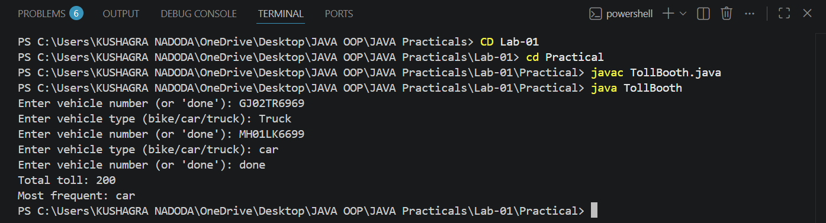
PROBLEM3 | (For Advanced Learners – home) Rock-Paper-Scissors-Lizard-Spock (RPSLS.java)  (a) Define an enum Move with ROCK, PAPER, SCISSORS, LIZARD, SPOCK.  (b) Write winner(Move a, Move b) returning 1 if a beats b, -1 if b beats a, 0 for a tie —use a switch expression listing what each move beats (Scissors cut Paper, Paper covers Rock, Rock crushes Lizard, Lizard poisons Spock, Spock smashes Scissors,and the five mirror cases).  (c) In main, play 5 rounds: pick a random computer Move, read the player’s Move, call winner(), print the round result and keep score.  (d) After 5 rounds, print the overall winner.  Expected output: each round prints both moves and the round winner; ends with a “You win 3–2” summary.
CODE | import java.util.Random;  import java.util.Scanner;  public class RPSLS {  enum Move {  ROCK, PAPER, SCISSORS, LIZARD, SPOCK;  Move[] beats() {  return switch (this) {  case ROCK -> new Move[]{SCISSORS, LIZARD};  case PAPER -> new Move[]{ROCK, SPOCK};  case SCISSORS -> new Move[]{PAPER, LIZARD};  case LIZARD -> new Move[]{SPOCK, PAPER};  case SPOCK -> new Move[]{SCISSORS, ROCK};  };  }  }  static int winner(Move a, Move b) {  if (a == b) {  return 0;  }  for (Move m : a.beats()) {  if (m == b) {  return 1;  }  }  return -1;  }  public static void main(String[] args) {  Scanner sc = new Scanner(System.in);  Random rand = new Random();  Move[] moves = Move.values();  int playerScore = 0;  int computerScore = 0;  for (int round = 1; round <= 5; round++) {  Move computerMove = moves[rand.nextInt(moves.length)];  System.out.print("Round " + round + " - Enter your move (ROCK/PAPER/SCISSORS/LIZARD/SPOCK): ");  Move playerMove = Move.valueOf(sc.next().toUpperCase());  int result = winner(playerMove, computerMove);  System.out.println("You: " + playerMove + ", Computer: " + computerMove);  if (result == 1) {  System.out.println("You win this round!");  playerScore++;  } else if (result == -1) {  System.out.println("Computer wins this round!");  computerScore++;  } else {  System.out.println("This round is a tie!");  }  }  System.out.println();  if (playerScore > computerScore) {  System.out.println("You win " + playerScore + "-" + computerScore);  } else if (computerScore > playerScore) {  System.out.println("Computer wins " + computerScore + "-" + playerScore);  } else {  System.out.println("It's a tie " + playerScore + "-" + computerScore);  }  }  }
OUTPUT | 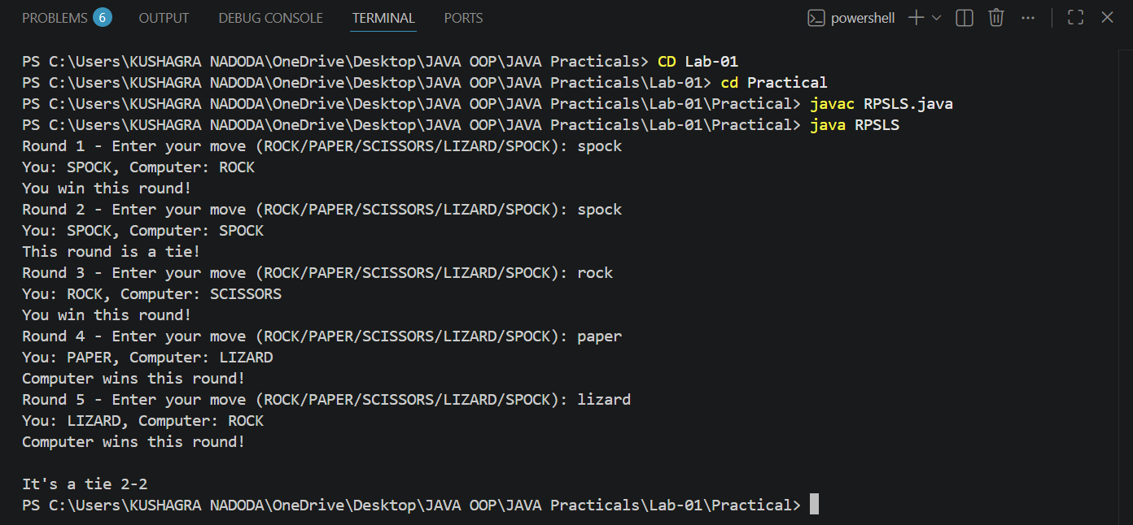

Part B — Project Work (Hour 2): Mini Bank
PROBLEM | MiniBank is the console banking application you will build across the whole semester. In this first lab you set up your tools and create the project and its menu shell — the screen the user navigates. Every later lab attaches one real banking feature behind these menu options.  1. Set up your environment: open the project in GitHub Codespaces (or install JDK 17+ and an IDE locally), and create a private GitHub repository named oop-minibank-<rollno>; add the faculty as a collaborator.  2. Create a public class named MiniBank that contains the main method.  3. Define a record named BankInfo with two String fields, name and branch (a record is a short, read-only class; Java auto-generates its constructor and field accessors). Print one BankInfo object as the application header.  4. Define an enum named MenuOption with the constants OPEN_ACCOUNT, DEPOSIT, WITHDRAW, TRANSFER and EXIT — these are the actions MiniBank will offer.  5. Display the numbered menu to the user and read the chosen number with a Scanner.  6. Use a switch expression on the choice to print a short placeholder for that option (for example, “Deposit — to be implemented in a later lab”). Keep showing the menu in a loop until the user selects EXIT, then print a goodbye message.
CODE | import java.util.Scanner;  public class MiniBank {  record BankInfo(String name, String branch) {}  enum MenuOption {  OPEN_ACCOUNT, DEPOSIT, WITHDRAW, TRANSFER, EXIT  }  public static void main(String[] args) {  Scanner sc = new Scanner(System.in);  BankInfo bank = new BankInfo("MiniBank", "Main Branch");  System.out.println(bank);  boolean running = true;  while (running) {  System.out.println();  System.out.println("1. Open Account");  System.out.println("2. Deposit");  System.out.println("3. Withdraw");  System.out.println("4. Transfer");  System.out.println("5. Exit");  System.out.print("Enter your choice: ");  int choice = sc.nextInt();  MenuOption option = MenuOption.values()[choice - 1];  String message = switch (option) {  case OPEN_ACCOUNT -> "Open Account — to be implemented in a later lab";  case DEPOSIT -> "Deposit — to be implemented in a later lab";  case WITHDRAW -> "Withdraw — to be implemented in a later lab";  case TRANSFER -> "Transfer — to be implemented in a later lab";  case EXIT -> "Goodbye!";  };  System.out.println(message);  if (option == MenuOption.EXIT) {  running = false;  }  }  }  }
OUTPUT | 