Part A — Practice Programs (Hour 1)
PROBLEM1 | Distinct points (Point.java + Driver.java with main)  (a) Create class Point with private int x, y and a constructor.  (b) Override toString() to return “(x, y)”.  (c) Override equals(Object) to be true when both x and y match, and hashCode() to agree (e.g. Objects.hash(x, y)).  (d) In Driver.main: build a Point[] with some repeated coordinates.  (e) Count distinct points: for each point, use equals() to check whether it already appeared earlier; count those that did not.  (f) Print “Distinct: N”.  Expected output: 5 points with 2 repeats → “Distinct: 3”.
CODE | public class Point {  private int x, y;  public Point(int x, int y) {  this.x = x;  this.y = y;  }  public void print() {  System.out.print("(" + x + ", " + y + ")");  }  public boolean isSame(Point other) {  return this.x == other.x && this.y == other.y;  }  }  public class Driver {  public static void main(String[] args) {  Point[] pts = {  new Point(1, 2),  new Point(3, 4),  new Point(1, 2),  new Point(5, 6),  new Point(3, 4)  };  int count = 0;  for (int i = 0; i < pts.length; i++) {  boolean seen = false;  for (int j = 0; j < i; j++) {  if (pts[i].isSame(pts[j])) {  seen = true;  break;  }  }  if (!seen) count++;  }  System.out.println("Distinct: " + count);  }  }
OUTPUT | 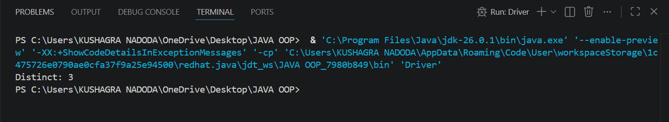
PROBLEM2 | Duplicate card check (Card.java + Driver.java)  (a) Create class Card with private String rank, suit and a constructor.  (b) Override toString() to return rank + “of” + suit (e.g. “Queen of Hearts”).  (c) Override equals()/hashCode() by rank + suit.  (d) In Driver.main: add cards to a Card[] one at a time; before adding each, use equals() to check it against the earlier cards.  (e) Print “Duplicate found: <card>” the first time a repeat appears.  Expected output: a second “Ace of Spades” → “Duplicate found: Ace of Spades”.
CODE | public class Card {  private String rank, suit;  public Card(String rank, String suit) {  this.rank = rank;  this.suit = suit;  }  public void print() {  System.out.print(rank + " of " + suit);  }  public boolean isSame(Card other) {  return this.rank.equals(other.rank) && this.suit.equals(other.suit);  }  }  public class CardTest {  public static void main(String[] args) {  Card[] cards = new Card[5];  int size = 0;  Card[] newCards = {  new Card("Ace", "Spades"),  new Card("King", "Hearts"),  new Card("Queen", "Hearts"),  new Card("Ace", "Spades"),  new Card("Jack", "Clubs")  };  for (Card c : newCards) {  boolean dup = false;  for (int i = 0; i < size; i++) {  if (cards[i].isSame(c)) {  dup = true;  break;  }  }  if (dup) {  System.out.print("Duplicate found: ");  c.print();  System.out.println();  break;  }  cards[size] = c;  size++;  }  }  }
OUTPUT | 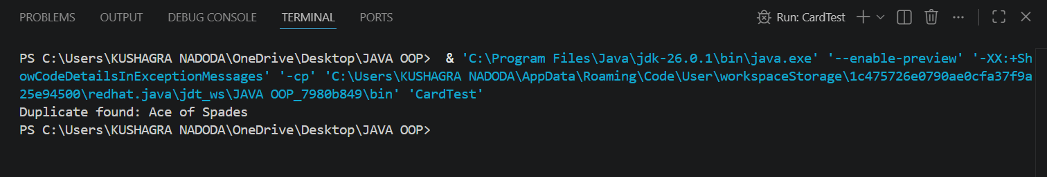
PROBLEM3 | (For Advanced Learners – home) Fractions (Fraction.java + Driver.java)  (a) Create class Fraction with private int num, den.  (b) In the constructor, reduce to lowest terms: compute g = gcd(num, den) and divide both by g.  (c) Override toString() to return num + “/” + den.  (d) Override equals()/hashCode() using the reduced num and den.  (e) In Driver.main: create several equivalent fractions (1/2, 2/4, 3/6) and confirm they are all equal and print the same.  Expected output: new Fraction(2,4) prints “1/2” and equals new Fraction(1,2).
CODE | public class Fraction {  private int num, den;  public Fraction(int num, int den) {  int g = gcd(Math.abs(num), Math.abs(den));  this.num = num / g;  this.den = den / g;  }  private int gcd(int a, int b) {  if (b == 0) return a;  return gcd(b, a % b);  }  public void print() {  System.out.print(num + "/" + den);  }  public boolean isSame(Fraction other) {  return this.num == other.num && this.den == other.den;  }  }  public class FractionTest {  public static void main(String[] args) {  Fraction a = new Fraction(1, 2);  Fraction b = new Fraction(2, 4);  Fraction c = new Fraction(3, 6);  a.print();  System.out.println();  b.print();  System.out.println();  c.print();  System.out.println();  System.out.println("a equals b: " + a.isSame(b));  System.out.println("b equals c: " + b.isSame(c));  System.out.println("a equals c: " + a.isSame(c));  }  }
OUTPUT | 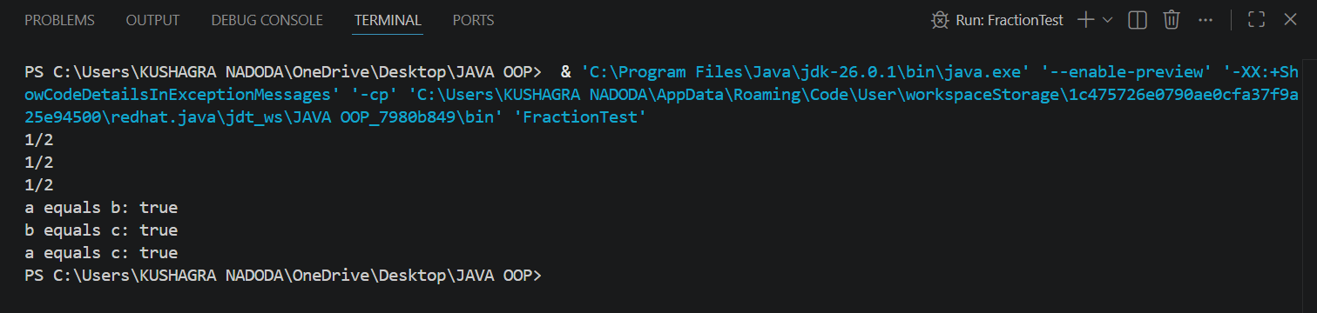

Part B — Project Work (Hour 2): Mini Bank
PROBLEM | In Practical 2 you created the Account and Customer classes. Here you make their objects behave correctly — they print as readable text (toString) and are compared by account number (equals/hashCode) — and you add a nested Address class. Correct equals/hashCode is essential because Practical 12 will store accounts in collections that rely on it.  1. In Account, override the toString() method to return a readable line containing accountNumber, ownerName and balance.  2. In Account, override equals(Object o) and hashCode() so that two accounts are equal when their accountNumber values are equal.  3. In Customer, add a public static nested class named Address with String fields line, city and pincode plus getters; add an Address field to Customer and a getAddress() method.  4. In Customer, add a clone() method (implement Cloneable) that returns a copy of the customer.  5. In main, print accounts using toString(), compare two Account objects with equals(), and use instanceof to check an object’s type.
CODE | import java.util.Scanner;  public class MiniBank {  record BankInfo(String name, String branch) {}  enum MenuOption {  OPEN_ACCOUNT, DEPOSIT, WITHDRAW, TRANSFER, EXIT  }  public static void main(String[] args) {  Scanner sc = new Scanner(System.in);  BankInfo bank = new BankInfo("MiniBank", "Main Branch");  System.out.println(bank);  Account[] accounts = new Account[3];  accounts[0] = new Account("Alice", 1000);  accounts[1] = new Account("Bob");  accounts[2] = new Account("Charlie", 500);  accounts[0].deposit(200);  accounts[1].deposit(300);  accounts[2].withdraw(100);  accounts[2].withdraw(1000);  for (Account acc : accounts) {  System.out.println(acc.getAccountNumber() + " (" + acc.getOwnerName() + "): Rs. " + acc.getBalance());  }  // Practical 3 additions: print(), isSame(), instanceof  System.out.println(accounts[0].print());  System.out.println(accounts[1].print());  boolean same = accounts[0].isSame(accounts[1]);  System.out.println("accounts[0] and accounts[1] are the same account? " + same);  Object obj = accounts[0];  if (obj instanceof Account) {  System.out.println("obj is an Account object");  }  boolean running = true;  while (running) {  System.out.println();  System.out.println("1. Open Account");  System.out.println("2. Deposit");  System.out.println("3. Withdraw");  System.out.println("4. Transfer");  System.out.println("5. Exit");  System.out.print("Enter your choice: ");  int choice = sc.nextInt();  MenuOption option = MenuOption.values()[choice - 1];  String message = switch (option) {  case OPEN_ACCOUNT -> "Open Account — to be implemented in a later lab";  case DEPOSIT -> "Deposit — to be implemented in a later lab";  case WITHDRAW -> "Withdraw — to be implemented in a later lab";  case TRANSFER -> "Transfer — to be implemented in a later lab";  case EXIT -> "Goodbye!";  };  System.out.println(message);  if (option == MenuOption.EXIT) {  running = false;  }  }  }  }  class Customer {  private String name;  private String email;  private String mobile;  private final String customerId;  private Address address;  private static long customerCounter = 100;  private static String generateCustomerId() {  customerCounter++;  return "CUST" + customerCounter;  }  public Customer(String name, String email, String mobile) {  this.name = name;  this.email = email;  this.mobile = mobile;  this.customerId = generateCustomerId();  }  private Customer(String customerId, String name, String email, String mobile, Address address) {  this.customerId = customerId;  this.name = name;  this.email = email;  this.mobile = mobile;  this.address = address;  }  public String getName() { return name; }  public String getEmail() { return email; }  public String getMobile() { return mobile; }  public String getCustomerId() { return customerId; }  public void setAddress(Address address) {  this.address = address;  }  public Address getAddress() {  return address;  }  public Customer copy() {  return new Customer(this.customerId, this.name, this.email, this.mobile, this.address);  }  public static class Address {  private String line;  private String city;  private String pincode;  public Address(String line, String city, String pincode) {  this.line = line;  this.city = city;  this.pincode = pincode;  }  public String getLine() { return line; }  public String getCity() { return city; }  public String getPincode() { return pincode; }  }  }  class Account {  private final String accountNumber;  private String ownerName;  private long balance;  private boolean active;  private static int accountCounter = 0;  private static String generateAccountNumber() {  accountCounter++;  return String.format("AC%04d", accountCounter);  }  public Account(String ownerName, long openingBalance) {  this.accountNumber = generateAccountNumber();  this.ownerName = ownerName;  this.balance = openingBalance;  this.active = true;  }  public Account(String ownerName) {  this(ownerName, 0);  }  public void deposit(long amount) {  balance += amount;  }  public boolean withdraw(long amount) {  if (balance >= amount) {  balance -= amount;  return true;  }  return false;  }  public String getAccountNumber() { return accountNumber; }  public String getOwnerName() { return ownerName; }  public long getBalance() { return balance; }  public boolean isActive() { return active; }  public String print() {  return "Account[" + accountNumber + ", " + ownerName + ", Balance: " + balance + "]";  }  public boolean isSame(Account other) {  if (other == null) {  return false;  }  return this.accountNumber.equals(other.accountNumber);  }  }
OUTPUT | 