Part A — Practice Programs (Hour 1)
PROBLEM1 | Remote control: an interface Switchable with on()/off() and a default toggle(); Fan and Light implement it. Loop over a Switchable[] toggling each. Then add a functional interface that decides, given a device and an hour, whether it may switch on, and supply it once as an anonymous class and once as a lambda.
CODE | interface Switchable{  void on();  void off();  default void toggle(){  System.out.println("Toggling device...");  }  }  class Fan implements Switchable{  public void on(){  System.out.println("Fan is ON");  }  public void off() {  System.out.println("Fan is OFF");  }  }  class Light implements Switchable{  public void on(){  System.out.println("Light is ON");  }  public void off(){  System.out.println("Light is OFF");  }  }  @FunctionalInterface  interface SwitchDecision{  boolean maySwitchOn(Switchable device, int hour);  }  public class RemoteControl{  public static void main(String[] args){  Switchable[] devices = {new Fan(),new Light()};  System.out.println("---- Toggling Devices ----");  for (Switchable device : devices){  device.toggle();  }  SwitchDecision decision1 = new SwitchDecision(){  public boolean maySwitchOn(Switchable device, int hour){  return hour >= 6 && hour <= 22;  }  };  SwitchDecision decision2 = (device, hour) -> hour >= 6 && hour <= 22;  System.out.println("\n---- Anonymous Class ----");  System.out.println("Can switch Fan at 10 AM: " + decision1.maySwitchOn(devices[0], 10));  System.out.println("Can switch Light at 2 AM: " + decision1.maySwitchOn(devices[1], 2));  System.out.println("\n---- Lambda Expression ----");  System.out.println("Can switch Fan at 8 PM: " + decision2.maySwitchOn(devices[0], 20));  System.out.println("Can switch Light at 11 PM: " + decision2.maySwitchOn(devices[1], 23));  }  }
OUTPUT | 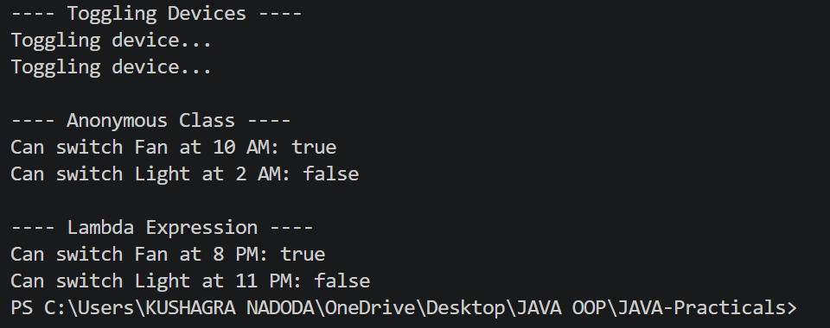
PROBLEM2 | Notification senders: a functional interface Notifier with send(String); make email and SMS senders as lambdas, hold them in an array, and broadcast one message through all. Add a marker interface Urgent and send twice for senders marked urgent.
CODE | @FunctionalInterface  interface Notifier{  void send(String message);  }  interface Urgent {  }  public class NotificationSenders{  public static void main(String[] args){  Notifier email = (message) -> System.out.println("Email: " + message);  Notifier sms = (message) -> System.out.println("SMS: " + message);  Notifier[] senders = {email,sms};  String message = "Exam starts at 10 AM";  System.out.println("---- Broadcasting Message ----");  for (Notifier sender : senders) {  sender.send(message);  if (sender instanceof Urgent) {  sender.send(message);  }  }  }  }
OUTPUT | 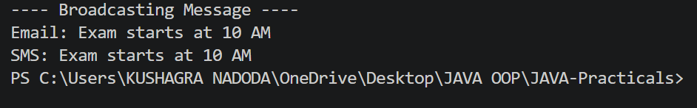
PROBLEM3 | (For Advanced Learners – home) Build a small discount engine where each rule is a lambda the user picks at runtime and applies to a list of prices; organise it into packages and ship it as a runnable JAR.
CODE | DiscountRule.java  package discount;  @FunctionalInterface  public interface DiscountRule {  double apply(double price);  }  DiscountEngine.java  package app;  import discount.DiscountRule;  import java.util.Scanner;  public class DiscountEngine {  public static void main(String[] args) {  Scanner sc = new Scanner(System.in);  double[] prices = {  500,  1000,  1500,  2000,  2500  };  System.out.println("===== DISCOUNT ENGINE =====");  System.out.println("1. 10% Discount");  System.out.println("2. 20% Discount");  System.out.println("3. Flat Rs. 100 Discount");  System.out.println("4. 30% Discount for prices above Rs. 1000");  System.out.print("Choose a discount rule: ");  int choice = sc.nextInt();  DiscountRule rule;  switch (choice) {  case 1:  rule = price -> price * 0.90;  break;  case 2:  rule = price -> price * 0.80;  break;  case 3:  rule = price -> price - 100;  break;  case 4:  rule = price -> {  if (price > 1000) {  return price * 0.70;  }  return price;  };  break;  default:  System.out.println("Invalid choice.");  sc.close();  return;  }  System.out.println("\n===== FINAL PRICES =====");  for (double price : prices) {  double finalPrice = rule.apply(price);  System.out.println(  "Original Price: Rs. " + price +  " | Final Price: Rs. " + finalPrice  );  }  sc.close();  }  }
OUTPUT | 