PRACTICAL - 14
Part A — Practice Programs (Hour 1)

PROBLEM1 | Assemble and test: build a tiny layered app (a model, a service using an ArrayList, and a menu main), then write two or three JUnit @Test methods checking that adding increases the count and an invalid action throws — practice before testing MiniBank.
CODE | Book.java  public class Book {  private String title;  public Book(String title) {  this.title = title;  }  public String getTitle() {  return title;  }  }  LibraryService.java  import java.util.ArrayList;  public class LibraryService {  private ArrayList<Book> books = new ArrayList<>();  public void addBook(String title) {  if (title == null || title.trim().isEmpty()) {  throw new IllegalArgumentException("Title cannot be empty");  }  books.add(new Book(title));  }  public int getBookCount() {  return books.size();  }  public ArrayList<Book> getBooks() {  return new ArrayList<>(books);  }  public void validateAction(int action) {  if (action < 1 || action > 3) {  throw new IllegalArgumentException("Invalid action");  }  }  }  LibraryApp.java  import java.util.Scanner;  public class LibraryApp {  public static void main(String[] args) {  Scanner sc = new Scanner(System.in);  LibraryService service = new LibraryService();  while (true) {  System.out.println("\n--- Library Menu ---");  System.out.println("1. Add book");  System.out.println("2. View books");  System.out.println("3. Exit");  System.out.print("Enter choice: ");  int choice;  if (!sc.hasNextInt()) {  System.out.println("Please enter a number.");  sc.nextLine();  continue;  }  choice = sc.nextInt();  sc.nextLine();  try {  service.validateAction(choice);  switch (choice) {  case 1:  System.out.print("Enter book title: ");  String title = sc.nextLine();  service.addBook(title);  System.out.println("Book added!");  break;  case 2:  System.out.println("Total books: "  + service.getBookCount());  for (Book book : service.getBooks()) {  System.out.println(book.getTitle());  }  break;  case 3:  System.out.println("Goodbye!");  sc.close();  return;  }  } catch (IllegalArgumentException e) {  System.out.println(e.getMessage());  }  }  }  }
OUTPUT | 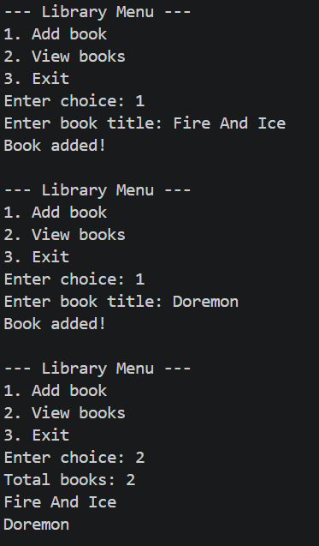  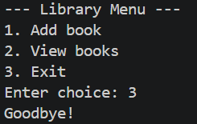
PROBLEM2 | (For Advanced Learners – home) Organise that app into packages, build a runnable JAR, and add a test that saves and reloads its data unchanged.
CODE | Book.java  package model;  import java.io.Serializable;  public class Book implements Serializable {  private static final long serialVersionUID = 1L;  private String title;  public Book(String title) {  this.title = title;  }  public String getTitle() {  return title;  }  }  LibraryService.java  package service;  import model.Book;  import java.io.FileInputStream;  import java.io.FileOutputStream;  import java.io.IOException;  import java.io.ObjectInputStream;  import java.io.ObjectOutputStream;  import java.nio.file.Path;  import java.util.ArrayList;  import java.util.List;  public class LibraryService {  private ArrayList<Book> books = new ArrayList<>();  public void addBook(String title) {  if (title == null || title.trim().isEmpty()) {  throw new IllegalArgumentException(  "Title cannot be empty"  );  }  books.add(new Book(title));  }  public int getBookCount() {  return books.size();  }  public List<Book> getBooks() {  return new ArrayList<>(books);  }  public void validateAction(int action) {  if (action < 1 || action > 3) {  throw new IllegalArgumentException("Invalid action");  }  }  // Save books to a file  public void saveTo(Path file) throws IOException {  try (ObjectOutputStream out = new ObjectOutputStream(  new FileOutputStream(file.toFile()))) {  out.writeObject(books);  }  }  // Load books from a file  @SuppressWarnings("unchecked")  public static LibraryService loadFrom(Path file)  throws IOException, ClassNotFoundException {  LibraryService service = new LibraryService();  try (ObjectInputStream in = new ObjectInputStream(  new FileInputStream(file.toFile()))) {  service.books = (ArrayList<Book>) in.readObject();  }  return service;  }  }  LibraryApp.java  package app;  import model.Book;  import service.LibraryService;  import java.nio.file.Path;  import java.util.Scanner;  public class LibraryApp {  public static void main(String[] args) {  Scanner sc = new Scanner(System.in);  LibraryService service = new LibraryService();  while (true) {  System.out.println("\n--- Library Menu ---");  System.out.println("1. Add book");  System.out.println("2. View books");  System.out.println("3. Save and Exit");  System.out.print("Enter choice: ");  if (!sc.hasNextInt()) {  System.out.println("Please enter a number.");  sc.nextLine();  continue;  }  int choice = sc.nextInt();  sc.nextLine();  try {  service.validateAction(choice);  switch (choice) {  case 1:  System.out.print("Enter book title: ");  String title = sc.nextLine();  service.addBook(title);  System.out.println("Book added!");  break;  case 2:  System.out.println(  "Total books: " + service.getBookCount()  );  for (Book book : service.getBooks()) {  System.out.println(book.getTitle());  }  break;  case 3:  service.saveTo(Path.of("books.dat"));  System.out.println("Books saved!");  System.out.println("Goodbye!");  sc.close();  return;  }  } catch (IllegalArgumentException e) {  System.out.println("Error: " + e.getMessage());  } catch (Exception e) {  System.out.println("File error: " + e.getMessage());  }  }  }  }
OUTPUT | 