Part A — Practice Programs (Hour 1)
PROBLEM1 | Form validator: define @NotBlank and @MaxLength(int) for fields and annotate a SignupForm. Write a checker that uses reflection to read each field’s annotations and returns the list of validation errors for a given object.
CODE | NotBlank.java  import java.lang.annotation.*;  @Retention(RetentionPolicy.RUNTIME)  @Target(ElementType.FIELD)  public @interface NotBlank {  }  MaxLength.java  import java.lang.annotation.*;  @Retention(RetentionPolicy.RUNTIME)  @Target(ElementType.FIELD)  public @interface MaxLength {  int value();  }  SignupForm.java  public class SignupForm {  @NotBlank  @MaxLength(10)  private String name;  @NotBlank  private String email;  @MaxLength(8)  private String pass;  public SignupForm(String name, String email, String pass) {  this.name = name;  this.email = email;  this.pass = pass;  }  }  Checker.java  import java.lang.reflect.Field;  import java.util.ArrayList;  import java.util.List;  public class Checker {  public static List<String> check(Object o) throws IllegalAccessException {  List<String> errs = new ArrayList<>();  for (Field f : o.getClass().getDeclaredFields()) {  f.setAccessible(true);  String v = (String) f.get(o);  if (f.isAnnotationPresent(NotBlank.class)) {  if (v == null || v.isBlank()) {  errs.add(f.getName() + " must not be blank");  }  }  if (f.isAnnotationPresent(MaxLength.class)) {  int max = f.getAnnotation(MaxLength.class).value();  if (v != null && v.length() > max) {  errs.add(f.getName() + " must be at most " + max + " characters");  }  }  }  return errs;  }  }  FormDemo.java  import java.util.List;  public class FormDemo {  public static void main(String[] args) throws Exception {  SignupForm bad = new SignupForm("", "a@b.com", "verylongpassword");  SignupForm ok = new SignupForm("Riya", "r@b.com", "pass123");  System.out.println("Bad form:");  List<String> e1 = Checker.check(bad);  for (String s : e1) {  System.out.println(" " + s);  }  System.out.println("Good form:");  List<String> e2 = Checker.check(ok);  if (e2.isEmpty()) {  System.out.println(" No errors");  }  }  }
OUTPUT | 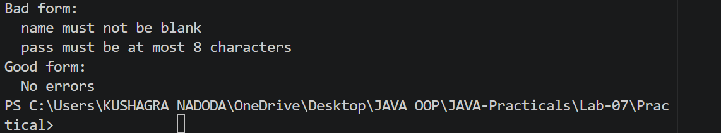
PROBLEM2 | Mini test runner: define a @Run annotation and mark some no-arg methods of a class with it. Use reflection to find and invoke only the @Run methods and report how many ran — the idea behind how JUnit finds @Test methods.
CODE | import java.lang.annotation.*;  import java.lang.reflect.*;  @Retention(RetentionPolicy.RUNTIME)  @Target(ElementType.METHOD)  @interface Run {  }  class MyTests {  @Run  public void testLogin() {  System.out.println("testLogin executed");  }  public void normalMethod() {  System.out.println("normalMethod executed");  }  @Run  public void testSignup() {  System.out.println("testSignup executed");  }  public void anotherMethod() {  System.out.println("anotherMethod executed");  }  @Run  public void testLogout() {  System.out.println("testLogout executed");  }  }  public class MiniTestRunner {  public static void main(String[] args) {  MyTests testObject = new MyTests();  Method[] methods = MyTests.class.getDeclaredMethods();  int count = 0;  for (Method method : methods) {  if (method.isAnnotationPresent(Run.class)) {  try {  method.invoke(testObject);  count++;  } catch (Exception e) {  System.out.println("Error running: "  + method.getName());  }  }  }  System.out.println("Total tests run: " + count);  }  }
OUTPUT | 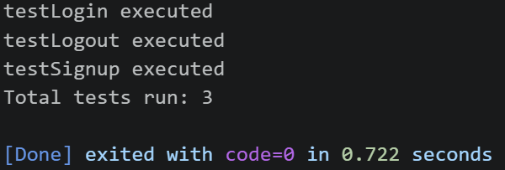
PROBLEM3 | (For Advanced Learners – home) Define a @Column(name) annotation and, by reflection, populate an object’s fields from a header row and a data row by matching column names; decide how to handle a missing column.
CODE | import java.lang.annotation.*;  import java.lang.reflect.Field;  @Retention(RetentionPolicy.RUNTIME)  @Target(ElementType.FIELD)  @interface Column {  String name();  }  class Student {  @Column(name = "id")  private int id;  @Column(name = "name")  private String name;  @Column(name = "email")  private String email;  @Column(name = "age")  private int age;  public void display() {  System.out.println("ID: " + id);  System.out.println("Name: " + name);  System.out.println("Email: " + email);  System.out.println("Age: " + age);  }  }  public class ColumnMapper {  public static void populate(Object obj, String[] headers, String[] data) {  Field[] fields = obj.getClass().getDeclaredFields();  for (Field field : fields) {  if (!field.isAnnotationPresent(Column.class)) {  continue;  }  Column column = field.getAnnotation(Column.class);  String columnName = column.name();  int index = -1;  // Find column in header  for (int i = 0; i < headers.length; i++) {  if (headers[i].equals(columnName)) {  index = i;  break;  }  }  // Missing column  if (index == -1) {  System.out.println(  "Missing column: " + columnName  );  continue;  }  try {  field.setAccessible(true);  if (field.getType() == int.class) {  field.setInt(obj, Integer.parseInt(data[index]));  } else if (field.getType() == String.class) {  field.set(obj, data[index]);  }  } catch (Exception e) {  System.out.println(  "Error setting " + columnName  );  }  }  }  public static void main(String[] args) {  String[] headers = {  "name", "id", "email"  };  String[] data = {  "Kushagra", "101", "kushagra@gmail.com"  };  Student student = new Student();  populate(student, headers, data);  System.out.println("\nStudent details:");  student.display();  }  }
OUTPUT | 