Part A — Practice Programs (Hour 1)
PROBLEM1 | Guarded calculator: read two numbers and an operator; throw a custom DivideByZeroException and catch invalid-number input separately, printing a clear message each time; loop until a valid calculation succeeds and use finally to log each attempt.
CODE | import java.util.Scanner;  class DivideByZeroException extends Exception{  DivideByZeroException(String msg){  super(msg);  }  }  public class CalculatorDemo{  public static void main(String[] args){  Scanner sc = new Scanner(System.in);  boolean done = false;  int n = 0;  while (!done){  n++;  System.out.print("Enter first number: ");  String a = sc.next();  System.out.print("Enter second number: ");  String b = sc.next();  System.out.print("Enter operator (+,-,*,/): ");  String op = sc.next();  try{  double n1 = Double.parseDouble(a);  double n2 = Double.parseDouble(b);  double res = calc(n1, op, n2);  System.out.println("Result: " + res);  done = true;  } catch (NumberFormatException e){  System.out.println("Invalid number entered. Please try again.");  } catch (DivideByZeroException e){  System.out.println("Error: " + e.getMessage());  } catch (IllegalArgumentException e){  System.out.println("Invalid operator. Please use +, -, * or /.");  } finally{  System.out.println("Attempt " + n + " logged");  }  }  }  static double calc(double n1, String op, double n2) throws DivideByZeroException{  switch (op){  case "+": return n1 + n2;  case "-": return n1 - n2;  case "*": return n1 * n2;  case "/":  if (n2 == 0) {  throw new DivideByZeroException("Cannot divide by zero");  }  return n1 / n2;  default:  throw new IllegalArgumentException("Unknown operator: " + op);  }  }  }
OUTPUT | 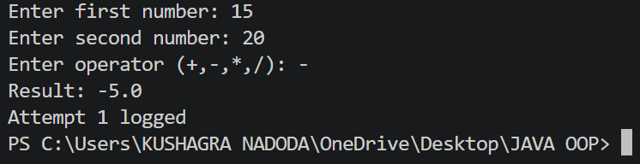
PROBLEM2 | Stock issue: a Warehouse where issue(item, qty) throws a custom checked OutOfStockException carrying the shortfall, and InvalidQuantityException for qty ≤ 0. Process a list of requests, catching and reporting each failure without stopping the run.
CODE | import java.util.*;  class OutOfStockException extends Exception{  private int shortfall;  public OutOfStockException(int shortfall){  super("Out of stock");  this.shortfall = shortfall;  }  public int getShortfall(){  return shortfall;  }  }  class InvalidQuantityException extends Exception{  public InvalidQuantityException(){  super("Quantity must be greater than 0");  }  }  public class Warehouse{  String[] items = {"Laptop", "Mouse", "Keyboard"};  int[] stock = {10, 5, 8};  public void issue(String item, int qty)  throws OutOfStockException, InvalidQuantityException{  if (qty <= 0){  throw new InvalidQuantityException();  }  int index = -1;  for (int i = 0; i < items.length; i++){  if (items[i].equals(item)) {  index = i;  break;  }  }  if (index == -1){  throw new OutOfStockException(qty);  }  if (qty > stock[index]){  int shortfall = qty - stock[index];  throw new OutOfStockException(shortfall);  }  stock[index] -= qty;  System.out.println("Issued " + qty + " " + item);  System.out.println("Remaining stock: " + stock[index]);  }  public static void main(String[] args){  Warehouse warehouse = new Warehouse();  String[][] requests = {{"Laptop", "3"}, {"Mouse", "10"}, {"Keyboard", "2"}, {"Laptop", "0"}, {"Mouse", "2"}, {"Tablet", "1"}};  for (String[] request : requests){  String item = request[0];  int qty = Integer.parseInt(request[1]);  System.out.println("\nRequest: " + item + " - " + qty);  try{  warehouse.issue(item, qty);  } catch (OutOfStockException e){  System.out.println("Failed: Out of stock");  System.out.println("Shortfall: " + e.getShortfall());  } catch (InvalidQuantityException e){  System.out.println("Failed: " + e.getMessage());  }  }  System.out.println("\nAll requests processed.");  }  }
OUTPUT | 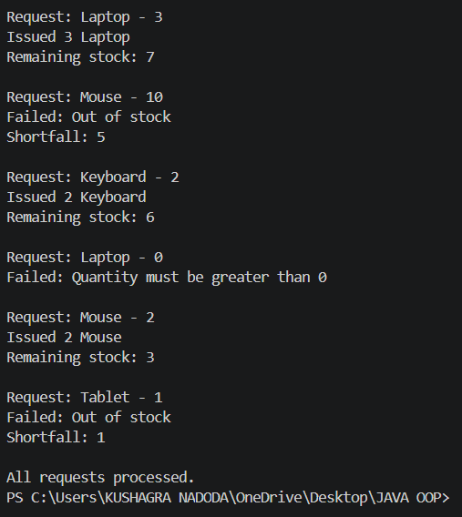
PROBLEM3 | (For Advanced Learners – home) Create an AutoCloseable resource and use try-with-resources to prove it always closes — even when an exception is thrown inside the block— and that the original error is the one reported. Decide what to model as the resource.
CODE | FileResource.java  class MyResource implements AutoCloseable{  public MyResource(){  System.out.println("Resource opened");  }  public void use(){  System.out.println("Using resource...");  throw new RuntimeException("Error while using resource");  }  @Override  public void close(){  System.out.println("Resource closed");  }  }  public class FileResource{  public static void main(String[] args){  try (MyResource resource = new MyResource()){  resource.use();  } catch (Exception e){  System.out.println("Exception: " + e.getMessage());  }  }  }  AutoClosableDemo.java  class FileResource implements AutoCloseable{  public FileResource(){  System.out.println("Resource opened");  }  public void use(){  System.out.println("Using resource...");  throw new RuntimeException("Error while using resource");  }  @Override  public void close(){  System.out.println("Resource closed");  }  }  public class AutoCloseableDemo{  public static void main(String[] args){  try (FileResource resource = new FileResource()){  resource.use();  } catch (Exception e){  System.out.println("Exception: " + e.getMessage());  }  }  }
OUTPUT | 