Part A — Practice Programs (Hour 1)
PROBLEM1 | Counter race: several threads each increment a shared counter many times. Run it without synchronization to watch the total come out too low, then make the increment synchronized and confirm it is exactly right every run.
CODE | public class CounterRace {  static int counter = 0;  static void incrementWithoutSync() {  counter++;  }  static synchronized void incrementWithSync() {  counter++;  }  public static void main(String[] args) throws InterruptedException {  int numberOfThreads = 10;  int incrementsPerThread = 100000;  counter = 0;  Thread[] threads = new Thread[numberOfThreads];  for (int i = 0; i < numberOfThreads; i++) {  threads[i] = new Thread(() -> {  for (int j = 0; j < incrementsPerThread; j++) {  incrementWithoutSync();  }  });  threads[i].start();  }  for (Thread t : threads) {  t.join();  }  int expected = numberOfThreads * incrementsPerThread;  System.out.println("Without synchronization:");  System.out.println("Expected count: " + expected);  System.out.println("Actual count: " + counter);  counter = 0;  for (int i = 0; i < numberOfThreads; i++) {  threads[i] = new Thread(() -> {  for (int j = 0; j < incrementsPerThread; j++) {  incrementWithSync();  }  });  threads[i].start();  }  for (Thread t : threads) {  t.join();  }  System.out.println("\nWith synchronization:");  System.out.println("Expected count: " + expected);  System.out.println("Actual count: " + counter);  }  }
OUTPUT | 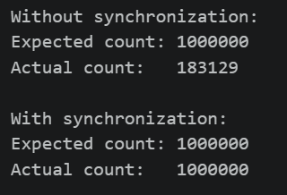
PROBLEM2 | Seat booking race: a shared seatsLeft of 5 with about 10 threads each trying to book one seat. Without synchronization show that more than 5 can succeed (oversell); with a synchronized book() exactly 5 do.
CODE | public class SeatBookingRace {  static class BookingSystem {  int seatsLeft = 5;  boolean bookWithoutSync() {  if (seatsLeft > 0) {  try {  Thread.sleep(10);  } catch (InterruptedException e) {  Thread.currentThread().interrupt();  }  seatsLeft--;  return true;  }  return false;  }  synchronized boolean book() {  if (seatsLeft > 0) {  seatsLeft--;  return true;  }  return false;  }  }  public static void main(String[] args) throws InterruptedException {  int numberOfThreads = 10;  BookingSystem system1 = new BookingSystem();  Thread[] threads = new Thread[numberOfThreads];  int[] successfulBookings = {0};  for (int i = 0; i < numberOfThreads; i++) {  threads[i] = new Thread(() -> {  if (system1.bookWithoutSync()) {  synchronized (successfulBookings) {  successfulBookings[0]++;  }  System.out.println(  Thread.currentThread().getName()  + " booked a seat"  );  }  });  threads[i].start();  }  for (Thread t : threads) {  t.join();  }  System.out.println("\nWithout synchronization:");  System.out.println(  "Successful bookings: " + successfulBookings[0]  );  System.out.println(  "Seats left: " + system1.seatsLeft  );  BookingSystem system2 = new BookingSystem();  Thread[] threads2 = new Thread[numberOfThreads];  int[] successfulBookings2 = {0};  for (int i = 0; i < numberOfThreads; i++) {  threads2[i] = new Thread(() -> {  if (system2.book()) {  synchronized (successfulBookings2) {  successfulBookings2[0]++;  }  System.out.println(  Thread.currentThread().getName()  + " booked a seat"  );  }  });  threads2[i].start();  }  for (Thread t : threads2) {  t.join();  }  System.out.println("\nWith synchronization:");  System.out.println(  "Successful bookings: " + successfulBookings2[0]  );  System.out.println(  "Seats left: " + system2.seatsLeft  );  }  }
OUTPUT | 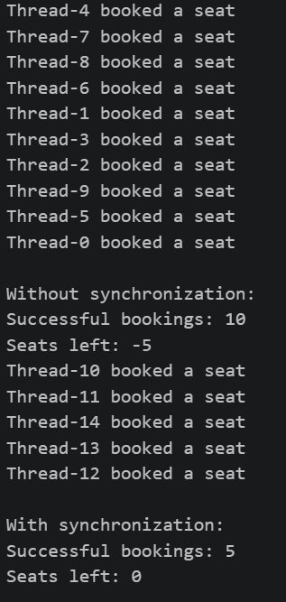
PROBLEM3 | (For Advanced Learners – home) Split a large array of numbers across several threads that add into one shared total, show the wrong result, then fix it two ways and compare;decide how to measure the difference.
CODE | import java.util.concurrent.atomic.AtomicLong;  public class ArraySumRace {  static long sharedTotal = 0;  static void addWithoutSync(long value) {  sharedTotal += value;  }  static synchronized void addWithSync(long value) {  sharedTotal += value;  }  public static void main(String[] args) throws InterruptedException {  int arraySize = 1_000_000;  int numberOfThreads = 8;  long[] numbers = new long[arraySize];  for (int i = 0; i < arraySize; i++) {  numbers[i] = 1;  }  long expectedTotal = 0;  for (long n : numbers) {  expectedTotal += n;  }  System.out.println("Expected total: " + expectedTotal);  System.out.println();  sharedTotal = 0;  Thread[] threads = new Thread[numberOfThreads];  int chunk = arraySize / numberOfThreads;  long start = System.nanoTime();  for (int i = 0; i < numberOfThreads; i++) {  int startIndex = i * chunk;  int endIndex = (i == numberOfThreads - 1)  ? arraySize  : startIndex + chunk;  threads[i] = new Thread(() -> {  for (int j = startIndex; j < endIndex; j++) {  addWithoutSync(numbers[j]);  }  });  threads[i].start();  }  for (Thread t : threads) {  t.join();  }  long end = System.nanoTime();  System.out.println("WITHOUT SYNCHRONIZATION");  System.out.println("Actual total: " + sharedTotal);  System.out.println("Expected total: " + expectedTotal);  System.out.println("Time: " + (end - start) + " ns");  System.out.println();  sharedTotal = 0;  threads = new Thread[numberOfThreads];  start = System.nanoTime();  for (int i = 0; i < numberOfThreads; i++) {  int startIndex = i * chunk;  int endIndex = (i == numberOfThreads - 1)  ? arraySize  : startIndex + chunk;  threads[i] = new Thread(() -> {  for (int j = startIndex; j < endIndex; j++) {  addWithSync(numbers[j]);  }  });  threads[i].start();  }  for (Thread t : threads) {  t.join();  }  end = System.nanoTime();  System.out.println("WITH SYNCHRONIZATION");  System.out.println("Actual total: " + sharedTotal);  System.out.println("Expected total: " + expectedTotal);  System.out.println("Time: " + (end - start) + " ns");  System.out.println();  AtomicLong atomicTotal = new AtomicLong(0);  threads = new Thread[numberOfThreads];  start = System.nanoTime();  for (int i = 0; i < numberOfThreads; i++) {  int startIndex = i * chunk;  int endIndex = (i == numberOfThreads - 1)  ? arraySize  : startIndex + chunk;  threads[i] = new Thread(() -> {  for (int j = startIndex; j < endIndex; j++) {  atomicTotal.addAndGet(numbers[j]);  }  });  threads[i].start();  }  for (Thread t : threads) {  t.join();  }  end = System.nanoTime();  System.out.println("WITH ATOMICLONG");  System.out.println("Actual total: " + atomicTotal.get());  System.out.println("Expected total: " + expectedTotal);  System.out.println("Time: " + (end - start) + " ns");  }  }
OUTPUT | 