PRACTICAL - 11
Part A — Practice Programs (Hour 1)

PROBLEM1 | Save/load: make a small class Serializable, save an array of its objects to a file with  ObjectOutputStream, then read it back into fresh objects and confirm the values survived.  Mark one field transient and show it is not saved.
CODE | import java.io.*;  class Student implements Serializable {  private static final long serialVersionUID = 1L;  int rollNo;  String name;  double marks;  transient String password;  Student(int rollNo, String name, double marks, String password) {  this.rollNo = rollNo;  this.name = name;  this.marks = marks;  this.password = password;  }  void display() {  System.out.println("Roll No: " + rollNo);  System.out.println("Name: " + name);  System.out.println("Marks: " + marks);  System.out.println("Password: " + password);  System.out.println("--------------------");  }  }  public class SerializationDemo {  public static void main(String[] args) {  Student[] students = {  new Student(1, "Alice", 85.5, "alice123"),  new Student(2, "Bob", 90.0, "bob456"),  new Student(3, "Charlie", 78.5, "charlie789")  };  try (ObjectOutputStream out =  new ObjectOutputStream(  new FileOutputStream("students.dat"))) {  out.writeObject(students);  System.out.println("Objects saved successfully.");  } catch (IOException e) {  System.out.println("Error saving objects: " + e.getMessage());  }  try (ObjectInputStream in =  new ObjectInputStream(  new FileInputStream("students.dat"))) {  Student[] loadedStudents = (Student[]) in.readObject();  System.out.println("\nLoaded student details:");  for (Student s : loadedStudents) {  s.display();  }  } catch (IOException | ClassNotFoundException e) {  System.out.println("Error loading objects: " + e.getMessage());  }  }  }
OUTPUT | 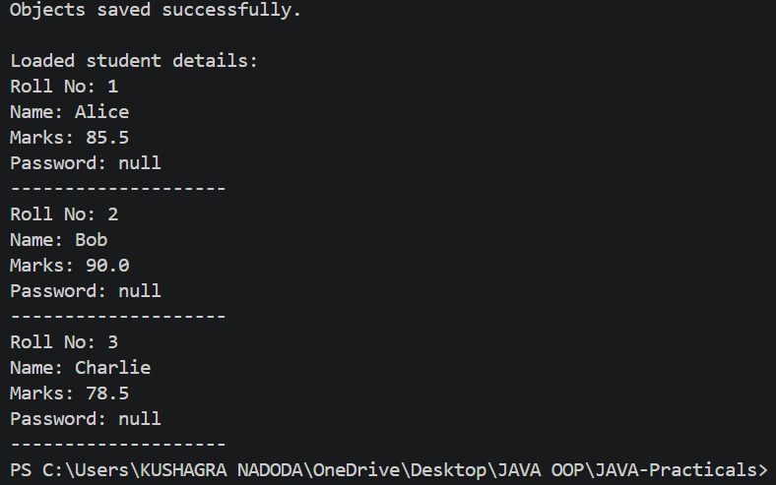
PROBLEM2 | Log analyzer: create a few text files, then use Path/Files to read each line by line and  count the total lines and how many contain a keyword across all files; also print each  file’s size from its attributes.
CODE | import java.io.IOException;  import java.nio.file.Files;  import java.nio.file.Path;  import java.nio.file.Paths;  import java.nio.file.attribute.BasicFileAttributes;  import java.util.List;  public class LogAnalyzer {  public static void main(String[] args) {  Path folder = Paths.get("logs");  try {  Files.createDirectories(folder);  Files.write(folder.resolve("app1.txt"), List.of(  "Application started",  "User logged in",  "ERROR: Database connection failed",  "Application closed"  ));  Files.write(folder.resolve("app2.txt"), List.of(  "Server started",  "ERROR: File not found",  "User logged out"  ));  Files.write(folder.resolve("app3.txt"), List.of(  "System running normally",  "User logged in",  "ERROR: Network timeout"  ));  String keyword = "ERROR";  int totalLines = 0;  int matchingLines = 0;  try (var files = Files.list(folder)) {  for (Path file : files.filter(Files::isRegularFile).toList()) {  BasicFileAttributes attributes =  Files.readAttributes(file, BasicFileAttributes.class);  System.out.println("\nFile: " + file.getFileName());  System.out.println("Size: " + attributes.size() + " bytes");  List<String> lines = Files.readAllLines(file);  for (String line : lines) {  totalLines++;  if (line.contains(keyword)) {  matchingLines++;  System.out.println("Match: " + line);  }  }  }  }  System.out.println("\n----- SUMMARY -----");  System.out.println("Total lines: " + totalLines);  System.out.println("Lines containing '" + keyword  + "': " + matchingLines);  } catch (IOException e) {  System.out.println("File error: " + e.getMessage());  }  }  }
OUTPUT | 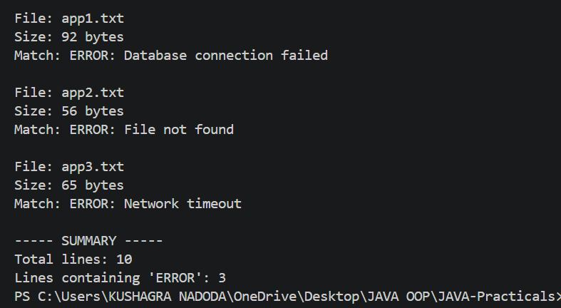
PROBLEM3 | (For Advanced Learners – home) Walk a folder tree with NIO and produce a report of the files it contains (name, size, modified time), writing the summary to a file; decide what to include.
CODE | import java.io.IOException;  import java.nio.file.Files;  import java.nio.file.Path;  import java.nio.file.Paths;  import java.nio.file.attribute.BasicFileAttributes;  import java.time.Instant;  import java.time.ZoneId;  import java.time.format.DateTimeFormatter;  import java.util.stream.Stream;  public class FileTreeReport {  public static void main(String[] args) {  Path folder = Paths.get("myfolder");  Path report = Paths.get("file_report.txt");  int fileCount = 0;  long totalSize = 0;  DateTimeFormatter formatter =  DateTimeFormatter.ofPattern("dd-MM-yyyy HH:mm:ss")  .withZone(ZoneId.systemDefault());  try {  Files.createDirectories(folder.resolve("subfolder"));  Files.writeString(folder.resolve("notes.txt"),  "Java NIO practical");  Files.writeString(folder.resolve("subfolder/data.txt"),  "This is a sample file.");  Files.writeString(folder.resolve("subfolder/info.txt"),  "File tree report");  try (var writer = Files.newBufferedWriter(report);  Stream<Path> paths = Files.walk(folder)) {  writer.write("FILE TREE REPORT");  writer.newLine();  writer.write("================");  writer.newLine();  for (Path path : paths.toList()) {  if (Files.isRegularFile(path)) {  BasicFileAttributes attr =  Files.readAttributes(  path, BasicFileAttributes.class);  String name = folder.relativize(path).toString();  long size = attr.size();  String modifiedTime =  formatter.format(  attr.lastModifiedTime().toInstant());  writer.write("Name: " + name);  writer.newLine();  writer.write("Size: " + size + " bytes");  writer.newLine();  writer.write("Modified: " + modifiedTime);  writer.newLine();  writer.write("------------------------");  writer.newLine();  fileCount++;  totalSize += size;  }  }  writer.newLine();  writer.write("Total files: " + fileCount);  writer.newLine();  writer.write("Total size: " + totalSize + " bytes");  }  System.out.println("Report created successfully!");  System.out.println("Files found: " + fileCount);  System.out.println("Total size: " + totalSize + " bytes");  System.out.println("Report saved to: " + report.toAbsolutePath());  } catch (IOException e) {  System.out.println("Error: " + e.getMessage());  }  }}
OUTPUT | 