PRACTICAL - 10
Part A — Practice Programs (Hour 1)

PROBLEM1 | 1. Counter race: several threads each increment a shared counter many times. Run it  without synchronization to watch the total come out too low, then make the increment  synchronized and confirm it is exactly right every run.
CODE | import java.util.concurrent.ExecutorService;  import java.util.concurrent.Executors;  import java.util.concurrent.TimeUnit;  public class ThreadPoolRunner {  public static void main(String[] args) {  // Create a fixed thread pool with 3 threads  ExecutorService executor = Executors.newFixedThreadPool(3);  // Submit 10 tasks  for (int i = 1; i <= 10; i++) {  int taskId = i;  executor.submit(() -> {  try {  System.out.println(  "Task " + taskId + " is running on " +  Thread.currentThread().getName()  );  // Sleep briefly  Thread.sleep(1000);  System.out.println(  "Task " + taskId + " completed by " +  Thread.currentThread().getName()  );  } catch (InterruptedException e) {  Thread.currentThread().interrupt();  }  });  }  // No more tasks will be submitted  executor.shutdown();  try {  // Wait until all tasks are completed  if (executor.awaitTermination(30, TimeUnit.SECONDS)) {  System.out.println("All tasks completed.");  } else {  System.out.println("Timeout! Some tasks are still running.");  }  } catch (InterruptedException e) {  Thread.currentThread().interrupt();  }  }  }
OUTPUT | 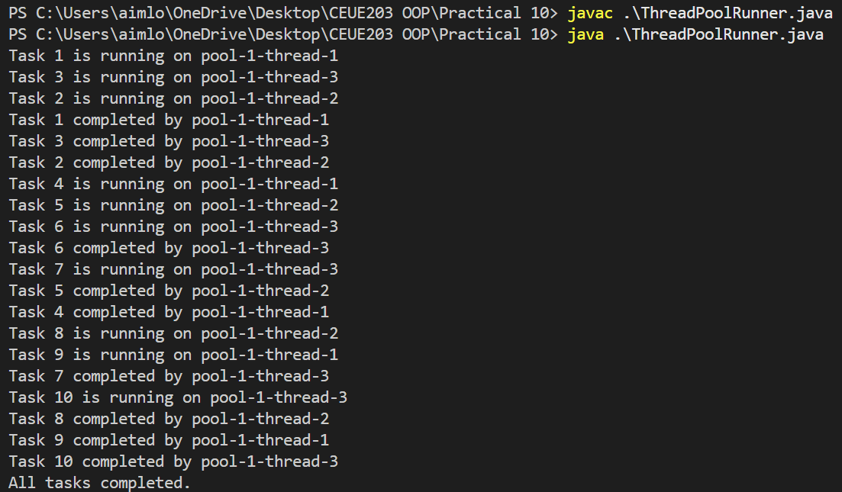
PROBLEM2 | 2. Producer–consumer: one thread adds numbers to a small shared buffer and another  removes them, coordinated with wait()/notify(); produce and consume a fixed number of  items in order with none lost.
CODE | class SharedBuffer {  private int item;  private boolean available = false;  // Producer adds an item  public synchronized void produce(int value) throws InterruptedException {  // Wait if buffer is full  while (available) {  wait();  }  item = value;  available = true;  System.out.println("Produced: " + value);  // Notify consumer  notify();  }  // Consumer removes an item  public synchronized int consume() throws InterruptedException {  // Wait if buffer is empty  while (!available) {  wait();  }  int value = item;  available = false;  System.out.println("Consumed: " + value);  // Notify producer  notify();  return value;  }  }  public class ProducerConsumer {  public static void main(String[] args) {  SharedBuffer buffer = new SharedBuffer();  int numberOfItems = 10;  // Producer thread  Thread producer = new Thread(() -> {  try {  for (int i = 1; i <= numberOfItems; i++) {  buffer.produce(i);  Thread.sleep(200);  }  } catch (InterruptedException e) {  Thread.currentThread().interrupt();  }  });  // Consumer thread  Thread consumer = new Thread(() -> {  try {  for (int i = 1; i <= numberOfItems; i++) {  buffer.consume();  Thread.sleep(300);  }  } catch (InterruptedException e) {  Thread.currentThread().interrupt();  }  });  producer.start();  consumer.start();  try {  producer.join();  consumer.join();  } catch (InterruptedException e) {  Thread.currentThread().interrupt();  }  System.out.println("All items produced and consumed.");  }  }
OUTPUT | 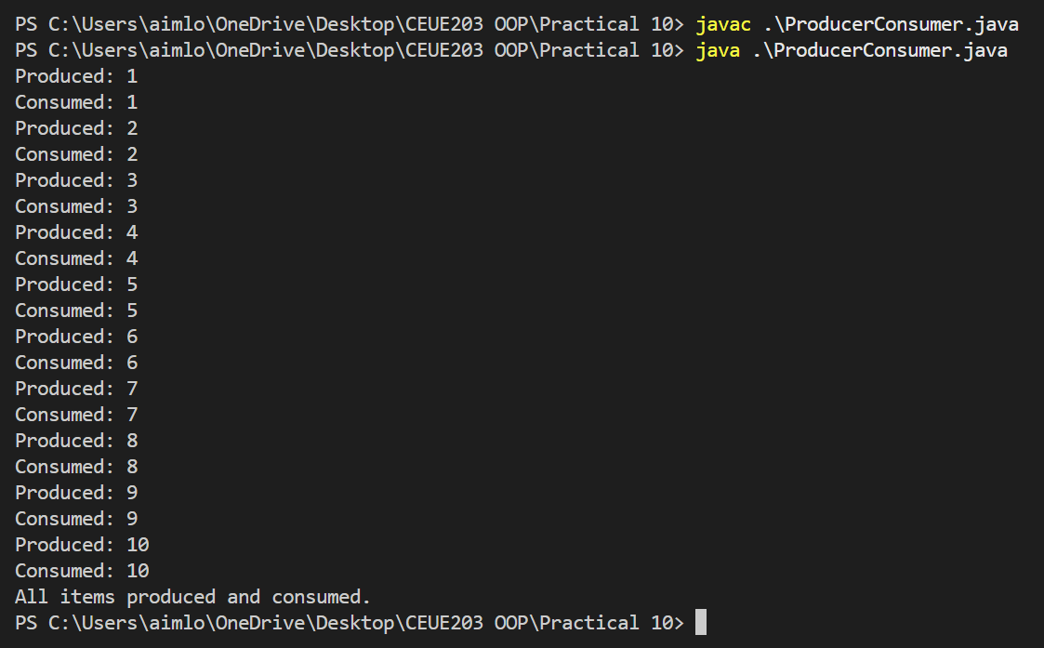
PROBLEM3 | 3. (For Advanced Learners – home) Reproduce a deadlock between two threads that lock  two objects in opposite order, then remove it with a consistent lock order. Choose the  scenario yourself.
CODE | public class DeadlockDemo {  static Object accountA = new Object();  static Object accountB = new Object();  // This method can cause DEADLOCK  static void transferAtoB() {  synchronized (accountA) {  System.out.println("Thread 1 locked Account A");  try {  Thread.sleep(100);  } catch (InterruptedException e) {  Thread.currentThread().interrupt();  }  synchronized (accountB) {  System.out.println("Thread 1 locked Account B");  }  }  }  // Locks objects in the OPPOSITE order  static void transferBtoA() {  synchronized (accountB) {  System.out.println("Thread 2 locked Account B");  try {  Thread.sleep(100);  } catch (InterruptedException e) {  Thread.currentThread().interrupt();  }  synchronized (accountA) {  System.out.println("Thread 2 locked Account A");  }  }  }  public static void main(String[] args) {  Thread thread1 = new Thread(DeadlockDemo::transferAtoB);  Thread thread2 = new Thread(DeadlockDemo::transferBtoA);  thread1.start();  thread2.start();  }  }
OUTPUT | 