Part A — Practice Programs (Hour 1)
PROBLEM1 | Shape areas: an abstract Shape with abstract area(); subclasses Circle, Rectangle, Triangle. Put a mix in a Shape[] and loop once to print each area and the running total, tracking the largest — one loop handling every shape through polymorphism.
CODE | abstract class Shape {  abstract double area();  }  class Circle extends Shape {  double r;  Circle(double r) { this.r = r; }  double area() { return Math.PI * r * r; }  }  class Rectangle extends Shape {  double w, h;  Rectangle(double w, double h) { this.w = w; this.h = h; }  double area() { return w * h; }  }  class Triangle extends Shape {  double b, h;  Triangle(double b, double h) { this.b = b; this.h = h; }  double area() { return 0.5 * b * h; }  }  public class ShapeDemo {  public static void main(String[] args) {  Shape[] arr = {  new Circle(5),  new Rectangle(4, 6),  new Triangle(3, 7)  };  double sum = 0;  double max = 0;  Shape big = null;  for (Shape s : arr) {  double a = s.area();  sum += a;  if (a > max) {  max = a;  big = s;  }  System.out.println(s.getClass().getSimpleName() + " area: " + a + ", running total: " + sum);  }  System.out.println("Largest: " + big.getClass().getSimpleName() + " with area " + max);  }  }
OUTPUT | 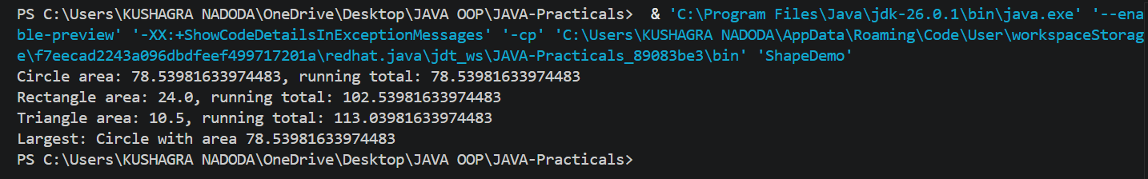
PROBLEM2 | Payroll: an abstract Employee with abstract monthlySalary(); FullTime (fixed), PartTime (hours × rate) and Intern (stipend), each calling super for the shared name/id. Loop a mixed array to print each salary and the total; use instanceof to add a note only for interns.
CODE | abstract class Employee {  String name;  String id;  Employee(String name, String id) {  this.name = name;  this.id = id;  }  abstract double monthlySalary();  }  class FullTime extends Employee {  double sal;  FullTime(String name, String id, double sal) {  super(name, id);  this.sal = sal;  }  double monthlySalary() { return sal; }  }  class PartTime extends Employee {  double hrs, rate;  PartTime(String name, String id, double hrs, double rate) {  super(name, id);  this.hrs = hrs;  this.rate = rate;  }  double monthlySalary() { return hrs * rate; }  }  class Intern extends Employee {  double stipend;  Intern(String name, String id, double stipend) {  super(name, id);  this.stipend = stipend;  }  double monthlySalary() { return stipend; }  }  public class PayrollDemo {  public static void main(String[] args) {  Employee[] arr = {  new FullTime("Alice", "E1", 50000),  new PartTime("Bob", "E2", 80, 300),  new Intern("Charlie", "E3", 10000)  };  double total = 0;  for (Employee e : arr) {  double sal = e.monthlySalary();  total += sal;  String note = (e instanceof Intern) ? " (Intern)" : "";  System.out.println(e.name + " (" + e.id + "): Rs. " + sal + note);  }  System.out.println("Total payroll: Rs. " + total);  }  }
OUTPUT | 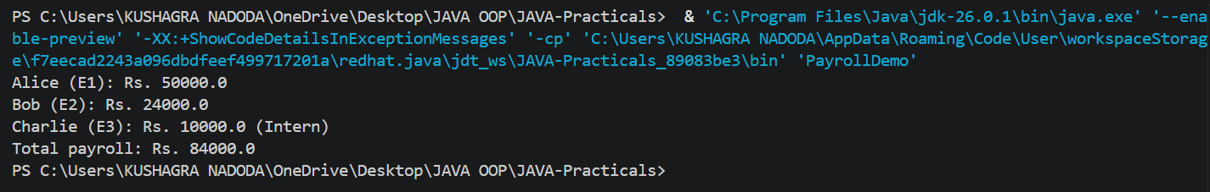
PROBLEM3 | (For Advanced Learners – home) Model a few media types that each compute a late fee differently and total the fees for a returned batch. Design the hierarchy and rules yourself.
CODE | abstract class Media {  String title;  int daysLate;  Media(String title, int daysLate) {  this.title = title;  this.daysLate = daysLate;  }  abstract double lateFee();  }  class Book extends Media {  Book(String title, int daysLate) { super(title, daysLate); }  double lateFee() { return daysLate * 5; }  }  class Dvd extends Media {  Dvd(String title, int daysLate) { super(title, daysLate); }  double lateFee() { return daysLate * 10; }  }  class Magazine extends Media {  Magazine(String title, int daysLate) { super(title, daysLate); }  double lateFee() { return daysLate * 2; }  }  public class MediaFeeDemo {  public static void main(String[] args) {  Media[] arr = {  new Book("Java Basics", 3),  new Dvd("Movie X", 5),  new Magazine("Tech Weekly", 10)  };  double total = 0;  for (Media m : arr) {  double fee = m.lateFee();  total += fee;  System.out.println(m.title + " (" + m.daysLate + " days): Rs. " + fee);  }  System.out.println("Total fees: Rs. " + total);  }  }
OUTPUT | 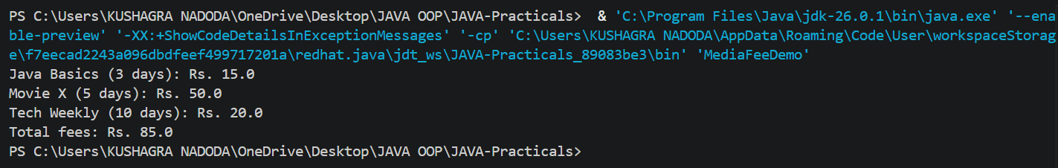

Part B — Project Work (Hour 2): Mini Bank
PROBLEM | A real bank has different account types. Building on the single Account class, this lab makes Account abstract and adds three subclasses — SavingsAccount, CurrentAccount and FixedDepositAccount — each with its own interest and withdrawal rules chosen automatically by polymorphism. This lets the rest of MiniBank treat every account through one common type.  1. Make Account an abstract class. Add two abstract methods: double interestRate() and boolean canWithdraw(long amount).  2. Create a class SavingsAccount that extends Account with a long field minBalance; interestRate() returns 4.0; canWithdraw() returns true only if the balance stays greater than or equal to minBalance.  3. Create a class CurrentAccount that extends Account with a long field overdraftLimit; interestRate() returns 0; canWithdraw() allows the balance to fall to minus overdraftLimit.  4. Create a class FixedDepositAccount that extends Account; interestRate() returns 7.0; canWithdraw() returns false (the deposit is locked).  5. Call super(...) from each subclass constructor to initialise the inherited fields.  6. In main, place objects of the three types in an Account[] array, loop through it and call interestRate() on each (this demonstrates run-time polymorphism); use a pattern instanceof check to handle one type specially.
CODE | import java.util.Scanner;  import java.util.regex.Pattern;  public class MiniBank {  record BankInfo(String name, String branch) {}  enum MenuOption {  OPEN_ACCOUNT, DEPOSIT, WITHDRAW, TRANSFER, EXIT  }  public static void main(String[] args) {  Scanner sc = new Scanner(System.in);  BankInfo bank = new BankInfo("MiniBank", "Main Branch");  System.out.println(bank);  Account[] arr = {  new SavingsAccount("Alice", 1000, 200),  new CurrentAccount("Bob", 0, 500),  new FixedDepositAccount("Charlie", 500)  };  arr[0].deposit(200);  arr[1].deposit(300);  arr[2].withdraw(100);  double total = 0;  for (Account a : arr) {  double rate = a.interestRate();  total += rate;  System.out.println(a.print() + ", Interest rate: " + rate + "%");  if (a instanceof SavingsAccount sa) {  System.out.println(" Min balance rule: " + sa.minBalance);  }  }  System.out.println("Sum of interest rates: " + total);  boolean same = arr[0].isSame(arr[1]);  System.out.println("Same account? " + same);  System.out.println("isValidMobile(\"9876543210\"): " + Validator.isValidMobile("9876543210"));  System.out.println("isValidMobile(\"12345\"): " + Validator.isValidMobile("12345"));  System.out.println("isValidEmail(\"abc@xyz.com\"): " + Validator.isValidEmail("abc@xyz.com"));  System.out.println("isValidEmail(\"abc@xyz\"): " + Validator.isValidEmail("abc@xyz"));  System.out.println("isValidPan(\"ABCDE1234F\"): " + Validator.isValidPan("ABCDE1234F"));  System.out.println("isValidPan(\"ABCDE1234\"): " + Validator.isValidPan("ABCDE1234"));  System.out.println("isValidIfsc(\"SBIN0001234\"): " + Validator.isValidIfsc("SBIN0001234"));  System.out.println("isValidIfsc(\"SBIN1234\"): " + Validator.isValidIfsc("SBIN1234"));  Command cmd = CommandParser.parse("DEPOSIT AC0001 500");  System.out.println("type=" + cmd.type() + ", accountNumber=" + cmd.accountNumber() + ", amount=" + cmd.amount());  boolean running = true;  while (running) {  System.out.println();  System.out.println("1. Open Account");  System.out.println("2. Deposit");  System.out.println("3. Withdraw");  System.out.println("4. Transfer");  System.out.println("5. Exit");  System.out.print("Enter your choice: ");  int choice = sc.nextInt();  MenuOption option = MenuOption.values()[choice - 1];  String message = switch (option) {  case OPEN_ACCOUNT -> "Open Account — to be implemented in a later lab";  case DEPOSIT -> "Deposit — to be implemented in a later lab";  case WITHDRAW -> "Withdraw — to be implemented in a later lab";  case TRANSFER -> "Transfer — to be implemented in a later lab";  case EXIT -> "Goodbye!";  };  System.out.println(message);  if (option == MenuOption.EXIT) {  running = false;  }  }  }  }  class Customer {  private String name;  private String email;  private String mobile;  private final String customerId;  private Address address;  private static long customerCounter = 100;  private static String generateCustomerId() {  customerCounter++;  return "CUST" + customerCounter;  }  public Customer(String name, String email, String mobile) {  this.name = name;  this.email = email;  this.mobile = mobile;  this.customerId = generateCustomerId();  }  private Customer(String customerId, String name, String email, String mobile, Address address) {  this.customerId = customerId;  this.name = name;  this.email = email;  this.mobile = mobile;  this.address = address;  }  public String getName() { return name; }  public String getEmail() { return email; }  public String getMobile() { return mobile; }  public String getCustomerId() { return customerId; }  public void setAddress(Address address) { this.address = address; }  public Address getAddress() { return address; }  public Customer copy() {  return new Customer(this.customerId, this.name, this.email, this.mobile, this.address);  }  public static class Address {  private String line;  private String city;  private String pincode;  public Address(String line, String city, String pincode) {  this.line = line;  this.city = city;  this.pincode = pincode;  }  public String getLine() { return line; }  public String getCity() { return city; }  public String getPincode() { return pincode; }  }  }  abstract class Account {  private final String accNum;  private String owner;  private long bal;  private boolean active;  private static int counter = 0;  private static String genAccNum() {  counter++;  return String.format("AC%04d", counter);  }  public Account(String owner, long openingBal) {  this.accNum = genAccNum();  this.owner = owner;  this.bal = openingBal;  this.active = true;  }  public Account(String owner) {  this(owner, 0);  }  public void deposit(long amt) {  bal += amt;  }  public boolean withdraw(long amt) {  if (canWithdraw(amt)) {  bal -= amt;  return true;  }  return false;  }  abstract double interestRate();  abstract boolean canWithdraw(long amt);  public String getAccountNumber() { return accNum; }  public String getOwnerName() { return owner; }  public long getBalance() { return bal; }  public boolean isActive() { return active; }  public String print() {  return "Account[" + accNum + ", " + owner + ", Balance: " + bal + "]";  }  public boolean isSame(Account other) {  if (other == null) {  return false;  }  return this.accNum.equals(other.accNum);  }  }  class SavingsAccount extends Account {  long minBalance;  SavingsAccount(String owner, long openingBal, long minBalance) {  super(owner, openingBal);  this.minBalance = minBalance;  }  double interestRate() { return 4.0; }  boolean canWithdraw(long amt) {  return getBalance() - amt >= minBalance;  }  }  class CurrentAccount extends Account {  long overdraftLimit;  CurrentAccount(String owner, long openingBal, long overdraftLimit) {  super(owner, openingBal);  this.overdraftLimit = overdraftLimit;  }  double interestRate() { return 0; }  boolean canWithdraw(long amt) {  return getBalance() - amt >= -overdraftLimit;  }  }  class FixedDepositAccount extends Account {  FixedDepositAccount(String owner, long openingBal) {  super(owner, openingBal);  }  double interestRate() { return 7.0; }  boolean canWithdraw(long amt) {  return false;  }  }  class Validator {  private static final Pattern MOBILE = Pattern.compile("^[6-9][0-9]{9}$");  private static final Pattern EMAIL = Pattern.compile("^[\\w.+-]+@[\\w-]+\\.[a-zA-Z]{2,}$");  private static final Pattern PAN = Pattern.compile("^[A-Z]{5}[0-9]{4}[A-Z]$");  private static final Pattern IFSC = Pattern.compile("^[A-Z]{4}0[A-Z0-9]{6}$");  private static final Pattern AMOUNT = Pattern.compile("^[1-9][0-9]*$");  public static boolean isValidMobile(String s) { return MOBILE.matcher(s).matches(); }  public static boolean isValidEmail(String s) { return EMAIL.matcher(s).matches(); }  public static boolean isValidPan(String s) { return PAN.matcher(s).matches(); }  public static boolean isValidIfsc(String s) { return IFSC.matcher(s).matches(); }  public static boolean isValidAmount(String s) { return AMOUNT.matcher(s).matches(); }  }  enum TransactionType {  DEPOSIT, WITHDRAW, TRANSFER  }  record Command(TransactionType type, String accountNumber, long amount) {}  class CommandParser {  public static Command parse(String line) {  String[] p = line.split(" ");  if (p.length != 3) {  throw new IllegalArgumentException("Expected 3 parts, got " + p.length);  }  TransactionType type = TransactionType.valueOf(p[0].toUpperCase());  String acc = p[1];  long amt = Long.parseLong(p[2]);  return new Command(type, acc, amt);  }  }  class StatementFormatter {  public static String buildStatement(Account acc) {  StringBuilder sb = new StringBuilder();  sb.append("---- Account Statement ----\n");  sb.append("Account Number: ").append(acc.getAccountNumber()).append("\n");  sb.append("Owner: ").append(acc.getOwnerName()).append("\n");  sb.append("Balance: Rs. ").append(acc.getBalance()).append("\n");  sb.append("----------------------------\n");  return sb.toString();  }  }
OUTPUT | 