New Product Uploading Process
Complete Video Analysis, Step-by-Step SOP, and Operational Commentary
Source file: New_Product Uploading201124.mp4 inside New_Product Uploading201124.zip
Item | Observed value / interpretation
Video duration | 25:00 minutes approximately
Video resolution | 1364 x 768 screen recording
Visible process date | 20-Nov-2024 in Windows/Magento UI
Primary tools used | Google Drive, Microsoft Excel macro workbooks, Google Sheets, Google Colab, Magento Admin Panel, MageWorx custom option templates
Primary business object | Loose gemstone / product catalog upload, including media files, certificate data, Magento product import data, and custom-option/template assignments
Analysis method | Visual review of sampled frames and keyframes from the uploaded video. Audio was not used as a primary source because no reliable transcript was embedded in the file.

Scope note
This document explains what is visible in the video and turns the screen recording into a structured process document. Some tiny spreadsheet cells and browser text are not fully readable at video resolution; those areas are marked as observed/inferred rather than treated as exact system truth.

Document map
1. Executive summary
2. System and data-flow map
3. Detailed timestamped walkthrough
4. Detailed SOP by operating phase
5. Data fields and transformation logic
6. Magento import and custom-option assignment logic
7. Quality-control checklist
8. Risks, failure points, and automation recommendations
9. Final operator checklist

1. Executive summary
The video demonstrates a manual-plus-semi-automated catalog upload workflow for GemPundit loose gemstones. The operator starts from product files and inventory/certificate data, normalizes the data through Excel and Google Sheets, runs a Google Colab notebook to generate Magento-ready CSV outputs, imports those outputs into Magento, and finally attaches products to custom option templates such as Pooja/Energization and Lab Certificate options.
The process is not a single clean upload. It is a chained workflow: file renaming, SKU assignment, certificate extraction/matching, metadata normalization, image-query generation, Magento product import, image/media linking, and post-import custom-option/template assignment. The manual checks are necessary because one broken SKU, image name, certificate number, or option assignment can create a live product with missing media or wrong customer-facing options.
Phase | What is happening | Why it matters
Source collection | The operator opens Google Drive and local folders containing product media/data for live cataloging. | This is the input pool: photos, videos, certificates, inventory references, and working spreadsheets.
Renaming and SKU mapping | Renaming_File.xlsm lists raw filenames, assigns/looks up SKUs, identifies missing matches, and prepares final naming. | Magento relies heavily on SKU and media filenames; inconsistent names break image imports and product matching.
Data enrichment | Excel master sheets and validation sheets normalize gemstone, origin, treatment, shape/cut, certificate, dimensions, price, and old inventory mappings. | Raw supplier/catalog data is converted into controlled Magento-compatible values.
Google Sheet staging | Catalog_Upload_Loose is populated with inventory, certificate, gem type, criteria, calibrated, renaming, and image query data. | This becomes the structured staging layer used by Colab.
Colab generation | Catalog_Loose.ipynb runs cells to update inventory, fetch details, build database-linked data, fix blanks, generate naming conventions, final catalog, image query, video query, and after-catalog files. | The notebook converts messy working data into Magento import CSVs and query files.
Magento import | Final_Catalog CSV is uploaded as Products with Append Complex Data; profile imports then run image and after-catalog CSVs. | This creates/updates product records and media associations in Magento.
Custom option assignment | MageWorx option templates are filtered, opened, and assigned to selected product SKUs or product grids. | This attaches purchasable/service options such as Pooja/Energization and Lab Certificate rules to the uploaded products.
Final verification | The operator cross-checks SKUs, filters, price buckets, and template assignment pages. | This prevents live catalog errors before products are considered complete.

2. System and data-flow map
The end-to-end data flow visible in the screen recording is below. It is intentionally linear because each stage depends on the previous stage being clean.
# | System/stage | Input/output | Mechanism
1 | Google Drive / local folders | Raw folders: product images, certificates, possible videos, inventory exports, and support sheets. | Human selects correct folder/set.
2 | Renaming_File.xlsm | Macro workbook creates file list, detects file types, maps inventory to SKUs, shows Not found records, and prepares renamed media filenames. | Clear_Data, Pick Folder, Certificate Name/No., Export Inv Match, SKU Assign, SKU Renaming, Rename Folder.
3 | Excel master/validation workbooks | Master inventory, TT sheet, old inventory IDs, data validation lists, final data sheet. | XLOOKUPs and lookup tables normalize and enrich attributes.
4 | Catalog_Upload_Loose Google Sheet | Staging tabs such as Get_data_inv, certificate_data, Gem_type, Calibrated, Criteria, Renaming. | Used by Colab as a cloud-readable source.
5 | Catalog_Loose.ipynb in Colab | Runs pandas/gspread workflows and exports Final_Catalog, 1st/2nd image query, video query, after-catalog CSVs. | Automated transformation/generation layer.
6 | Magento Admin | System > Import and Import/Export Profiles > Import temp. | Uploads product data and supplementary media/catalog updates.
7 | MageWorx custom option templates | Templates such as Pooja/Energization, Lab Certificate, SO-* price/category option templates. | Assigns customer-facing custom options to the new products.
8 | QA/verification | Magento grids, Excel filters, sheet counts, SKU lists, option template product counts. | Confirms catalog is live and options are attached correctly.

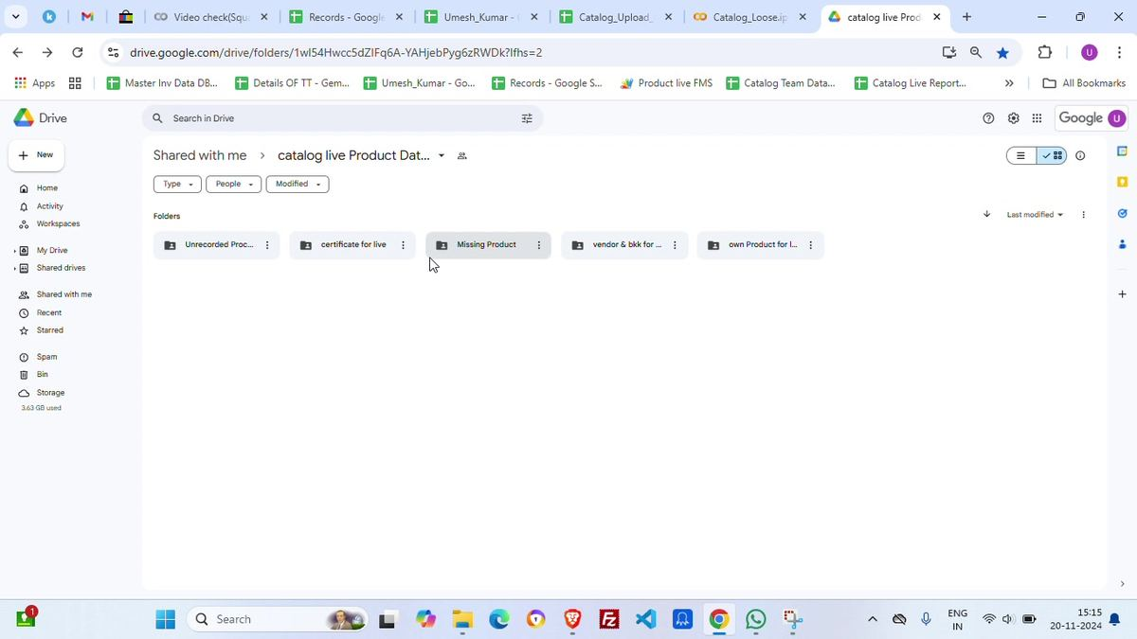
Screenshot 00:30 - The workflow begins inside a shared Google Drive folder for catalog live product data.
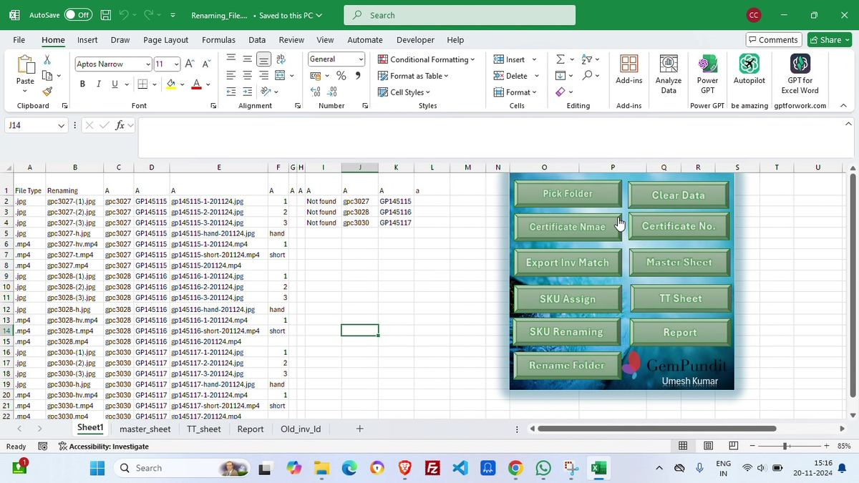
Screenshot 01:10 - The macro workbook is used as the file/SKU renaming control panel.

3. Detailed timestamped walkthrough
This section maps the video into operating steps. The timestamp column gives the approximate point in the video where the action is visible.
Timestamp | Stage | What is visible | Operational commentary
00:00-00:30 | Workspace setup | Windows desktop moves into Chrome/Google Drive. The Drive folder is titled around catalog live product data and contains subfolders such as unrecorded processing, certificate for live, missing product, vendor & BKK, and own product for live. | The operator is selecting the right batch/source location before touching the upload files.
00:40-01:00 | Open local processing assets | File Explorer opens a working folder; Excel opens the macro workbook used for product renaming. | The workflow starts with local processing, not directly in Magento. That is good because raw file names must be cleaned first.
01:10-02:30 | Renaming workbook review | Renaming_File.xlsm shows rows for JPG/MP4, original names, planned names, image positions, hand/certificate labels, short video flags, and a button panel. | This is the first hard checkpoint. Any Not found value means the data link is not complete. Do not upload until these rows are resolved or intentionally excluded.
02:30-03:20 | Final data generation | The operator opens/uses a certificate details workbook with a Final_Data_Sheet. Visible columns include SKU, Certificate No., weight, Color, Shape/Cut, Measurement, and generated inventory/SKU fields. | This consolidates certificate and stone details into a format that can be joined with inventory and catalog data.
03:20-05:00 | Master sheet enrichment | The master sheet contains inventory, GP-ID, status, min price, price per carat, carat weight, gemstone, treatment, dollar flag, pricing contact, certificate links/labs/numbers, dimensions and shape. XLOOKUP formulas are used. | The workbook is enriching raw IDs with commercial and catalog fields. Formula references are brittle: renamed files or moved workbooks can break them.
05:10-06:10 | Magento upload CSV template review | A catalog CSV workbook opens with Magento import-style columns. Later tabs show data validation values for shapes, cuts, certificates and origins. | The operator is aligning normalized spreadsheet data to Magento column requirements.
06:40-08:40 | Google Sheet staging | Catalog_Upload_Loose is opened. Tabs include Get_data_inv, certificate_data, Gem_type, Calibrated, Criteria and Renaming. The operator filters columns such as image_type and validates jpg/mp4 rows. | Google Sheets acts as the shared staging database that Colab can read. The red columns indicate fields that need attention, generated warnings, or protected validation zones.
08:40-15:10 | Colab automation run | Catalog_Loose.ipynb runs cells: Update Inventory, details fetch from Catalog_Upload_Loose, database pull, blank/fixed updates, naming convention, final catalog, image query, short/long video query, after catalog, and image checks. | This is the main transformation engine. It uses Python/pandas/gspread logic to generate the CSVs Magento will consume.
15:20-16:20 | Output file inspection | Downloads are opened. The operator inspects output folders and final CSVs in Excel, including Final_Catalog_20-11-2024.csv. | Manual spot-checking catches bad values before upload. Important columns include sku, _store, _attribute_set, _type, category_ids, product website, carat/certificate/colour/cut/description/dimension fields.
16:40-17:30 | Magento product import | Magento Admin is opened. System > Import is used with Entity Type = Products and Import Behavior = Append Complex Data. Final_Catalog CSV is selected and checked. | Append Complex Data updates products without replacing all complex product data. The selected CSV must be UTF-8/ANSI and under the visible 600MB upload limit.
17:30-18:30 | Import/export profile run | The operator opens Import/Export Profiles > Import temp. Files are uploaded/selected from a timestamped dropdown, including 1st_image_query, 2nd_image_query and After_Catalog CSVs. | The product data import is only part of the job. Image/media and after-catalog updates are run separately through profile jobs.
18:40-21:00 | Option template search | The operator opens MageWorx Manage Options Templates, filters template titles, and locates options such as Pooja/Energization New. | Newly imported products must receive service/custom option templates after the product import.
21:00-22:20 | Product SKU assignment | The template page is switched to Product SKUs and comma-separated GP SKUs are pasted. Excel is used to produce SKU lists. | Assigning by SKU is faster than selecting products one by one. The risk is pasting an incomplete or polluted SKU list.
22:20-25:00 | Custom option segmentation | The 7.Custom_Option.xlsx workbook is used with tabs like LAB, POOJA, Pair, Simple_Custom_Option and EXPERIMENT. Products are split into below/above 40K price buckets and attached to appropriate templates such as SO-Amethyst-COM-A40K. | This appears to control which products get specific custom options based on gemstone, certificate eligibility, and price threshold logic.

4. Detailed SOP by operating phase

4.1 Source batch selection
Open the correct Drive/shared folder and identify the batch to be processed. The visible folder is a live product catalog workspace with subfolders for processing, certificates, missing products, vendors and owned product data. The key action is choosing the right batch; processing the wrong folder will cascade wrong filenames, wrong inventory matches and wrong upload outputs.

4.2 File renaming and SKU assignment
Open Renaming_File.xlsm. Use the macro dashboard to pick the folder and load product files. The sheet classifies file type (.jpg, .mp4), original filename, planned renamed filename, certificate/hand labels, image position, short-video flag and SKU mapping. The operator should clear old data first, then generate fresh matches, then inspect Not found rows before renaming the folder.

4.3 Certificate and inventory matching
Use certificate name/number extraction and export inventory matching. In the video, the workbook shows Certificate No., weight, color, shape/cut, measurement, inventory and SKU columns. The intended output is a reliable row-level bridge between media files, certificate records and inventory IDs.

4.4 Master sheet enrichment
Open the master sheet and let formulas/XLOOKUPs enrich inventory rows with GP-ID, status, price, gemstone, treatment, origin, certificate lab/number, dimensions and shape. The visible formula uses XLOOKUP against the Renaming_File.xlsm master_sheet range. This enriches the batch but depends on exact workbook names and range stability.

4.5 Data validation mapping
Use Data_Validation to standardize raw values. Visible mappings convert raw shape/cut strings like Oval/Mixed or Octagon/Step into controlled Shape and Cut values. The sheet also lists certificate labels and origin values. This prevents Magento import errors caused by inconsistent vendor naming.

4.6 Old inventory and SKU continuity
Use Old_inv_Id or similar mapping to preserve relationships between old entity IDs, old SKUs, new entity IDs/SKUs, gemstone2 and origin. The visible sheet tracks a Last SKU value around GP145114 and then new SKUs in the GP145115+ range. This prevents duplicate SKU collisions.
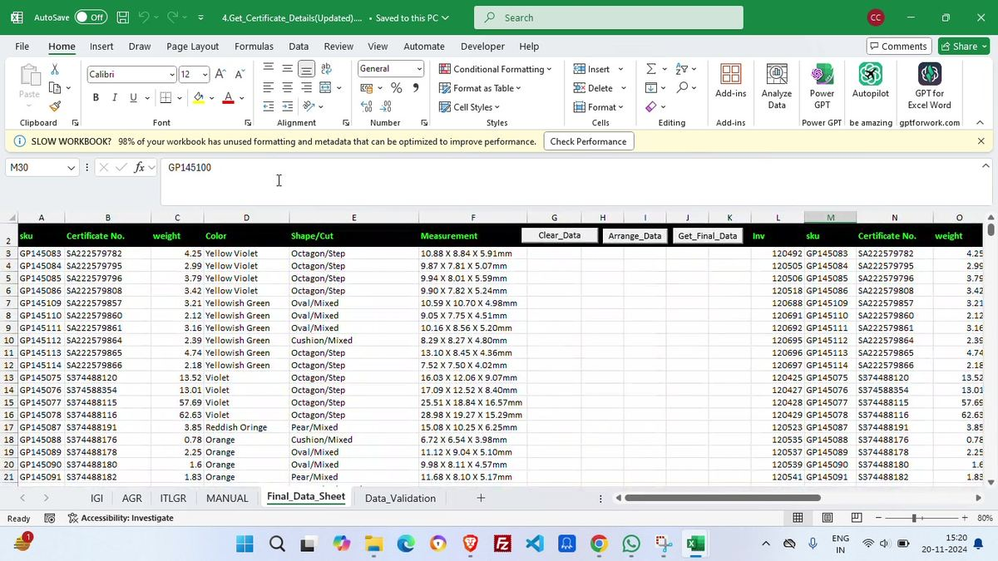
Screenshot 05:10 - Final data sheet consolidating certificate and inventory fields.
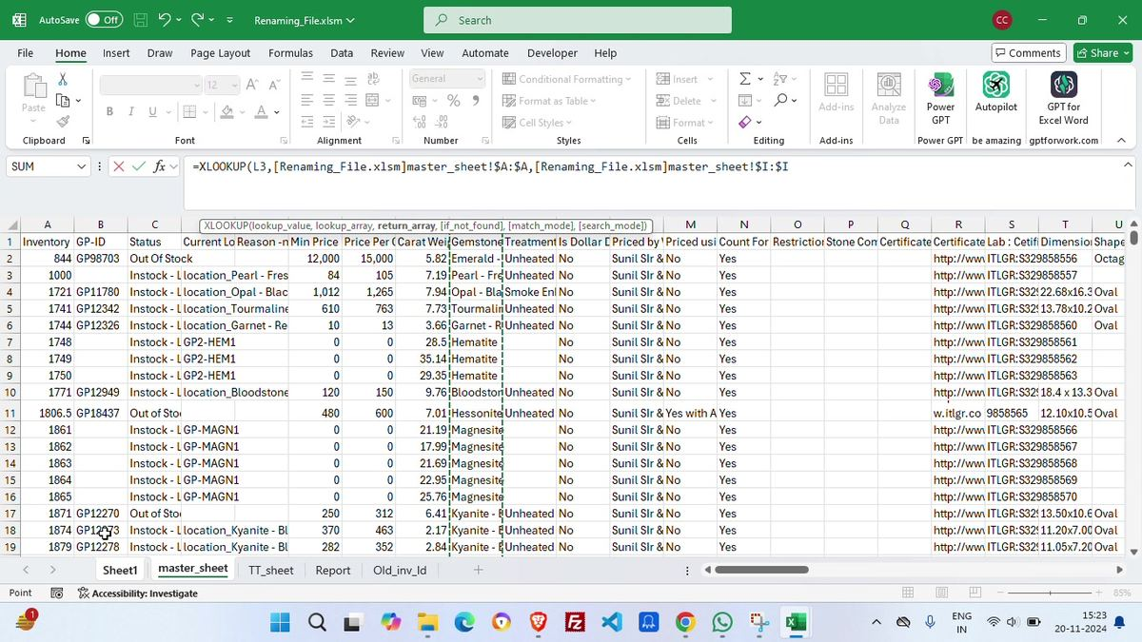
Screenshot 08:10 - Master sheet formula-driven enrichment for commercial and catalog attributes.
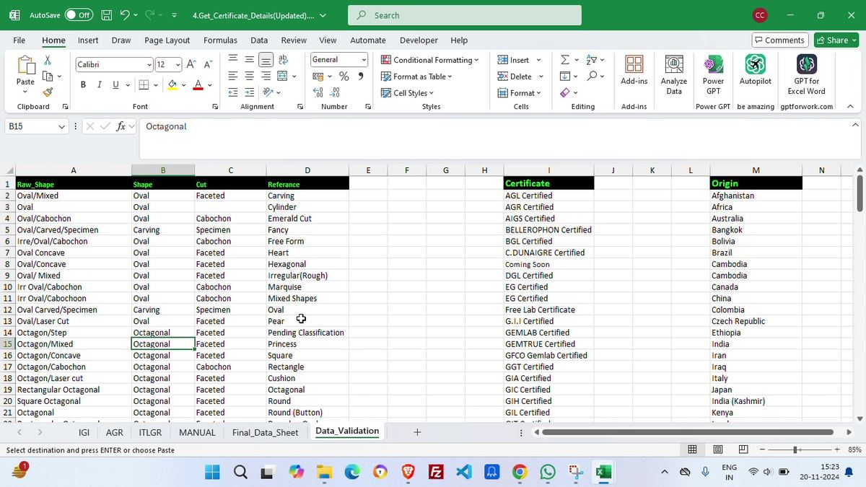
Screenshot 09:00 - Validation sheet normalizing raw shape/cut, certificate and origin values.
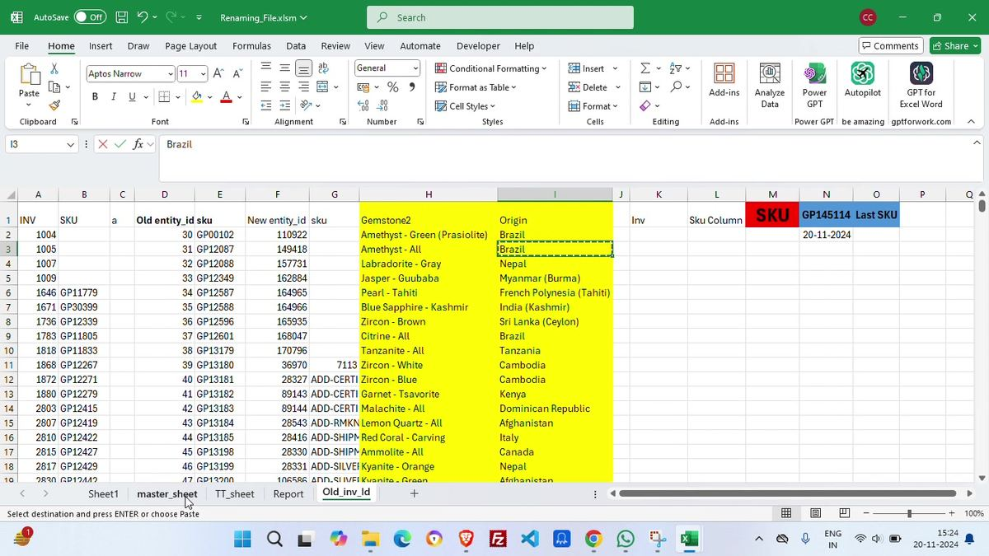
Screenshot 09:40 - Old inventory and last-SKU tracking used to avoid collisions.
Visible macro/button | Likely function in the process | Operator check
Pick Folder | Loads the selected folder and lists files into the workbook. | Confirm the folder is the exact product batch.
Clear Data | Clears old rows from the workbook before loading a new batch. | Run before processing a new batch to avoid mixed data.
Certificate Nmae / Certificate No. | Extracts or populates certificate naming/numbering details. | Verify lab names, certificate numbers and missing values.
Export Inv Match | Compares media/certificate rows with inventory/master data. | Resolve Not found rows.
Master Sheet / TT Sheet | Moves to supporting master/inventory sheets. | Check formulas and referenced workbooks are valid.
SKU Assign | Assigns new SKU ranges to product rows. | Confirm last SKU and no duplicate GP IDs.
SKU Renaming | Builds new media names based on assigned SKUs. | Verify image positions and video suffixes.
Rename Folder | Physically renames the source media files. | Only run after all matches are clean.
Report | Generates review/report output for batch status. | Use it as pre-upload QA.

4.7 Google Sheet staging
Open Catalog_Upload_Loose and populate/inspect staging tabs. Visible tabs include Get_data_inv, certificate_data, Gem_type, Calibrated, Criteria and Renaming. Columns visible in certificate_data include INV, Gem_Type, product_type_C, Treatment_C, Origin_C, Certificate Number_C, weight_C and Color_C. The Renaming tab tracks sku, renaming, image_type, exe_type, image_position and video_query.

4.8 Temporary filters in Google Sheets
The operator applies filters to fields such as image_type and reviews JPG/MP4 entries. This ensures the right files are sent to image query and video query generation logic. Filter mistakes here can silently exclude product media.

4.9 Google Colab automation
Run Catalog_Loose.ipynb. The visible notebook sections are an ordered pipeline: Update Inventory, details from Catalog_Upload_Loose, database fetch, blank updates, fixed updates, other fields like origin/gemstone/dimensions, naming convention, final catalog sheet, image query, short/long video query, after catalog, and image checks via HTML.

4.10 Output CSV review
After Colab downloads the outputs, open the CSVs in Excel. The video shows Final_Catalog_20-11-2024.csv with Magento columns. The operator scrolls across columns to validate key fields. This is the final local checkpoint before Magento import.
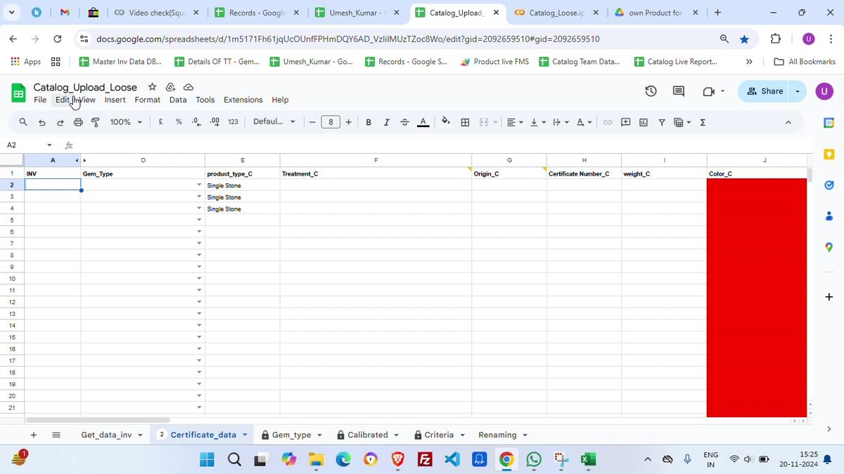
Screenshot 10:40 - Catalog_Upload_Loose certificate data staging area.
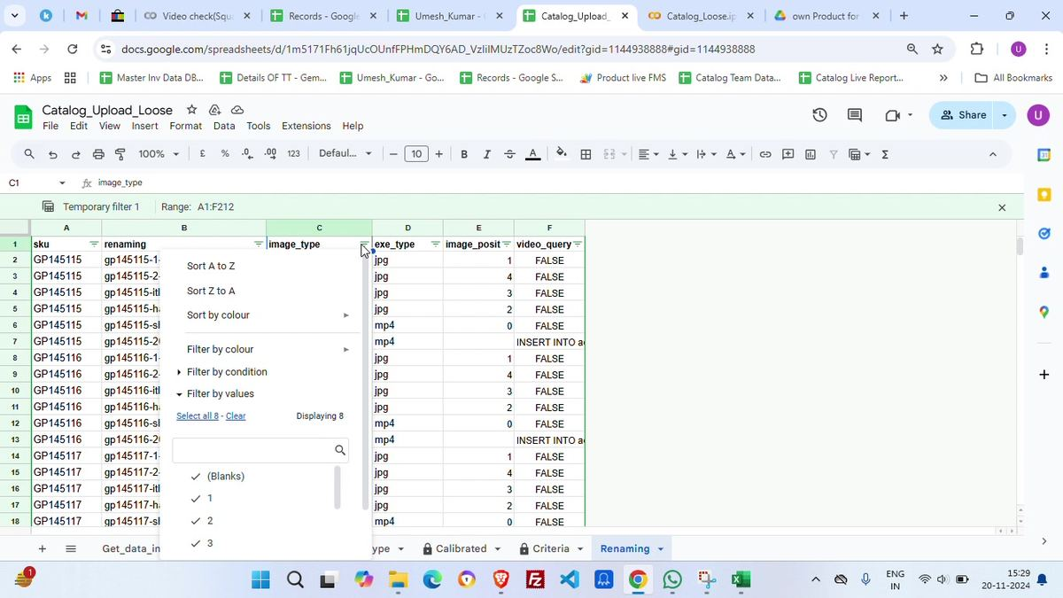
Screenshot 13:50 - Renaming tab filter and media position fields.
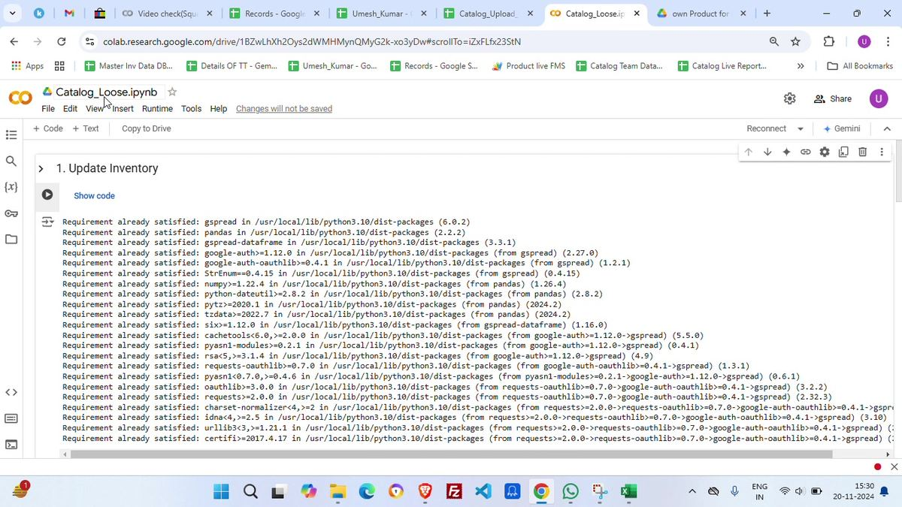
Screenshot 14:10 - Colab notebook environment and update-inventory cell output.
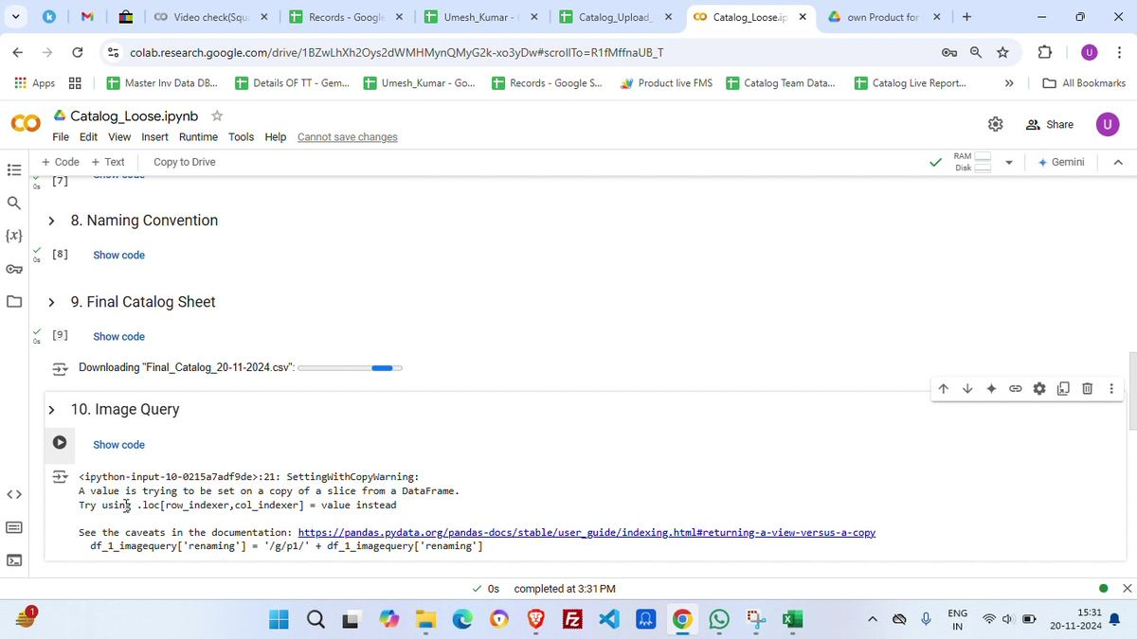
Screenshot 15:00 - Colab output generation and file download sequence.
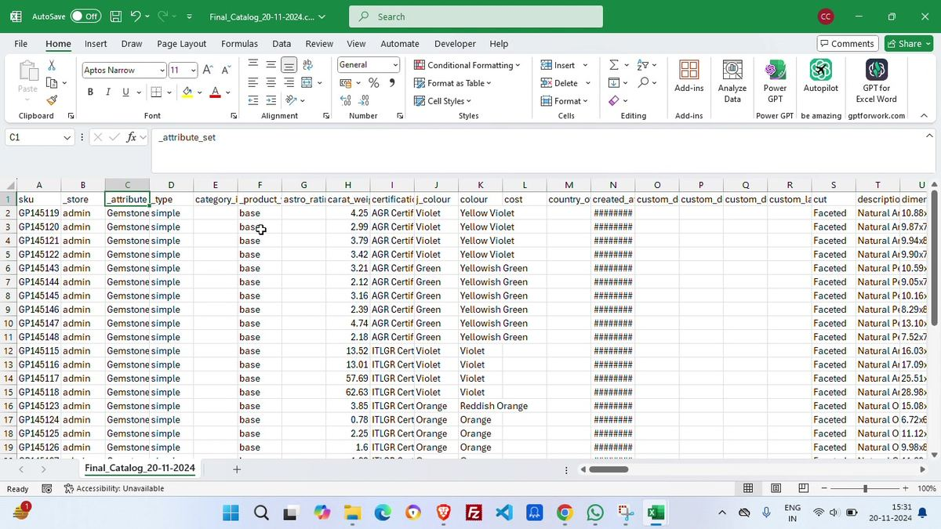
Screenshot 15:50 - Final Catalog CSV spot-check before upload.
Visible notebook section | Purpose | Output/check
1. Update Inventory | Installs/imports dependencies and updates inventory source data. | No dependency errors; inventory source reachable.
2. Get Details From Catalog_Upload_Loose | Reads staged Google Sheet data. | Expected rows loaded from the correct sheet.
3. Get Database | Fetches existing database/product/catalog reference data. | Used to avoid duplicates and enrich mappings.
4. Update Blank | Fills missing values where possible. | Blanks reduced without overwriting intentional empty values.
5. Update Fixed | Applies fixed rules/default values. | Controlled defaults are correct for the batch.
6. Others: Origin, Gemstone, Dimensions, etc. | Derives/cleans supporting catalog fields. | Gemstone, origin, dimensions and related fields consistent.
8. Naming Convention | Applies final naming pattern for SKU/media/catalog fields. | Names are GP/SKU compatible and collision-free.
9. Final Catalog Sheet | Creates and downloads the Magento-ready final catalog CSV. | Final_Catalog_20-11-2024.csv downloaded.
10. Image Query | Generates image/media import query data. | Pandas warning observed; output still proceeds but code should be cleaned.
11. Short Video Query | Generates short video rows or query updates. | Short video flags validated.
12. Long Video Query | Generates long video rows or query updates. | Long video flags validated.
13. After Catalog | Creates after-catalog update CSV. | After_Catalog_20-11-2024.csv downloaded.
14. Check Images Via HTML | Visual/media verification helper. | Image paths/URLs should resolve before final signoff.

Technical commentary
The Colab output shows a pandas SettingWithCopyWarning during image query generation. The pipeline may still work, but this warning indicates chained assignment in pandas. In production code, this should be replaced with explicit .loc assignments to avoid silent mutation bugs.

4.11 Magento product import
Open Magento Admin Panel. The video first checks Manage Products, then navigates to System > Import. Import Settings show Entity Type = Products, Import Behavior = Append Complex Data, and the selected file as Final_Catalog_20-11-2024.csv. The operator clicks Check Data to validate the CSV before import.

4.12 Import/Export profile uploads
Open System > Import/Export Profiles and use the Import temp profile. The Upload File page supports File 1, File 2 and File 3. The warnings show the server allows uploads up to 600M and requires consistent UTF-8 or ANSI encoding. The Run Profile dropdown shows timestamped import files such as 1st_image_query, 2nd_image_query and After_Catalog files.

4.13 Profile execution order
The visible sequence suggests the operator uploads or selects supplementary CSVs after the product import. The image query files should run before/alongside media linking, and After_Catalog should run after the core product rows exist. The exact dependency should be documented in the actual codebase, but visually it is a multi-profile import, not a one-file process.
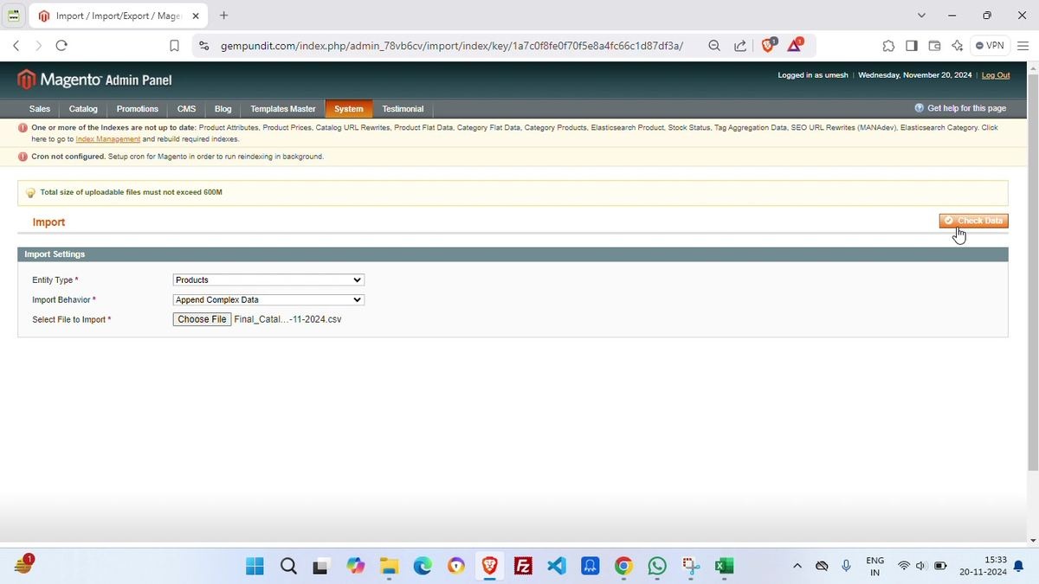
Screenshot 17:00 - Magento import screen with Products and Append Complex Data selected.
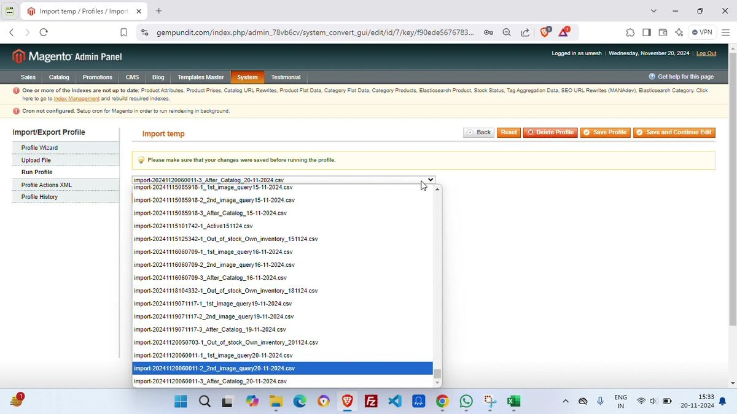
Screenshot 17:50 - Import profile selecting timestamped image/after-catalog CSVs.
Magento step | Visible setting/action | Commentary
System > Import | Entity Type: Products | Correct for product catalog CSV upload.
System > Import | Import Behavior: Append Complex Data | Useful when updating products/media/options without replacing full product structure. Confirm this is intentional for every batch.
File selection | Final_Catalog_20-11-2024.csv selected | This should be the clean, final Colab output only. Do not upload intermediate sheet exports.
Check Data | Validation button clicked | Validation must pass before import. Any warning should be exported into a QA log.
Import temp profile | File 1/2/3 upload fields | Used for additional CSVs such as image query and after-catalog updates.
Run Profile | Timestamped CSV dropdown | Pick the latest correct timestamp; this is a manual error hotspot.
System warnings | Indexes not up to date and cron not configured warnings are visible | These should be fixed or actively handled; stale indexes can delay or hide product changes on frontend.

5. Magento custom-option/template assignment
After products are imported, the video moves into MageWorx custom option templates. This is a separate operational phase from product creation. The operator finds templates, opens them, and assigns products either by grid multiselect, product IDs, or product SKUs.
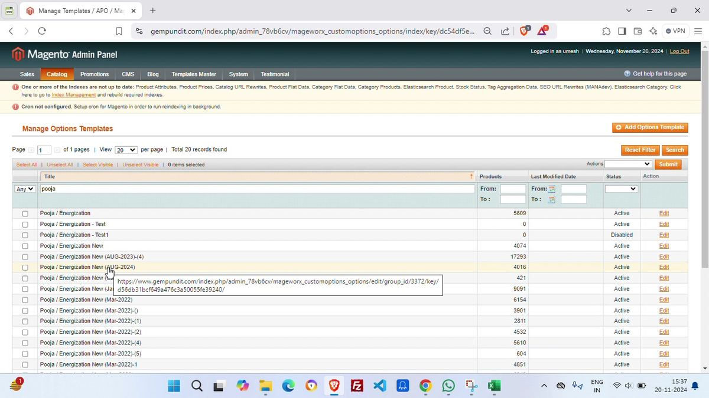
Screenshot 19:50 - Searching option templates by title, e.g., Pooja/Energization.
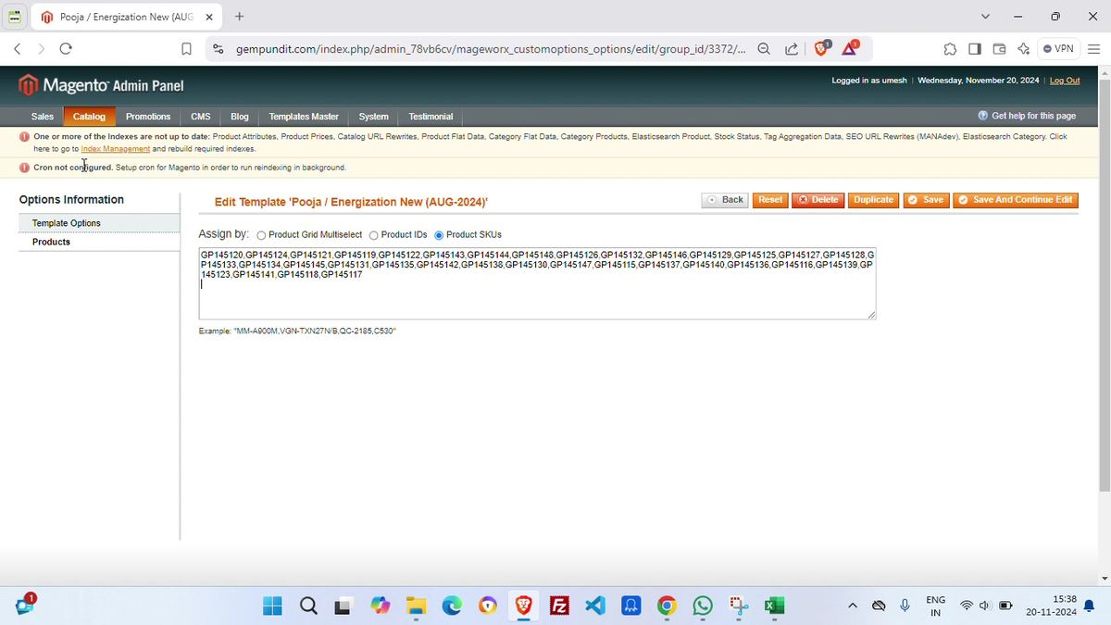
Screenshot 20:50 - Assigning template products by comma-separated GP SKUs.
Template/object observed | What it appears to control | How products are assigned
Pooja / Energization New (AUG-2024) | Customer-facing Pooja/Energization service option. | Products tab; assignment by Product Grid Multiselect, Product IDs, or Product SKUs. In the video, SKUs are pasted as comma-separated values.
Lab Certificate All Gemstone | Lab certificate option template across many gemstone products. | Products are selected from a large product grid or assigned in bulk.
LAB_Certificate / FREE_LAB_CERTIFICATE in Excel | Logic bucket for paid/free lab certificate availability by gemstone/category. | Excel produces SKU lists or rule buckets for template assignment.
SO-Amethyst-COM-A40K and similar templates | Specific simple/custom option group by gemstone/category and price threshold. | Excel EXPERIMENT tab splits products below/above 40K and generates SKU lists.

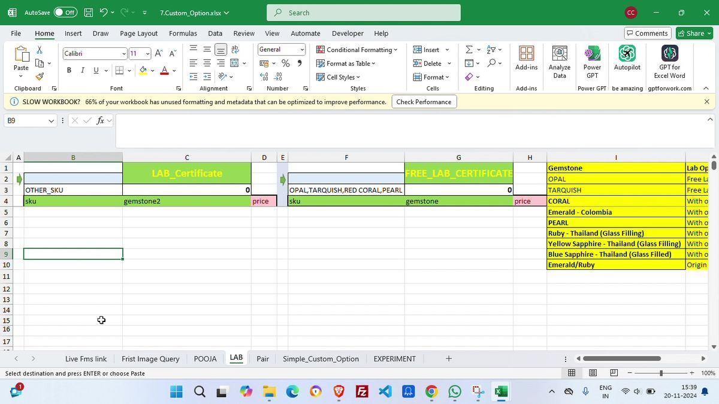
Screenshot 21:50 - Custom option workbook for lab certificate logic.
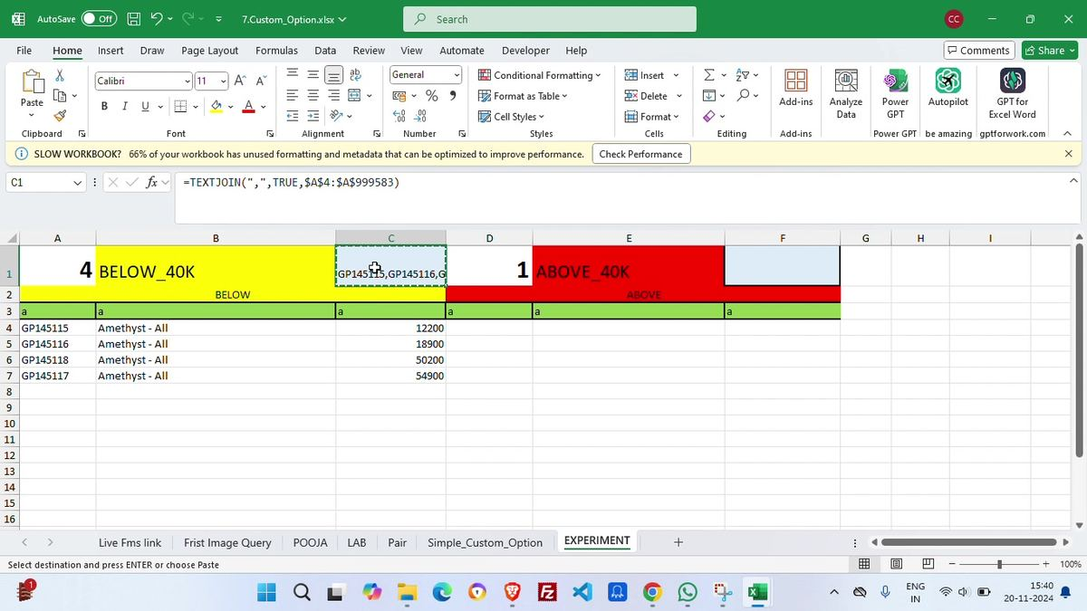
Screenshot 22:50 - Below/above 40K split used for custom-option assignment.
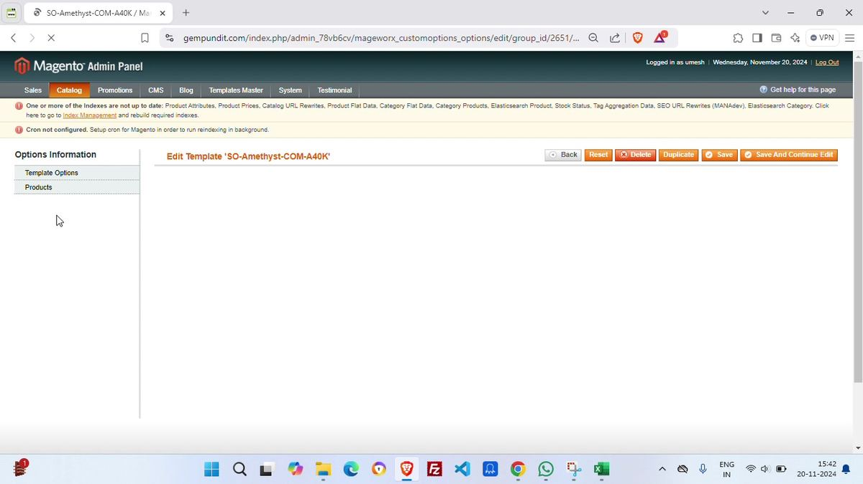
Screenshot 24:20 - Specific custom-option template page opened in Magento.

6. Data fields and transformation logic
The process depends on converting many inconsistent source fields into Magento-safe controlled values. The following field map is based on visible sheets and import outputs.
Field group | Role in workflow | Validation requirement
inventory / INV | Internal inventory identifier used to connect product media, certificate rows and catalog records. | Must be unique per product row or intentionally repeated for media rows.
GP-ID / sku | Customer/catalog product SKU such as GP145115. | Primary Magento product key. Any duplicate/missing SKU breaks imports.
Renaming | Final media filename prefix/name based on SKU and position. | Used to map product images/videos to SKUs.
File Type / exe_type | File extension or type such as jpg/mp4. | Controls whether row becomes image query or video query.
image_type / image_position | Image classification and display order. | Controls which image becomes main/secondary/hand/certificate/media image.
video_query | TRUE/FALSE or query flag for video handling. | Separates image imports from video imports.
Certificate No. / Certificate Number_C | Certificate identifier from lab/supplier. | Customer trust field; wrong number is a serious catalog issue.
certificate / Certificate Lab | Lab/certificate display name: AGR/ITLGR/etc. | Must match Magento option/attribute accepted values.
Gemstone / Gemstone2 / Gem_Type | Stone classification such as Amethyst, Fire Opal, Emerald. | Drives categories, product naming, filters and custom-option logic.
Origin_C / Origin | Origin country/location such as Brazil, Afghanistan, India (Kashmir). | Shown in filters/specifications; controlled list recommended.
Treatment_C / Treatment | Treatment such as Unheated, Smoked, etc. | Important for gemstone trust and pricing.
Shape/Cut | Normalized from raw vendor shapes into Shape and Cut values. | Used in filters and product titles/descriptions.
weight_C / carat_weight / weight_ratti | Carat/ratti weight fields. | Used in product details and price calculations.
dimensions / Measurement | Physical size, e.g., 10.88 x 8.84 x 5.91mm. | Product detail requirement; formatting must remain consistent.
price / special_price / cost | Commercial values for Magento product and/or option logic. | Critical for frontend price and below/above 40K classification.
category_ids / category | Magento category placement. | Wrong category makes products invisible or misplaced.
custom option template lists | Comma-separated SKU lists or grid selections. | Attaches customer-facing options after upload.

Visible sheet/import area | Representative visible columns
Renaming_File.xlsm - Sheet1 | File Type, Renaming, File Type, original/inventory reference, Not found, image/media naming output, old/new SKU fields.
Final_Data_Sheet | sku, Certificate No., weight, Color, Shape/Cut, Measurement, Inv, sku.
master_sheet | Inventory, GP-ID, Status, Current Location, Reason, Min Price, Price Per Ct, Carat Weight, Gemstone, Treatment, Is Dollar, Priced by, Certificate, Certificate Lab, Certificate No., Dimension, Shape.
Data_Validation | Raw_Shape, Shape, Cut, Reference, Certificate, Origin.
Catalog_Upload_Loose - certificate_data | INV, Gem_Type, product_type_C, Treatment_C, Origin_C, Certificate Number_C, weight_C, Color_C.
Catalog_Upload_Loose - Renaming | sku, renaming, image_type, exe_type, image_position, video_query.
Final_Catalog_20-11-2024.csv | sku, _store, _attribute_set, _type, category_ids, _product_websites, astro_ratti, carat_weight, certificate, j_colour, colour, cost, country_of_manufacture, custom fields, cut, description, dimension and many Magento import columns.
7.Custom_Option.xlsx | Live FMS link, First Image Query, POOJA, LAB, Pair, Simple_Custom_Option, EXPERIMENT tabs; below/above 40K segmentation; TEXTJOIN SKU lists.

7. Quality-control checklist
This checklist should be completed before a product batch is allowed to go live.
Checkpoint | Required validation
Source folder | Correct batch folder selected; no old files mixed in; images/videos/certificates present.
Renaming workbook | No unresolved Not found rows unless intentionally excluded; image positions correct; hand/certificate/short-video rows classified correctly.
SKU assignment | Last SKU confirmed; no duplicate GP SKUs; SKU list matches expected product count.
Certificate data | Certificate number, lab, weight, color, shape/cut and measurement populated for all required rows.
Validation mappings | Raw shape/cut/origin/certificate values map to Magento-accepted values.
Google Sheet staging | Get_data_inv, certificate_data and Renaming tabs have correct row count and filters cleared after review.
Colab run | All cells run in order; outputs downloaded with correct date; warnings reviewed.
Final catalog CSV | Open in Excel and spot-check sku, category, price, carat, certificate, URL/media fields, descriptions and dimensions.
Magento import | Entity Type Products; Append Complex Data intentional; Check Data passes; import completes without errors.
Image/profile imports | 1st image query, 2nd image query, video query and after-catalog outputs run in intended order.
Template options | Pooja, lab certificate and price-threshold custom options assigned to exact SKU lists.
Frontend QA | Randomly open new products: title, price, image gallery, certificate, specs, category, custom options and add-to-cart behaviour.
Index/cache | Magento index and cache state checked after import. Visible index/cron warnings should not be ignored.

8. Risks, failure points, and automation recommendations
Risk | How it can break | Recommended fix
Manual folder selection | Wrong Drive/local folder can contaminate the entire batch. | Use batch manifest files and upload IDs.
Excel macro dependency | Macros/buttons hide logic and make version control difficult. | Move core logic into Python scripts with tests; keep Excel only for review/export if needed.
XLOOKUP external references | Broken workbook names/paths silently create wrong blanks or #N/A values. | Replace cross-workbook formulas with deterministic joins in Python/pandas.
Not found rows | Unresolved media/inventory rows can become missing images or skipped products. | Fail the pipeline if unresolved rows exceed zero unless overridden.
Google Sheet manual filters | Active filters can hide rows and cause incomplete exports. | Read all rows via API and use explicit query filters in code.
Colab warnings | SettingWithCopyWarning can lead to unreliable pandas mutations. | Refactor to .loc and add unit tests for transformations.
Timestamped import files | Operator may select wrong dated CSV in Magento profile dropdown. | Generate and upload one batch folder with manifest; validate selected filename matches batch ID.
Magento index/cron warnings | Products may not appear correctly or immediately after import. | Automate reindex/cache clear; fix cron configuration.
Custom option SKU paste | Comma-separated SKU copy/paste can omit or add wrong SKUs. | Use Magento/MageWorx API or controlled import endpoint for template assignment.
No centralized run log | Hard to audit which products were imported and what failed. | Create a per-batch run report with counts, errors, output filenames and product URLs.

Automation recommendation
The best production version should not depend on an operator remembering 20 manual clicks. Build a batch pipeline: ingest media and inventory -> validate -> generate final catalog and media CSVs -> dry-run checks -> Magento import/API updates -> option-template assignment -> reindex/cache -> QA report. Excel/Google Sheets can remain as review surfaces, but the source of truth should be an auditable pipeline.

8.1 Suggested production architecture
Module | Responsibility | Benefit
Ingestion service | Accepts product media zip/folder and inventory/certificate sheets. | Creates batch ID and stores raw files unchanged.
Validation engine | Checks filenames, SKUs, duplicates, certificate numbers, accepted attribute values and missing media. | Fails fast with a readable error report.
Transformation engine | Replaces workbook formulas/Colab with tested Python transforms. | Outputs Final_Catalog, image query, video query and after-catalog files.
Magento integration | Uses Magento import or API with controlled sequence. | Uploads products/media and captures errors.
Option assignment module | Assigns MageWorx/custom options by generated SKU lists/rules. | Avoids manual paste into admin.
QA report generator | Creates product count summary, warning list, sample product URLs, image checks and option-template assignment logs. | Gives manager-level confidence before live signoff.

9. Final operator checklist
- Confirm the correct Drive/local batch folder before running macros.
- Clear old workbook data before importing a new folder.
- Run folder pick/listing, certificate extraction, inventory match and SKU assignment in order.
- Resolve every Not found row or mark it intentionally excluded.
- Validate last SKU and duplicate GP-ID/Inventory values.
- Normalize shape/cut/origin/certificate through validation tables.
- Populate Google Sheet staging tabs and clear filters after checks.
- Run Colab cells from top to bottom; do not skip intermediate outputs.
- Open final CSVs locally and spot-check rows/columns before Magento.
- Use Magento Products import with the correct CSV and pass Check Data.
- Run import profile files in the intended order: image query files and after-catalog update.
- Assign Pooja/Lab/price-based custom option templates to the correct SKUs.
- Run Magento reindex/cache operations or confirm they are automated.
- Open sample live products and verify images, certificate, title, price, category, custom options and add-to-cart behaviour.
- Save a final batch report with file names, SKU count, failed rows, import status and template assignment status.

Appendix A - Screenshot evidence index
Timestamp | Screenshot / evidence purpose
00:30 | Google Drive source folder for live product data
01:10 | Renaming_File.xlsm macro dashboard and generated filename rows
02:30 | Renaming workbook showing Not found checks before matching
05:10 | Final_Data_Sheet after certificate/inventory consolidation
08:10 | master_sheet enrichment using inventory, GP-ID, price, gemstone, certificate and dimensions
09:00 | Data_Validation mapping sheet for shape/cut, certificate and origin normalization
09:40 | Old inventory/SKU mapping and last SKU tracking
10:40 | Catalog_Upload_Loose Google Sheet certificate_data tab
13:50 | Renaming tab in Google Sheets with image type, file extension and video query flags
14:10 | Catalog_Loose.ipynb Colab notebook: Update Inventory setup
15:00 | Colab generation stage: Final Catalog, Image Query and output download
15:50 | Final_Catalog CSV opened in Excel for spot checking Magento columns
17:00 | Magento System > Import screen with Products / Append Complex Data
17:50 | Magento Import/Export profile Run Profile file selector
19:50 | MageWorx Manage Options Templates filtered for Pooja/Energization
20:50 | Pooja/Energization template assigned by comma-separated Product SKUs
21:50 | Custom option workbook LAB tab with Lab Certificate and Free Lab Certificate logic
22:50 | Experiment tab splitting custom options by below/above 40K price threshold
24:20 | Magento template screen for SO-Amethyst-COM-A40K custom option assignment

