STEP1-Download node.

STEP2-

STEP-3

STEP-4

STEP-5-

Creact-react-app “project name”

Development Process-

Go to specific folder where you have created your project with the help of Creact-react-app “project name” Command.

After going there type cmd in address bar in your local folder path and start your project in local browser with the help of npm start command.

Cmd respond –

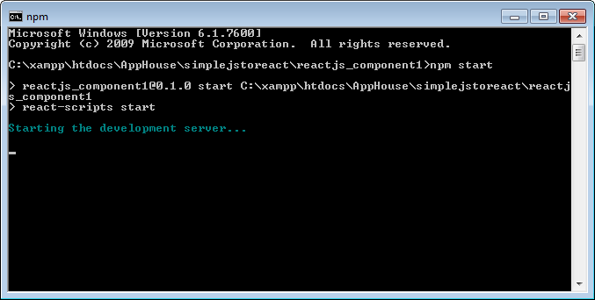

Browser respond-