Assignment – 6

Name: Kushagra Singh.
Roll.No. : 244CA024

1. Create the following tables with the following attributes and constraints on them.

a. Employee:


b. Departments:
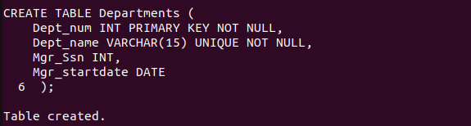
c. Department Locations:
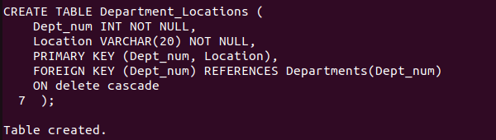
d. Project:
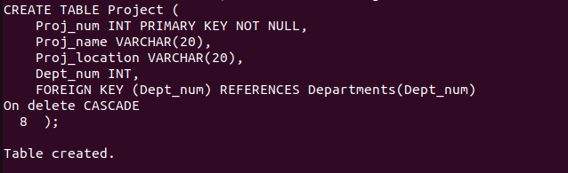

e. Employee Project
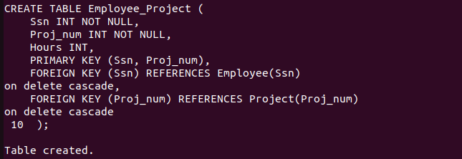

f. Dependent

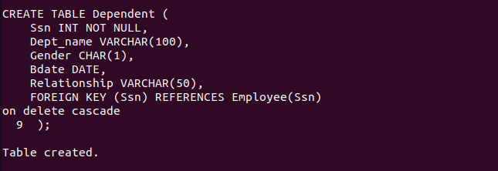

Inserting Data into Relations.

a. Employee

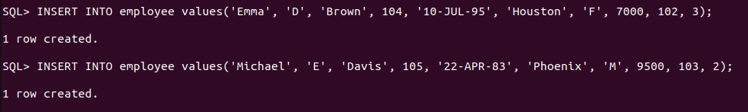
b. Departments:
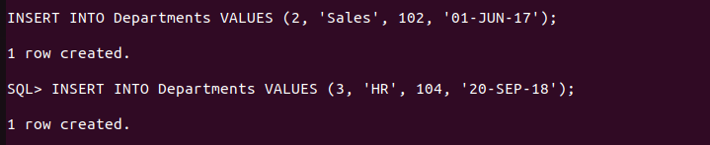
c. Department Location:


d. Project :

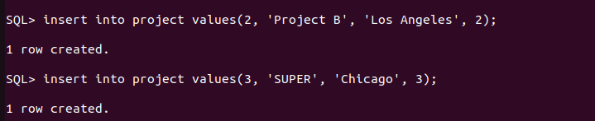

e. Employee Project :

f. Dependent :
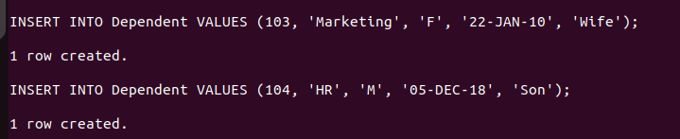

2. Add two column blood group and hobbies to employee table



3. Increase the size of column blood group to 15 to the employee table.


4. Drop column hobbies from the employee table.


5. Rename Employee Table to Employee_details.



6. Insert atleast five records in each table.

--Inserted above--

7. Give 1000 rupees bonus to each employee.



8. Increase the salary of the employees having salary <5000 by 500 rupees.



9. Give 100 rupees bonus to employees having salary less than 10000 rupees and birth date before 1990.



10. Give 100 rupees bonus to employees having salary less than 10000 rupees or birth date before 1990.


11. Give 100 rupees bonus to employees having salary between 1000 to 5000 rupees and birth date before 1990.
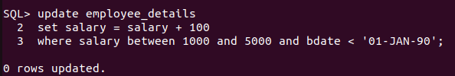
12. Give 100 rupees bonus to employees having salary between 1000, 3000 and 5000 rupees.


13. Update phone number with 0000 where NULL


14. Give 100 rupees bonus to employees having salary not between 1000 to 5000 rupees and birth date before 1990.

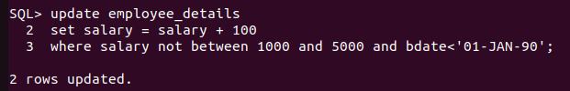

15. Give 100 rupees bonus to employees having salary between 1000, 3000 and 5000 rupees.

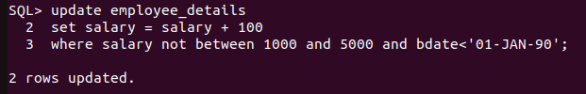

16. Delete from employee the rows having bdate less than 1970.



17. List the name and age of all employees.

18. Display the salaries offered to the employees.



19. List the Bdate and Salary of Employee ‘Smith’.

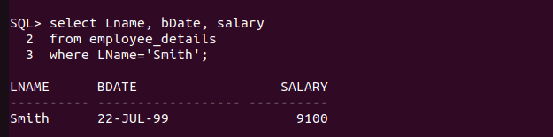

20. Find the location of Project ‘SUPER’.

