Software Requirements Specification

for

Medicine Donation System  
(Medona)

Prepared by

Harish A Jartarghar, 1RV18CS061

Kirti Nandan, 1RV18CS071

<Dept. of Computer Science and Engineering, RVCE>

<01.11.20>

Table of Contents

Table of Contents ii

Revision History ii

1. Introduction 1

1.1 Purpose 1

1.2 Document Conventions 1

1.3 Intended Audience and Reading Suggestions 1

1.4 Product Scope 1

1.5 References 1

2. Overall Description 2

2.1 Product Perspective 2

2.2 Product Functions 2

2.3 User Classes and Characteristics 2

2.4 Operating Environment 2

2.5 Design and Implementation Constraints 2

2.6 User Documentation 2

2.7 Assumptions and Dependencies 3

3. External Interface Requirements 3

3.1 User Interfaces 3

3.2 Hardware Interfaces 3

3.3 Software Interfaces 3

3.4 Communications Interfaces 3

4. System Features 4

4.1 System Feature 1 4

4.2 System Feature 2 (and so on) 4

5. Other Nonfunctional Requirements 4

5.1 Performance Requirements 4

5.2 Safety Requirements 5

5.3 Security Requirements 5

5.4 Software Quality Attributes 5

5.5 Business Rules 5

6. Other Requirements 5

Appendix A: Glossary 5

Appendix B: Analysis Models 5

Appendix C: To Be Determined List 6

Revision History

|  |  |  |  |
| --- | --- | --- | --- |
| **Name** | **Date** | **Reason for Changes** | **Version** |
|  |  |  |  |
|  |  |  |  |

# Introduction

**1.1 Purpose**

The purpose of the S.R.S is to present a detailed description of the software, Medicine Donation System , also known as Medona in short. It will explain the purpose and features of the software, the interfaces of the software, what the software will do and the constraints under which it must operate. This S.R.S is intended for users of the software and also potential developers. This s.r.s will also provide a reference to verify whether the developed software meets the intended objectives, at any phase of development.

## Document Conventions

This SRS was created based on the IEEE template for System Requirement Specification Documents.

## Intended Audience

* Donors (General public), can use this system for donating medicines by updating the details on the online platform.
* Non-profit organizations & NGOs, that can browse through the list of medicine and accept it by placing an order.
* Super Admins, who will take care and keep track of the inventory.
* Programmers, who are interested in the field of web development or who want to improve this project by fixing bugs/adding functionalities etc.

## Reading Suggestions

* END USERS (Donors & NGOs): 1.1 purpose,1.5 Product scope,1.6 References,2.2Product functions,2.4 Operating environment,2.6 User documentation,4 .System features

6.Glossary

* PROGRAMMERS: 1.1 purpose,1.5 Product scope,2.2 Product functions,

2.4 Operating environment,2.5 Design and implementational constraints

2.6 User documentation,3.External Interface Requirements ,4 .System features,

5.Other non functional requirements,6.Other requirements

* ADMINISTRATOR: 1.Introduction,2.2 Product functions,

2.4 Operating environment,2.6 User documentation,3.External Interface Requirements ,

4.System features,5.Other non functional requirements,6.Other requirements

.

## Product Scope

The proposed software will utilize the concept of e-commerce platforms in order to act as a medium for donating medicines from the general public and NGOs. A well-defined UI for better user experience will be there for ease of transactioning. Records and details of the users and orders will be stored in the database. Analysis of the orders placed will be done and depicted on the website based on various parameters.

## References

1.Maykin Warasart and Pramote Kuacharoen (2012).” Paper-based Document Authentication using Digital Signature and QR Code”, 2012 4TH International Conference on Computer Engineering and Technology (ICCET 2012)

2. Vijaypal Singh Dhaka, Mukta Rao, Manu Pratap Singh (2009).” Signature Verification on Bank Checks Using Hopfield Neural Network”, KARPAGAM Journal of Computer Science,volume 3(4) .(ICCET 2016).

3. Saroj Ramadas, Geethu P.C (2015) Comparative Study On Offline Handwritten Signature Verification Schemes, International Journal of Advanced Research Trends in Engineering and Technology (IJARTET), vol. 2(10), March 2015.

4. Rajpal Kaur, Pooja Choudhary (2015) Offline Signature Verification in Punjabi based on SURF Features and Critical Point Matching using HMM, International Journal of Computer Applications , vol. 111(16), pp. 0975–8887, February 2015.

# Overall Description

## Product Perspective

The idea of the proposed software was conceived, keeping in mind the way of functioning of E-commerce platforms that are an essential part of the digitalization of selling-purchasing of different goods and services. The proposed software is an attempt to utilize the concepts of this existing working involved of e-commerce websites for the benefit of needy people. This software will act as a medium between the general people and NGOs for providing free medicines donation towards the welfare of unfortunate children and elders.

A simple diagram that shows the major components of the overall system, subsystem interconnections, and external interfaces can be helpful

## Product Functions

* Login/ Module: Preliminary identification of the user (Donor/NGO/Super Admin).
* Register Module: For signing up new users.

* A robust Forgot Password functionality, to aid the user just in case.
* An Order functionality, to place an order by the NGO for the selected medicines.
* Search/Filter functionalities, for shortlisting and searching as per the user needs.
* Write about how user will update medicine and modify it , analysis dikhaana hai jo and if add to cart karna hai toh

## User Classes and Characteristics

Such is the importance and simplicity of the subject of this software, that it is expected to be used by users of various classes. Some classes are mentioned as follows:

* Donors (General public), can use this system for donating medicines by updating the details on the online platform.
* Non-profit organizations & NGOs, that can browse through the list of medicine and accept it by placing an order.
* Super Admins, who will take care and keep track of the inventory.
* Programmers, who are interested in the field of web development or who want to improve this project by fixing bugs/adding functionalities etc.

## Operating Environment

* Modern Operating System: Windows 7 or 10 /Mac OS X 10.11 or higher, 64-bit /Linux: RHEL 6/7, 64-bit (almost all libraries also work in Ubuntu)
* database: MySQL+ MongoDB
* platform: vb.net/Python/Flask/Django

## Design and Implementation Constraints

Following could be the constraints on the design and implementation of the proposed software:

* A user using multiple styles of signatures for different organizations/purposes.
* If the uploaded signature has a different ink type than the one stored in the system, the accuracy of the prediction may reduce.

* Artificial neural networks will be used for image classification, which might not 100% accurate.
* For proper training of the neural network model, in order to give accurate prediction, a large dataset of signature images will need to be stored in the database, which might lead to redundancy of data.
* Retrieval of stored images, rather than text information such as OTP, CVV, will take comparatively higher times.
* Three global schema, fragmentation schema, and allocation schema.
* SQL commands for above queries/applications
* How the response to the queries will be generated. Assuming these are global queries. Explain how various fragments will be combined to do so.
* Implement the database at least using a centralized database management system.

## User Documentation - react k modules and web development ka 2-3 links daal do

<https://ieeexplore.ieee.org/document/7522526>

<https://ieeexplore.ieee.org/document/5481137>

## Assumptions and Dependencies

The software is to be developed using python and deployed as a web application on Flask. For back-end storage and management, it requires MySQL, MongoDB as well as the elastic search engine. Programmers or testers, who are looking to examine the correctness of the software, should have the above-mentioned softwares installed on their system. This applies to Windows, Mac as well as Linux users.

# External Interface Requirements

## User Interfaces

* Front-end software: Flask, Django
* Back-end software: MySQL, MongoDB

## Hardware Interfaces

* Windows, Mac, Linux.
* A browser which supports HTML & JavaScript and basic related functionalities.
* An Internet connection

## Software Interfaces

The crux or the fulcrum of this project is image classification, which will be done using Artificial Neural Networks, in Python’s environment. For achieving image classification, libraries, such as TensorFlow, Keras, SciPy and SciKit will be required. For pre-processing the dataset, we will use NumPy and Pandas. The model will be developed on Anaconda’s Jupyter Notebook platform, which facilitates easy testing and verification. The neural network model will communicate with the database, using Python’s MySQL connector. Lastly, all the above-mentioned services will be realized and assembled in an application deployed on Flask.

## Communications Interfaces

The proposed software supports almost all kind of browsers. Simple forms for various stages of authentication ,transacitioning and processes will be involved. All the standard internet protocols, such as HTTP, FTP, DNS etc. will be supported by the developed software.

# System Features

This section demonstrates prominent features of the project and explains how they can be used and the results they will give back to the user.

## Pre-liminary identification and authorization

The first stage of gaining access to the application will be through a gateway which conducts a pre-liminary or basic identification. This can be done by providing basic details such as name and/or UserID. Some amount of authorization can be added to this process by employing a password system as well.

In the database, the basic details and credentials of all the users will be stored, and will subsequently be retrieved and checked when a user tries to login or demand access to the system.

## Forgot Password functionality

The proposed system will cover the prospects/possibility of a user forgetting credentials. At the time of registration, each user will be allowed to record a personal question and its corresponding answer, which will act as a key to regaining the credentials, in any such case.

## Signature Authentication Module

The most important component of this product, the system will have a mandatory requirement of uploading/drawing of the user’s signature. This signature will be used as the final means of verification. Each signature will be processed by the embedded neural network module, to authorize/unauthorize further access to the application and its services to the user. If the signature does not match, 2 more attempts will be given to the user to furnish the current signature, failure to do so will result in access denial for a stipulated period of time.

On successful authorization, the user will be able to access all the services that the application provides, as well as updating/modifying previously stored data.

# Other Nonfunctional Requirements

## Performance Requirements

The web application, for performing the transactions and processes of updation,etc. involved in the project will require a system with at least 1 GHz CPU clock rate and 512 MB RAM.

Performance will depend upon the speed and quality of the internet connection as well.

## Safety Requirements

If uploading an image of signature is provides as an option, then fraudulent users, who from some source can get possession of the image, may misuse this feature. Hence, rather than uploading, input of signature from the user will be taken in the form of drawing it on a canvas provided in the module. This will safeguard any theft of signatures, as copying an entire signature, isn’t an easy task.

## Security Requirements

The entire system is to be developed in order to increase the level of security of various kinds of applications. Quite obviously, access to the application, in which this functionality will be embedded will be completely secure in nature, as every user will have to undergo a minimum of two-step authentication.

## Software Quality Attributes

The proposed system due to its well designed and easy to use interface it can be used by both old and new users. Users can follow up the interface step by step for their purpose.

## Business Rules

Our system will authenticate the user at the time of registration on the website and will give the permission of uploading the data of the medicines into the database, Authorities will have complete control over what kind of information the user can see or modify. For e.g. The NGO users cannot modify the medicine product details specified on the website, they can just select the quantity and place an order.

# Other Requirements

Appendix A: Glossary

* **Python**: Python is an interpreted, high-level, general-purpose programming language
* **Flask**: Flask is a micro web framework written in Python.
* **Web framework**: A web framework (WF) or web application framework (WAF) is a software framework that is designed to support the development of web applications
* **MySQL**: MySQL is an open-source relational database management system
* **MongoDB**: MongoDB is a cross-platform document-oriented database program. Classified as a NoSQL database program
* **Neural Networks**: A neural network is a series of algorithms that endeavors to recognize underlying relationships in a set of data through a process that mimics the way the human brain operates.

Appendix B: Analysis Models

ER Diagram

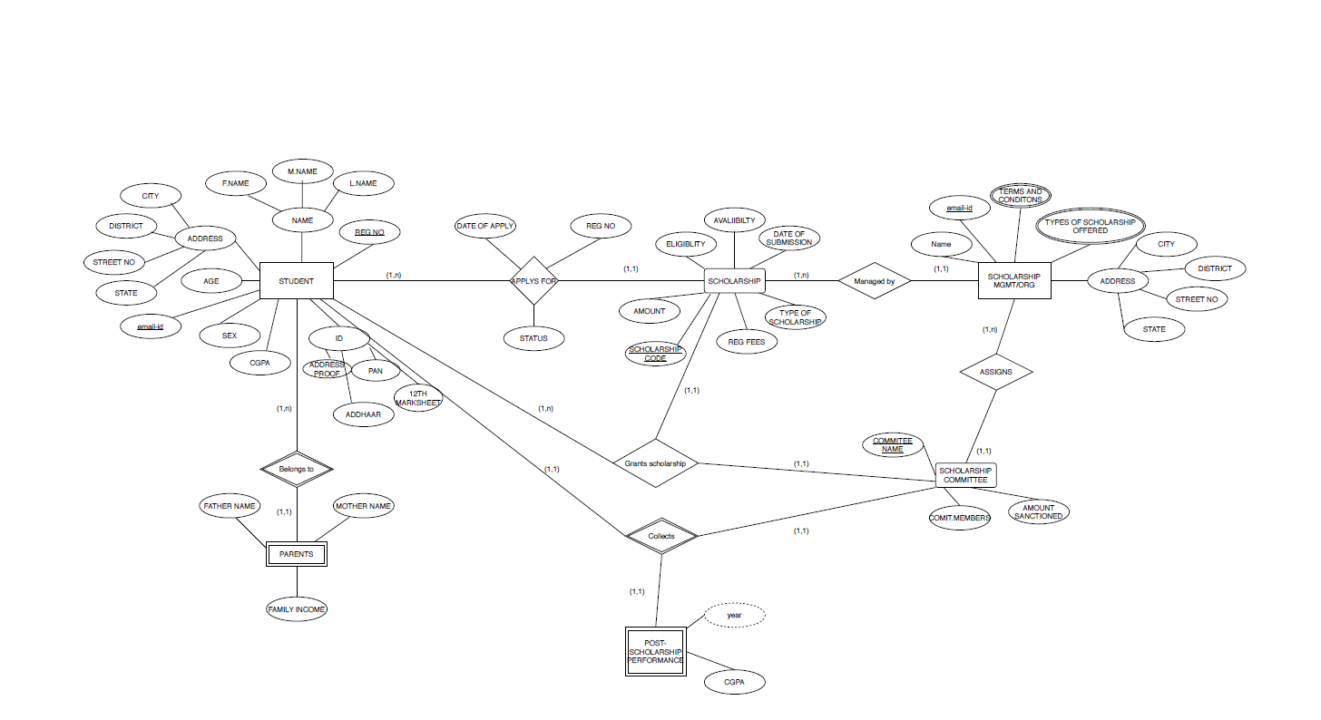

Appendix C: To Be Determined List

<Collect a numbered list of the TBD (to be determined) references that remain in the SRS so they can be tracked to closure.>