**CSA2001 – Fundamentals of AI & ML**

**Project 1: Autonomous Delivery Agent**

Submitted by: *Kushagra Yadav*  
Reg No: *24BAS10072*  
Course Instructor: VISHNUVARTHANAN  
Institution: VIT Bhopal University

**Introduction**

The growing demand for **autonomous delivery systems** has led to significant research in the fields of **Artificial Intelligence (AI)** and **path planning**. From drones delivering packages to self-driving vehicles transporting goods, efficient navigation through complex environments is a critical challenge.

This project focuses on designing an **autonomous delivery agent** that navigates a 2D grid environment with:

* Static obstacles (e.g., buildings, barriers),
* Different terrain costs (e.g., roads vs rough terrain),
* Dynamic moving obstacles (e.g., vehicles, pedestrians).

The agent must operate **rationally** — making decisions that maximize efficiency while considering **time** and **fuel cost constraints**.

To achieve this, we implemented:

1. **Uninformed search algorithms**: Breadth-First Search (BFS) and Uniform-Cost Search (UCS).
2. **Informed search algorithm**: A* Search with an admissible heuristic.
3. **Local search strategy**: Hill-climbing with random restarts, integrated into a replanning framework to handle dynamic changes.

The performance of each algorithm was evaluated experimentally, comparing **path cost, nodes expanded, and computation time**.

**Environment Model**

2.1 Grid World Representation

The environment is represented as an H × W grid:

* Each grid cell has an integer cost ≥ 1.
* Obstacles are represented as -1 (impassable).
* Terrain costs represent difficulty (e.g., paved roads = 1, rough terrain = 3).

Example from *map_small.txt*:



**2.2 Agent Assumptions**

* Moves allowed: up, down, left, right (4-connected).
* Each step cost = terrain value of the destination cell.
* Agent starts at (0,0) and goal is at (H-1,W-1) in most experiments.

**2.3 Dynamic Obstacles**

Dynamic obstacles (e.g., vehicles) appear at certain times and block cells.

We model them using a **time-based schedule**:

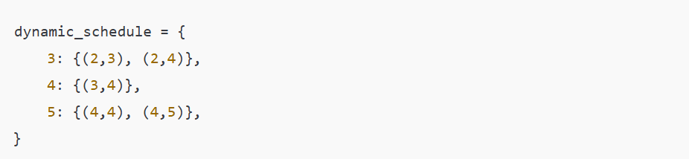

At t=3, cells (2,3) and (2,4) become occupied, forcing the agent to replan.

**3. Algorithms Implemented**

**3.1 Breadth-First Search (BFS)**

* Explores nodes level by level.
* Guarantees the shortest path only if all step costs are equal.
* On weighted grids, BFS expands unnecessary nodes.
* Useful as a baseline.

**3.2 Uniform-Cost Search (UCS)**

* Expands the node with the lowest cumulative path cost.
* Guarantees optimality for varying terrain costs.
* Disadvantage: may expand a large number of nodes in large maps.

**3.3 A* Search**

* Combines UCS with a heuristic:  
  f(n) = g(n) + h(n)  
  where:
  + g(n) = path cost so far
  + h(n) = heuristic estimate to goal
* We used **Manhattan distance**:



This heuristic is admissible because it never overestimates true cost.

A* achieves optimality + efficiency, making it the best practical choice.

**3.4 Local Search & Replanning**

* Implemented **hill-climbing with random restarts** to improve paths under uncertainty.
* In dynamic maps, when an obstacle blocks the path, the agent:
  1. Detects collision.
  2. Triggers replanning from current position.
  3. Resumes delivery using updated path.

**4. Experimental Setup**

**4.1 Test Maps**

* **Small (7×5)** → simple grid with few obstacles.
* **Medium (20×12)** → mixed terrain and barriers.
* **Large (40×30)** → large-scale city grid with multiple terrains.
* **Dynamic (10×10)** → obstacles appearing at defined times.

**4.2 Metrics**

We evaluated algorithms on:

* Path cost
* Nodes expanded
* Computation time
* Path length

**4.3 Tools Used**

* Python 3.10
* matplotlib for visualization
* pandas for results handling

**5. Results & Analysis**

**5.1 Results Table (Small Map)**



**5.2 Dynamic Map Logs (Extract)**

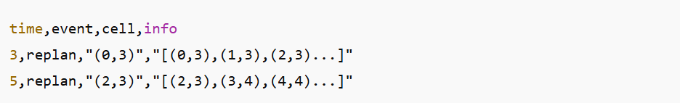

**5.3 Analysis**

* **BFS**: Expanded too many nodes; inefficient with costs.
* **UCS**: Optimal but slower as map size increases.
* **A**\*: Optimal with far fewer node expansions; best overall.
* **Dynamic replanning**: Agent adapted to new obstacles without failure.

**6. Conclusion & Future Work**

This project successfully implemented and compared **search algorithms for autonomous navigation** in a grid environment.

**Key findings:**

* BFS is unsuitable for weighted environments.
* UCS ensures optimal solutions but is computationally heavy.
* A* is the best balance — optimal and efficient.
* Replanning enables survival in dynamic, real-world scenarios.

**Future directions:**

1. Extend to **probabilistic obstacles** (uncertain movement).
2. Implement *D Lite*\* or **Lifelong Planning A**\* for faster replanning.
3. Move to **continuous 2D/3D space** for drone delivery.