* I have created a **mock object** of ExternalApi
* Stubbed it to return "Mock Data"
* Used it inside MyService
* Asserted that fetchData() returns "Mock Data". Below is **MyServiceTest.java** test method:
* Shows: mock creation, stubbing, and assertion.

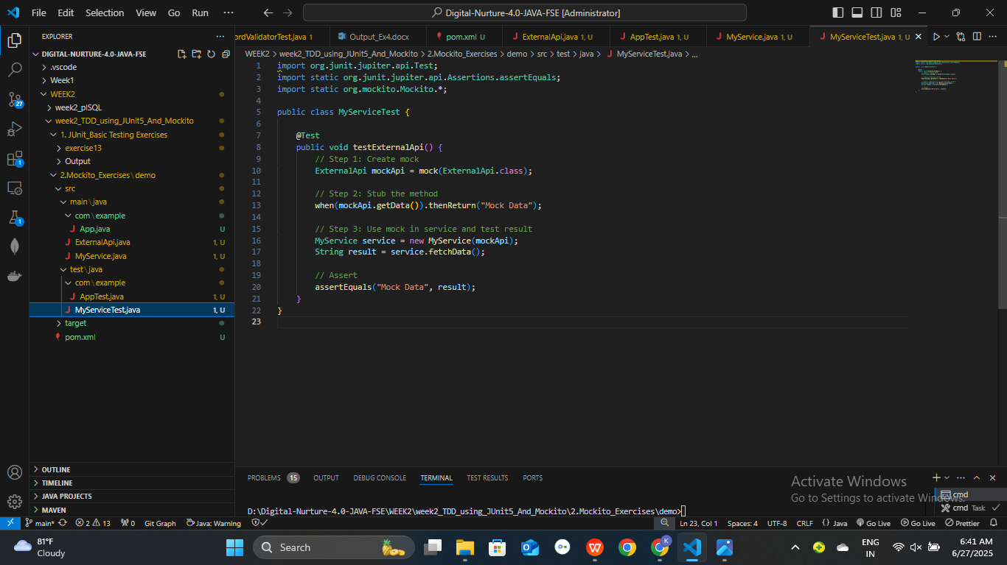

* **Terminal output** from ‘ mvn test’:

[INFO] Tests run: 1, Failures: 0, Errors: 0, Skipped: 0, Time elapsed: 1.542 s - in MyServiceTest

