* We want to **check whether** the method getData() was called on the **mockApi** object.

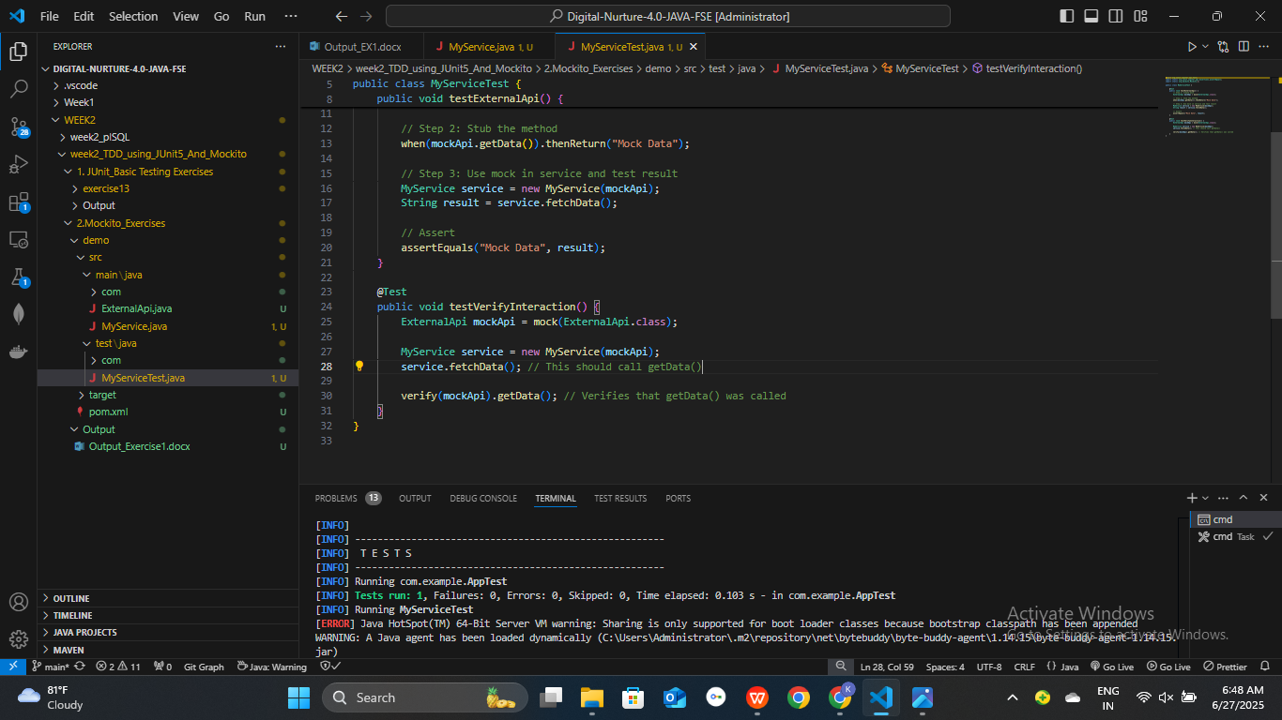

* **Terminal output** from ‘ mvn test’:

[INFO] Tests run: 2, Failures: 0, Errors: 0, Skipped: 0, Time elapsed: 1.769 s - in MyServiceTest

