I completed the task in the following steps:

**1.Maven Project Library Management Created:**

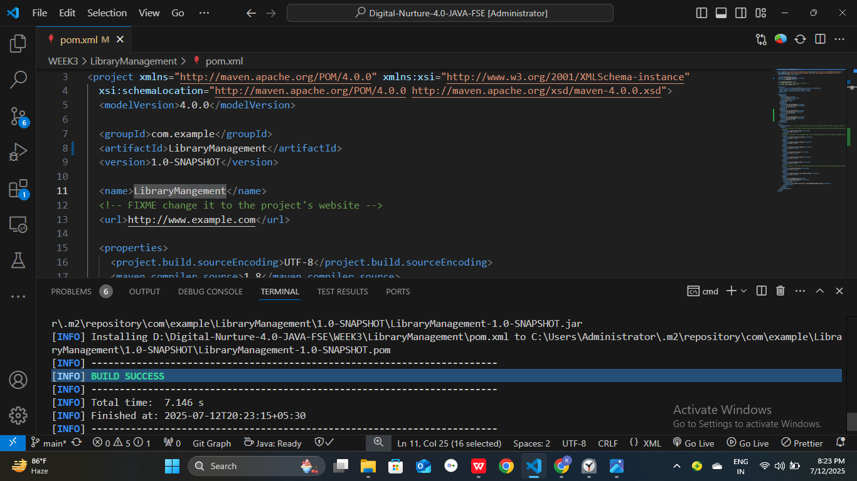

2.**Spring Dependencies added to pom.xml:**

Dependencies for Spring context, Spring AOP & Spring WebMVC are added.

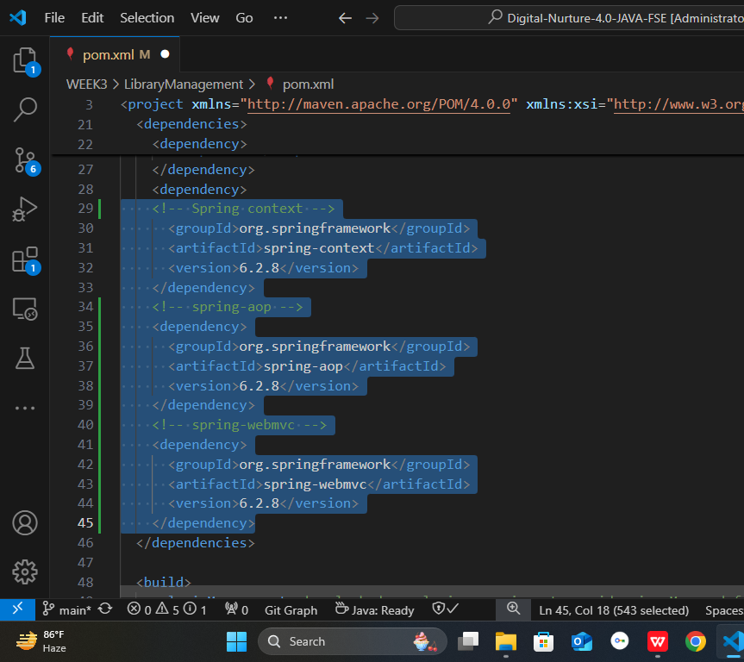

#### 

#### 

#### **3. Maven plugins Configured:**

* Maven Compiler Plugin configured for Java version 1.8 in the pom.xml file

