* **Output:**

In the output first all the linear searches are done since they do not require any sorting.

Before the binary search array of *Product* is sorted by the required field(id/name/category).

Then binary searches are done for both single occurrence & all occurrences for ProdName & category.

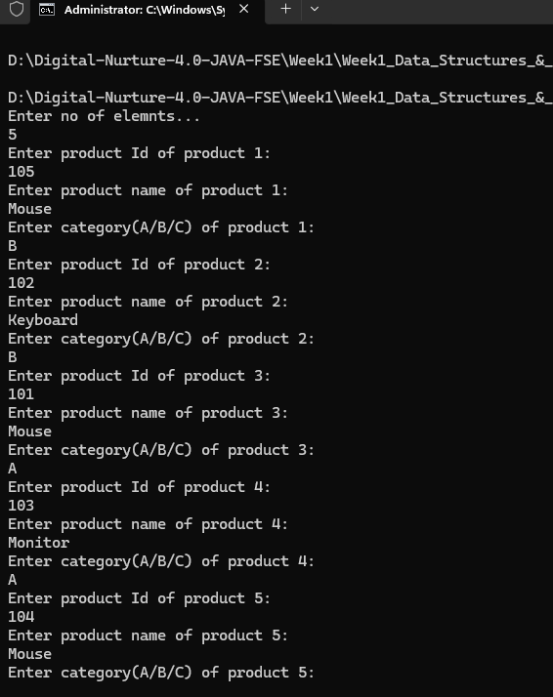

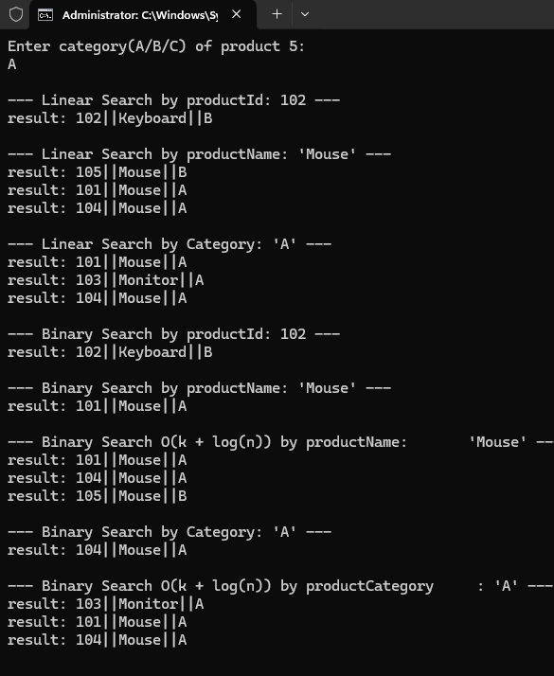

* **Analysis:**

Linear search has a time complexity of *O(n)*, making it inefficient for large datasets as it checks each item one by one. Binary search, with a time complexity of *O(log n)*, is much faster but requires the data to be *sorted*. However, in an e-commerce platform where multiple products can share the same *name* or *category*, a single match isn’t enough.

To handle this, we use *range-based binary search*, which finds one match in *O(log n)* and then scans adjacent items to collect all matches in *O(k)*, making the total complexity *O(log n + k)*. This approach ensures both *speed* and *completeness*, making it more suitable for real-world search needs on such platforms.