

Technical Documentation

Document ID:5464 and 5458
Document Version:1.0
Authors:P Kushal and Harsh Nagvanshi
Team-3

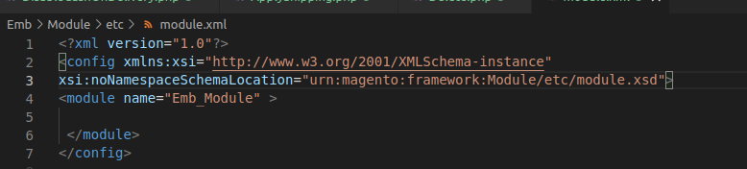
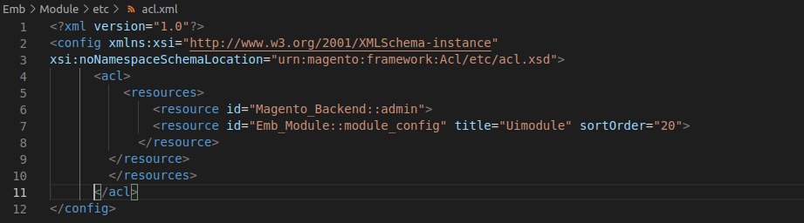

1. Overall Description
This document contains all the functionalities that we successfully finished. Here we are creating Grid and From in the magento backend admin panel
2. Tecnical Requirements
2.1 GRID and FORM
Step 1: Creating the Module: In the magento root directory app/code, create the folder to build the extension in a given structure which is defined as in this project the vendor name as ‘Emb’ and module name as ‘Module’.
app/code/Emb/Module/etc/module.xml

Step 2: Create the acl.xml: Magento 2 admin acl use an authentication system and a robust system for create Access Control List Rules (ACL) which allows customer for free shipping to create fine grained roles for each and every user in their system.
app/code/Emb/Module/etc/acl.xml

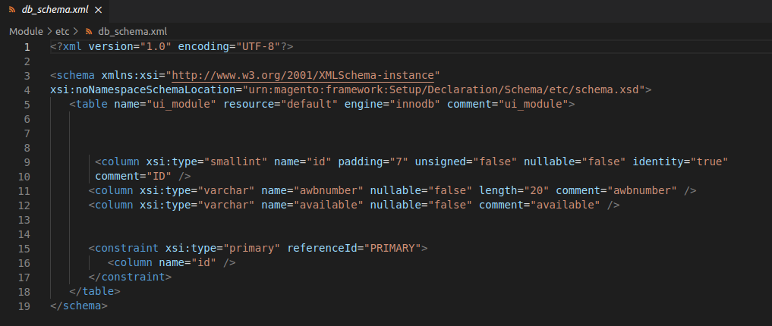
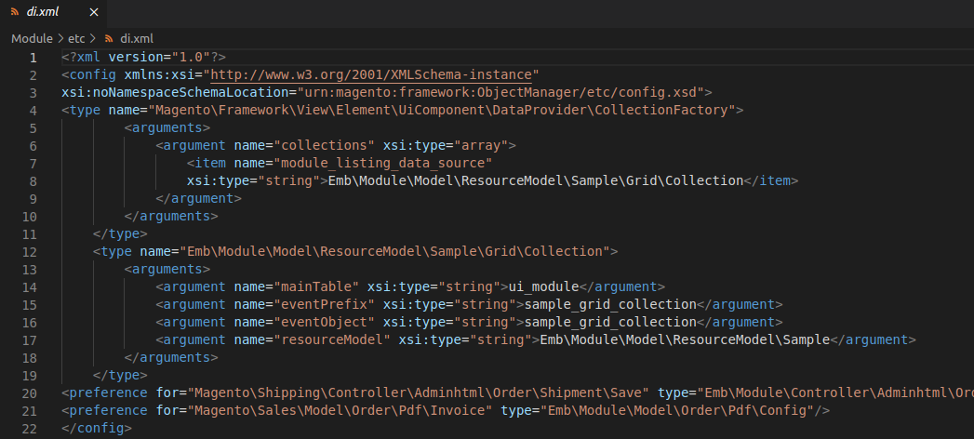

Step 3: Create the db_schema.xml: This file is used to create the new tables or maintain the tables which avoids the unneccesary version checking for creating new columns or delete columns and also for backward compactibility with php script.

app/code/Emb/Module/etc/db_schema.xml

Step 4:Create the di.xml: This file configures which dependencies are injected by object manager and the application reads all the di.xml configuration files which will be merged all together by appending all nodes.

app/code/Emb/Module/etc/di.xml
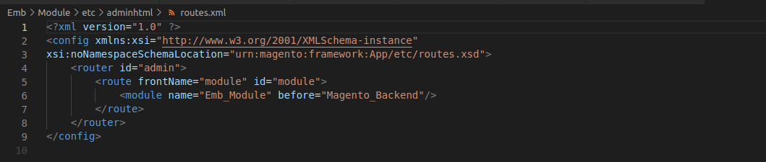
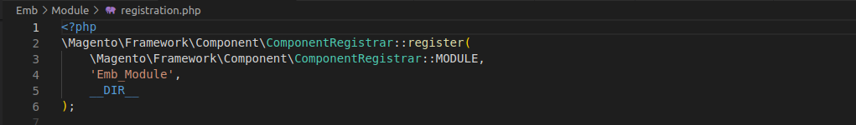

Step 5: Create the routes.xml in adminhtml: The route will define the name for the module which will be used in the url to find the module and execute the controller action.

app/code/Emb/Module/etc/adminhtml/routes.xml

Step 6: Create the registration.php: It is used to notify to magento application about the module in the system. It is also used to provide the location for register the module.

app/code/Emb/Module/registration.php

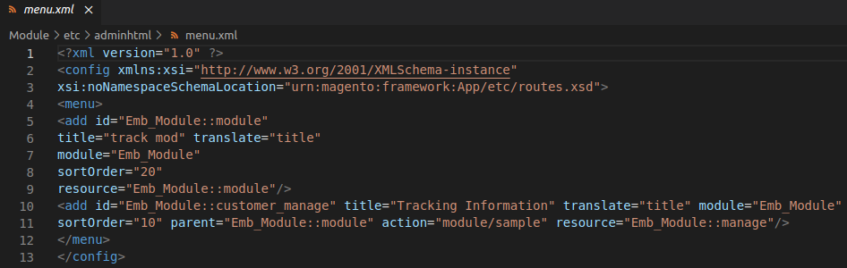
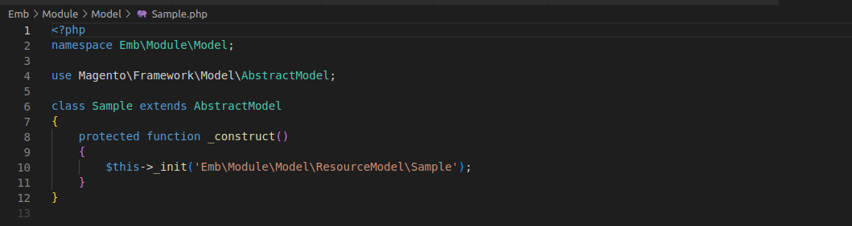

Step 7: Create the menu.xml in adminhtml: It is located in module’s etc/adminhtml folder which consists of menu nodes, config and add multiple directives.

app/code/Emb/Module/etc/adminhtml/menu.xml

Step 8: Create the Sample.php in Model: The Sample.php file in the model folder is a PHP class that represents the data model for a specific entity in the system. This file is typically used to define the business logic that relates to that entity, such as saving and retrieving data from the database.
app/code/Emb/Module/Model/Sample.php

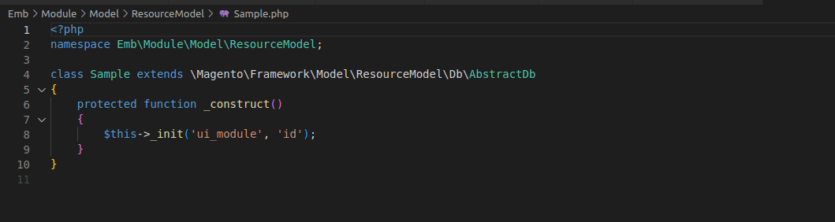
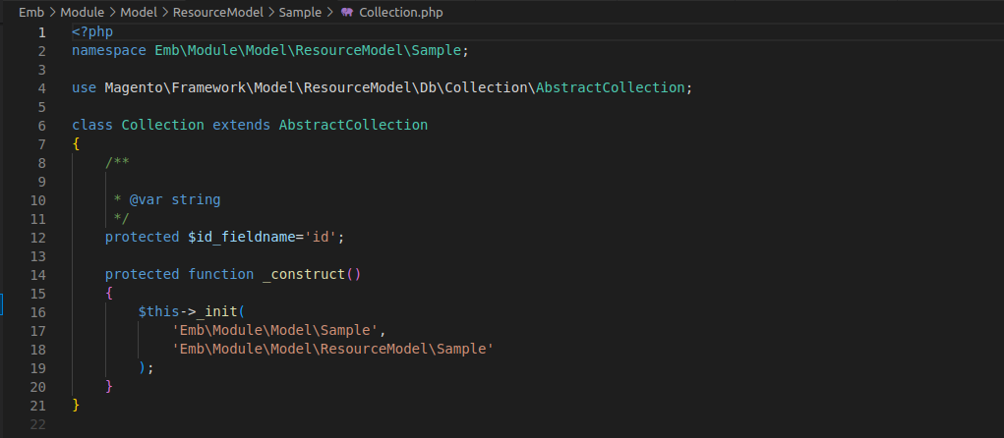

Step 9: Create the Sample.php in Model-ResourceModel folder:

app/code/Emb/Module/Model/ResourceModel/Sample.php

Step 10: Create the Collection.php in Model-ResouceModel-Sample folder: The Collection class in Magento 2 is used to retrieve a set of data from the database. The Collection class is typically used to work with data from custom database tables or to extend core Magento 2 models and work with data from their associated database tables.
app/code/Emb/Module/Model/ResourceModel/Sample/Collection.php

Step 11: Create the Collection.php in Model-ResouceModel-Sample-Grid folder: In Magento 2, the Collection class for a grid is used to retrieve a set of data that will be displayed in the grid. The Collection class is typically defined in a file called Collection.php, which is located in the Model/ResourceModel directory of a module.
app/code/Emb/Module/Model/ResourceModel/Sample/Grid/Collection.php
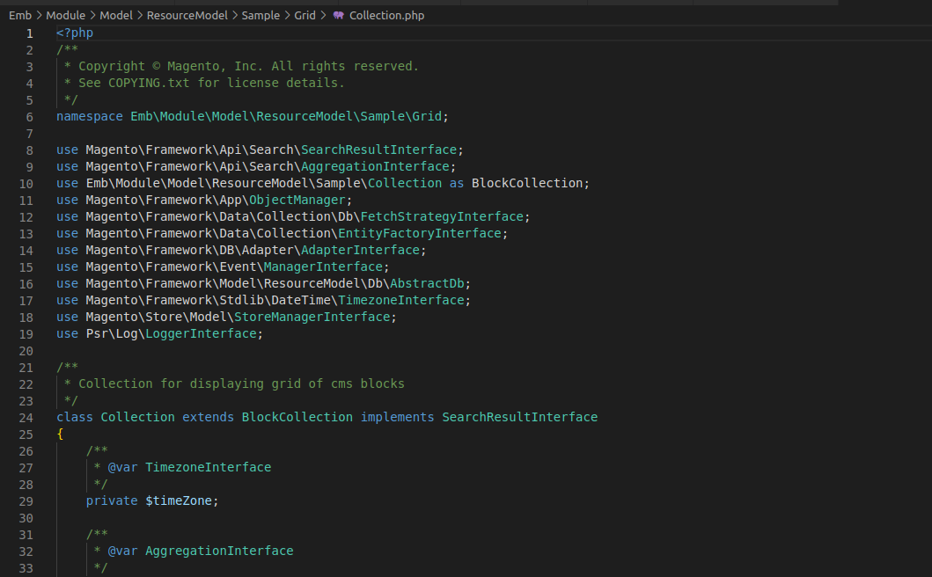
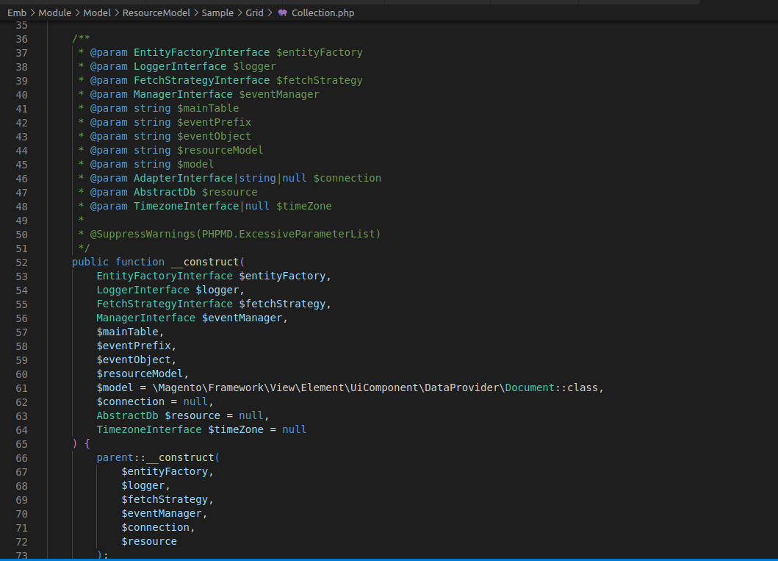

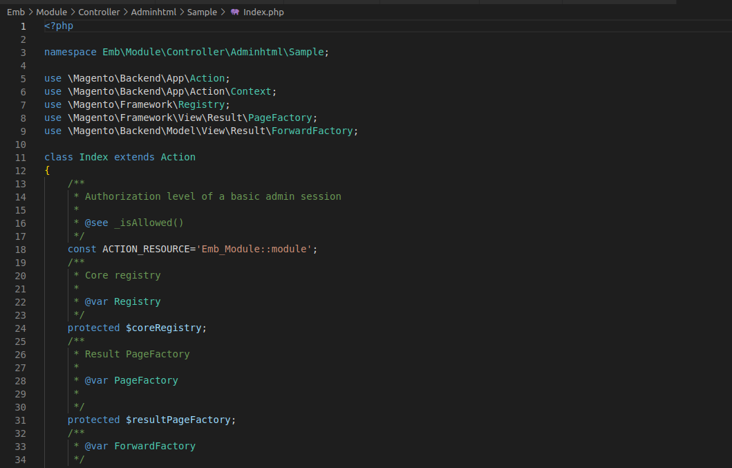
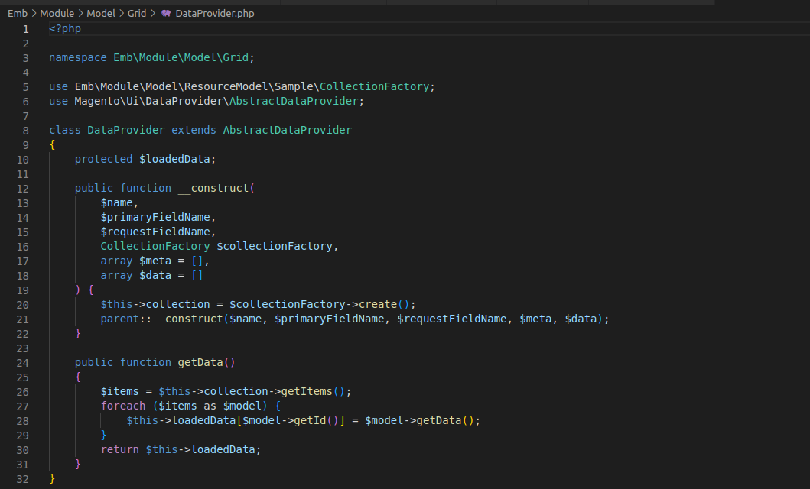
Step 12: Create the DataProvider.php: The DataProvider class for a grid is responsible for retrieving data from a collection object and preparing it for display in the grid. The DataProvider class is typically defined in a file called DataProvider.php, which is located in the model directory of a module.
app/code/Emb/Module/Model/Grid/DataProvider.php

Step 13: Create the index.php in the Controller-Adminhtml:
The index.php file located in the adminhtml directory is the main entry point for the Magento admin panel. It is responsible for initializing the admin application and routing incoming requests to the appropriate controller.

app/code/Emb/Module/Controller/Adminhtml/Sample/Index.php

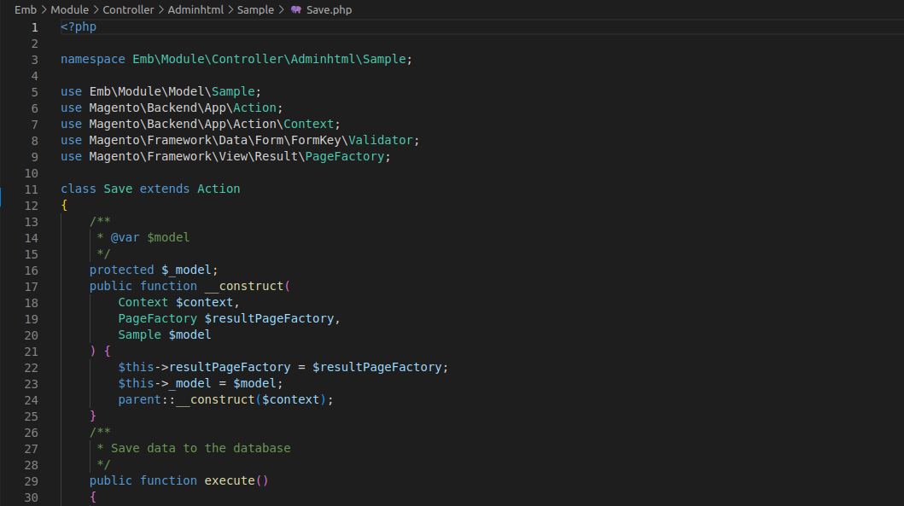
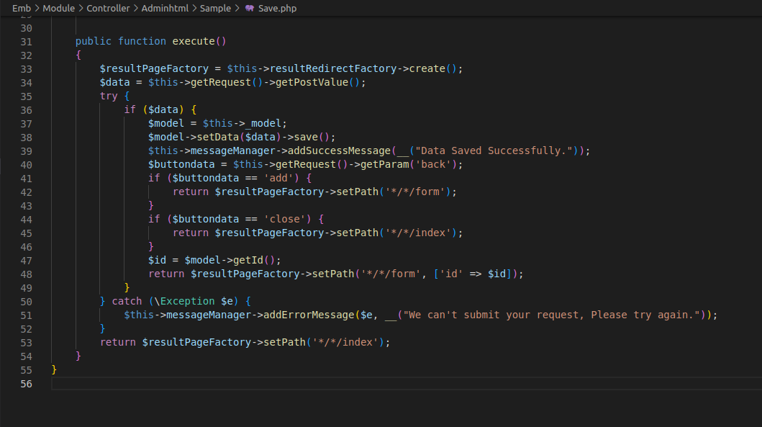

Step 14: Create the Save.php file in Controller – Adminhtml:
The save.php file in a custom controller could potentially be responsible for processing a form submission, saving data to the database, or performing some other action related to data manipulation or persistence.
app/code/Emb/Module/Controller/Adminhtml/Sample/Save.php

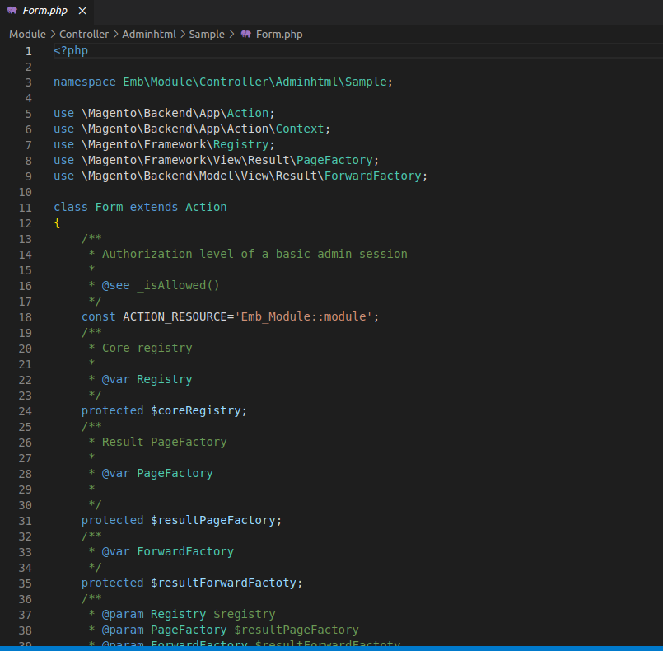
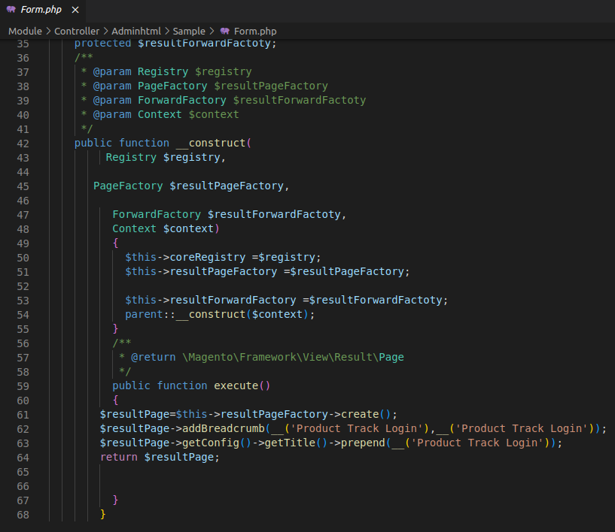
Step 15: Create the Form.php file in Controller folder:
A Form.php file in a custom controller could potentially be responsible for rendering a form for creating or updating and processing a form submission, saving data to the database, or performing some other action related to form management.
app/code/Emb/Module/Controller/Adminhtml/Sample/Form.php

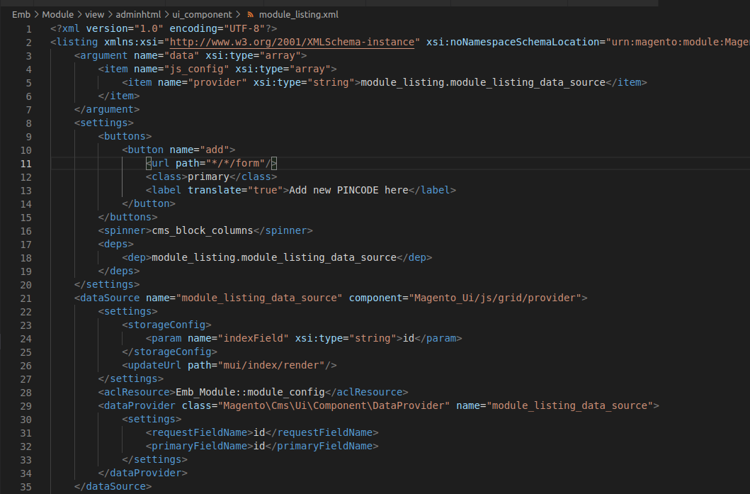
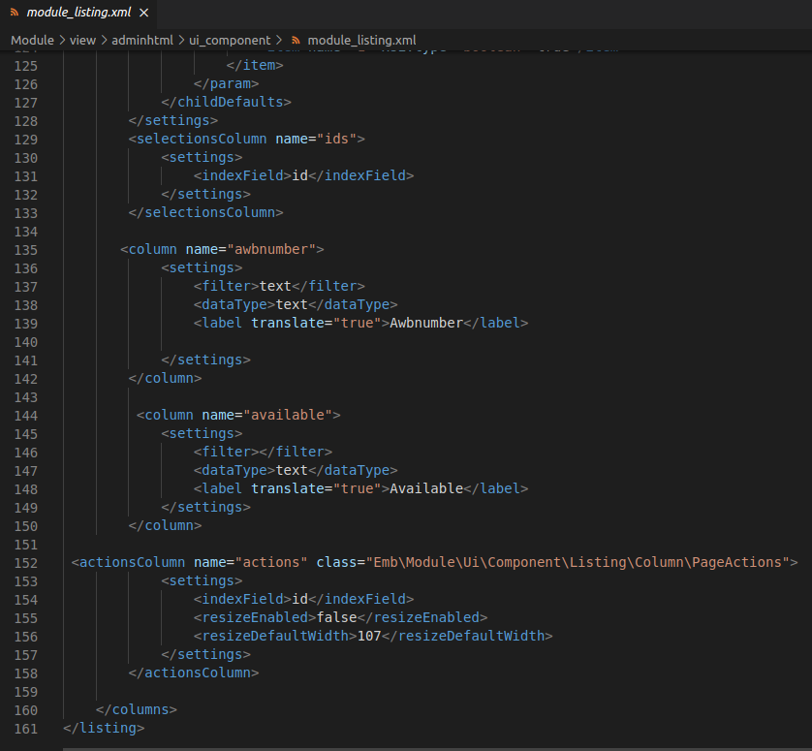
Step 16: Create the module_listing.xml:
module_isting.xml file is a UI Component file that is used to define the structure and behavior of a listing page for a specific entity type.This file is typically located n the view/adminhtml/ui component directory of a custom module or extension and is used to configure the appearance and functionality of the listing page in the Magento Admin Panel.
app/code/Emb/Module/view/adminhtml/ui_component/module_listing.xml

i

Step 17: Create the ui_form.xml:
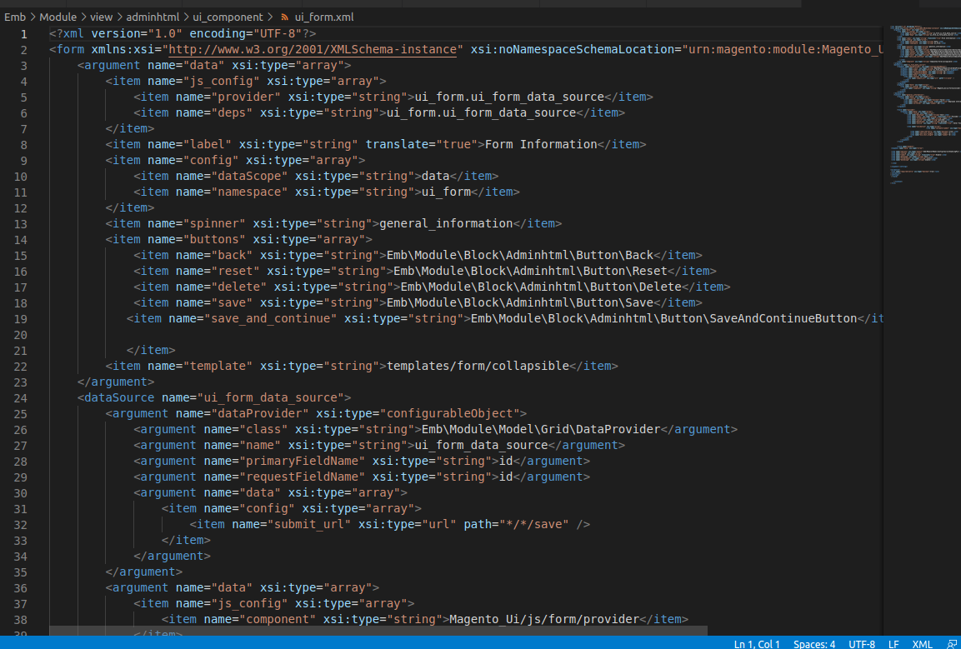
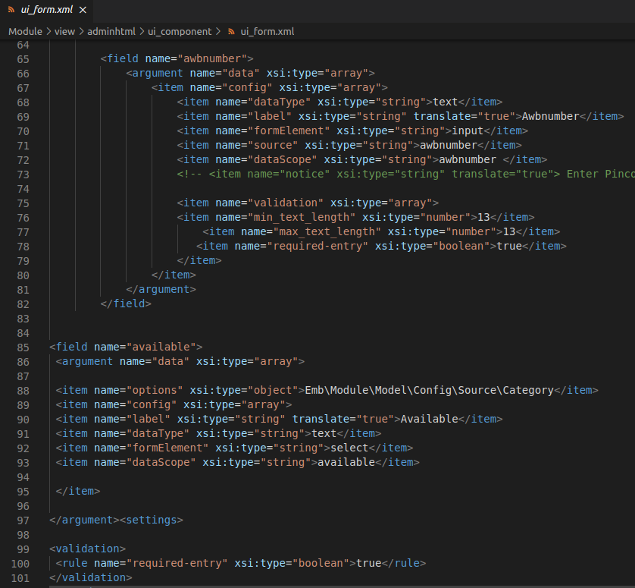

The form.xml file defines the structure of the form page by specifying the fields and input elements that should be displayed to the user. It also defines the data sources that should be used to populate the form fields, such as database tables or API endpoints.
app/code/Emb/Module/view/adminhtml/ui_component/ui_form.xml

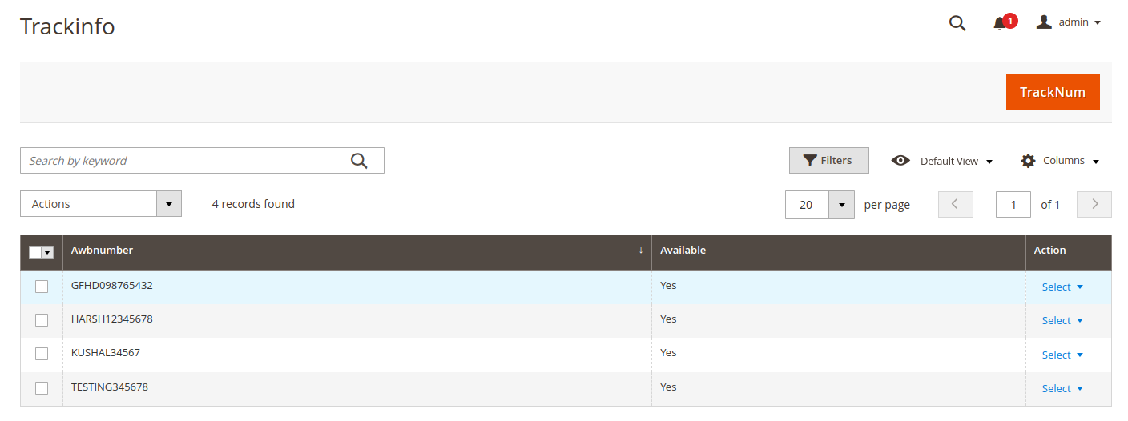
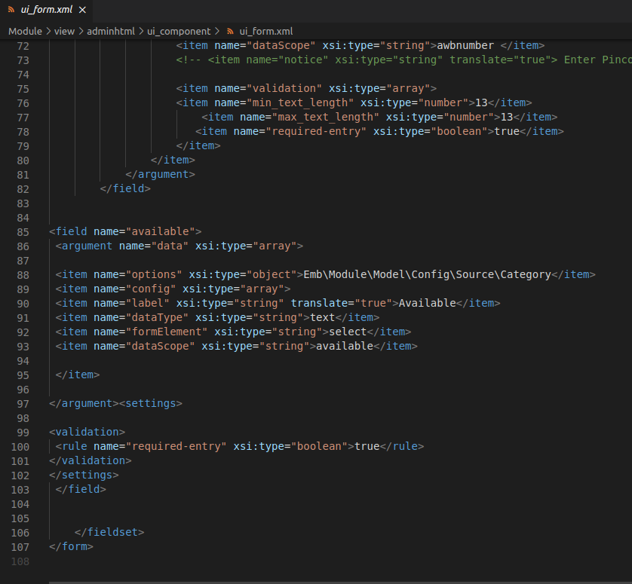

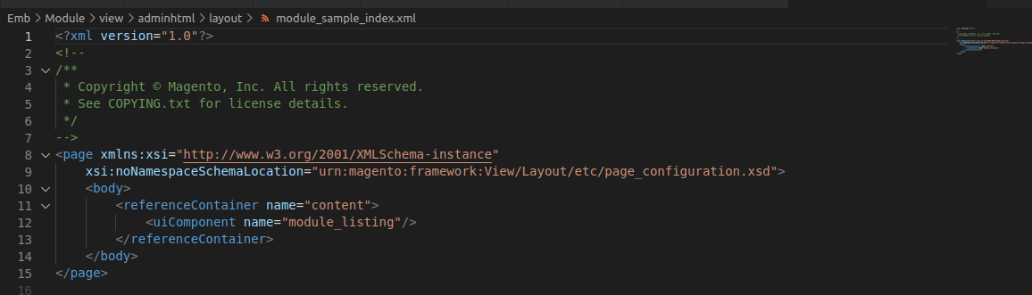
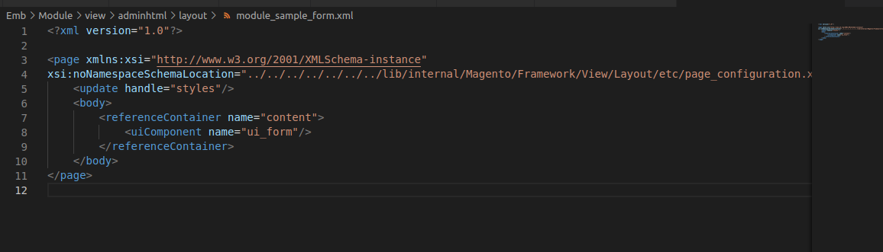

Step 19: Create the module_sample_index.xml in view-adminhtml-layout folder:The index.xml file can define the layout of the blocks on the dashboard page, such as the position, size, and alignment of each block. It can also specify the content that should be displayed in each block.
app/code/Emb/Module/view/adminhtml/layout/module_sample_index.xml

Step 20: Create the module_sample_form.xml in view-adminhtml-layout folder:
The form.xml file can define the layout of the blocks on the dashboard page, such as the position, size, and alignment of each block. It can also specify the content that should be displayed in each block, such as Pincode number, Enabiling options.The form.xml file include instructions for adding custom buttons or actions to the form page, or for modifying existing buttons or actions to add additional functionality or styling.
app/code/Emb/Module/view/adminhtml/layout/module_sample_form.xml

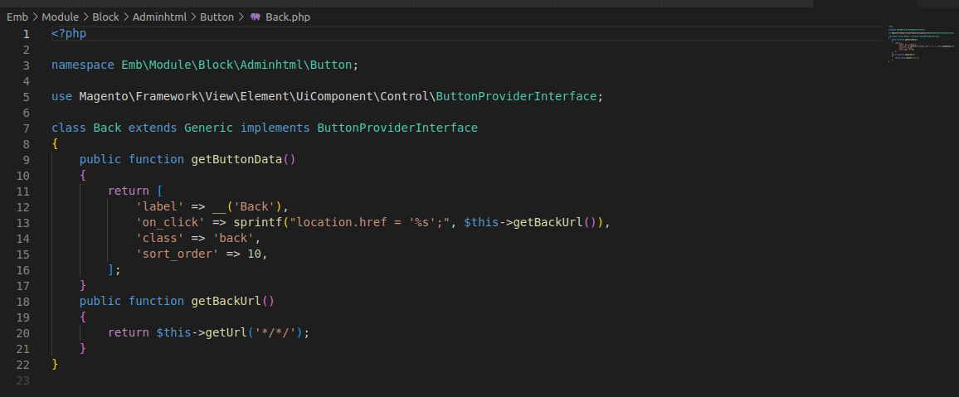
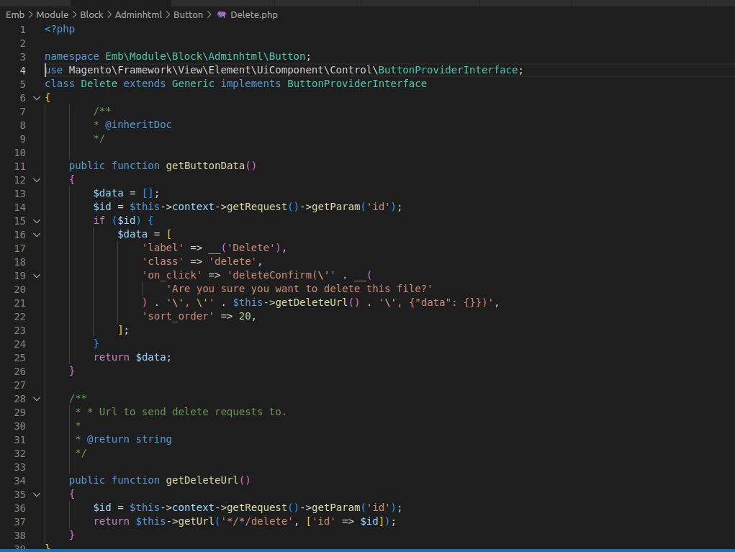

2.2 ADDING THE BUTTONS:
1. Back.php: In Magento the back button is used to navigate to the previous page in the users browsing history.
app/code/Emb/Module/Block/Adminhtml/Button/Back.php

2. Delete.php: The delete button is used to delete the details of the storelocator in which the user can add the other details in the store form.
app/code/Emb/Module/Block/Adminhtml/Button/Delete.php

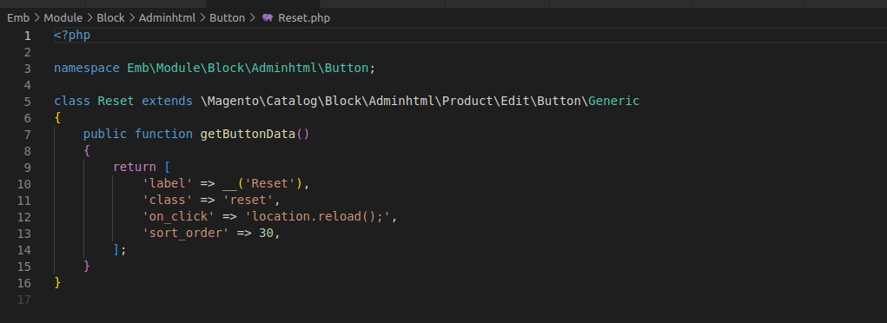

3.Generic.php:
app/code/Emb/Module/Block/Adminhtml/Button/Generic.php
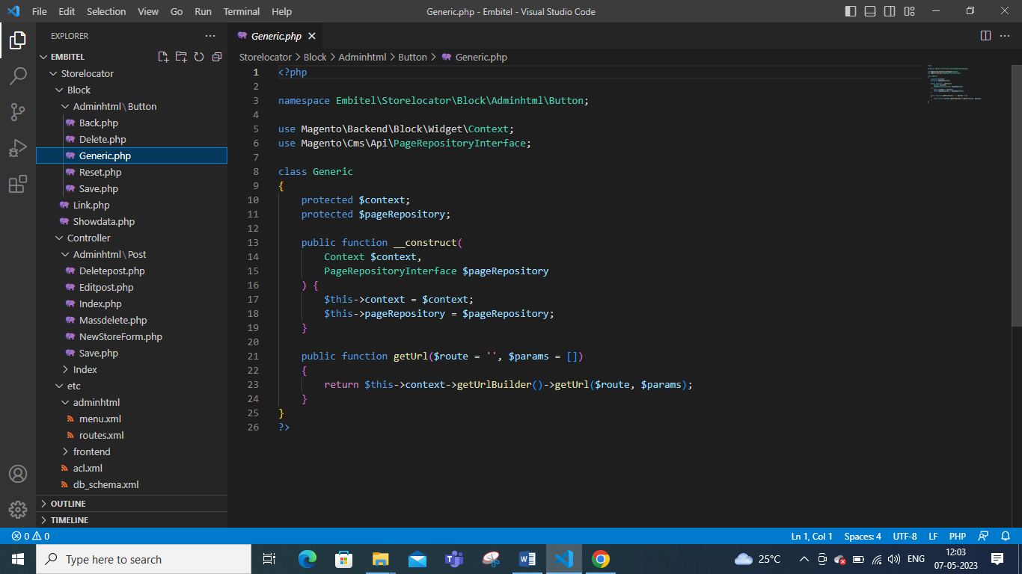

4. Reset.php: It is typically used to undo any changes made to the form or configuration settings and restore the default values and found in the same page of save button in which the user can change various settings.
app/code/Emb/Module/Block/Adminhtml/Button/Reset.php

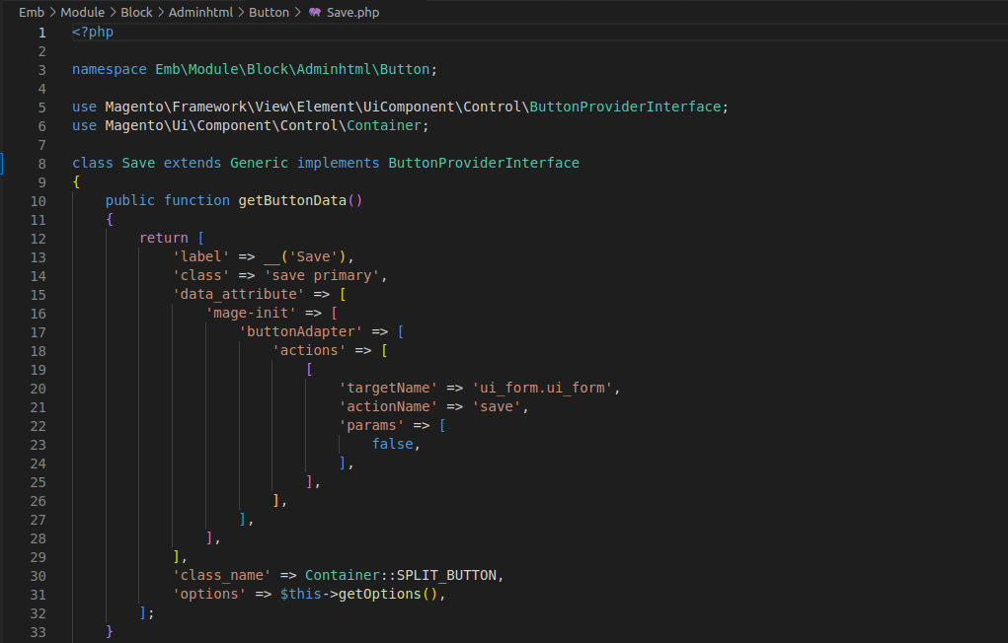
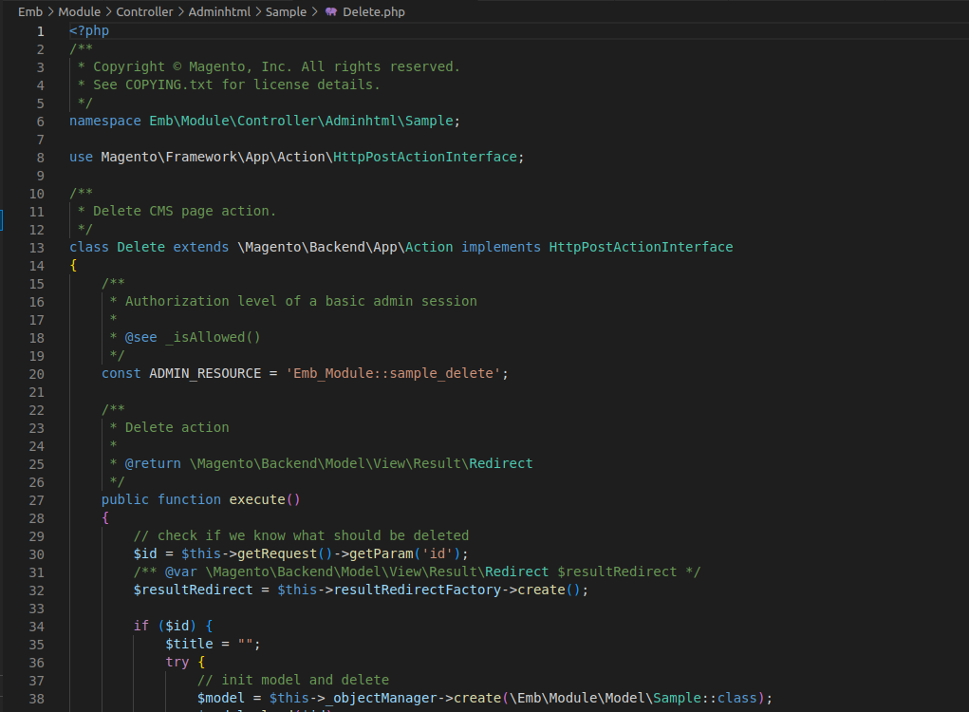
5. Save.php: The save.php is used to apply the changes made to a form or configuration changes and update the corresponding entity in the system and the user can make changes.
app/code/Emb/Module/Block/Adminhtml/Button/Save.php

2.3 ADDING UI COMPONENT:
1. Delete.php: It is the standard file name used in the adminhtml controller directory to handle the deletions of specific entity in which the customer can delete the details.
app/code/Emb/Module/Controller/Adminhtml/Sample/Delete.php

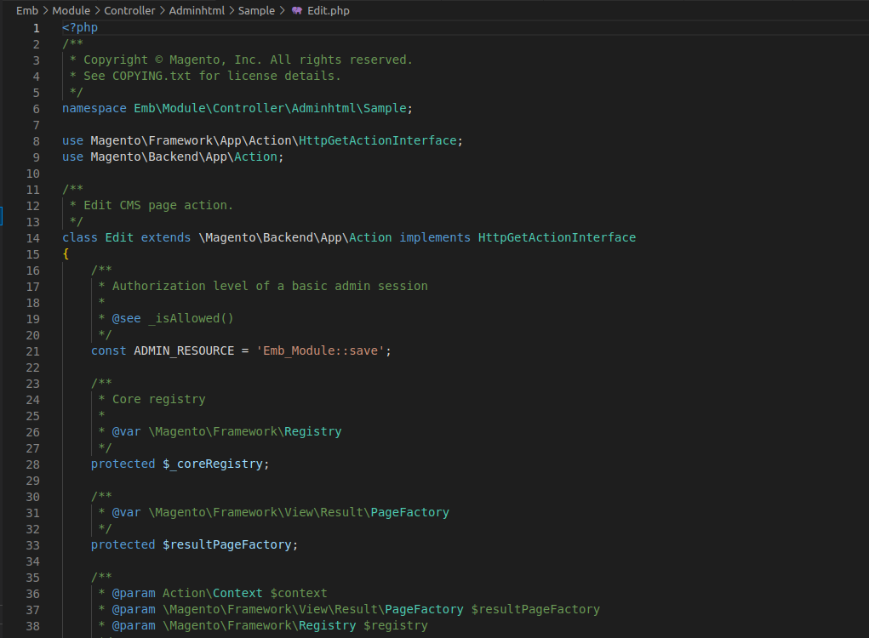
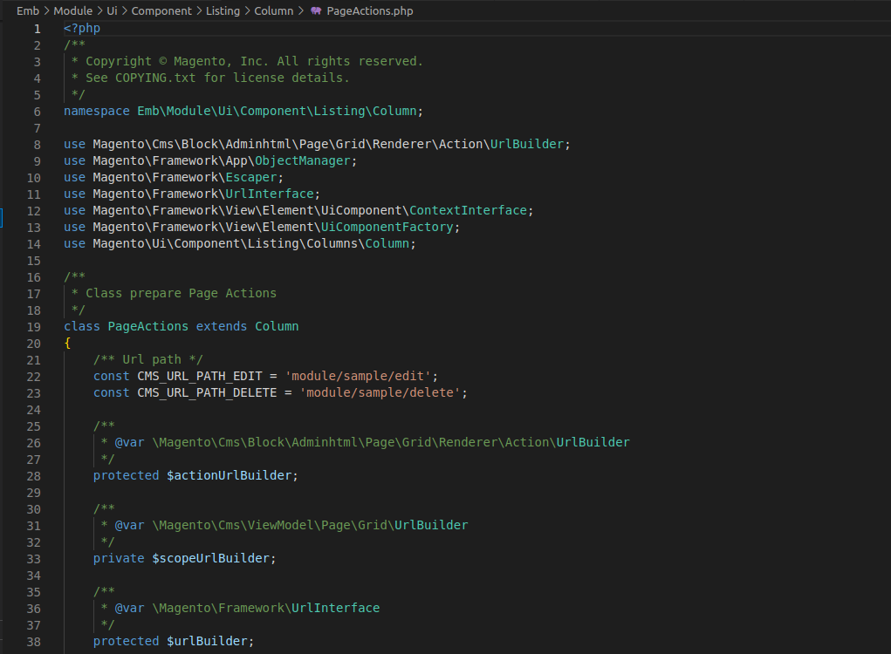
2. Edit.php: It is the standard file name used in the adminhtml controller directory to handle the deletions of specific entity in which the customer can edit the details.
app/code/Emb/Module/Controller/Adminhtml/Sample/Edit.php

2.4 UI COMPONENT:
1. PageActions.php: It is a file in the UI component directory that is responsible for handling various actions triggered by the user interface. This file receives the request from UI components and execute the corresponding action based on the request parameter.
app/code/Emb/Module/Ui/Component/Listing/Column/PageActions.php

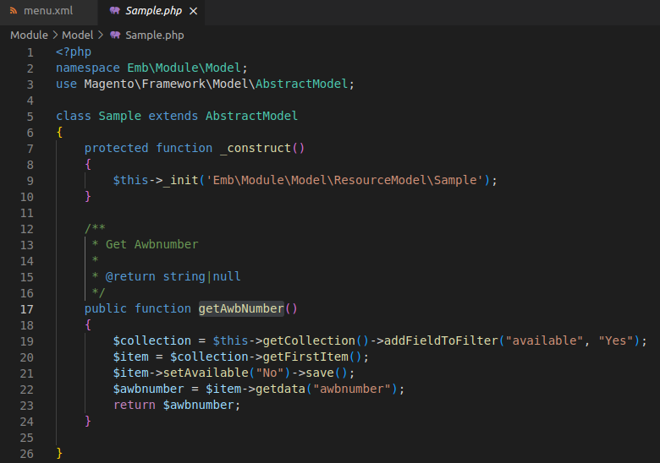
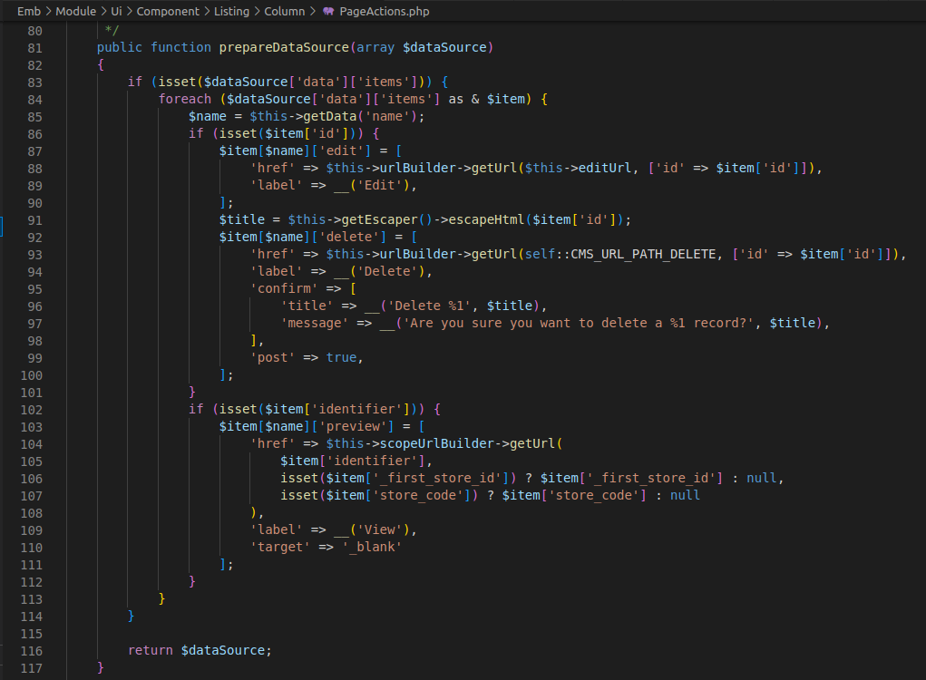

2.5 Overriding:
1. getAwbNumber: This function will fetch the awb number from the database.

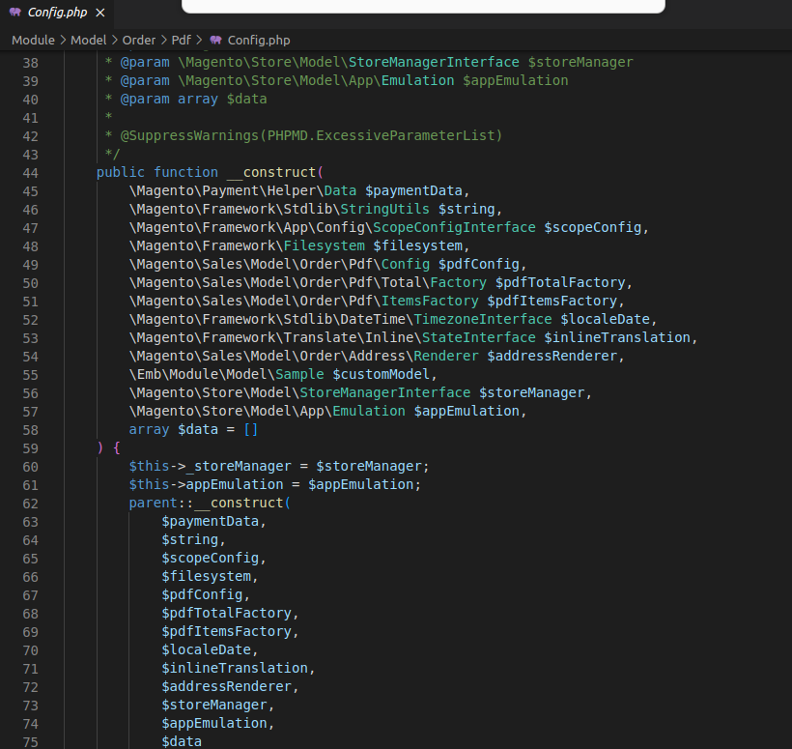
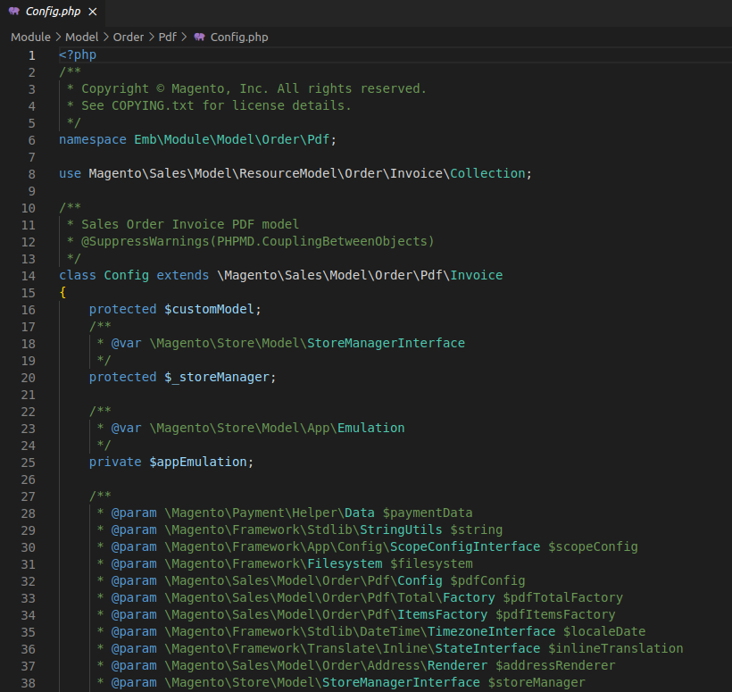
2. config.php: It fetches the awb number from the database and prints in invoice pdf through getpdf function.

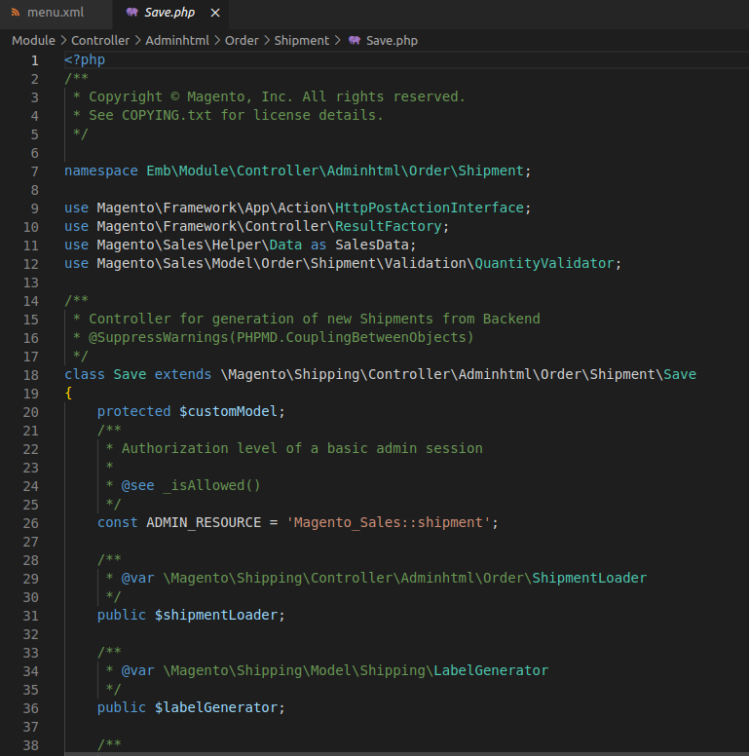
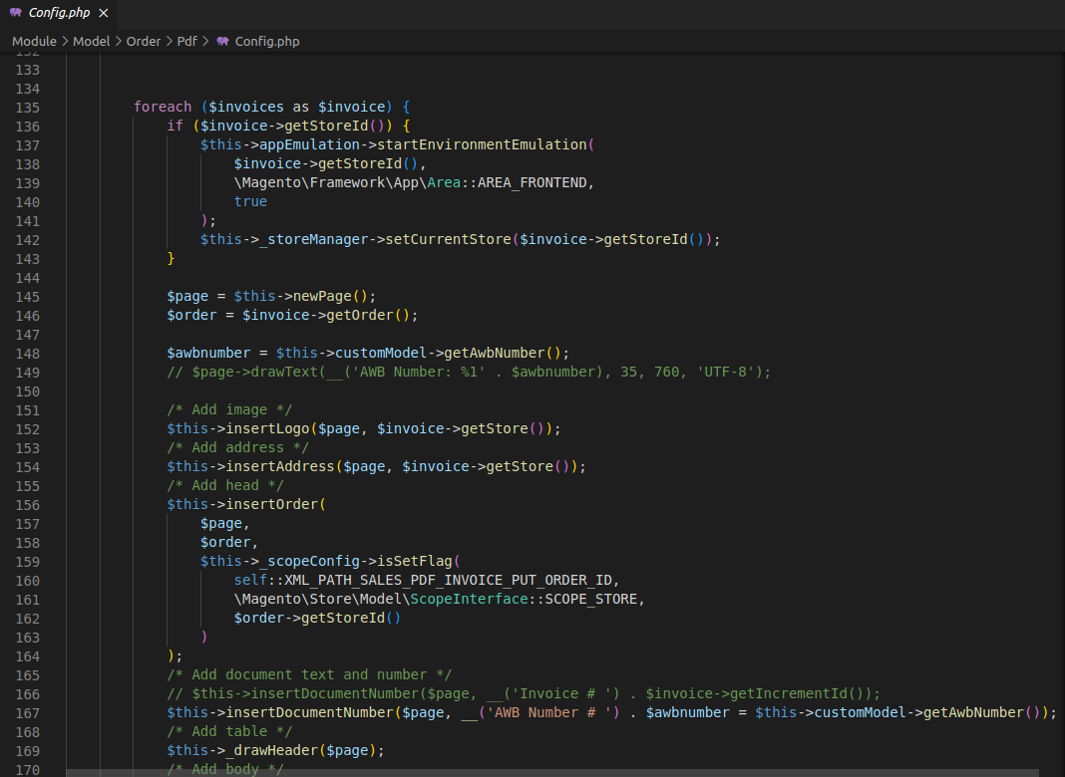

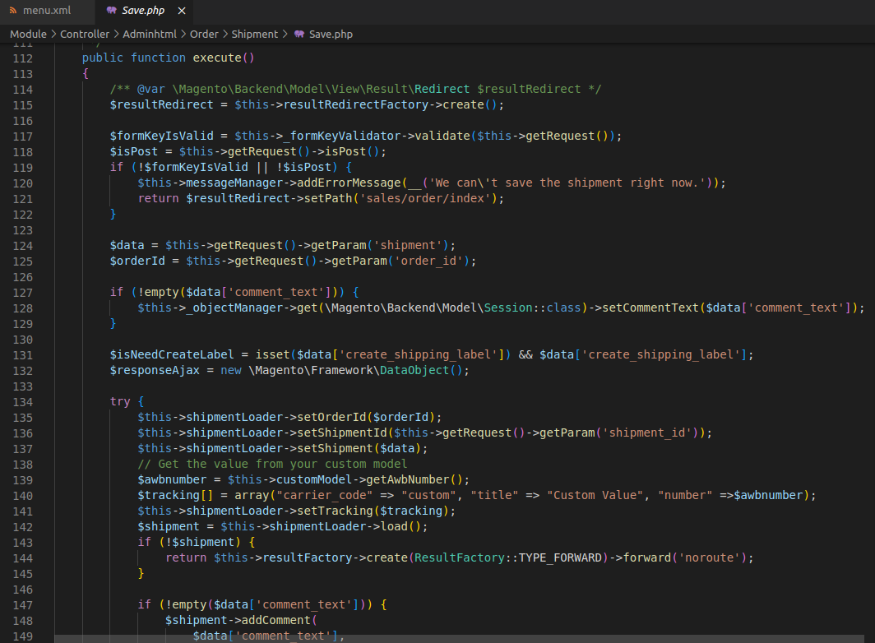
3. Save.php: This represents the submit shipment button.

