LOG ANALYTICS SYSTEM FOR A WEB SERVER USING HADOOP HDFS AND APACHE SPARK
A PROJECT REPORT
(50% Review)
Submitted by
KUSHAL MOHAN [RA2411028010082]
KRITI SINGH [RA2411028010081]
GARGI [____________________]

Under the Guidance of
______________________________
Designation, Department of Networking and Communications
in partial fulfillment of the requirements for the degree of
BACHELOR OF TECHNOLOGY
in
COMPUTER SCIENCE ENGINEERING
with specialization in Cloud Computing

DEPARTMENT OF NETWORKING AND COMMUNICATIONS
COLLEGE OF ENGINEERING AND TECHNOLOGY
SRM INSTITUTE OF SCIENCE AND TECHNOLOGY
KATTANKULATHUR – 603 203
OCTOBER 2026


SRM INSTITUTE OF SCIENCE AND TECHNOLOGY
KATTANKULATHUR – 603 203
BONAFIDE CERTIFICATE
Certified that 21CSC314P – Big Data Essentials mini-project report titled “LOG ANALYTICS SYSTEM FOR A WEB SERVER USING HADOOP HDFS AND APACHE SPARK” is the bonafide work of “KUSHAL MOHAN [RA2411028010082], KRITI SINGH [RA2411028010081], GARGI [____________________]” who carried out the mini-project work under my supervision. Certified further, that to the best of my knowledge the work reported herein does not form any other project report or dissertation on the basis of which a degree or award was conferred on an earlier occasion on this or any other candidate.
SIGNATURE  ______________________________  Designation  Department of Networking and Communications  SRM Institute of Science and Technology | SIGNATURE  ______________________________  Head of the Department  Department of Networking and Communications  SRM Institute of Science and Technology

Panel Reviewer I  SIGNATURE | Panel Reviewer II  SIGNATURE
Department of Networking and Communications
SRM Institute of Science & Technology
Own Work* Declaration Form
Degree / Course | : B.Tech CSE-CC / Big Data Essentials
Student Names | : Kushal Mohan, Kriti Singh, Gargi
Registration Numbers | : RA2411028010082, RA2411028010081, ____________
Title of Work | : LOG ANALYTICS SYSTEM FOR A WEB SERVER USING HADOOP HDFS AND APACHE SPARK
I / We hereby certify that this assessment complies with the University's Rules and Regulations relating to Academic misconduct and plagiarism**, as listed in the University Website, Regulations, and the Education Committee guidelines.
I / We confirm that all the work contained in this assessment is my / our own except where indicated, and that I / We have met the following conditions:
- Clearly referenced / listed all sources as appropriate
- Referenced and put in inverted commas all quoted text (from books, web, etc)
- Given the sources of all pictures, data etc. that are not my own
- Not made any use of the report(s) or essay(s) of any other student(s) either past or present
- Acknowledged in appropriate places any help that I have received from others (e.g. fellow students, technicians, statisticians, external sources)
- Complied with any other plagiarism criteria specified in the Course handbook / University website
I understand that any false claim for this work will be penalized in accordance with the University policies and regulations.
DECLARATION:
I am aware of and understand the University's policy on Academic misconduct and plagiarism and I certify that this assessment is my / our own work, except where indicated by referring, and that I have followed the good academic practices noted above.
Kushal Mohan  (RA2411028010082) | Kriti Singh  (RA2411028010081) | Gargi  (____________________)

Date: ____ / ____ / 2026
ACKNOWLEDGEMENT
We would like to sincerely thank our faculty guide from the Department of Networking and Communications at SRM Institute of Science and Technology for the guidance, consistent support and constructive feedback given throughout the development of our project, “Log Analytics System for a Web Server using Hadoop HDFS and Apache Spark.” The guidance we received on distributed storage and data processing gave us a strong foundation for approaching this topic with confidence.
We also thank the faculty members of the School of Computing, whose dedication to a collaborative and practical learning environment greatly enriched our experience, and our classmates, whose discussions and shared resources helped us at many points of the project.
We are grateful to the open-source communities behind Apache Hadoop, Apache Spark, Apache Parquet, Docker and Flask, whose software and documentation made this project possible, and to the Internet Traffic Archive and the original contributors of the NASA-HTTP traces for making real web server logs freely available for research and teaching. Online communities such as Stack Overflow helped us solve many practical problems along the way.
Finally, we thank our families for their constant support and encouragement throughout this academic journey. Through this project we have learned how large, raw data can be stored safely, processed at scale and turned into answers that people can use.
Authors
ABSTRACT
Web servers record every request they receive in access logs, which quickly grow to millions of lines. These logs contain valuable information — traffic peaks, popular pages, broken links and bandwidth usage — but their size and lack of structure make them impractical to analyse with spreadsheets or single-machine scripts. This project presents a Log Analytics System that stores, processes and presents web server access logs using a distributed big-data stack. The system runs as a Docker cluster with Hadoop Distributed File System (HDFS) 3.3.6, consisting of one NameNode and two DataNodes with a replication factor of two, and Apache Spark 3.5.3 with a master and a worker. It is demonstrated on the public NASA-HTTP dataset of 3,461,612 requests made to NASA's Kennedy Space Center web server in July and August 1995. The raw logs are stored unchanged in an HDFS raw zone; a Spark ETL job parses every line with regular expressions into typed fields, separates malformed records, adds derived date, hour, weekday and file-type columns, and writes Snappy-compressed Parquet partitioned by date; and eleven Spark SQL reports summarise traffic, content, errors and performance. An export job condenses the results into a 198 KB JSON summary that a Flask web application presents as four pages of hand-drawn SVG charts, searchable tables and CSV/JSON downloads, which remain available even when the cluster is stopped. All 3,461,612 lines were parsed successfully. The analysis shows that traffic peaks at 15:00 with 230,665 requests, 3.9 times the overnight minimum; that 89.6% of requests succeed while 20,899 return 404 errors across 3,544 URLs, with two files accounting for 18% of them; and that MPEG video files make up 1.3% of requests but about 30% of the 61 GB transferred. This report covers the first 50% of the project; behaviour-based bot detection, attack classification and live streaming are planned for the second half.
TABLE OF CONTENTS
CHAPTER NO. | TOPIC | PAGE NO.
 | ABSTRACT | iv
 | LIST OF FIGURES | vii
 | LIST OF TABLES | viii
 | LIST OF ABBREVIATIONS | ix
1 | INTRODUCTION | 1
 | 1.1 Problem Statement | 1
 | 1.2 Motivation | 1
 | 1.3 Objectives | 2
 | 1.4 Ideas | 2
 | 1.5 Solution Proposed | 3
 | 1.6 Challenges | 3
 | 1.7 Scope of the 50% Review | 3
2 | LITERATURE REVIEW | 4
3 | PROPOSED METHODOLOGY | 7
 | 3.1 Data Collection | 7
 | 3.2 Data Preprocessing | 8
 | 3.3 Feature Engineering | 8
 | 3.4 System Architecture | 9
 | 3.5 Evaluation Metrics | 10
 | 3.6 Visualization Techniques | 11
4 | IMPLEMENTATION | 12
 | 4.1 Environment and Cluster Setup | 12
 | 4.2 Data Acquisition and Ingestion into HDFS | 13
 | 4.3 Data Cleaning and Preprocessing using Apache Spark | 14
 | 4.4 Analytical Reports using Spark SQL | 15
 | 4.5 Dashboard Export | 16
 | 4.6 Web Application | 16
 | 4.7 Verification and Testing | 17
 | 4.8 Division of Work | 17
 | 4.9 System Summary | 17
5 | RESULTS AND DISCUSSIONS | 18
 | 5.1 Data Processing Results | 18
 | 5.2 Exploratory Data Analysis Results | 18
 | 5.2.1 Traffic by Hour of Day | 18
 | 5.2.2 Daily Request Volume | 19
 | 5.2.3 Traffic by Weekday | 19
 | 5.2.4 Most Visited Content | 20
 | 5.3 Error Analysis | 21
 | 5.4 Performance Analysis | 23
 | 5.5 Dashboard Results | 23
 | 5.6 Discussion of Results | 26
 | 5.7 Summary of Findings | 27
6 | CONCLUSION AND FUTURE WORK | 28
7 | REFERENCES | 30
LIST OF FIGURES
Figure No | Title | Page No
3.1 | System architecture of the Log Analytics System | 9
3.2 | States of the data through the pipeline and their owners | 10
4.1 | Complete workflow of the first half and the owner of each stage | 12
4.2 | HDFS write path in the Docker cluster | 13
4.3 | Execution of the Spark ETL job on the cluster | 15
4.4 | Data flow of the web application | 16
5.1 | Requests by hour of day | 19
5.2 | Daily request volume, 1 July – 31 August 1995 | 19
5.3 | Requests by day of the week | 20
5.4 | Top 10 most-visited pages | 20
5.5 | Requests and bandwidth by file type | 21
5.6 | Distribution of HTTP status codes | 21
5.7 | Daily 404 (Not Found) error rate | 22
5.8 | Top 10 broken links | 22
5.9 | Distribution of response sizes | 23
5.10 | Overview page of the dashboard | 24
5.11 | Requests by hour and day heatmap | 24
5.12 | Traffic page of the dashboard | 25
5.13 | Errors page of the dashboard | 26
5.14 | Performance page of the dashboard | 26
LIST OF TABLES
Table No | Title | Page No
2.1 | Summary of the literature reviewed | 5
3.1 | Raw dataset summary | 7
3.2 | Fields of a Common Log Format line | 7
3.3 | Schema of the curated dataset | 8
4.1 | Containers in the Docker Compose cluster | 12
4.2 | Spark SQL reports | 15
4.3 | Division of work among team members | 17
5.1 | Data processing summary | 18
5.2 | HTTP status code distribution | 21
5.3 | Response size percentiles (HTTP 200) | 23
LIST OF ABBREVIATIONS
Abbreviation | Full Form
AQE | Adaptive Query Execution
CLF | Common Log Format
CSV | Comma-Separated Values
ETL | Extract, Transform, Load
GB / MB / KB | Gigabyte / Megabyte / Kilobyte
GFS | Google File System
GMM | Gaussian Mixture Model
HDFS | Hadoop Distributed File System
HTML | HyperText Markup Language
HTTP | HyperText Transfer Protocol
JDK | Java Development Kit
JSON | JavaScript Object Notation
KSC | Kennedy Space Center
MLP | Multilayer Perceptron
NASA | National Aeronautics and Space Administration
RDD | Resilient Distributed Dataset
RPC | Remote Procedure Call
SQL | Structured Query Language
SVG | Scalable Vector Graphics
UI | User Interface
URL | Uniform Resource Locator
UTC | Coordinated Universal Time
XSS | Cross-Site Scripting

CHAPTER 1
INTRODUCTION
Every request made to a web server is written as one line in an access log: which host asked, for which page, at what time, whether the request succeeded, and how many bytes were sent back. A busy website writes millions of these lines every day. Hidden inside them are answers that matter to the people who run the site — which pages are popular, when traffic peaks, which links are broken, and which files consume most of the bandwidth. In practice these logs are rarely read, because they are too large to open in a spreadsheet and too unstructured to query directly.
This project, the Log Analytics System for a Web Server, builds a distributed batch pipeline that turns raw access logs into clear traffic, error and performance reports. It runs on a real big-data stack — the Hadoop Distributed File System (HDFS) for storage and Apache Spark for processing — packaged as a Docker cluster with one NameNode, two DataNodes, a Spark master and a Spark worker. The pipeline is demonstrated on 3,461,612 real requests made to NASA's Kennedy Space Center web server in July and August 1995. This report covers the first 50% of the project: data ingestion, distributed storage, Spark ETL, Spark SQL reporting and the results website.

1.1 Problem Statement
Web server access logs grow continuously and quickly reach sizes that conventional tools cannot handle. A single month of logs from a moderately busy server runs into hundreds of megabytes and millions of lines. Spreadsheets cannot open files of this size, single-machine scripts become slow and fragile, and the raw text has no structure that a database or reporting tool can query directly. As a result, website owners rarely see basic facts that are recorded in their own logs, such as the number of broken links visitors keep hitting, the hours at which the server is under the most load, or the file types responsible for most of the bandwidth.
The problem addressed in this project is therefore: how to store large web server access logs safely and process them at scale, so that traffic, error and performance questions can be answered accurately and quickly, and the answers presented in a form that non-technical users can read. The solution must tolerate the failure of a storage node, must never alter the original logs, and must be reproducible on an ordinary laptop.

1.2 Motivation
Access logs are one of the richest and most neglected data sources in any organisation that runs a website. Every broken link, slow page and traffic spike is already recorded, yet the information remains locked in text files. Big-data platforms such as Hadoop and Spark were created precisely for this situation: data that is too large for one machine and needs to be split, processed in parallel and summarised. Building a log analytics pipeline is a practical way to learn and demonstrate the core ideas of big-data engineering — distributed storage, fault tolerance through replication, parallel ETL, columnar storage, partitioning and SQL on large data — on a problem whose results are easy to verify and immediately useful.
The NASA-HTTP dataset was chosen because it is real, public and unlabelled. Nobody has cleaned it in advance, so every step from parsing to reporting has to be engineered and validated by the team. It also uses the Common Log Format, which Apache and Nginx servers still write today, so the same pipeline can be pointed at a modern server's logs without changes.

1.3 Objectives
The primary objective of the first half of this project is to design and implement a distributed pipeline that stores, cleans, analyses and presents web server access logs. The specific objectives are:
- To build a reproducible Hadoop and Spark cluster using Docker, with HDFS replication so that the loss of one DataNode does not lose any data.
- To ingest the raw NASA-HTTP logs into an immutable raw zone in HDFS that serves as the audit trail of the pipeline.
- To parse every log line with Apache Spark into typed, validated columns, keeping malformed lines aside instead of silently dropping them.
- To store the clean data as Snappy-compressed Parquet partitioned by date, so that queries read only the columns and days they need.
- To answer traffic, content, error and performance questions with eleven readable Spark SQL reports.
- To export the results and present them on a four-page website with charts, searchable tables and CSV/JSON downloads that works even when the cluster is stopped.

1.4 Ideas
The central idea is to separate the pipeline into zones, as professional data platforms do. A raw zone holds the logs exactly as received and is never modified. A curated zone holds the cleaned, typed data and can always be rebuilt from raw. A reports zone holds small summary tables computed from curated data. The website sits outside the cluster and reads only an exported summary file. Each zone has one owner and one job, which makes the system easy to reason about, easy to test and safe to re-run: if a parsing rule turns out to be wrong, the rule is fixed and the curated zone is regenerated, with nothing lost.
A second idea is to keep every number traceable. Every figure on the website is produced by one named Spark SQL query, and the reports are written as plain SQL rather than opaque code, so a reviewer can read the query, re-run it and obtain the same number.

1.5 Solution Proposed
The proposed solution is a five-stage batch pipeline. The NASA logs are downloaded and copied into the HDFS raw zone, where every block is stored on two DataNodes. A Spark ETL job parses each line with regular expressions into host, timestamp, method, URL, protocol, status and bytes, adds derived columns (date, hour, weekday and file type), and writes the result to the curated zone as date-partitioned Parquet. A second Spark job registers the curated data as a SQL table and runs eleven reports covering traffic, content, errors and performance. An export job converts the report tables into a 198 KB JSON summary and downloadable CSV/JSON tables, which a Flask web application presents as four interactive pages. The whole system starts with a single Docker Compose command.

1.6 Challenges
Several challenges were faced while building the first half of the system. Running a NameNode, two DataNodes, a Spark master, a Spark worker and a web server at the same time requires at least 8 GB of memory for Docker, which is more than the default allocation. Downloading Hadoop and Spark from the throttled Apache archive during the image build took several hours on some networks, which was solved by allowing the build to use locally supplied archives. Container hostnames do not reverse-resolve, so the HDFS hostname check had to be disabled for the DataNodes to register. The dataset itself has gaps — no requests are recorded for 29–31 July and 2 August 1995, and the server was shut down for Hurricane Erin from 1 August 14:52 to 3 August 04:36 — so charts had to show these gaps honestly rather than interpolate across them. Finally, team members used both macOS and Windows, so commands, line endings and memory settings had to work on both.

1.7 Scope of the 50% Review
This report presents the first half of the project, which is complete and working: the Docker cluster and HDFS storage, the Spark ETL job, the eleven Spark SQL reports, the dashboard export and the four-page website. The second half — behaviour-based bot detection with a Gaussian Mixture Model, attack classification with a Multilayer Perceptron, live scoring with Spark Structured Streaming, and the interactive SQL console and raw-log explorer — is described in Chapter 6 as future work. The first half was divided among the three team members as shown in Table 4.3.

CHAPTER 2
LITERATURE REVIEW
The design of this project rests on two bodies of work: the distributed systems research that made large-scale data processing practical, and the web usage mining research that defined how server logs should be prepared and analysed. This chapter reviews ten studies from these areas and explains how each one shaped the system.
Dean and Ghemawat introduced MapReduce [1], a programming model in which a computation is expressed as a map function and a reduce function that the framework runs in parallel across a cluster of commodity machines. They showed that large jobs such as log processing could be split across thousands of machines while the framework handled partitioning, scheduling and failures. MapReduce writes intermediate results to disk after every stage, which makes it slow for workloads that pass over the same data repeatedly — one of the reasons this project uses Spark instead. The storage layer underneath MapReduce was the Google File System of Ghemawat, Gobioff and Leung [2], which splits files into large chunks and replicates each chunk across several servers so that the failure of commodity hardware is treated as normal rather than exceptional. GFS was internal to Google, but its design was reproduced in open source as the Hadoop Distributed File System.
Shvachko et al. [3] described HDFS: a NameNode that keeps the namespace and the mapping of files to blocks, and DataNodes that store the blocks and report to the NameNode through heartbeats and block reports. Blocks are replicated across DataNodes so that data survives node failures. This project uses HDFS 3.3.6 exactly in this form, with one NameNode, two DataNodes and a replication factor of two, and organises the data into raw, curated and report zones on top of it.
Zaharia et al. [4] introduced Resilient Distributed Datasets, the abstraction behind Apache Spark. An RDD is a read-only, partitioned collection that can be kept in memory and rebuilt from its lineage if a partition is lost. Keeping working data in memory made Spark up to twenty times faster than Hadoop MapReduce for iterative applications. Armbrust et al. [5] extended Spark with Spark SQL, which adds the DataFrame API and the Catalyst query optimiser so that relational queries and procedural code can be mixed and optimised together. This project's ETL job is written with DataFrames, and its eleven reports are written as plain Spark SQL so that they can be read and re-run by anyone.
Melnik et al. [6] described Dremel, Google's system for interactive analysis of web-scale datasets, whose key contribution was a nested columnar storage format. Storing data by column lets a query read only the fields it needs and compresses far better than row storage. Apache Parquet, which this project uses for its curated and report zones, implements the same columnar layout.
On the analysis side, Arlitt and Williamson [7] studied the access logs of six web servers, including the same NASA Kennedy Space Center server used in this project, and identified workload characteristics that held across all of them — for example, that most requests are successful and that HTML and image files account for most requests. Their work was done with single-machine tools; this project repeats the same kind of analysis at scale with Spark. Cooley, Mobasher and Srivastava [8] showed that raw server logs need careful preparation — cleaning, user identification and session identification — before any meaningful analysis, and Srivastava et al. [9] defined the overall web usage mining process as preprocessing, pattern discovery and pattern analysis. The ETL job in this project implements the preprocessing stage, and the reports and website implement pattern discovery and analysis. Finally, Greenwald and Khanna [10] described a space-efficient algorithm for computing approximate quantiles in a single pass with a guaranteed error bound. Spark's percentile_approx function, used in this project's response-size report, follows this approach, which allows percentiles to be computed over millions of rows without sorting them.
Table 2.1: Summary of the literature reviewed
No. | Author & Year | Method | Key Finding | Relevance to this Project
1 | Dean & Ghemawat (2004) | Map and reduce functions run in parallel over a cluster | Large log jobs can be split across many machines | Disk-based and slow for repeated passes; motivates Spark
2 | Ghemawat et al. (2003) | Large file chunks replicated across servers | Commodity machines can store huge data reliably | Design reproduced by HDFS
3 | Shvachko et al. (2010) | NameNode index + DataNodes with replicated blocks | Open-source, fault-tolerant storage for big data | Our raw, curated and report zones
4 | Zaharia et al. (2012) | In-memory datasets rebuilt from lineage | Up to 20× faster than Hadoop on iterative jobs | Engine of our ETL job
5 | Armbrust et al. (2015) | DataFrames + Catalyst query optimiser | SQL and code mixed and optimised together | Our 11 Spark SQL reports
6 | Melnik et al. (2010) | Nested columnar storage | Queries read only the needed fields | Format behind our Parquet layer
7 | Arlitt & Williamson (1997) | Workload study of six web servers incl. NASA | Common patterns across servers | We repeat the analysis at scale
8 | Cooley et al. (1999) | Cleaning and session identification | Logs need preprocessing before analysis | Our ETL cleaning and rejects
9 | Srivastava et al. (2000) | Survey of web usage mining | Preprocessing → discovery → analysis | Structure of our pipeline
10 | Greenwald & Khanna (2001) | Quantile summary with error bound | Percentiles without sorting all data | percentile_approx in our size report

Research gap. The distributed systems papers [1]–[6] provide general-purpose storage and processing engines but no ready analysis of web logs, while the web usage mining papers [7]–[10] define what to analyse but were developed for single machines and much smaller data. Existing log tools also tend either to require a running database for every query or to hide their calculations. This project combines the two strands into one reproducible pipeline: replicated HDFS storage with an immutable raw zone, Spark ETL with explicit reject handling, readable Spark SQL reports and a dashboard that keeps working without the cluster.

CHAPTER 3
PROPOSED METHODOLOGY
This chapter describes the methodology used to build the Log Analytics System. The approach is a zoned batch pipeline: data is collected, stored unchanged, cleaned into a structured form, summarised with SQL and finally exported for presentation. Each stage reads the output of the previous one and writes a new, clearly named dataset, so that every result can be traced back to the original log lines.

3.1 Data Collection
The project uses the NASA-HTTP dataset published by the Internet Traffic Archive (https://ita.ee.lbl.gov/html/contrib/NASA-HTTP.html). It contains every HTTP request made to the NASA Kennedy Space Center web server in Florida between 1 July and 31 August 1995, in two files. The collection script downloads the compressed files (about 37 MB) from a GitHub mirror, falling back to the original archive, and unpacks them into 356 MB of plain text.
Table 3.1: Raw dataset summary
Property | Value
Source | NASA Kennedy Space Center WWW server, Internet Traffic Archive
Files | access_log_Jul95 (1,891,714 lines), access_log_Aug95 (1,569,898 lines)
Total requests | 3,461,612
Size | about 37 MB compressed, 356 MB uncompressed
Period | 1 July – 31 August 1995 (58 days with data)
Time zone | UTC−04:00 (server local time)
Known gaps | No data for 29–31 July and 2 August; server shut down for Hurricane Erin, 1 Aug 14:52 – 3 Aug 04:36
Format | NCSA Common Log Format (CLF)

Each line follows the Common Log Format. A representative line and the meaning of each field are shown in Table 3.2.
199.72.81.55 - - [01/Jul/1995:00:00:01 -0400] "GET /history/apollo/ HTTP/1.0" 200 6245

Table 3.2: Fields of a Common Log Format line
Part of the line | Field | Meaning
199.72.81.55 | host | The client's IP address or host name
- - | identity, user | Always empty in this dataset
[01/Jul/1995:00:00:01 -0400] | timestamp | Date and time of the request, with time zone
"GET /history/apollo/ HTTP/1.0" | request | Method, requested URL and protocol
200 | status | HTTP status code (200 OK, 304 Not Modified, 404 Not Found …)
6245 | bytes | Size of the response body; '-' when there is no body

3.2 Data Preprocessing
Preprocessing converts each free-text line into a structured record. It is performed by a Spark job that reads the raw zone line by line and applies five regular expressions: one each for the host (the first word), the timestamp (the text inside square brackets), the request (method, URL and protocol inside quotation marks), the status (a three-digit number) and the bytes (the last field). Each extracted value is then cast to a proper type: the timestamp is parsed with the pattern dd/MMM/yyyy:HH:mm:ss Z, the status becomes an integer and the bytes become a long integer, with a dash converted to zero rather than left empty.
A record is considered malformed if its timestamp cannot be parsed, its status is missing or its host is empty. Malformed lines are not silently discarded: they are written, exactly as they appeared, to a separate rejects folder for inspection, and the job prints the parse rate on every run and warns if it falls below 99%. This guards against a silent change in log format producing wrong numbers. In this dataset all 3,461,612 lines were parsed into valid records.

3.3 Feature Engineering
After cleaning, four derived columns are added to support the reports and to organise storage. The date column is used to partition the data on disk, the hour and dow (day of week) columns support traffic analysis, and the ext column — the lower-cased file extension of the URL — supports content and bandwidth analysis. The final curated schema is shown in Table 3.3.
Table 3.3: Schema of the curated dataset
Column | Type | Description | Example
host | string | Client host or IP address | 199.72.81.55
ts | timestamp | Request time (America/New_York) | 1995-07-01 00:00:01
method | string | HTTP method | GET
endpoint | string | Requested URL path | /history/apollo/
protocol | string | HTTP protocol version | HTTP/1.0
status | integer | HTTP status code | 200
bytes | long | Response size in bytes | 6245
date | date (partition) | Calendar date, one folder per day | 1995-07-01
hour | integer | Hour of the day, 0–23 | 0
dow | string | Day of the week | Saturday
ext | string | File extension of the URL | (empty for '/')

3.4 System Architecture
The system architecture is shown in Fig 3.1. Data flows from left to right through five layers. The data source layer is the pair of NASA log files. The ingestion layer downloads them and copies them into HDFS. The storage layer is HDFS, organised into a raw zone (immutable, replicated) and a curated zone (Parquet, partitioned by date). The processing layer is Apache Spark, which runs the ETL job, produces the curated data and runs the eleven Spark SQL reports. The serving layer is an export job that writes a JSON summary and downloadable tables, which a Flask web application presents in the browser. All components run as Docker containers built from a single image containing Java 11, Hadoop 3.3.6 and Spark 3.5.3.
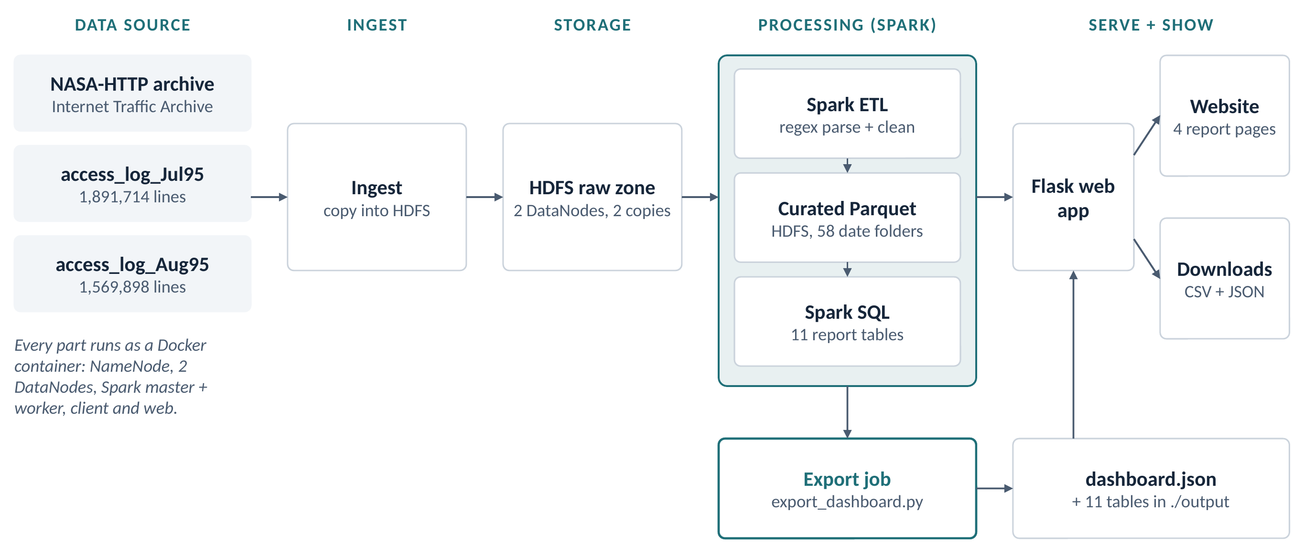
Fig 3.1: System architecture of the Log Analytics System
Fig 3.2 shows the same pipeline from the point of view of the data. In the first three states the data changes place but not content; in the curated state free text becomes typed rows; in the report state 3.46 million rows become a few hundred summary rows; and in the final states the summaries become a 198 KB JSON file and the charts and tables of the website.
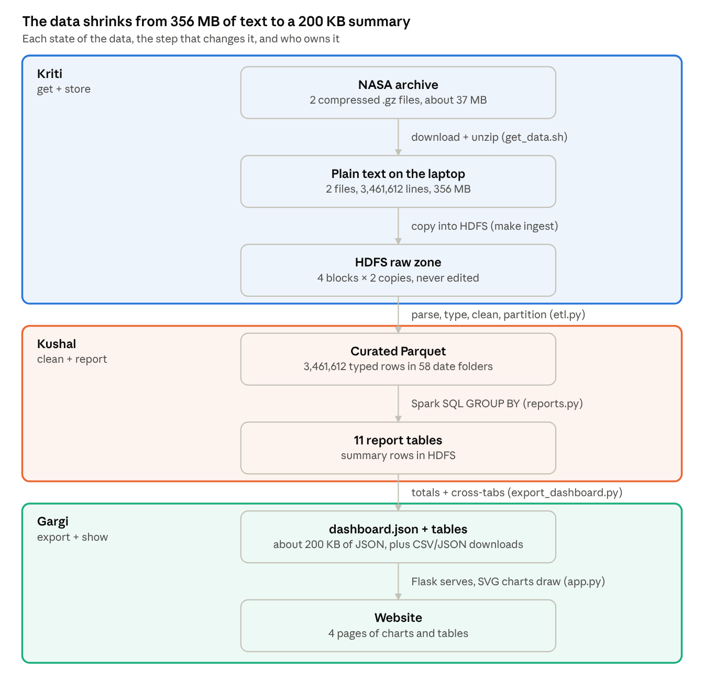
Fig 3.2: States of the data through the pipeline and their owners

3.5 Evaluation Metrics
Because the first half of the project is a data engineering pipeline rather than a predictive model, it is evaluated with data-quality and system metrics rather than accuracy scores. The metrics used are:
- Parse rate — the share of raw lines that become valid curated records; the job warns below 99%.
- Record reconciliation — the number of curated records must equal the number of raw lines minus rejects (3,461,612 in this run).
- Replication health — hdfs fsck must report every block with two live replicas on two different DataNodes and an overall status of HEALTHY.
- Fault tolerance — data must remain readable after one DataNode is stopped.
- Partition pruning — a query filtered on one date must read only that date's folder rather than all 58.
- Traceability — every number shown on the website must match the output of the Spark SQL query that produced it.
- Availability — the report pages must keep working when the Hadoop and Spark containers are stopped.

3.6 Visualization Techniques
Results are presented on a four-page website: Overview, Traffic, Errors and Performance. All charts are drawn directly as SVG by a small JavaScript module, without a charting library or any external network dependency, so the site works offline and follows a light or dark theme automatically. The visualisations used are line charts for daily volume and the daily 404 rate, with shaded bands where the dataset has missing days; bar charts for requests by hour, by weekday and by response size; horizontal bar charts for status codes, file types, top pages and broken links; and an hour-by-day heatmap of request volume. Every table can be searched, sorted, paged and downloaded as CSV or JSON. A date-range control filters the daily series, and two exported cross-tabs (hour × date and status × date) allow the hour-of-day and status charts to be recomputed for any selected range rather than showing period-wide totals.

CHAPTER 4
IMPLEMENTATION
The system was implemented as a set of small, single-purpose components, each owned by one team member. Fig 4.1 shows the three parts of the first half and how the data passes between them: Kriti built the cluster and HDFS storage, Kushal built the Spark ETL and Spark SQL reports, and Gargi built the dashboard export and the website.
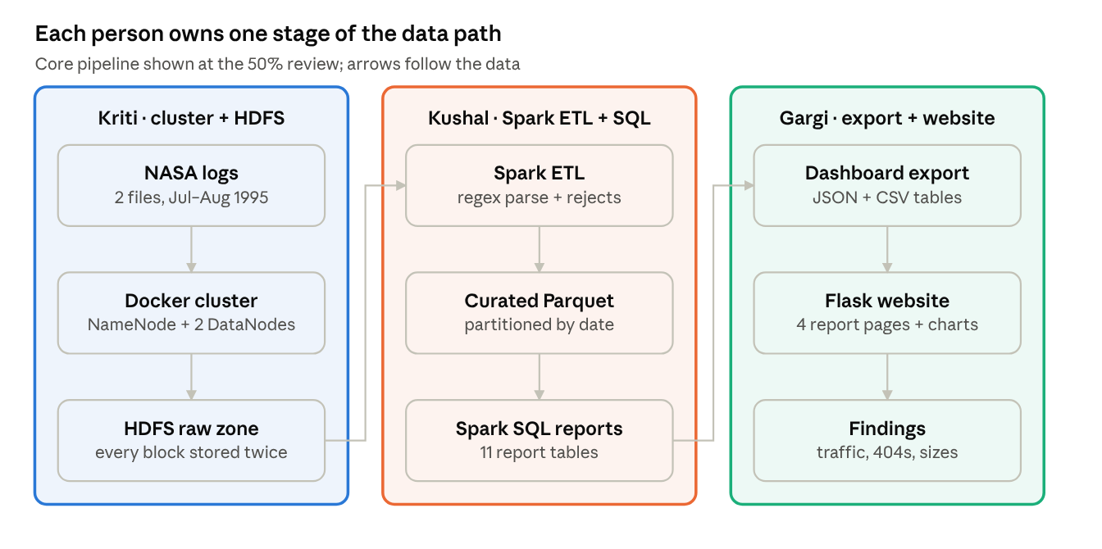
Fig 4.1: Complete workflow of the first half and the owner of each stage

4.1 Environment and Cluster Setup
The whole cluster is defined in Docker. A single image, built from the eclipse-temurin:11-jdk-jammy base (Ubuntu 22.04 with Java 11), installs Hadoop 3.3.6, Spark 3.5.3, Python 3 with numpy, and Flask 3.0.3. The image runs natively on both Intel and Apple Silicon machines. An entrypoint script decides what each container becomes: the NameNode formats HDFS only on its first start, the DataNodes and Spark worker wait until the NameNode or master is reachable, and the client container stays running so that commands can be executed inside it. Docker Compose starts the containers listed in Table 4.1, and each DataNode has its own storage volume so that the two copies of a block are physically separate.
Table 4.1: Containers in the Docker Compose cluster
Container | Role | Port
namenode | HDFS NameNode: namespace and block locations | 9870 (web UI), 8020 (RPC)
datanode1, datanode2 | HDFS DataNodes: store the blocks, each on its own volume | —
spark-master | Spark standalone master: allocates executors | 8080 (UI), 7077
spark-worker | Spark worker: runs executors (3 cores, 3 GB) | 8081
client | Where hdfs and spark-submit commands are run | —
web | Flask web application | 8050

HDFS is configured through two files. core-site.xml sets fs.defaultFS to hdfs://namenode:8020 so that every service finds the file system at the same address. hdfs-site.xml sets the replication factor to 2, disables the DataNode hostname check (container names do not reverse-resolve) and disables permission checks for this single-user teaching cluster. Fig 4.2 shows how a file is written: the client asks the NameNode where each block should go, writes the block to the first DataNode, and that DataNode forwards a copy to the second.
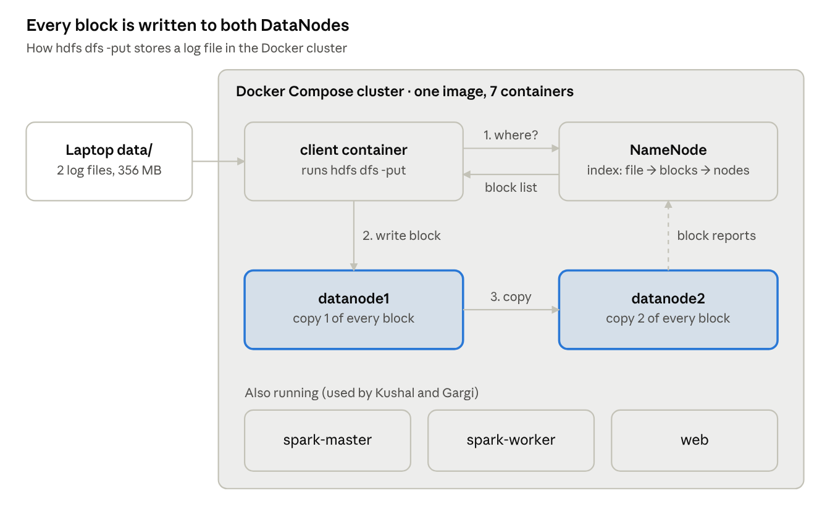
Fig 4.2: HDFS write path in the Docker cluster

4.2 Data Acquisition and Ingestion into HDFS
The download script fetches the two compressed files, writes them to a temporary .part file and renames them only when complete, so that an interrupted download never looks finished, and skips files that are already present. The ingestion step then creates the three HDFS zones and copies the raw files into the raw zone:
hdfs dfs -mkdir -p /data/weblogs/raw /data/weblogs/curated \
/data/weblogs/reports /spark-logs
hdfs dfs -put -f /workspace/data/access_log_* /data/weblogs/raw/
hdfs dfs -du -h /data/weblogs/raw

With the default block size of 128 MB, the 196 MB July file is stored as two blocks and the 160 MB August file as two blocks. With a replication factor of 2, these four blocks are stored as eight block copies across the two DataNodes. The raw zone is never modified after ingestion; it is the audit trail from which every later dataset can be rebuilt.

4.3 Data Cleaning and Preprocessing using Apache Spark
The ETL job (jobs/etl.py) is submitted to the Spark cluster with spark-submit. Its core is shown below: each field is extracted with a regular expression, converted to a proper type, and malformed records are separated before the clean data is written as date-partitioned, Snappy-compressed Parquet.
raw = spark.read.text("hdfs://namenode:8020/data/weblogs/raw")
parsed = raw.select(
F.regexp_extract("value", r'^(\S+)', 1).alias("host"),
F.regexp_extract("value", TS, 1).alias("ts_str"),
F.regexp_extract("value", REQ, 1).alias("method"),
F.regexp_extract("value", REQ, 2).alias("endpoint"),
F.regexp_extract("value", REQ, 3).alias("protocol"),
F.regexp_extract("value", STATUS, 1).cast(IntegerType())
.alias("status"),
F.regexp_extract("value", BYTES, 1).alias("bytes_str"))
.withColumn("bytes", F.when(F.col("bytes_str") == "-", 0)
.otherwise(F.col("bytes_str").cast(LongType())))
.withColumn("ts", F.to_timestamp("ts_str", "dd/MMM/yyyy:HH:mm:ss Z"))

bad = parsed.filter(F.col("ts").isNull() | F.col("status").isNull()
| (F.col("host") == ""))
clean = (parsed.filter(...)
.withColumn("date", F.to_date("ts"))
.withColumn("hour", F.hour("ts")) ...)
(clean.write.mode("overwrite").option("compression", "snappy")
.partitionBy("date").parquet(CURATED))

Spark evaluates these transformations lazily: the regular expressions and casts are only executed when an action such as count() or write needs a result, which allows Spark to plan the whole chain at once. Fig 4.3 shows how the job is executed on the cluster. The driver in the client container builds the plan and splits it into tasks; the master starts an executor on the worker; and the executor runs the tasks in parallel, each reading one HDFS block and writing its part of the Parquet output. Shared settings in spark-defaults.conf set 2 GB of driver and executor memory, 16 shuffle partitions (the default of 200 would produce hundreds of tiny files for data of this size), adaptive query execution, and the America/New_York session time zone so that hours are reported in the server's local time.
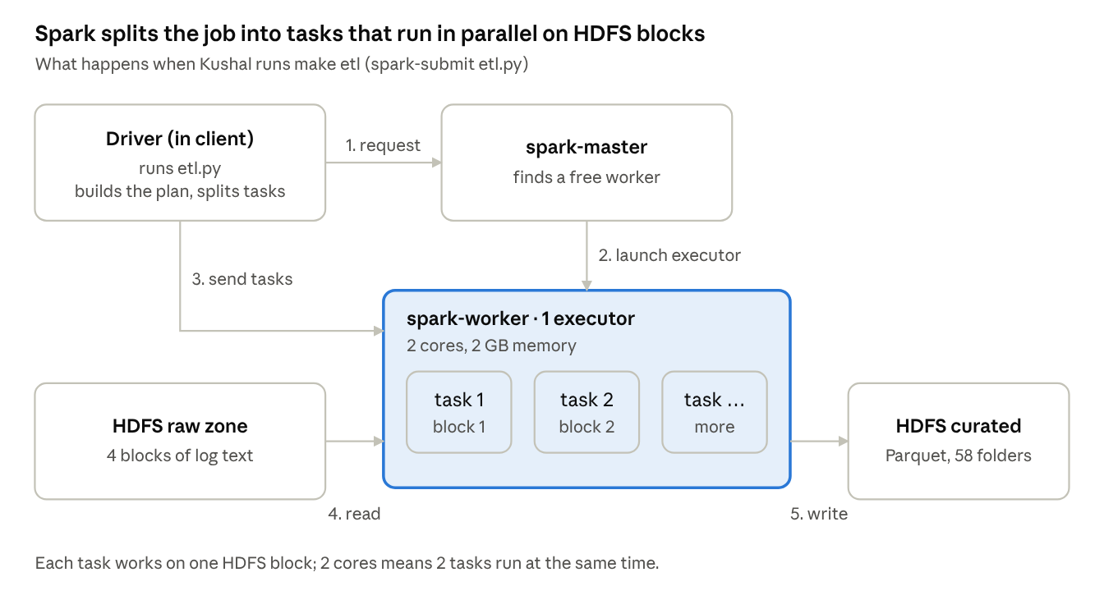
Fig 4.3: Execution of the Spark ETL job on the cluster

4.4 Analytical Reports using Spark SQL
The reports job (jobs/reports.py) reads the curated Parquet data, registers it as a temporary SQL view named access_logs, caches it in memory, and runs eleven SQL queries. Each result is written back to HDFS as a small Parquet table under /data/weblogs/reports. The reports are listed in Table 4.2. Tables that rank items are capped (300 rows, or 40 for file types), because a report is a summary rather than a second copy of the log.
Table 4.2: Spark SQL reports
# | Report | Question answered | Main SQL technique
1 | by_hour | Which hour of the day is busiest? | GROUP BY hour, COUNT(DISTINCT host)
2 | daily | Requests and visitors per day | GROUP BY date
3 | by_weekday | Which weekday is busiest? | GROUP BY dow
4 | top_urls | Most visited pages (images excluded) | WHERE status = 200 AND ext NOT IN (…), top 300
5 | by_content_type | Requests and GB per file type | CASE, SUM(bytes), top 40
6 | status_distribution | Share of each status code | Sub-query for the total, percentage
7 | errors_daily | 404 and 5xx rates per day | SUM(CASE WHEN status = 404 …)
8 | broken_links | Missing URLs by hits and visitors | WHERE status = 404, COUNT(DISTINCT host)
9 | size_percentiles | Typical and largest response sizes | percentile_approx
10 | size_buckets | Responses per size range | CASE WHEN bytes < 1024 …
11 | heaviest_hosts | Which clients request the most | GROUP BY host ORDER BY hits DESC

Two of the queries are shown below as examples.
SELECT hour, COUNT(*) AS hits, COUNT(DISTINCT host) AS visitors,
ROUND(SUM(bytes)/1024/1024/1024, 2) AS gb
FROM access_logs GROUP BY hour ORDER BY hour;

SELECT percentile_approx(bytes, 0.50) AS p50,
percentile_approx(bytes, 0.99) AS p99,
MAX(bytes) AS max_bytes, ROUND(AVG(bytes), 0) AS mean_bytes
FROM access_logs WHERE status = 200 AND bytes > 0;

4.5 Dashboard Export
The export job (jobs/export_dashboard.py) is a third Spark job that bridges the cluster and the website. It reads each report table from HDFS and writes the full table to output/tables/ as both CSV and JSON for the download buttons. It also computes the true totals from the full curated data — 3,461,612 records, 137,978 distinct hosts, 31,030 distinct URLs, 61.02 GB transferred and 20,899 404 errors across 3,544 URLs — because these cannot be derived from the capped report tables. Finally, it builds two cross-tabs, requests per hour per date (1,369 rows) and per status per date (295 rows), so that the website can recompute its charts for any date range. Everything is written into a single dashboard.json file of about 198 KB.

4.6 Web Application
The website is a Flask application (web/app.py) with one route per page, a data API at /api/data, a download route and a health check. Templates are written in Jinja2 and share a common layout. The application reads dashboard.json and reloads it only when the file changes on disk. Downloads are restricted to file names made of lower-case letters, digits and underscores and to the CSV and JSON types, so that no other file can be requested. Fig 4.4 shows how a page is served: Flask returns the HTML page, the page's JavaScript requests the data from /api/data, and the charts are drawn in the browser. Because the website never contacts HDFS or Spark, the report pages remain available when the cluster is stopped.
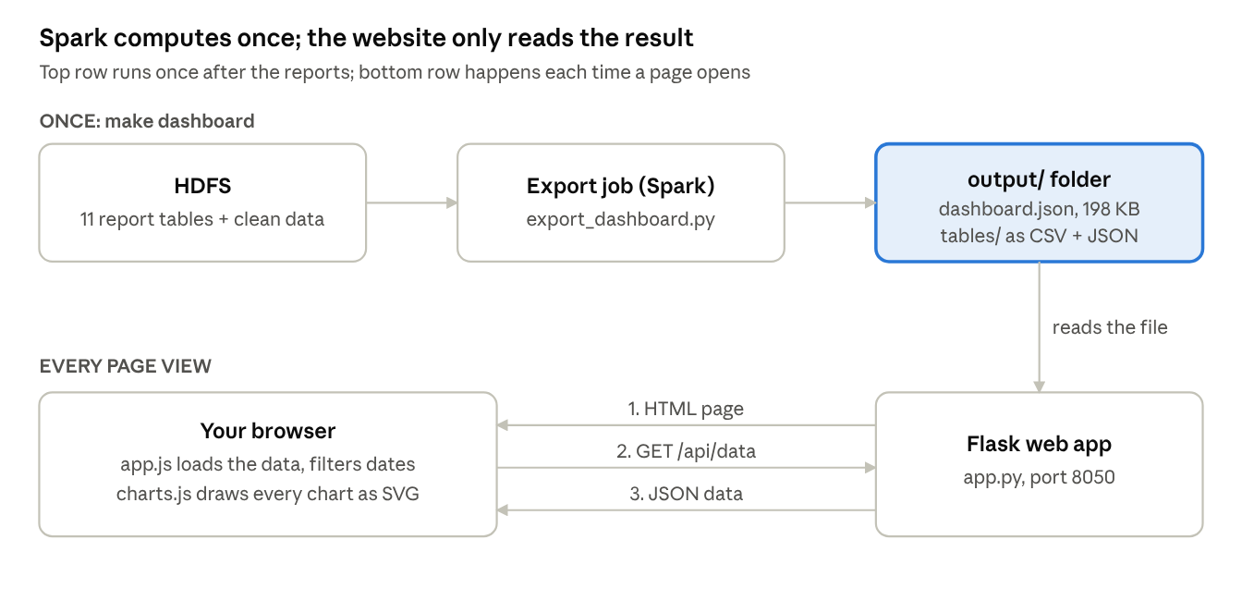
Fig 4.4: Data flow of the web application

4.7 Verification and Testing
Each property claimed for the system was verified with a direct test:
- Replication: hdfs fsck /data/weblogs/raw -files -blocks -locations reported every block with two live replicas on two DataNodes and an overall status of HEALTHY.
- Fault tolerance: with datanode2 stopped, the raw logs and report tables remained readable; the DataNode was then restarted.
- Record reconciliation: the ETL job read 3,461,612 raw lines and wrote 3,461,612 curated records, with no rejects.
- Partition pruning: a query on WHERE date = '1995-07-04' read a single date folder instead of all 58.
- Website availability: with the Hadoop and Spark containers stopped, all four report pages and the downloads continued to work, and /healthz reported 3,461,612 records and 11 downloadable tables.

4.8 Division of Work
The first half of the project was divided among the three team members by pipeline stage, as shown in Table 4.3. Each member owns the files of one stage and hands a clearly defined dataset to the next.
Table 4.3: Division of work among team members
Member | Module | Files owned | Output handed on
Kriti Singh | Cluster and HDFS storage | docker/Dockerfile, docker/entrypoint.sh, docker-compose.yml, conf/core-site.xml, conf/hdfs-site.xml, scripts/get_data.sh, Makefile | Raw logs in HDFS, replicated twice
Kushal Mohan | Spark ETL and Spark SQL reports | conf/spark-defaults.conf, jobs/etl.py, jobs/reports.py | Curated Parquet and 11 report tables
Gargi | Dashboard export and website | jobs/export_dashboard.py, web/app.py, web/templates/, web/static/ | dashboard.json, CSV/JSON tables, 4-page website

4.9 System Summary
The implemented system takes two public log files and, with five commands (make data, make build, make up, make skeleton and make dashboard), produces a replicated raw archive in HDFS, a clean date-partitioned Parquet dataset, eleven report tables and a four-page website. Every stage is reproducible, every number is traceable to a SQL query, and the original data is never modified. The same image and commands run on macOS and Windows.

CHAPTER 5
RESULTS AND DISCUSSIONS
This chapter presents the results produced by the first half of the system on the NASA-HTTP dataset. The results are grouped into data processing results, traffic, content, error and performance analysis, and the dashboard. All figures are computed by the Spark SQL reports described in Chapter 4.

5.1 Data Processing Results
Table 5.1 summarises how the data changed size and form as it moved through the pipeline. All 3,461,612 raw lines were parsed into valid records, so the parse rate was 100% and the rejects folder was empty. The final summary consumed by the website is about 1,800 times smaller than the raw text.
Table 5.1: Data processing summary
Stage | Form | Size / count
Downloaded | 2 compressed .gz files | about 37 MB
Raw zone (HDFS) | 2 text files, 4 blocks × 2 replicas | 356 MB; 3,461,612 lines
Curated zone (HDFS) | Snappy Parquet, partitioned by date | 3,461,612 rows in 58 date folders
Reports zone (HDFS) | 11 Parquet report tables | 1 to 300 rows each
Export | dashboard.json + 11 CSV/JSON tables | about 198 KB JSON
Totals | Distinct hosts / URLs / data transferred | 137,978 / 31,030 / 61.02 GB

5.2 Exploratory Data Analysis Results

5.2.1 Traffic by Hour of Day
Fig 5.1 shows the number of requests in each hour of the day, in the server's local time. Traffic rises steeply from 66,540 requests at 06:00 to over 210,000 by 11:00, stays above 210,000 until 16:00 and peaks at 15:00 with 230,665 requests. The quietest hour is 04:00 with 58,990 requests, giving a peak-to-trough ratio of 3.9×. This pattern reflects working hours in the United States and indicates that server capacity should be planned for mid-afternoon.
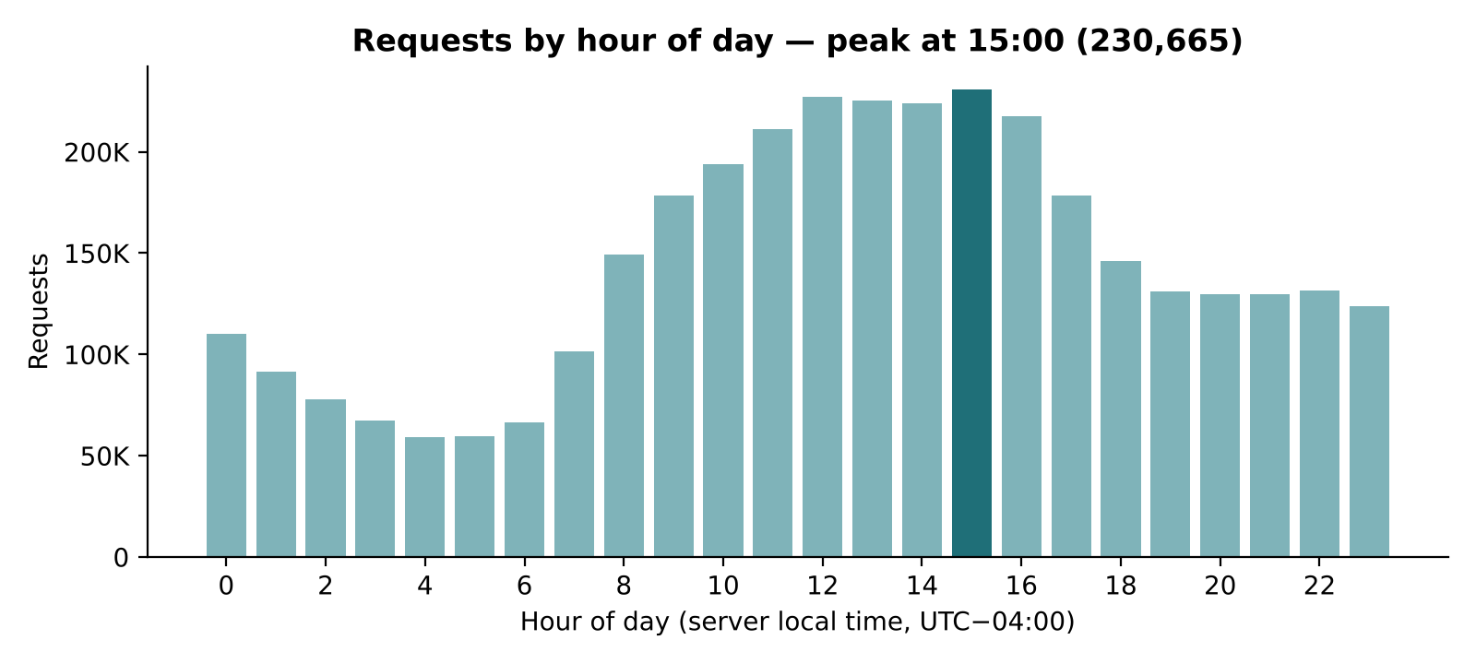
Fig 5.1: Requests by hour of day

5.2.2 Daily Request Volume
Fig 5.2 shows the daily request volume across the two months. The median day has 59,273 requests, and half of all days fall between about 42,000 and 68,000. The busiest day by far is 13 July with 134,203 requests — the launch day of Space Shuttle mission STS-70 — and the quietest full days fall on weekends. The shaded band marks the period with missing or partial data: there are no records for 29–31 July and 2 August, and the server was shut down for Hurricane Erin from 1 August 14:52 to 3 August 04:36. The chart shows this gap rather than drawing a line across it, so that the drop is not mistaken for a real fall in traffic.
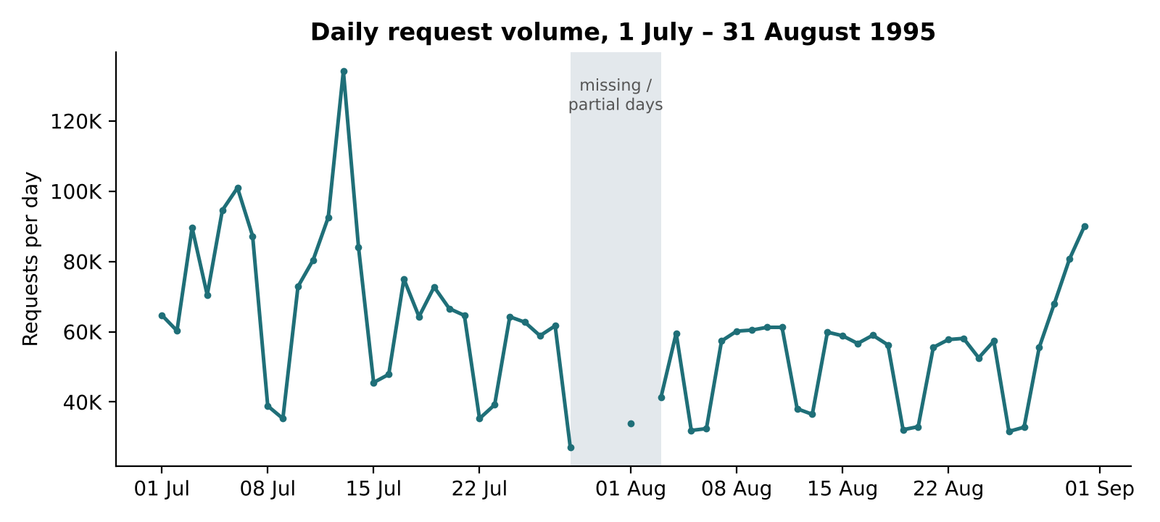
Fig 5.2: Daily request volume, 1 July – 31 August 1995

5.2.3 Traffic by Weekday
Fig 5.3 shows requests by day of the week. Weekdays are consistently busier than weekends: Thursday is the busiest day with 667,737 requests, while Saturday (318,046) and Sunday (317,276) receive less than half of that. This confirms that the site was used mainly during the working week.
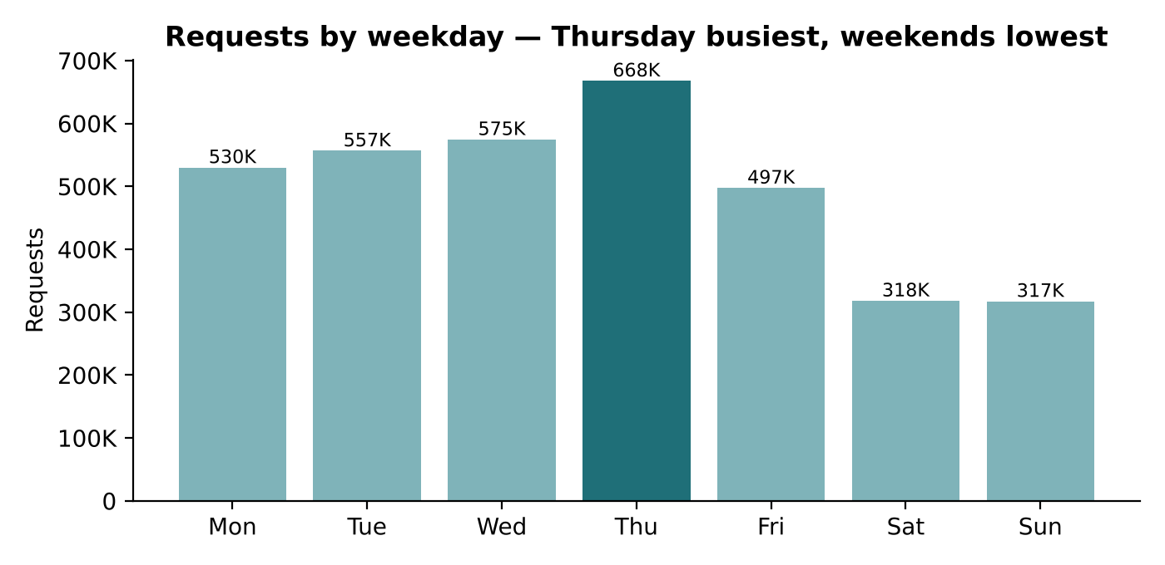
Fig 5.3: Requests by day of the week

5.2.4 Most Visited Content
Fig 5.4 lists the ten most-visited pages among successful requests, excluding images. The Kennedy Space Center home page /ksc.html is the most visited with 79,993 hits, followed by the shuttle countdown page (59,177) and the site root (56,875). Shuttle-mission pages dominate the list, reflecting public interest in the space shuttle missions of mid-1995.
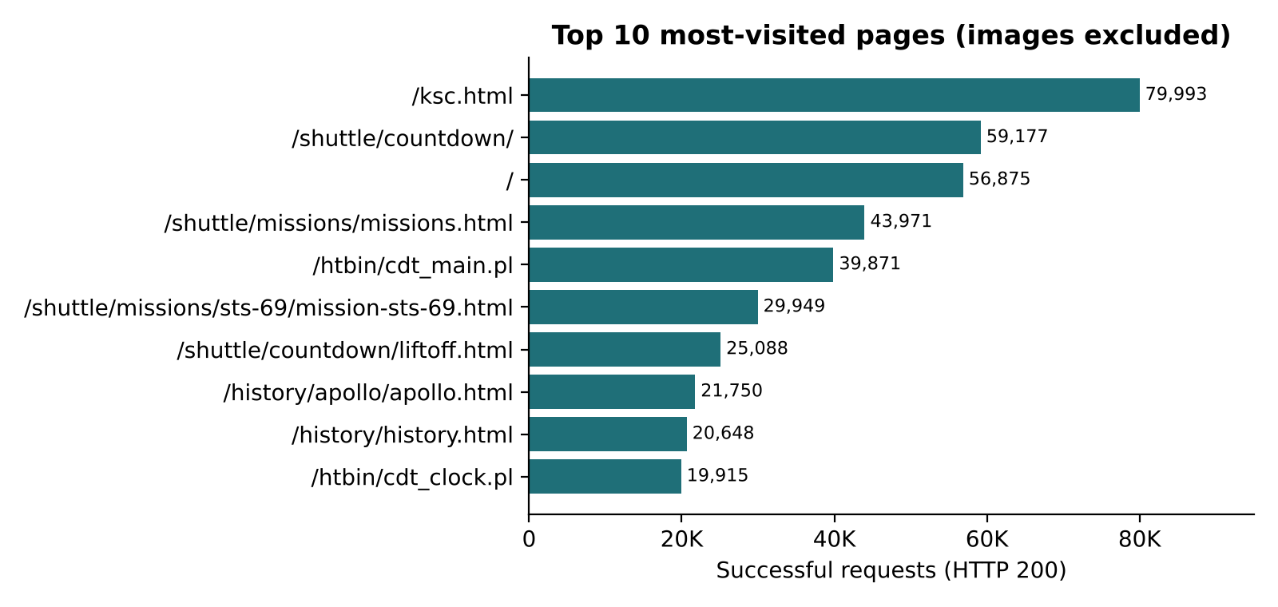
Fig 5.4: Top 10 most-visited pages
Fig 5.5 compares the number of requests and the volume of data transferred for each file type. GIF images account for 1,989,529 requests and 22.52 GB, the largest share of both. The comparison also reveals an important mismatch: MPEG video files make up only about 1.3% of requests but transfer 18.12 GB, nearly 30% of all bytes served. Request counts alone would hide this.
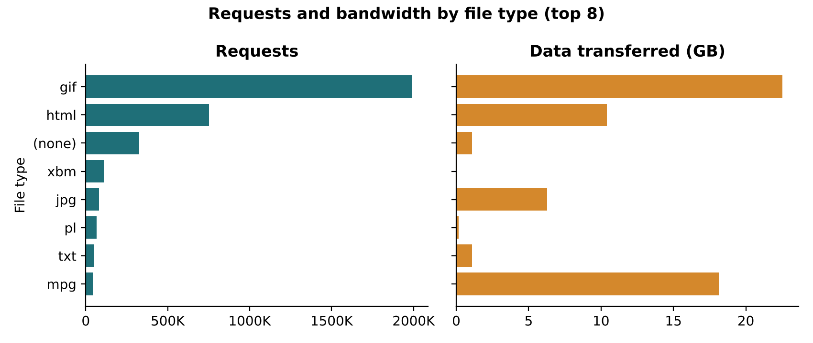
Fig 5.5: Requests and bandwidth by file type

5.3 Error Analysis
Fig 5.6 and Table 5.2 show the distribution of HTTP status codes. 89.57% of requests completed successfully (200), and a further 7.71% were answered with 304 Not Modified, meaning the client's cached copy was still valid. 20,899 requests (0.60%) returned 404 Not Found, and server errors were very rare, with 106 responses in the 5xx range. The overall error rate (4xx plus 5xx) was 0.61%.
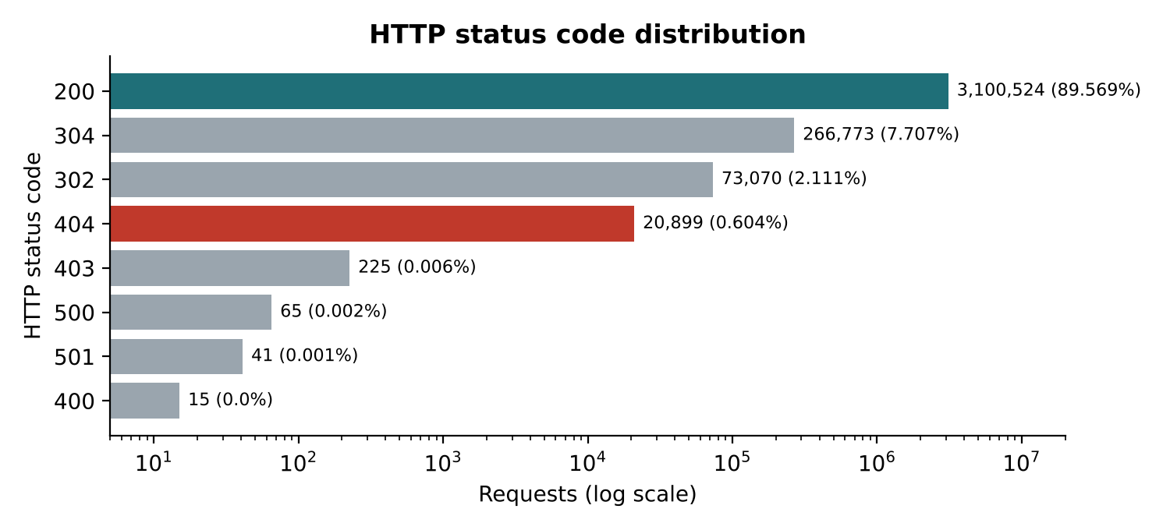
Fig 5.6: Distribution of HTTP status codes
Table 5.2: HTTP status code distribution
Status | Meaning | Requests | Share
200 | OK | 3,100,524 | 89.569%
304 | Not Modified | 266,773 | 7.707%
302 | Found (redirect) | 73,070 | 2.111%
404 | Not Found | 20,899 | 0.604%
403 | Forbidden | 225 | 0.006%
500 | Internal Server Error | 65 | 0.002%
501 | Not Implemented | 41 | 0.001%
400 | Bad Request | 15 | < 0.001%

Fig 5.7 shows the daily 404 rate. On half of the days it lies between 0.51% and 0.72% of requests. The highest rates — 1.16% on 26 August, 1.15% on 6 August and 1.13% on 27 August — all fall on weekends, when total traffic is low but requests for the same broken files continue, so the share of errors rises. A rate that rises steadily over several weekdays would instead indicate newly broken links after a site change.
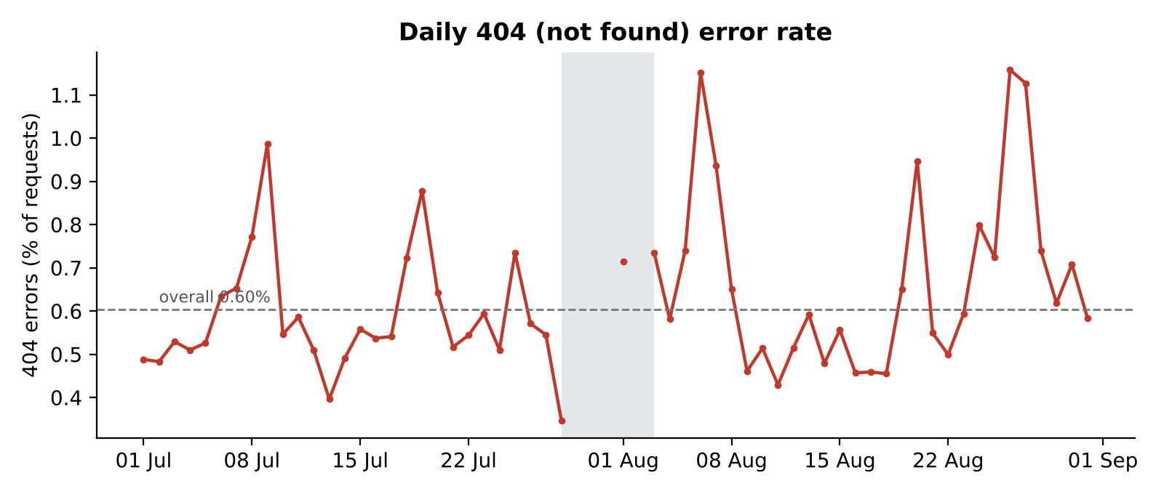
Fig 5.7: Daily 404 (Not Found) error rate
Fig 5.8 ranks the broken links by the number of failed requests. The 20,899 404 errors are spread across 3,544 distinct URLs, but they are highly concentrated: the top two, /pub/winvn/readme.txt (2,004 failures, 1,604 distinct visitors) and /pub/winvn/release.txt (1,732 failures, 1,433 visitors), alone account for 3,736 failures — 18% of all 404s. Fixing or redirecting these two files would remove nearly a fifth of all errors.
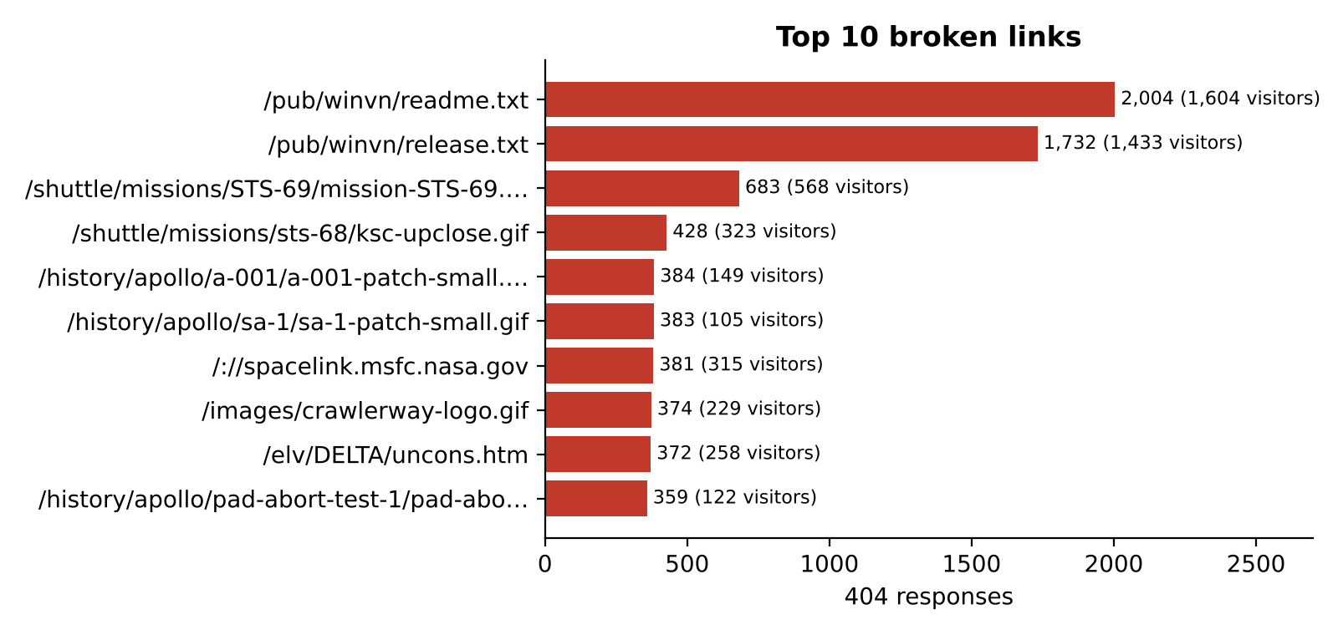
Fig 5.8: Top 10 broken links

5.4 Performance Analysis
The NASA logs do not record response times, so performance is measured by response size, which determines bandwidth use. Table 5.3 shows the percentiles of successful response sizes, computed with percentile_approx. The median response is only 4,179 bytes, but the distribution has a long tail: the 99th percentile is 283,389 bytes and the largest single response is 6.8 MB. The mean (21,222 bytes) is five times the median because of these large files.
Table 5.3: Response size percentiles (HTTP 200)
Statistic | Bytes | Approx.
Median (p50) | 4,179 | 4.1 KB
90th percentile | 46,573 | 45.5 KB
95th percentile | 83,915 | 81.9 KB
99th percentile | 283,389 | 276.7 KB
Maximum | 6,823,936 | 6.5 MB
Mean | 21,222 | 20.7 KB

Fig 5.9 groups successful responses by size. The largest group is 1–10 KB with 1,495,031 responses, followed by 10–100 KB (751,928) and under 1 KB (726,326). Only 4,633 responses exceeded 1 MB, but together with the MPEG files identified above, these large responses are where compression or caching would save the most bandwidth.
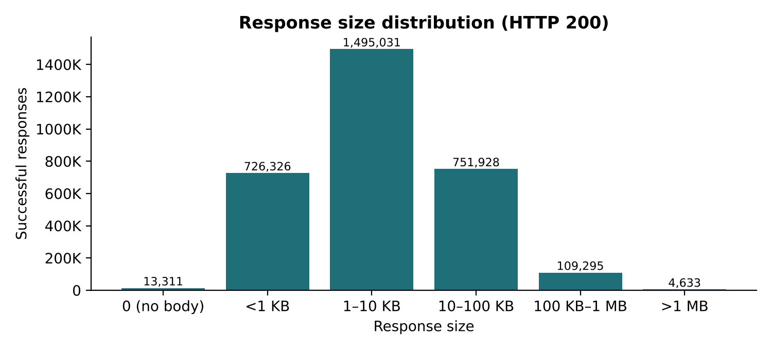
Fig 5.9: Distribution of response sizes

5.5 Dashboard Results
The results are presented on the four-page website. Fig 5.10 shows the Overview page, which opens with the first line of the July log annotated field by field, followed by the headline numbers, the daily request volume with the shaded data gap, and the status-code mix with the busiest hour. Fig 5.11 shows the hour-by-day heatmap on the same page, in which each row is a day and each column an hour; the missing days appear as empty rows.
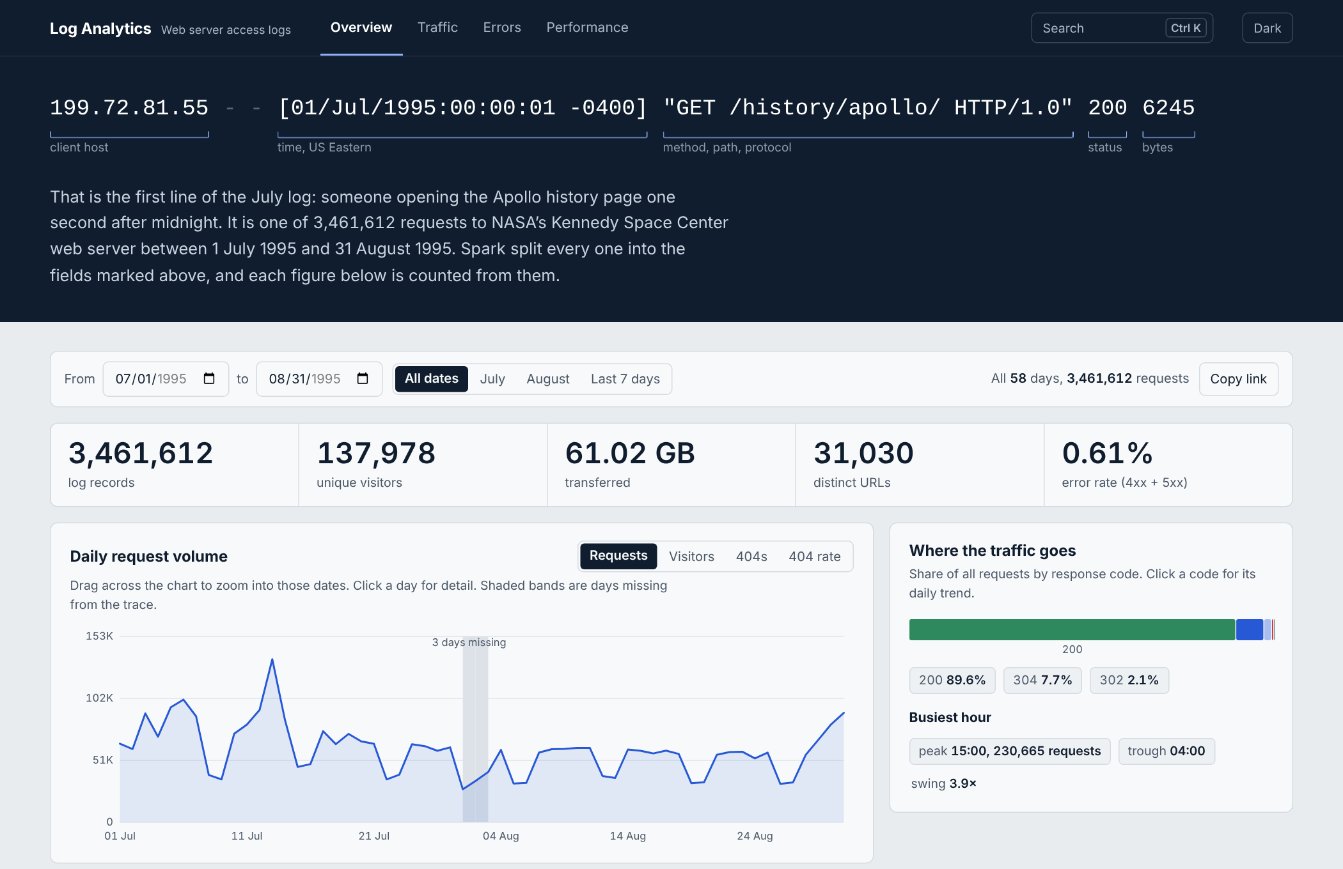
Fig 5.10: Overview page of the dashboard
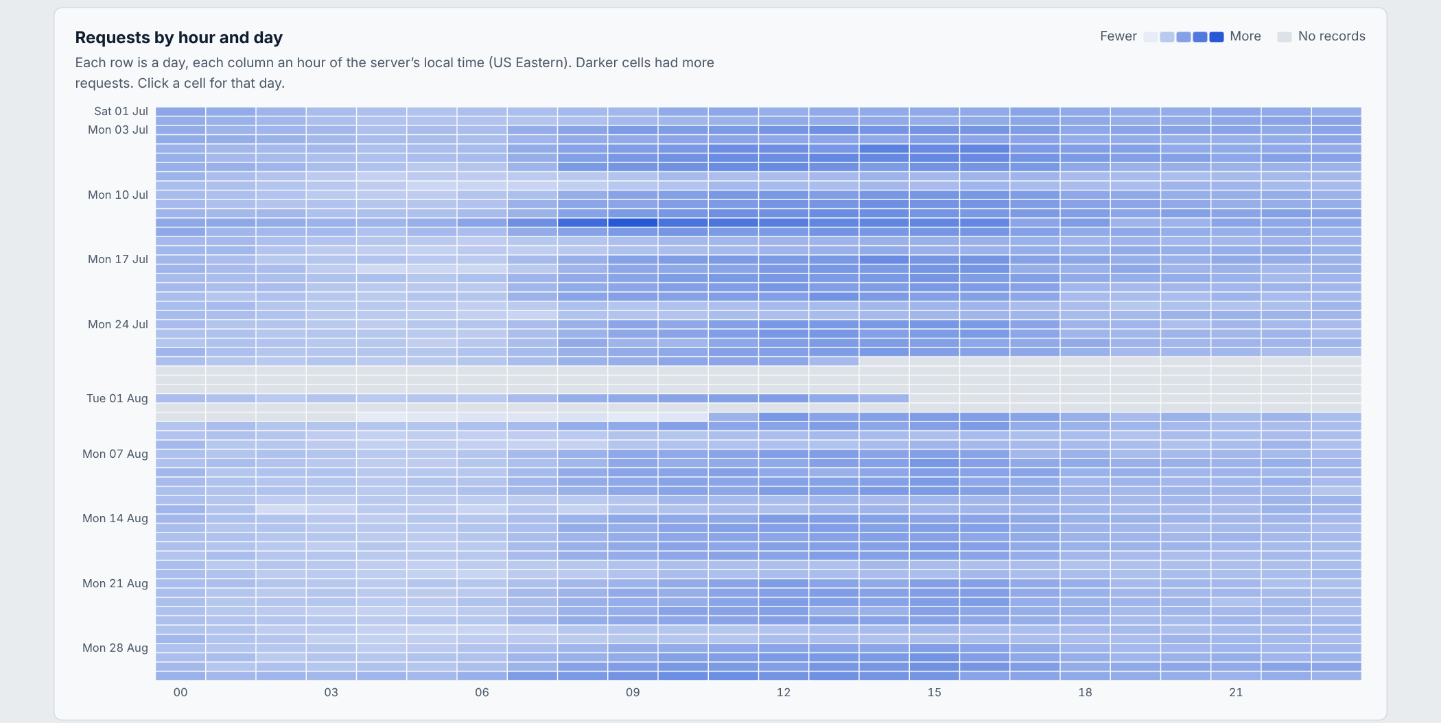
Fig 5.11: Requests by hour and day heatmap
Fig 5.12 shows the Traffic page, with the hour-of-day profile, the weekday totals and the daily volume and unique-visitor series. Fig 5.13 shows the Errors page, with the 404 rate over time, the status codes and the ranked, searchable table of broken links, which can be downloaded as CSV or JSON. Fig 5.14 shows the Performance page, with the response-size percentiles and buckets and the bandwidth by content type.
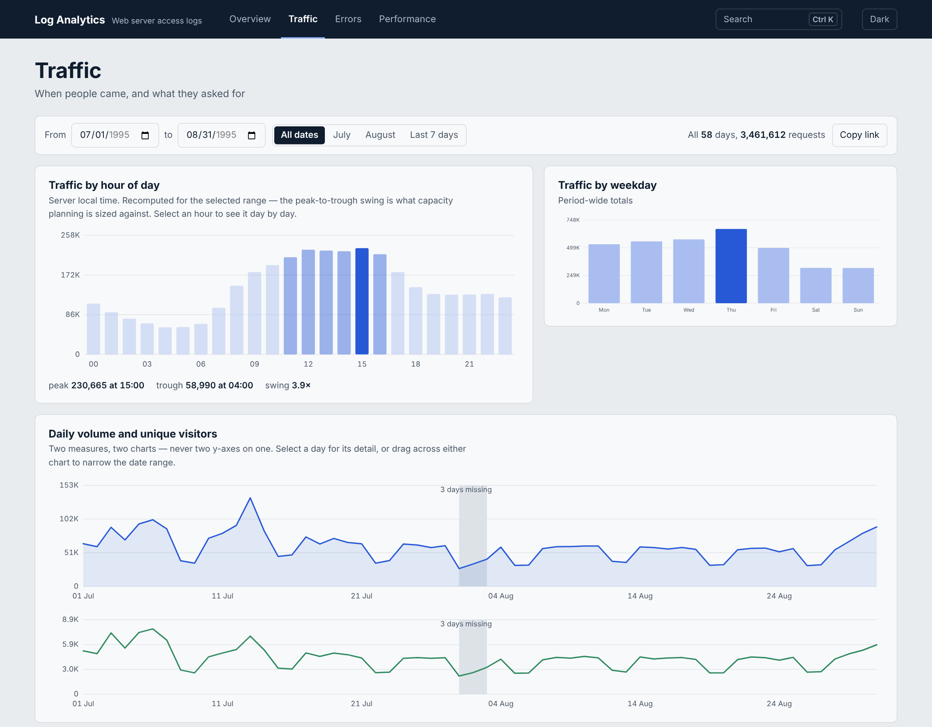
Fig 5.12: Traffic page of the dashboard
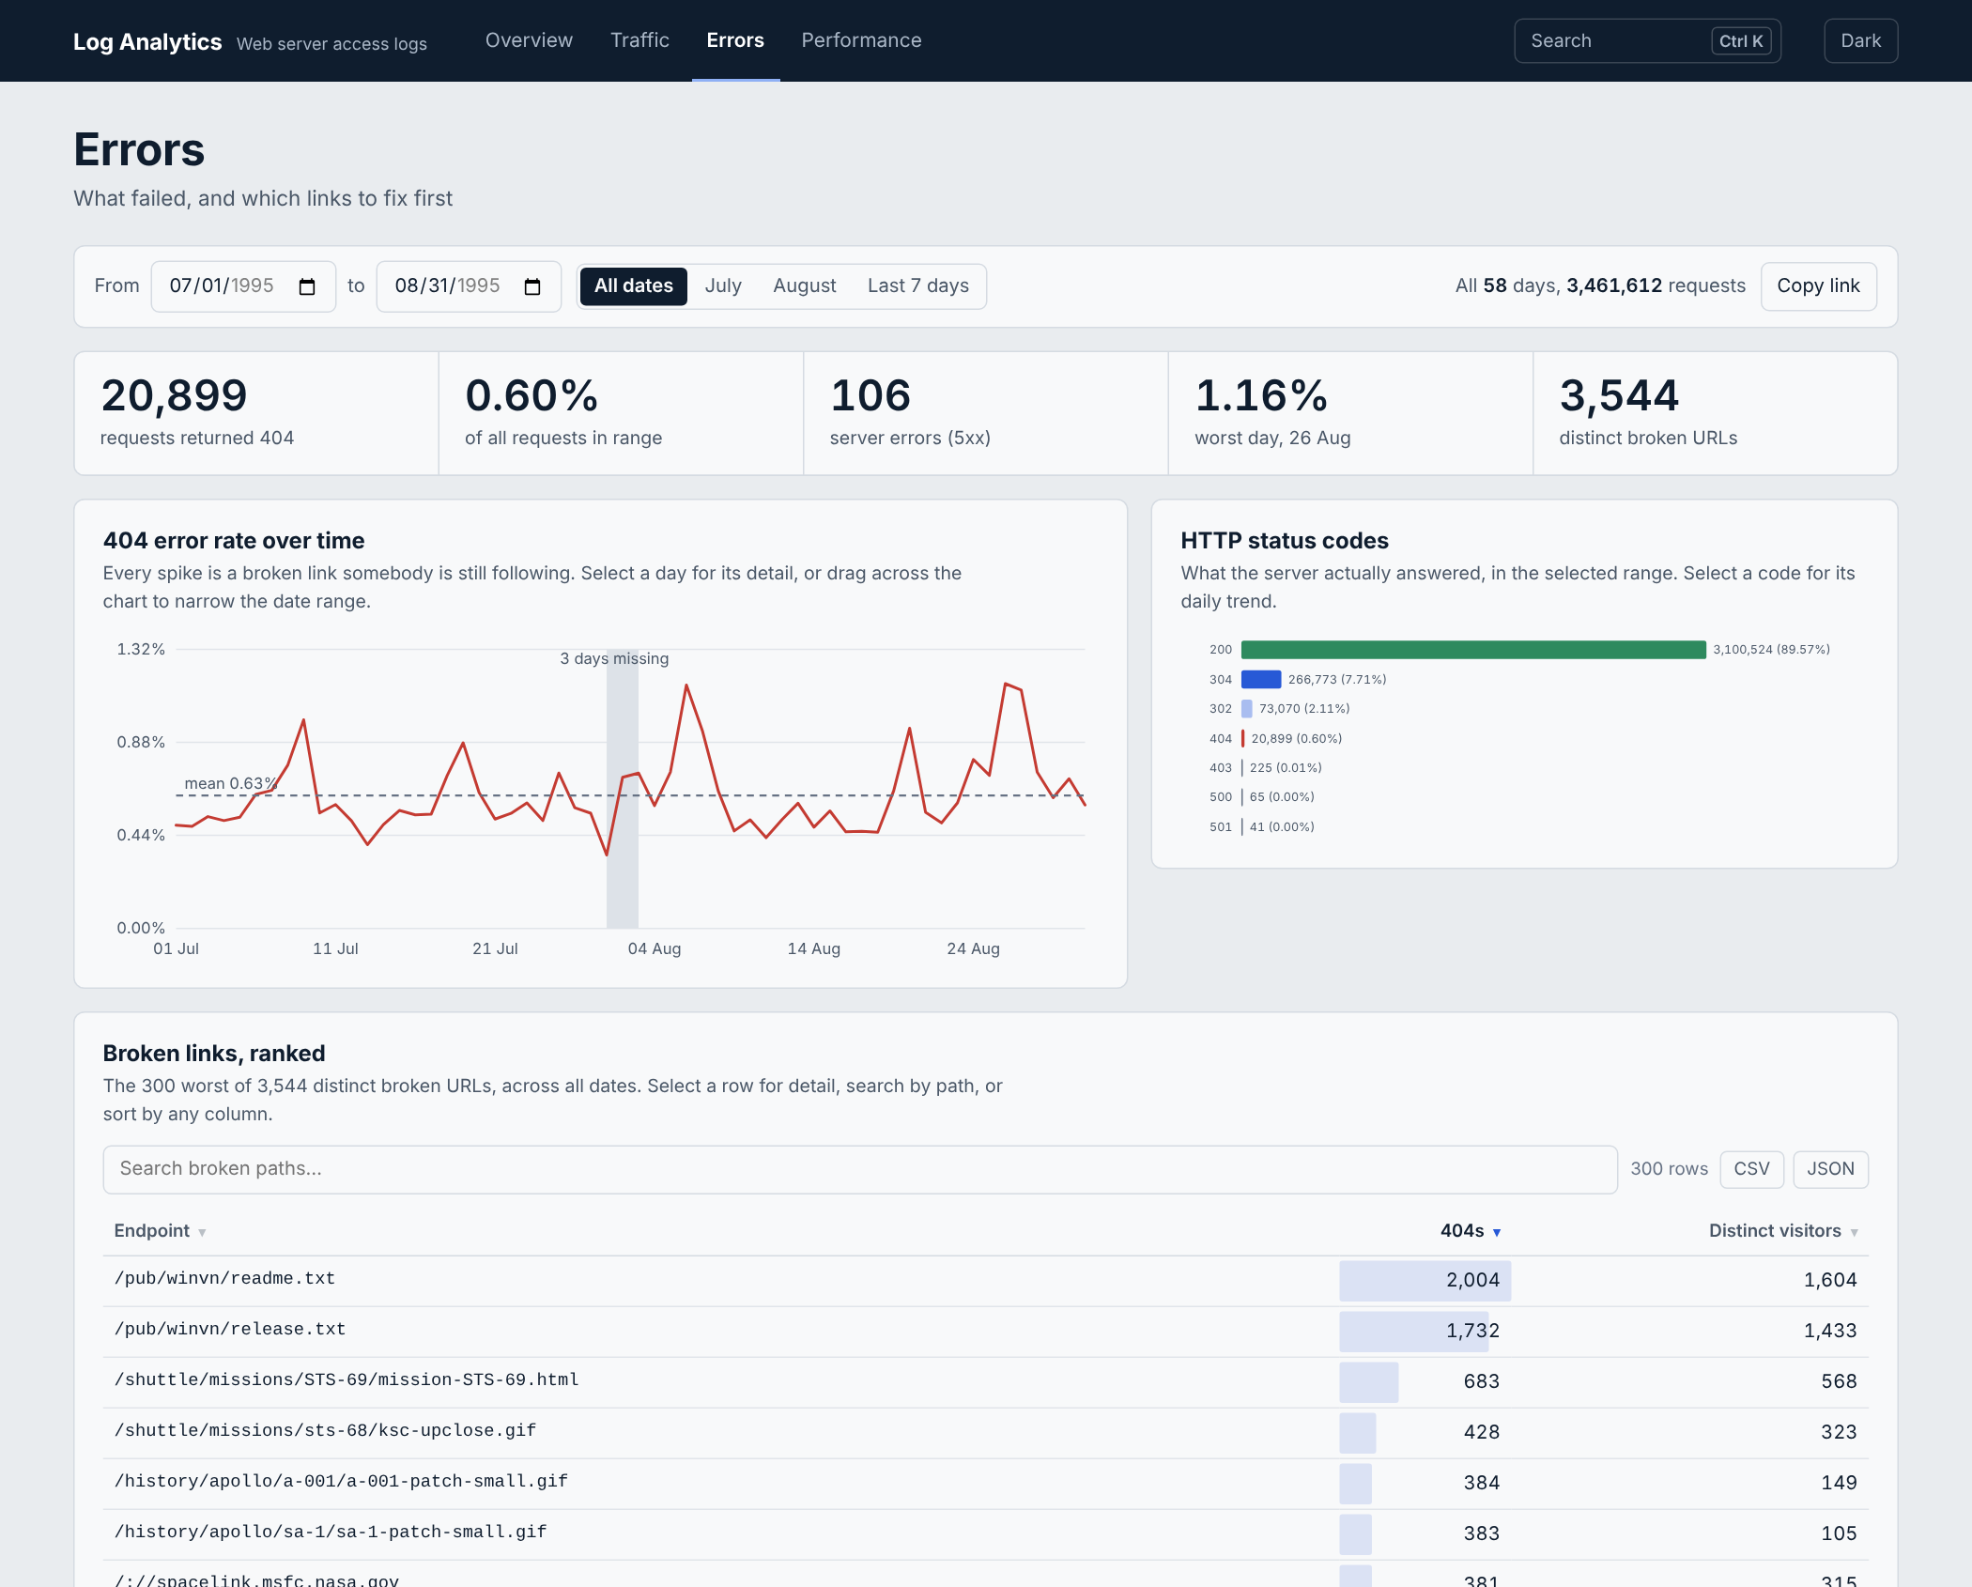
Fig 5.13: Errors page of the dashboard
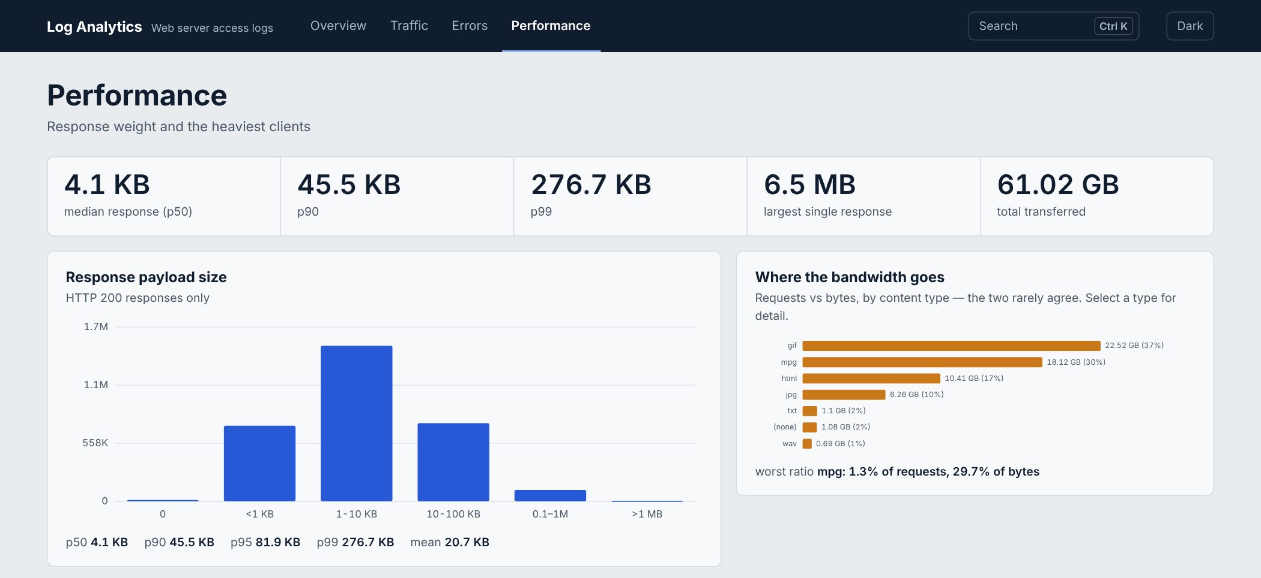
Fig 5.14: Performance page of the dashboard

5.6 Discussion of Results
The results show that the pipeline meets its objectives for the first half of the project. All 3.46 million lines were processed without loss, the replicated storage survived the loss of a DataNode, and every reported figure can be traced to a single SQL query. The analysis itself produced findings that are directly actionable for a site owner. Capacity should be planned for mid-afternoon on weekdays, when traffic is about four times the overnight minimum. Two broken files account for 18% of all 404 errors and are the obvious first fix. Bandwidth is dominated by images and a small number of video files, so compressing GIF images and caching or moving MPEG files would give the largest savings. These conclusions agree with the workload characteristics reported by Arlitt and Williamson [7] for the same server — a high success rate and a request mix dominated by HTML and image files — while confirming them on the full two-month dataset with a distributed engine.
The results also highlight the value of the design choices. Partitioning by date made single-day queries read one folder out of 58, and the columnar Parquet format meant that each report read only the columns it needed. Exporting a small summary allowed the website to remain fast and available independently of the cluster. The main limitation of the analysis is the dataset itself: it is from 1995, has gaps, and contains no response-time field, so performance can only be assessed through response size.

5.7 Summary of Findings
- 3,461,612 requests from 137,978 distinct hosts to 31,030 distinct URLs were processed, totalling 61.02 GB; the parse rate was 100%.
- Traffic peaks at 15:00 (230,665 requests) and is lowest at 04:00 (58,990), a 3.9× swing; Thursday is the busiest day and weekends the quietest.
- 89.6% of requests succeeded; 20,899 (0.60%) returned 404 across 3,544 URLs, and two files account for 18% of them.
- GIF images account for the most requests and bytes, while MPEG files are 1.3% of requests but about 30% of bytes.
- The median response is 4.1 KB, but the 99th percentile is 276.7 KB and the largest response 6.5 MB.
- HDFS replication, partition pruning and offline availability of the website were all verified.

CHAPTER 6
CONCLUSION AND FUTURE WORK
This report presented the first half of the Log Analytics System for a Web Server. A complete batch pipeline was designed and implemented on a real big-data stack: a Docker cluster with HDFS for replicated storage and Apache Spark for processing. Two months of NASA web server logs — 3,461,612 requests — were ingested into an immutable raw zone, cleaned by a Spark ETL job into typed, date-partitioned Parquet with explicit handling of malformed lines, analysed with eleven readable Spark SQL reports, and presented on a four-page website with charts, searchable tables and downloads that remains available when the cluster is stopped. The system was verified for replication, fault tolerance, record reconciliation and partition pruning, and its findings — the afternoon traffic peak, the concentration of broken links in two files and the bandwidth cost of images and video — are directly useful to the owner of the site.
The work was divided by pipeline stage: Kriti Singh built the cluster and HDFS storage, Kushal Mohan built the Spark ETL and reports, and Gargi built the export and website. This division gave each member a clear, testable deliverable and a well-defined hand-over to the next stage.
The second half of the project will add intelligence and interactivity on top of the same clean data. The planned work is:
- Bot detection with a Gaussian Mixture Model: group visitors into sessions with Spark window functions (a new session after 30 minutes of inactivity), compute behavioural features per host, and cluster them with a three-component GMM in Spark MLlib to separate automated crawlers from human visitors without labels.
- Attack classification with a Multilayer Perceptron: classify each request as normal, SQL injection, cross-site scripting, command injection or path traversal using 42 structural and keyword features, and test the model on an independent dataset to check that it generalises.
- Live scoring: use Spark Structured Streaming to score new traffic in five-second micro-batches instead of a single batch.
- Interactive tools: add a read-only Spark SQL console and a raw-log explorer to the website.
- Production pipeline: replace manual ingestion with Kafka or Flume, schedule nightly runs, and expose the tables through a Hive Metastore so that any SQL client can query them.
The main limitations of the current system are that it runs on a single laptop, so it demonstrates the distributed design rather than true speed-up; that it is batch-only; that the cluster has no authentication and is suitable only for local use; and that the dataset is old and lacks response times. Running the same pipeline on cloud servers and on a modern server's logs would address the first and last of these.

REFERENCES
[1] J. Dean and S. Ghemawat, “MapReduce: Simplified data processing on large clusters,” in Proc. 6th USENIX Symp. Operating Systems Design and Implementation (OSDI), San Francisco, CA, USA, 2004, pp. 137–150.
[2] S. Ghemawat, H. Gobioff, and S.-T. Leung, “The Google file system,” in Proc. 19th ACM Symp. Operating Systems Principles (SOSP), 2003, pp. 29–43.
[3] K. Shvachko, H. Kuang, S. Radia, and R. Chansler, “The Hadoop distributed file system,” in Proc. IEEE 26th Symp. Mass Storage Systems and Technologies (MSST), 2010, pp. 1–10.
[4] M. Zaharia et al., “Resilient distributed datasets: A fault-tolerant abstraction for in-memory cluster computing,” in Proc. 9th USENIX Symp. Networked Systems Design and Implementation (NSDI), 2012, pp. 15–28.
[5] M. Armbrust et al., “Spark SQL: Relational data processing in Spark,” in Proc. ACM SIGMOD Int. Conf. Management of Data, 2015, pp. 1383–1394.
[6] S. Melnik et al., “Dremel: Interactive analysis of web-scale datasets,” Proc. VLDB Endowment, vol. 3, no. 1–2, pp. 330–339, 2010.
[7] M. F. Arlitt and C. L. Williamson, “Internet web servers: Workload characterization and performance implications,” IEEE/ACM Trans. Networking, vol. 5, no. 5, pp. 631–645, 1997.
[8] R. Cooley, B. Mobasher, and J. Srivastava, “Data preparation for mining World Wide Web browsing patterns,” Knowledge and Information Systems, vol. 1, no. 1, pp. 5–32, 1999.
[9] J. Srivastava, R. Cooley, M. Deshpande, and P.-N. Tan, “Web usage mining: Discovery and applications of usage patterns from web data,” SIGKDD Explorations, vol. 1, no. 2, pp. 12–23, 2000.
[10] M. Greenwald and S. Khanna, “Space-efficient online computation of quantile summaries,” in Proc. ACM SIGMOD Int. Conf. Management of Data, 2001, pp. 58–66.

