Design and implement a multi-container using Docker Compose to deploy Apache Kafka and Zookeeper.

Prerequisites:

Docker installed on your system

Step1: Create a folder and a file

1.Create a Project Directory in C Drive, Name as Kafka

2. Create a docker-compose.yml FileCreate a file named docker-compose.yml in **Kafka** Folder

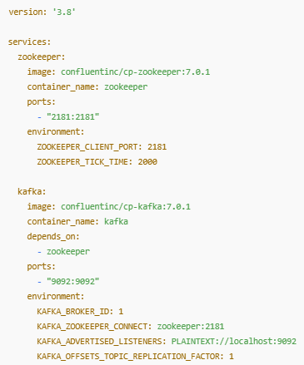

Step2: Starts all services

docker-compose up -d

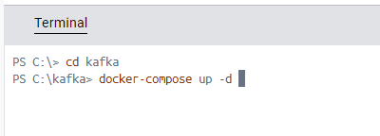

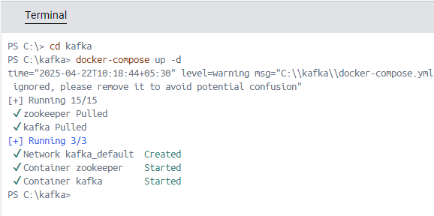

Note:

This will download and run both **Kafka and Zookeeper** containers in the background.

**Docker Compose runs:**

* zookeeper starts first
* kafka starts second **and connects to zookeeper**

**Command** **Description**

docker-compose up Starts all services

docker-compose up -d Starts in detached (background) mode.

docker-compose ps Lists running services

Step3: Check Running Containers

docker ps

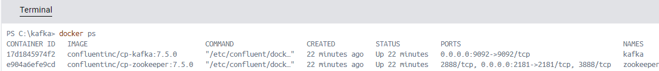

Or

Click the **"Containers"** tab in the left sidebar.

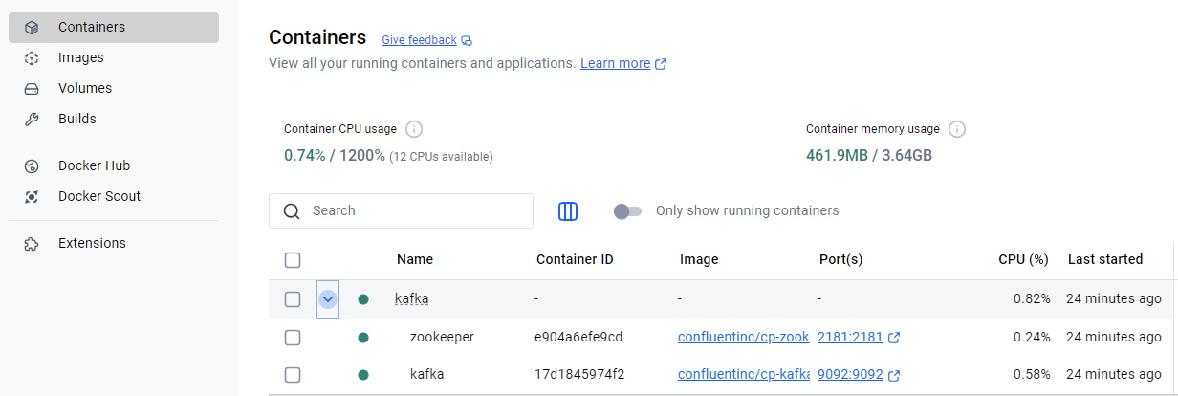

Step4: Open Two Windows PowerShell Terminals

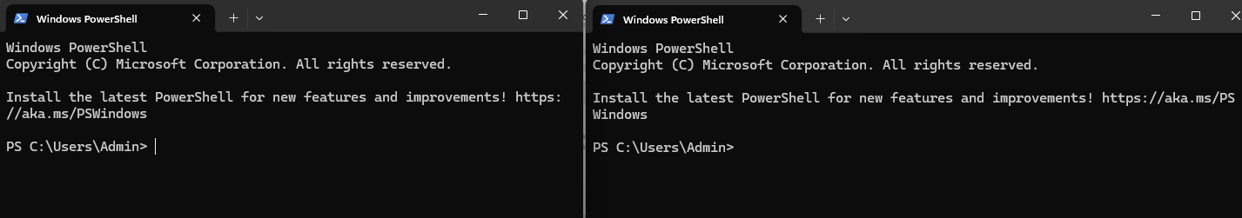

Terminal 1: Run 🡪 Kafka , to Produce Messages

1. Run Kafka

docker exec -it kafka bash

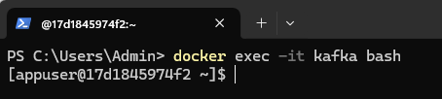

2. Create a topic

kafka-topics --create --topic test-topic --bootstrap-server localhost:9092 --partitions 1 --replication-factor 1

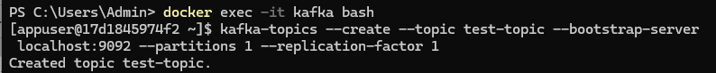

3. Verify topic is created

kafka-topics --list --bootstrap-server localhost:9092



4. Produce message

kafka-console-producer --broker-list localhost:9092 --topic test-topic



5. Type your messages and hit Enter button



Terminal 2: Run 🡪 Kafka , to Consume Message

1. Run Kafka

docker exec -it kafka bash



2. to Consume Message

kafka-console-consumer --bootstrap-server localhost:9092 --topic test-topic --from-beginning

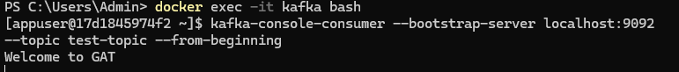

**----------------------------------------------------------------------**

Now, use the same Two Windows PowerShell Terminals and arrange them side by side on your screen.

so you can run your Kafka producer in one and consumer in the other.

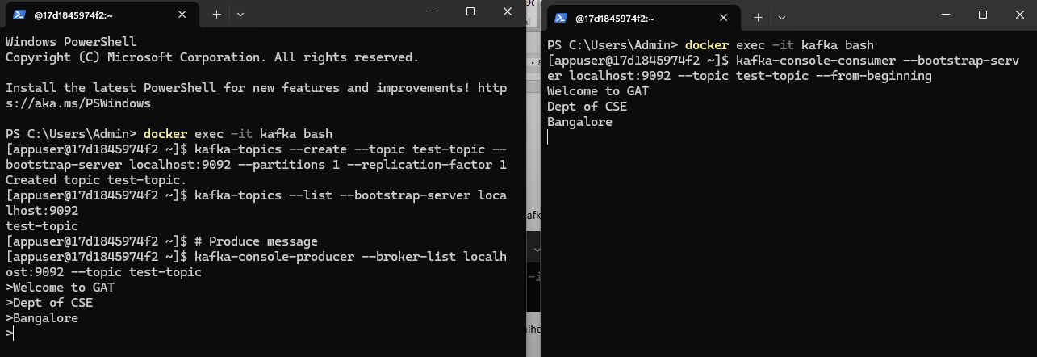

**stop** and remove **the Kafka and Zookeeper containers**

docker-compose down

**If you just want to stop without removing:**

**docker-compose stop**

**------------------------------------------------------------------------------------------------------------------**