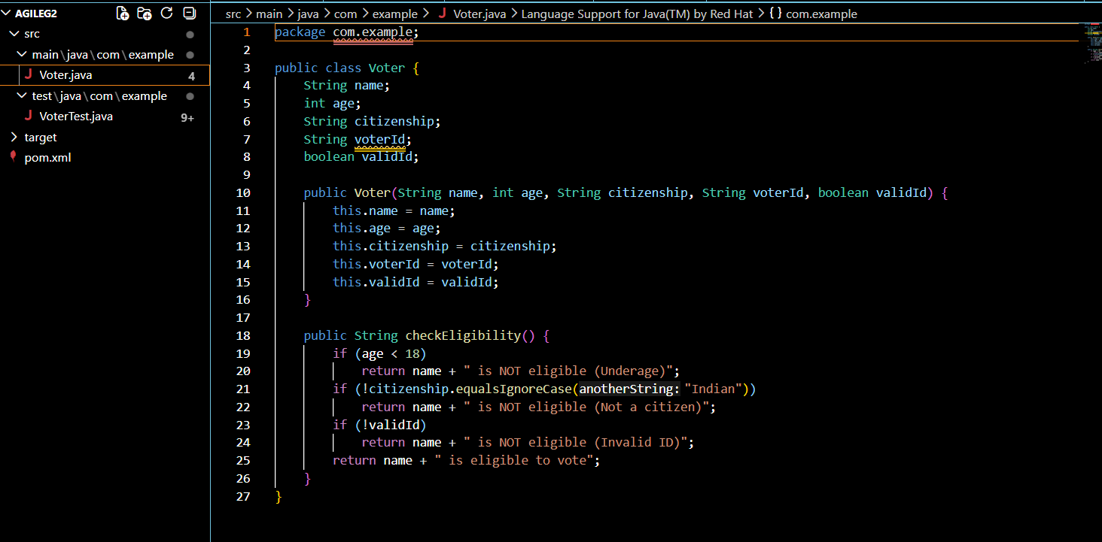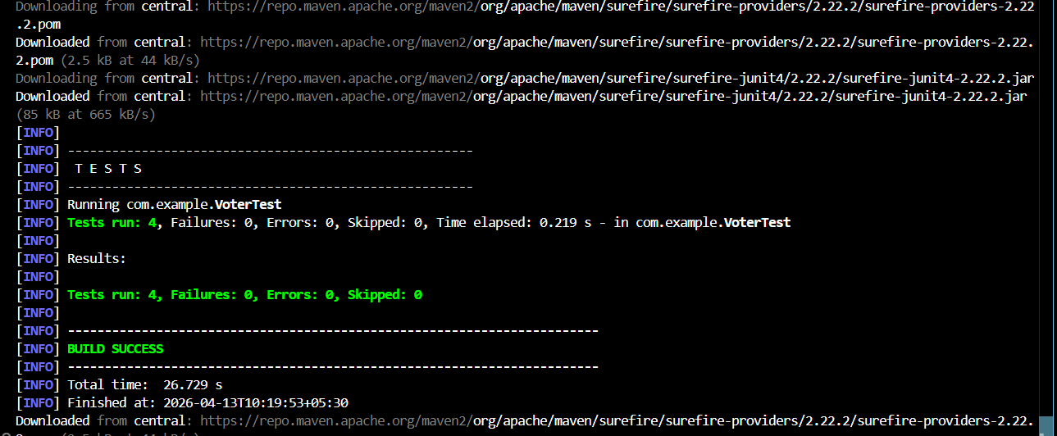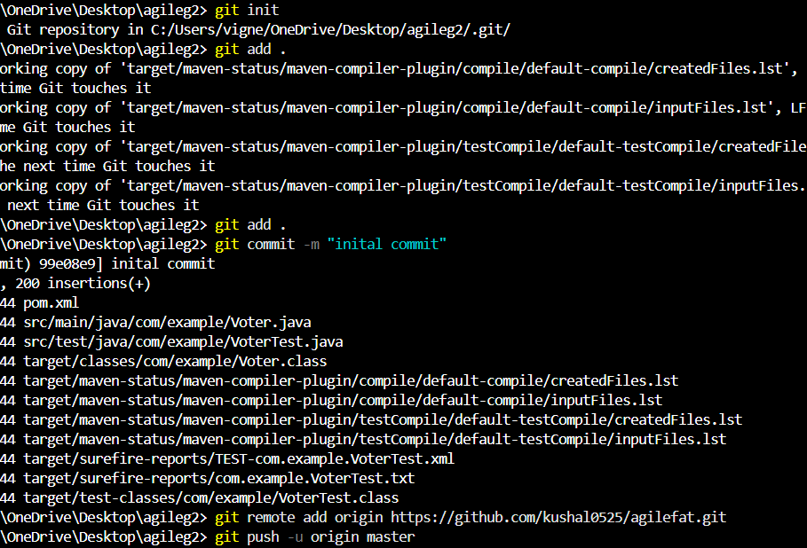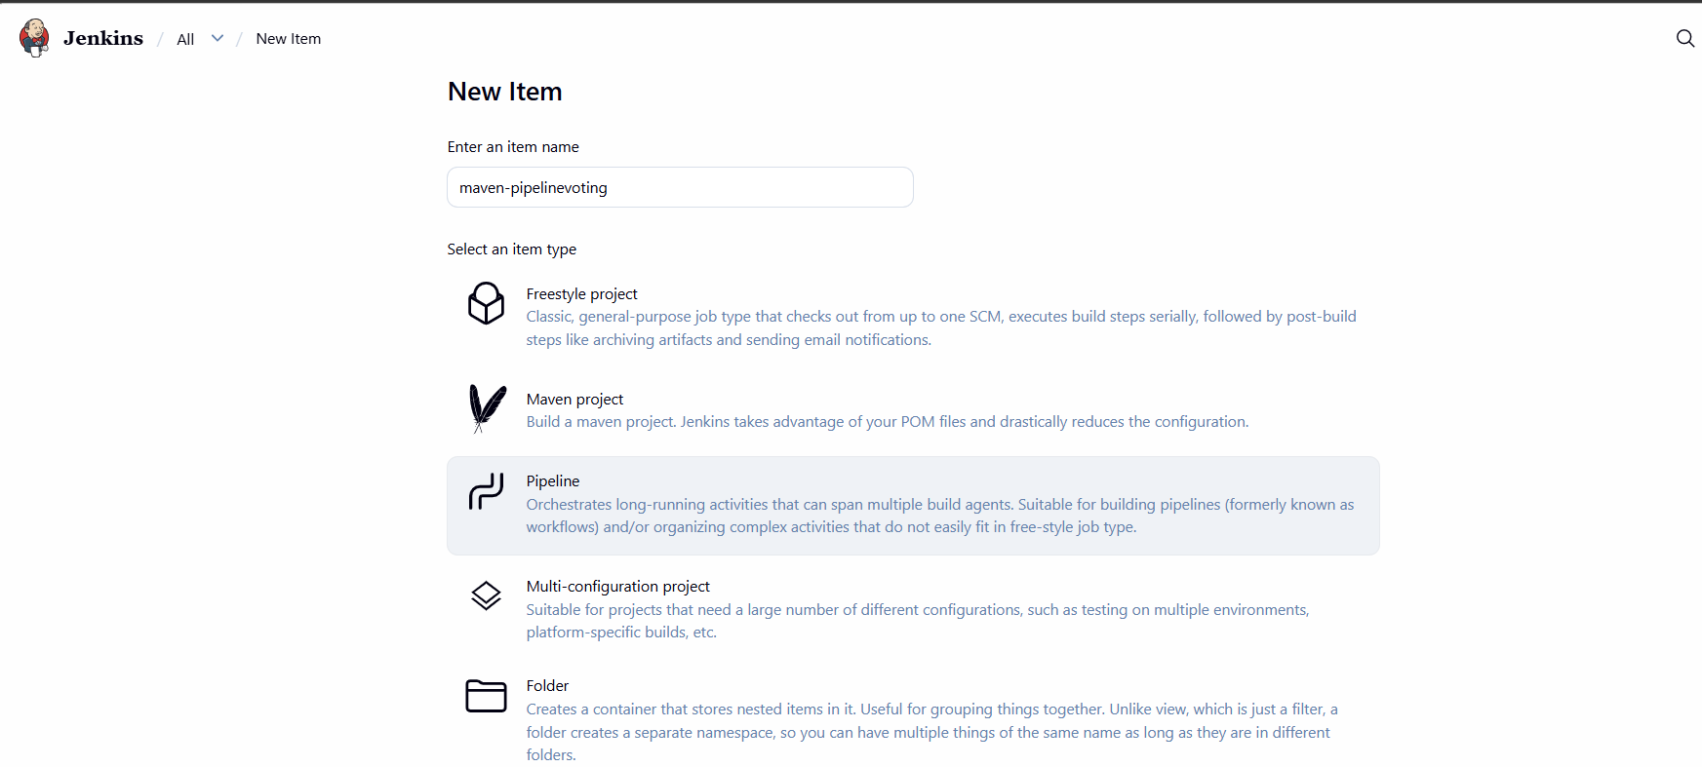
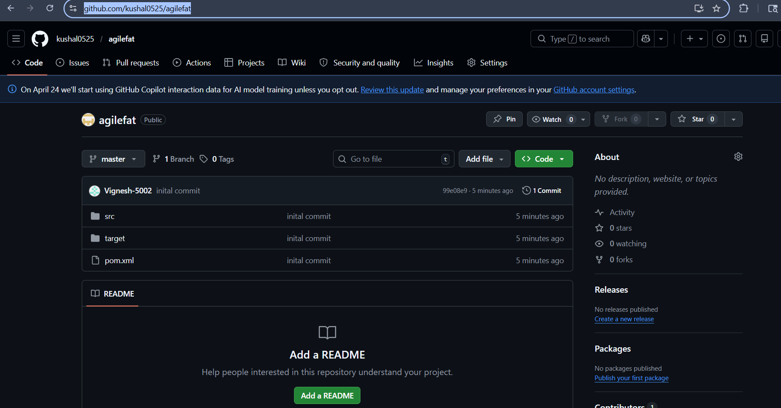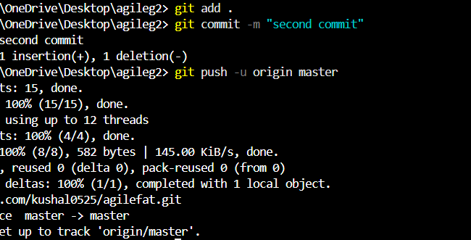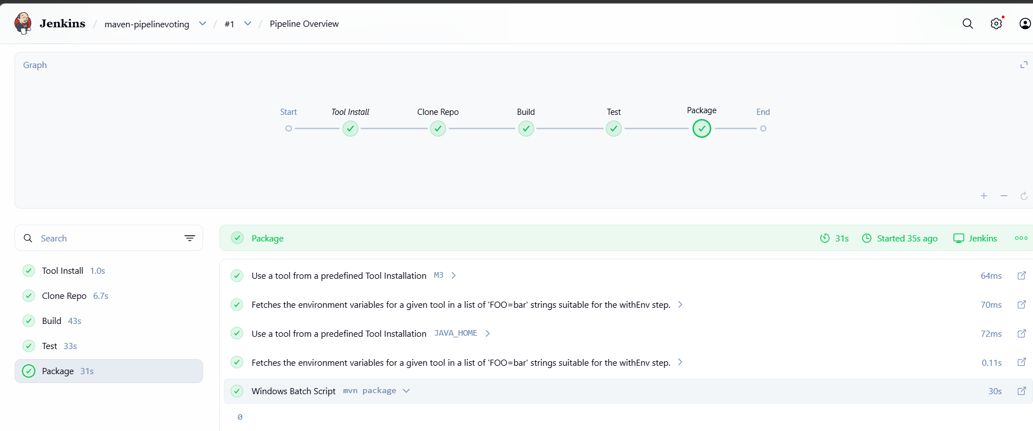
PIPELINE SCRIPT
pipeline {
agent any

tools {
maven 'M3'
jdk 'JAVA_HOME'
}

stages {

stage('Clone Repo') {
steps {
git 'https://github.com/kushal0525/agilefat.git'
}
}

stage('Build') {
steps {
bat 'mvn clean compile'
}
}

stage('Test') {
steps {
bat 'mvn test'
}
}

stage('Package') {
steps {
bat 'mvn package'
}
}
}
}
