**CREATING THE TABLES**

CREATE TABLE `schedule` (

`scode` varchar(4) DEFAULT NULL,

`tarr` varchar(6) DEFAULT NULL,

`tdept` varchar(6) DEFAULT NULL,

`tno` int(11) DEFAULT NULL,

`sname` varchar(30) DEFAULT NULL

) ENGINE=InnoDB DEFAULT CHARSET=utf8mb4;

INSERT INTO `schedule` (`scode`, `tarr`, `tdept`, `tno`, `sname`) VALUES

('sdh', '7.10', '7.15', 121, 'sealdah'),

('dum', '7.30', '7.45', 121, 'dumdum'),

('durg', '8.00', '8.05', 121, 'durganagar'),

('bar', '8.15', '8.25', 121, 'barasat'),

('bon', '8.15', '8.25', 121, 'bonga'),

('sdh', '7.45', '8.00', 122, 'sealdah'),

('dum', '8.15', '8.30', 122, 'dumdum'),

('dan', '9.00', '9.30', 122, 'dunkunki'),

('how', '11.00', '11.30', 123, 'howrah'),

('bard', '13.00', '13.30', 123, 'bardhaman'),

('sdh', '13.00', '13.30', 124, 'sealdah'),

('bid', '13.40', '13.45', 124, 'bidhannagar'),

('dum', '13.50', '13.55', 124, 'dumdum'),

('bark', '14.00', '14.15', 124, 'barrackpore'),

('kal', '14.50', '14.55', 124, 'kalyani'),

('ran', '14.60', '15.55', 124, 'ranaghat'),

('sdh', '14.60', '15.55', 124, 'sealdah'),

('sdh', '14.60', '15.55', 125, 'sealdah'),

('bid', '14.60', '15.55', 125, 'bidhannagar'),

('dum', '14.60', '15.55', 125, 'dumdum'),

('bark', '14.60', '15.55', 125, 'barackpore'),

('kal', '14.60', '15.55', 125, 'kalyani'),

('ran', '14.60', '15.55', 125, 'ranaghat'),

('kri', '14.60', '15.55', 125, 'krishnanagar');

CREATE TABLE `train` (

`tno` int(11) NOT NULL,

`tname` varchar(30) DEFAULT NULL,

`tsource` varchar(30) DEFAULT NULL,

`tdestination` varchar(30) DEFAULT NULL

) ENGINE=InnoDB DEFAULT CHARSET=utf8mb4;

INSERT INTO `train` (`tno`, `tname`, `tsource`, `tdestination`) VALUES

(121, 'bonga local', 'sealdah', 'bonga'),

(122, 'dankuni local', 'sealdah', 'dankuni'),

(123, 'keora local', 'howrah', 'bardhaman'),

(124, 'ranaghat local', 'sealdah', 'ranaghat'),

(125, 'krishnonagar local', 'sealdah', 'krishnonagar');

ALTER TABLE `schedule`

ADD KEY `tno` (`tno`);

ALTER TABLE `train`

ADD PRIMARY KEY (`tno`);

ALTER TABLE `schedule`

ADD CONSTRAINT `schedule_ibfk_1` FOREIGN KEY (`tno`) REFERENCES `train` (`tno`);

COMMIT;

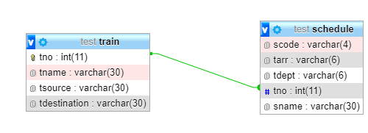**STRUCTURE OF THE TABLE:**

**TABLE:train**

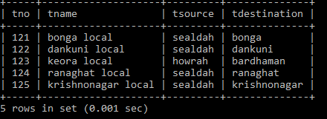

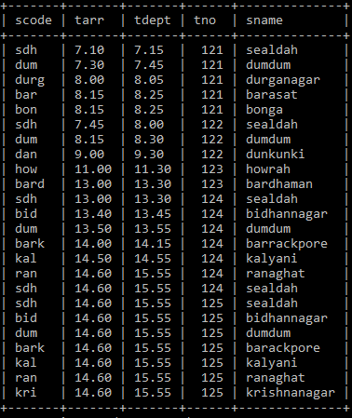**TABLE:schedule**

**QUERY**

select tname,tsource,tdestination

from train

where tno in(

select distinct(t.tno)

from schedule t,schedule s

where t.tno=s.tno

and

t.sname="sealdah"

and

s.sname="dumdum"

);

**OUTPUT**

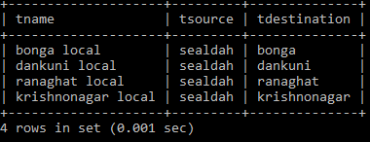

THANK YOU