HR DATABASE

**Queries to create the data base:**

--

-- Table structure for table `countries`

--

DROP TABLE IF EXISTS `countries` ;

FLUSH TABLES;

CREATE TABLE `countries` (

`country_id` int(11) NOT NULL,

`country_name` varchar(50) DEFAULT NULL,

`region_id` int(11) DEFAULT NULL

) ENGINE=InnoDB DEFAULT CHARSET=utf8mb4;

--

-- Dumping data for table `countries`

--

INSERT INTO `countries` (`country_id`, `country_name`, `region_id`) VALUES

(10, 'India', 7025),

(11, 'France', 7035),

(12, 'USA', 7038),

(13, 'Spain', 7040),

(14, 'Pakistan', 7045);

-- ------------------------------------------------

-- Table structure for table `dept`

--

DROP TABLE IF EXISTS `dept` ;

CREATE TABLE `dept` (

`dept_id` varchar(10) NOT NULL,

`dept_name` varchar(30) DEFAULT NULL,

`location_id` int(11) DEFAULT NULL,

`mgr_id` varchar(30) DEFAULT NULL

) ENGINE=InnoDB DEFAULT CHARSET=utf8mb4;

--

-- Dumping data for table `dept`

--

INSERT INTO `dept` (`dept_id`, `dept_name`, `location_id`, `mgr_id`) VALUES

('D1389', 'Sales', 127880, 'E420'),

('D1396', 'Administration', 127877, 'E125'),

('D1559', 'Human Resources', 137877, 'E558'),

('D1859', 'Public Relations', 137877, 'E127'),

('D2589', 'Shipping', 127887, 'E317'),

('D2679', 'IT', 130877, 'E422'),

('D4059', 'Accounting', 137877, 'E519'),

('D7559', 'Marketing', 130877, 'E252');

-- --------------------------------------------------------

-- Table structure for table `employee`

--

DROP TABLE IF EXISTS `employee` ;

CREATE TABLE `employee` (

`emp_id` varchar(20) NOT NULL,

`f_name` varchar(20) NOT NULL,

`l_name` varchar(20) NOT NULL,

`email` varchar(20) DEFAULT NULL,

`ph_no` varchar(12) DEFAULT NULL,

`hired_date` date NOT NULL,

`job_id` int(11) DEFAULT NULL,

`comm` int(11) DEFAULT NULL,

`mgr_id` varchar(30) DEFAULT NULL,

`dept_id` varchar(20) DEFAULT NULL,

`sal` int(11) DEFAULT NULL

) ;

--

-- Dumping data for table `employee`

--

INSERT INTO `employee` (`emp_id`, `f_name`, `l_name`, `email`, `ph_no`, `hired_date`, `job_id`, `comm`, `mgr_id`, `dept_id`, `sal`) VALUES

('E125', 'Suresh', 'Kumar', 'suresh.kumar@gmail.com', '+91785063254', '2017-10-13', 127, NULL, NULL, 'D1396', 15000),

('E127', 'Pankaj', 'Dev', 'p.dev@gmail.com', '+91956321489', '2017-08-17', 126, NULL, 'E125', 'D1859', 19000),

('E239', 'Riya', 'Shaw', 'r.shaw@gmail.com', '+81987465554', '2018-12-12', 126, NULL, 'E252', 'D7559', 16000),

('E252', 'Sia', 'Bundela', 's.bundela@gmail.com', '+81858665554', '2018-12-10', 123, NULL, 'E125', 'D7559', 16000),

('E317', 'Shreyashi', 'Kahali', 's.kahali@gmail.com', '+91957569842', '2015-05-29', 126, NULL, 'E125', 'D2589', 11500),

('E420', 'Sumeli', 'Rani', 'sumeli.rani@gmail.co', '+72850063254', '2017-09-23', 124, 1500, 'E125', 'D1389', 10000),

('E422', 'Raghav', 'Singh', 's.raghav@gmail.com', '+81858855254', '2018-10-10', 124, NULL, 'E125', 'D2679', 12000),

('E442', 'Rani', 'Shraddha', 's.rani@gmail.com', '+72850068854', '2018-09-13', 126, 1200, 'E420', 'D1389', 8000),

('E519', 'Anita', 'Misra', 'a.misra@gmail.com', '+81987775484', '2017-12-12', 124, NULL, 'E125', 'D4059', 20000),

('E558', 'Arnab', 'Karn', 'a.karn@gmail.com', '+91987756489', '2017-11-15', 126, NULL, 'E125', 'D1559', 20000);

-- --------------------------------------------------------

--

-- Table structure for table `jobs`

--

DROP TABLE IF EXISTS `jobs` ;

CREATE TABLE `jobs` (

`job_id` int(11) NOT NULL,

`job_title` varchar(50) NOT NULL,

`min_sal` int(11) DEFAULT NULL,

`max_sal` int(11) DEFAULT NULL

) ENGINE=InnoDB DEFAULT CHARSET=utf8mb4;

--

-- Dumping data for table `jobs`

--

INSERT INTO `jobs` (`job_id`, `job_title`, `min_sal`, `max_sal`) VALUES

(123, 'Accountant', 15000, 25000),

(124, 'Team Leader', 20000, 30000),

(125, 'Manager', 25000, 35000),

(126, 'Executive', 35000, 50000),

(127, 'CEO', 40000, 55000);

-- --------------------------------------------------------

--

-- Table structure for table `job_history`

--

DROP TABLE IF EXISTS `job_history` ;

CREATE TABLE `job_history` (

`emp_id` varchar(10) NOT NULL,

`start_date` date NOT NULL,

`end_date` date NOT NULL,

`job_id` int(11) DEFAULT NULL,

`dept_id` varchar(30) DEFAULT NULL

) ENGINE=InnoDB DEFAULT CHARSET=utf8mb4;

--

-- Dumping data for table `job_history`

--

INSERT INTO `job_history` (`emp_id`, `start_date`, `end_date`, `job_id`, `dept_id`) VALUES

('E125', '2017-10-13', '2020-04-12', 127, 'D1396'),

('E127', '2017-08-17', '2020-04-12', 126, 'D1859'),

('E239', '2018-12-12', '2019-12-12', 126, 'D7559'),

('E252', '2018-12-10', '2020-04-12', 123, 'D7559'),

('E317', '2015-05-29', '2020-04-12', 126, 'D2589'),

('E420', '2017-09-23', '2020-04-12', 124, 'D1389'),

('E422', '2018-10-10', '2019-04-05', 124, 'D2679'),

('E442', '2018-09-13', '2018-12-12', 126, 'D1389'),

('E519', '2017-12-12', '2020-04-12', 124, 'D4059'),

('E558', '2017-11-15', '2018-05-12', 126, 'D1559');

-- --------------------------------------------------------

--

-- Table structure for table `locations`

--

DROP TABLE IF EXISTS `locations` ;

CREATE TABLE `locations` (

`location_id` int(11) NOT NULL,

`street_address` varchar(50) DEFAULT NULL,

`postal_code` varchar(30) DEFAULT NULL,

`city` varchar(10) NOT NULL,

`state_province` varchar(30) DEFAULT NULL,

`country_id` int(11) DEFAULT NULL

) ENGINE=InnoDB DEFAULT CHARSET=utf8mb4;

-- Dumping data for table `locations`

--

INSERT INTO `locations` (`location_id`, `street_address`, `postal_code`, `city`, `state_province`, `country_id`) VALUES

(127877, '374 William Canning Street', 'UA00', 'Vioming', 'Jalisco', 12),

(127880, '180 North King Street', 'I700', 'Imphal', 'Mizoram', 10),

(127887, '700 Oak Street', 'F500', 'Marseille', 'Ile-de-France', 11),

(130877, 'Rio De Mohammad Street', 'PA80', 'Karachi', 'Punjab', 14),

(137877, '750 Tolstoy Street', 'S800', 'El Escoria', 'Barcelona', 13);

-- --------------------------------------------------------

--

-- Table structure for table `regions`

--

DROP TABLE IF EXISTS `regions` ;

CREATE TABLE `regions` (

`region_id` int(11) NOT NULL,

`region_name` varchar(50) DEFAULT NULL

) ENGINE=InnoDB DEFAULT CHARSET=utf8mb4;

--

-- Dumping data for table `regions`

--

INSERT INTO `regions` (`region_id`, `region_name`) VALUES

(7025, 'Manipur'),

(7035, 'Paris'),

(7038, 'Mexico'),

(7040, 'Madrid'),

(7045, 'Lahore');

--

-- Indexes for dumped tables

--

--

-- Indexes for table `countries`

--

ALTER TABLE `countries`

ADD PRIMARY KEY (`country_id`),

ADD KEY `region_id` (`region_id`);

--

-- Indexes for table `dept`

--

ALTER TABLE `dept`

ADD PRIMARY KEY (`dept_id`),

ADD KEY `location_id` (`location_id`),

ADD KEY `mgr_id` (`mgr_id`);

--

--

-- Indexes for table `employee`

--

ALTER TABLE `employee`

ADD PRIMARY KEY (`emp_id`),

ADD KEY `job_id` (`job_id`),

ADD KEY `mgr_id` (`mgr_id`),

ADD KEY `dept_id` (`dept_id`);

--

-- Indexes for table `jobs`

--

ALTER TABLE `jobs`

ADD PRIMARY KEY (`job_id`);

--

-- Indexes for table `job_history`

--

ALTER TABLE `job_history`

ADD PRIMARY KEY (`emp_id`,`start_date`),

ADD KEY `job_id` (`job_id`),

ADD KEY `dept_id` (`dept_id`);

--

-- Indexes for table `locations`

--

ALTER TABLE `locations`

ADD PRIMARY KEY (`location_id`),

ADD KEY `country_id` (`country_id`);

--

-- Indexes for table `regions`

--

ALTER TABLE `regions`

ADD PRIMARY KEY (`region_id`);

--

-- Constraints for dumped tables

--

--

-- Constraints for table `countries`

--

ALTER TABLE `countries`

ADD CONSTRAINT `countries_ibfk_1` FOREIGN KEY (`region_id`) REFERENCES `regions` (`region_id`);

--

-- Constraints for table `departments`

--

--

-- Constraints for table `dept`

--

ALTER TABLE `dept`

ADD CONSTRAINT `dept_ibfk_1` FOREIGN KEY (`location_id`) REFERENCES `locations` (`location_id`),

ADD CONSTRAINT `dept_ibfk_2` FOREIGN KEY (`mgr_id`) REFERENCES `employee` (`emp_id`);

--

-- Constraints for table `emp`

--

--

-- Constraints for table `employee`

--

ALTER TABLE `employee`

ADD CONSTRAINT `employee_ibfk_1` FOREIGN KEY (`job_id`) REFERENCES `jobs` (`job_id`),

ADD CONSTRAINT `employee_ibfk_2` FOREIGN KEY (`mgr_id`) REFERENCES `employee` (`emp_id`),

ADD CONSTRAINT `employee_ibfk_3` FOREIGN KEY (`dept_id`) REFERENCES `dept` (`dept_id`);

--

-- Constraints for table `job_history`

--

ALTER TABLE `job_history`

ADD CONSTRAINT `job_history_ibfk_1` FOREIGN KEY (`emp_id`) REFERENCES `employee` (`emp_id`),

ADD CONSTRAINT `job_history_ibfk_2` FOREIGN KEY (`job_id`) REFERENCES `jobs` (`job_id`),

ADD CONSTRAINT `job_history_ibfk_3` FOREIGN KEY (`dept_id`) REFERENCES `dept` (`dept_id`);

--

-- Constraints for table `locations`

--

ALTER TABLE `locations`

ADD CONSTRAINT `locations_ibfk_1` FOREIGN KEY (`country_id`) REFERENCES `countries` (`country_id`);

COMMIT;

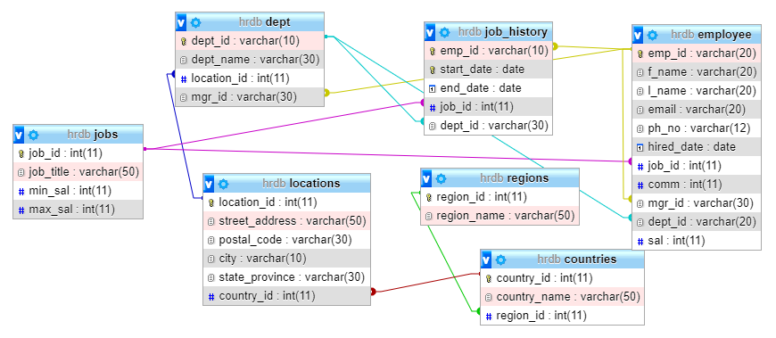**Schema Diagram of the DataBase:**

**Data Dictionary of hrdb:**

**countries**

|  |  |  |  |  |  |  |
| --- | --- | --- | --- | --- | --- | --- |
| **Column** | **Type** | **Null** | **Default** | **Links to** | **Comments** | **Media (MIME) type** |
| country_id *(Primary)* | int(11) | No |  |  |  |  |
| country_name | varchar(50) | Yes | *NULL* |  |  |  |
| region_id | int(11) | Yes | *NULL* | regions -> region_id |  |  |

**Indexes**

| **Keyname** | **Type** | **Unique** | **Packed** | **Column** | **Cardinality** | **Collation** | **Null** | **Comment** |
| --- | --- | --- | --- | --- | --- | --- | --- | --- |
| PRIMARY | BTREE | Yes | No | country_id | 5 | A | No |  |
| region_id | BTREE | No | No | region_id | 5 | A | Yes |  |

**dept**

|  |  |  |  |  |  |  |
| --- | --- | --- | --- | --- | --- | --- |
| **Column** | **Type** | **Null** | **Default** | **Links to** | **Comments** | **Media (MIME) type** |
| dept_id *(Primary)* | varchar(10) | No |  |  |  |  |
| dept_name | varchar(30) | Yes | *NULL* |  |  |  |
| location_id | int(11) | Yes | *NULL* | locations -> location_id |  |  |
| mgr_id | varchar(30) | Yes | *NULL* | employee -> emp_id |  |  |

**Indexes**

| **Keyname** | **Type** | **Unique** | **Packed** | **Column** | **Cardinality** | **Collation** | **Null** | **Comment** |
| --- | --- | --- | --- | --- | --- | --- | --- | --- |
| PRIMARY | BTREE | Yes | No | dept_id | 8 | A | No |  |
| location_id | BTREE | No | No | location_id | 8 | A | Yes |  |
| mgr_id | BTREE | No | No | mgr_id | 8 | A | Yes |  |

**employee**

|  |  |  |  |  |  |  |
| --- | --- | --- | --- | --- | --- | --- |
| **Column** | **Type** | **Null** | **Default** | **Links to** | **Comments** | **Media (MIME) type** |
| emp_id *(Primary)* | varchar(20) | No |  |  |  |  |
| f_name | varchar(20) | No |  |  |  |  |
| l_name | varchar(20) | No |  |  |  |  |
| email | varchar(20) | Yes | *NULL* |  |  |  |
| ph_no | varchar(12) | Yes | *NULL* |  |  |  |
| hired_date | date | No |  |  |  |  |
| job_id | int(11) | Yes | *NULL* | jobs -> job_id |  |  |
| comm | int(11) | Yes | *NULL* |  |  |  |
| mgr_id | varchar(30) | Yes | *NULL* | employee -> emp_id |  |  |
| dept_id | varchar(20) | Yes | *NULL* | dept -> dept_id |  |  |
| sal | int(11) | Yes | *NULL* |  |  |  |

**Indexes**

| **Keyname** | **Type** | **Unique** | **Packed** | **Column** | **Cardinality** | **Collation** | **Null** | **Comment** |
| --- | --- | --- | --- | --- | --- | --- | --- | --- |
| PRIMARY | BTREE | Yes | No | emp_id | 10 | A | No |  |
| job_id | BTREE | No | No | job_id | 10 | A | Yes |  |
| mgr_id | BTREE | No | No | mgr_id | 10 | A | Yes |  |
| dept_id | BTREE | No | No | dept_id | 10 | A | Yes |  |

**jobs**

|  |  |  |  |  |  |  |
| --- | --- | --- | --- | --- | --- | --- |
| **Column** | **Type** | **Null** | **Default** | **Links to** | **Comments** | **Media (MIME) type** |
| job_id *(Primary)* | int(11) | No |  |  |  |  |
| job_title | varchar(50) | No |  |  |  |  |
| min_sal | int(11) | Yes | *NULL* |  |  |  |
| max_sal | int(11) | Yes | *NULL* |  |  |  |

**Indexes**

| **Keyname** | **Type** | **Unique** | **Packed** | **Column** | **Cardinality** | **Collation** | **Null** | **Comment** |
| --- | --- | --- | --- | --- | --- | --- | --- | --- |
| PRIMARY | BTREE | Yes | No | job_id | 5 | A | No |  |

**job_history**

|  |  |  |  |  |  |  |
| --- | --- | --- | --- | --- | --- | --- |
| **Column** | **Type** | **Null** | **Default** | **Links to** | **Comments** | **Media (MIME) type** |
| emp_id *(Primary)* | varchar(10) | No |  | employee -> emp_id |  |  |
| start_date *(Primary)* | date | No |  |  |  |  |
| end_date | date | No |  |  |  |  |
| job_id | int(11) | Yes | *NULL* | jobs -> job_id |  |  |
| dept_id | varchar(30) | Yes | *NULL* | dept -> dept_id |  |  |

**Indexes**

| **Keyname** | **Type** | **Unique** | **Packed** | **Column** | **Cardinality** | **Collation** | **Null** | **Comment** |
| --- | --- | --- | --- | --- | --- | --- | --- | --- |
| PRIMARY | BTREE | Yes | No | emp_id | 10 | A | No |  |
| start_date | 10 | A | No |
| job_id | BTREE | No | No | job_id | 10 | A | Yes |  |
| dept_id | BTREE | No | No | dept_id | 10 | A | Yes |  |

**locations**

|  |  |  |  |  |  |  |
| --- | --- | --- | --- | --- | --- | --- |
| **Column** | **Type** | **Null** | **Default** | **Links to** | **Comments** | **Media (MIME) type** |
| location_id *(Primary)* | int(11) | No |  |  |  |  |
| street_address | varchar(50) | Yes | *NULL* |  |  |  |
| postal_code | varchar(30) | Yes | *NULL* |  |  |  |
| city | varchar(10) | No |  |  |  |  |
| state_province | varchar(30) | Yes | *NULL* |  |  |  |
| country_id | int(11) | Yes | *NULL* | countries -> country_id |  |  |

**Indexes**

| **Keyname** | **Type** | **Unique** | **Packed** | **Column** | **Cardinality** | **Collation** | **Null** | **Comment** |
| --- | --- | --- | --- | --- | --- | --- | --- | --- |
| PRIMARY | BTREE | Yes | No | location_id | 5 | A | No |  |
| country_id | BTREE | No | No | country_id | 5 | A | Yes |  |

**regions**

|  |  |  |  |  |  |  |
| --- | --- | --- | --- | --- | --- | --- |
| **Column** | **Type** | **Null** | **Default** | **Links to** | **Comments** | **Media (MIME) type** |
| region_id *(Primary)* | int(11) | No |  |  |  |  |
| region_name | varchar(50) | Yes | *NULL* |  |  |  |

**Indexes**

| **Keyname** | **Type** | **Unique** | **Packed** | **Column** | **Cardinality** | **Collation** | **Null** | **Comment** |
| --- | --- | --- | --- | --- | --- | --- | --- | --- |
| PRIMARY | BTREE | Yes | No | region_id | 5 | A | No |  |

**Tables:**

**Countries**

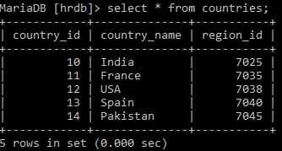

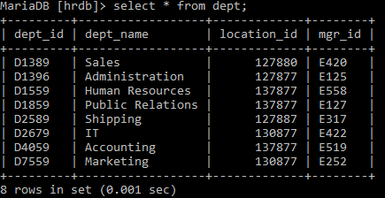**Dept:**

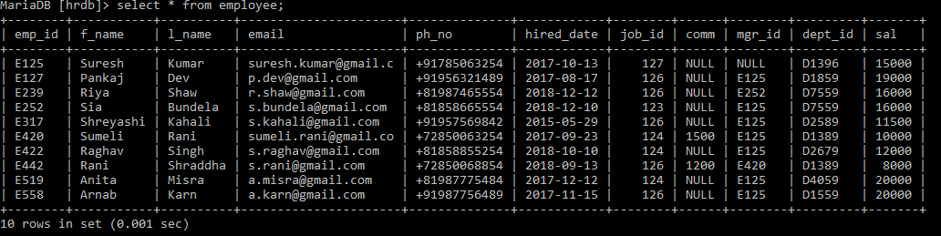**Employee:**

**Job_history:**

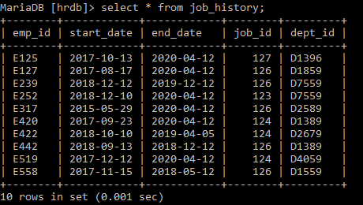

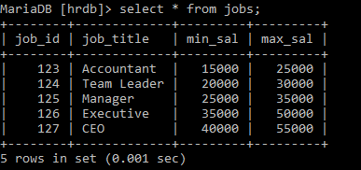**Jobs:**

**Locations:**

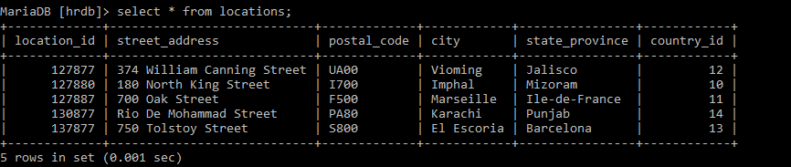

**Regions:**

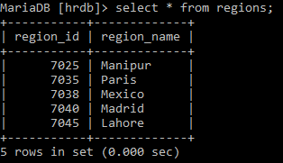

THANK YOU