**Session 10 Assignment 2**

Moving the given data set to hdfs ->

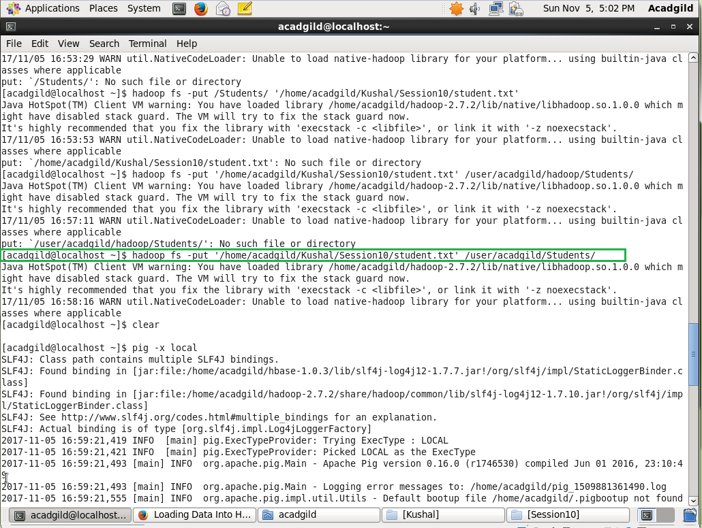

Listing the Dataset file ->

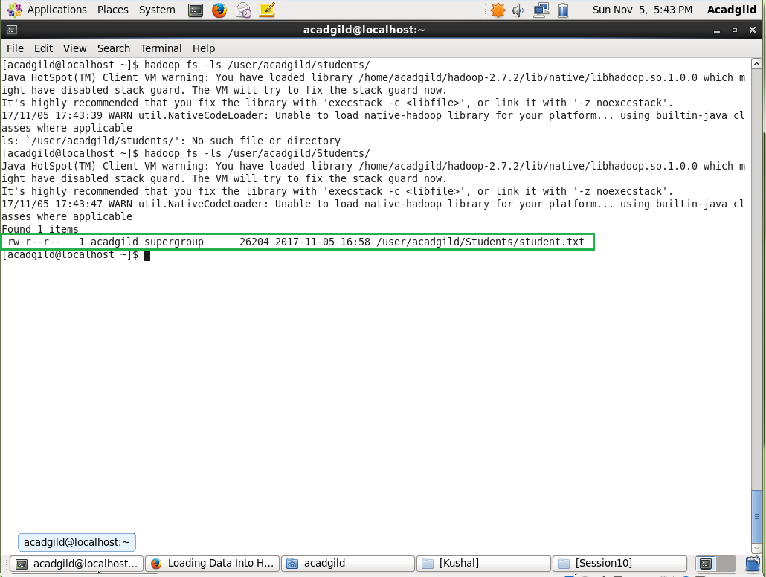

Included few jar files of HBase to the Pig classpath.

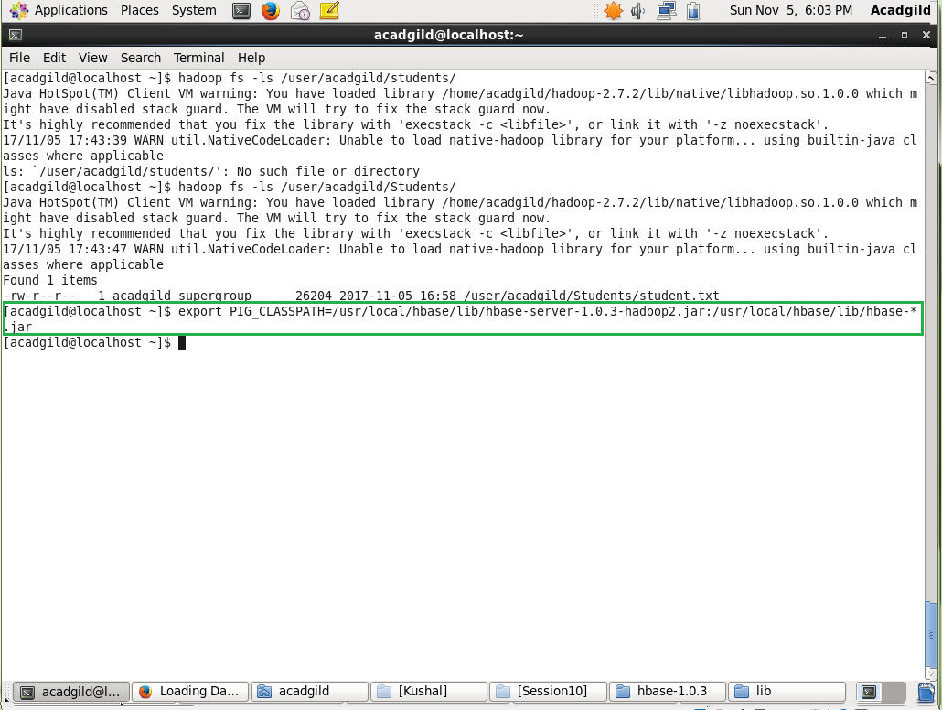

Logged into HBase shell and created the table studentAcad

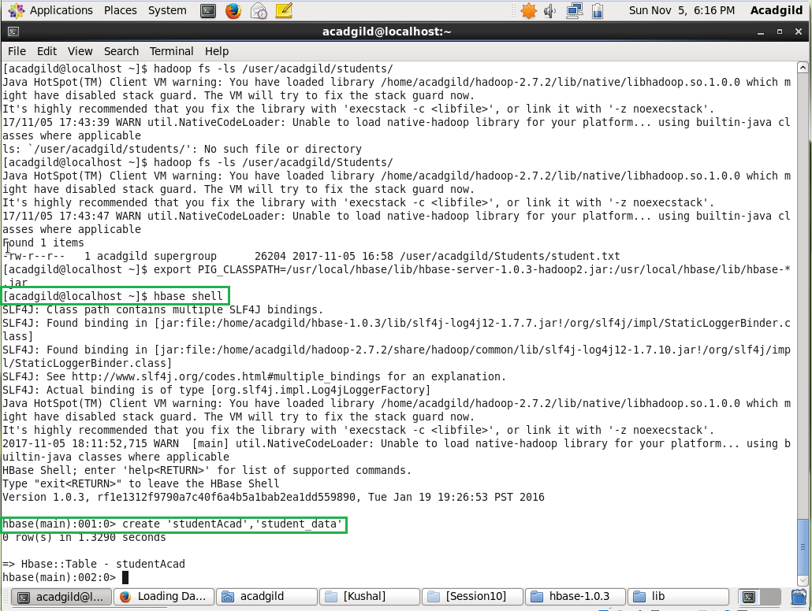

Data loaded into pig ->

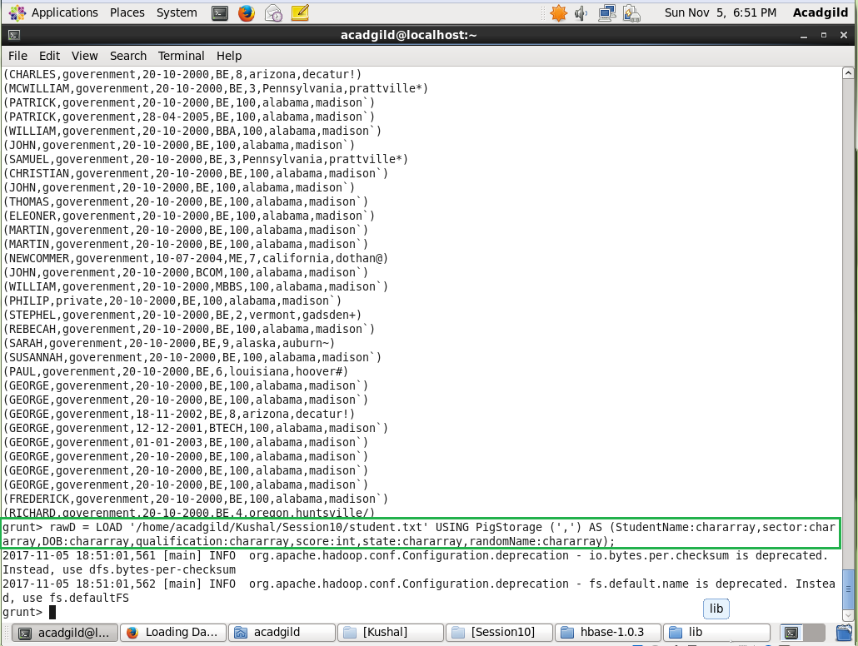

Moving the data into the HBase

