**Session 11 Assignment 1**

Task 1: Transfer Data between MySQL – HDFS

* Start and log-in to MySQL created a database “demo” -> table “employee”

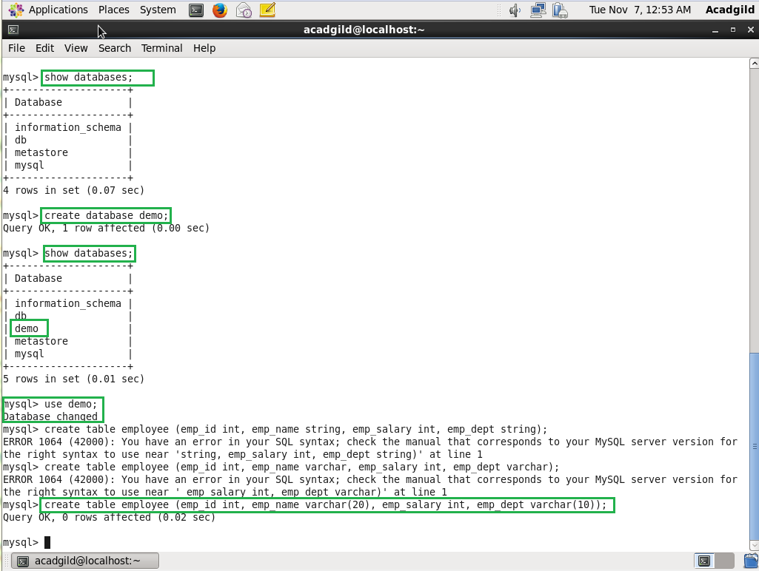

* Add few records of employee into employee table.

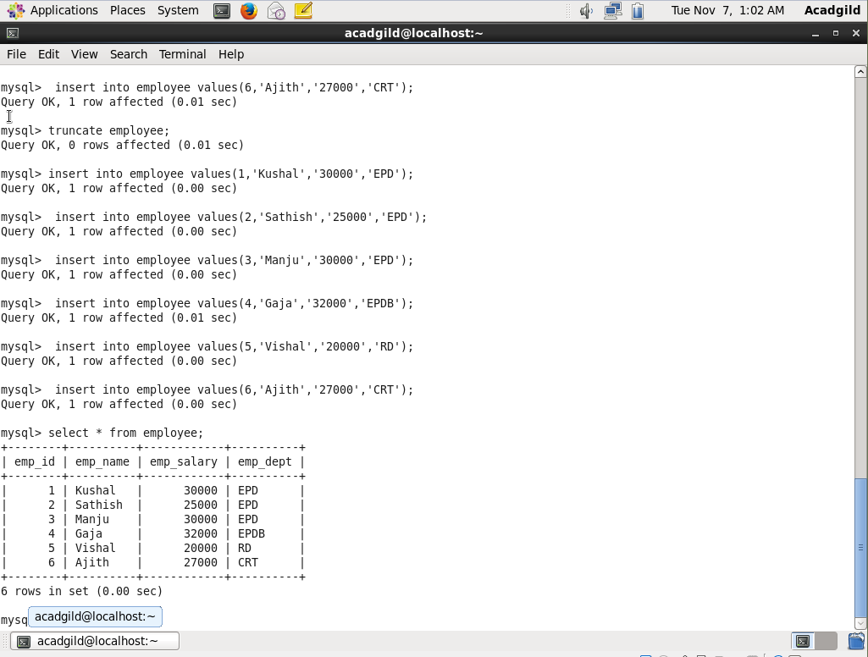

* Give the Sqoop import command by specifying the database name and the table which needs to imported into MySQL

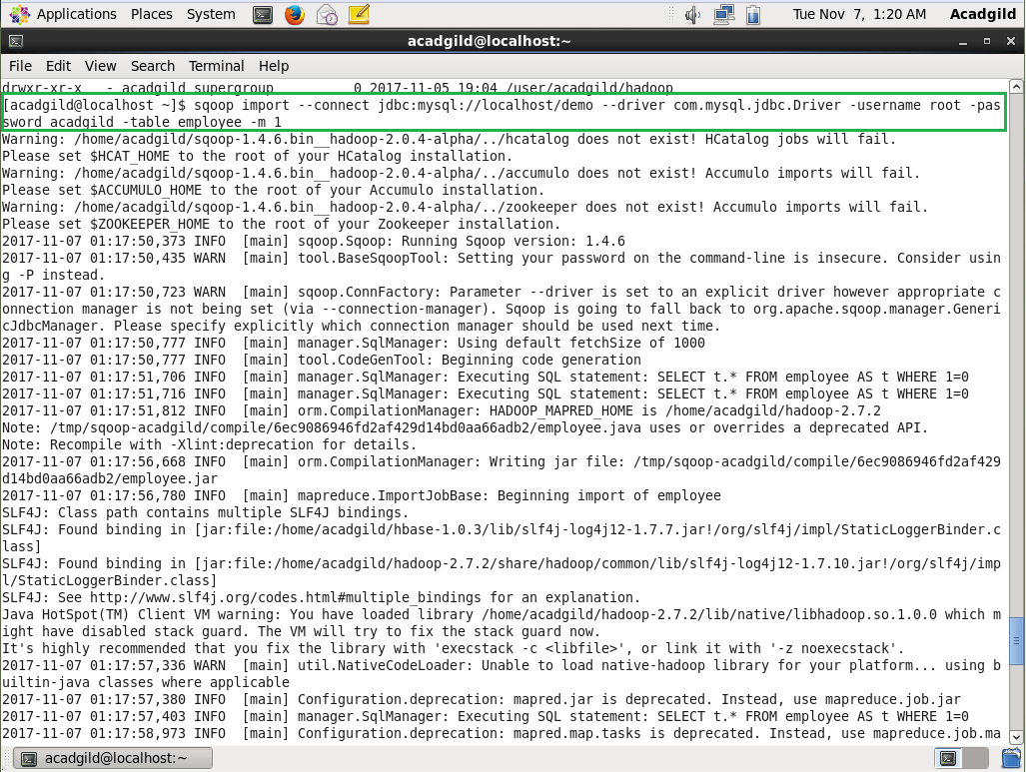

* Displaying the data using –cat which is migrated from the MySQL to HDFS using the above command.

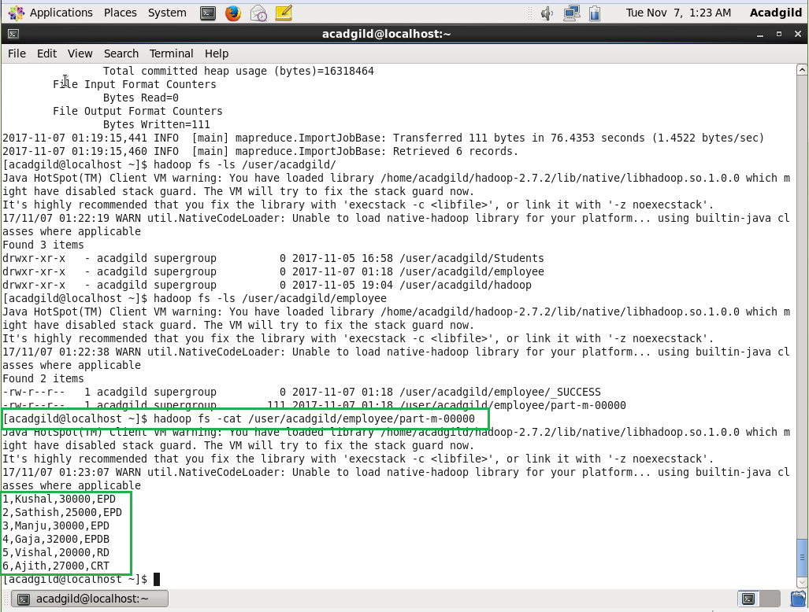

Task 1: Transfer Data between HDFS – MySQL

* Create a table in MySQL database with the same schema for which dataset has to be imported.

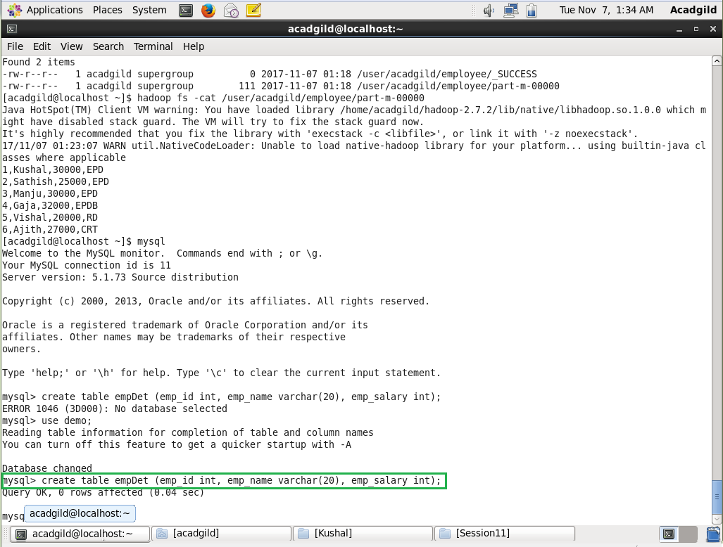

* Put the data set into the hdfs

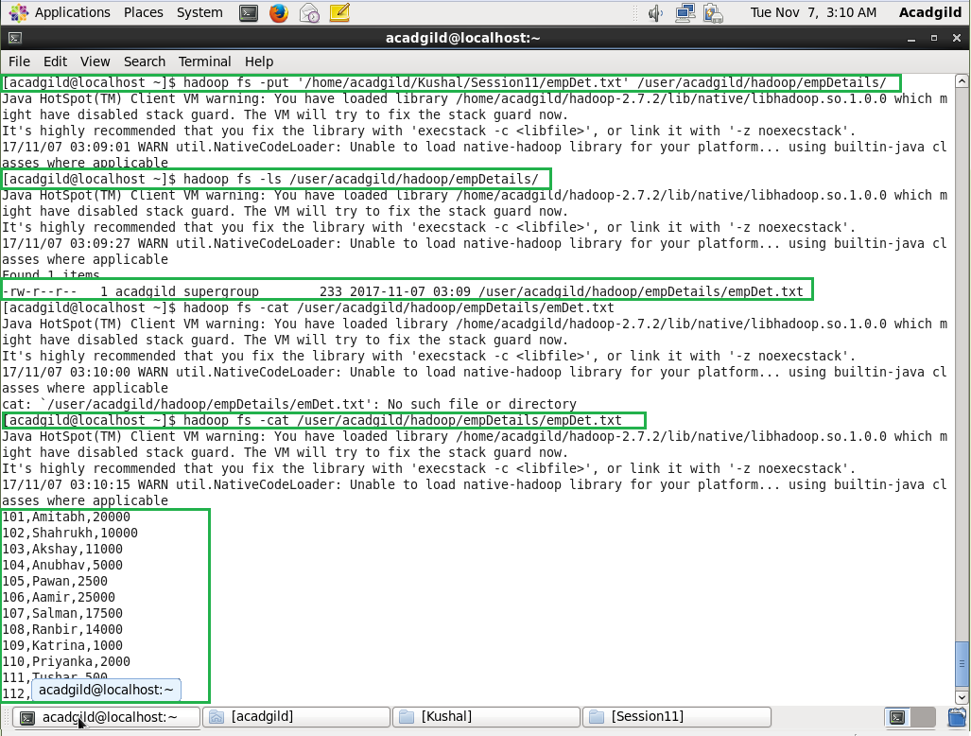

* Enter Export command to transfer from the hdfs to MySQL

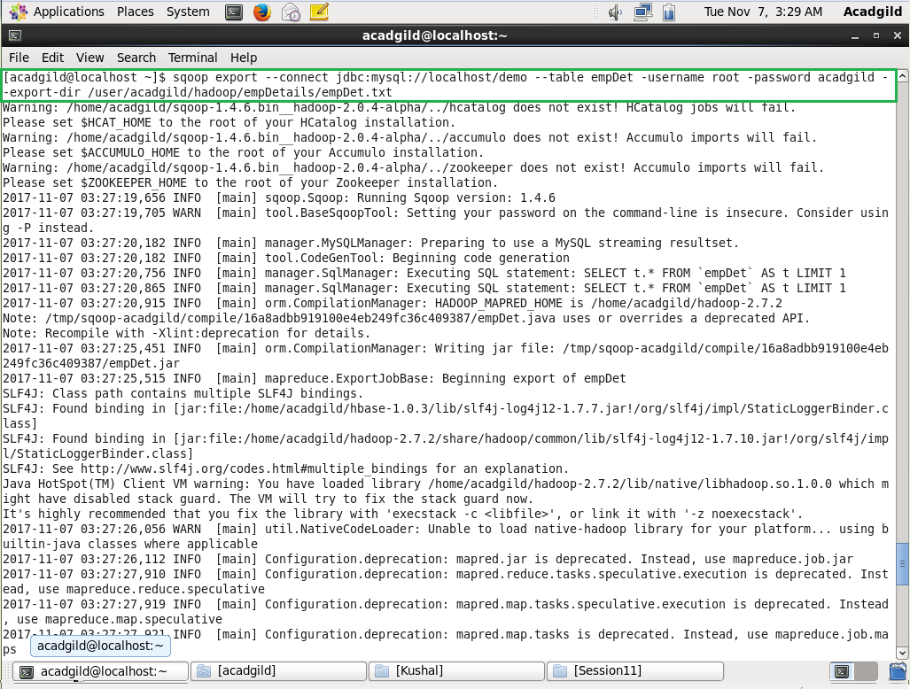

* Log on to MySQL and check the data

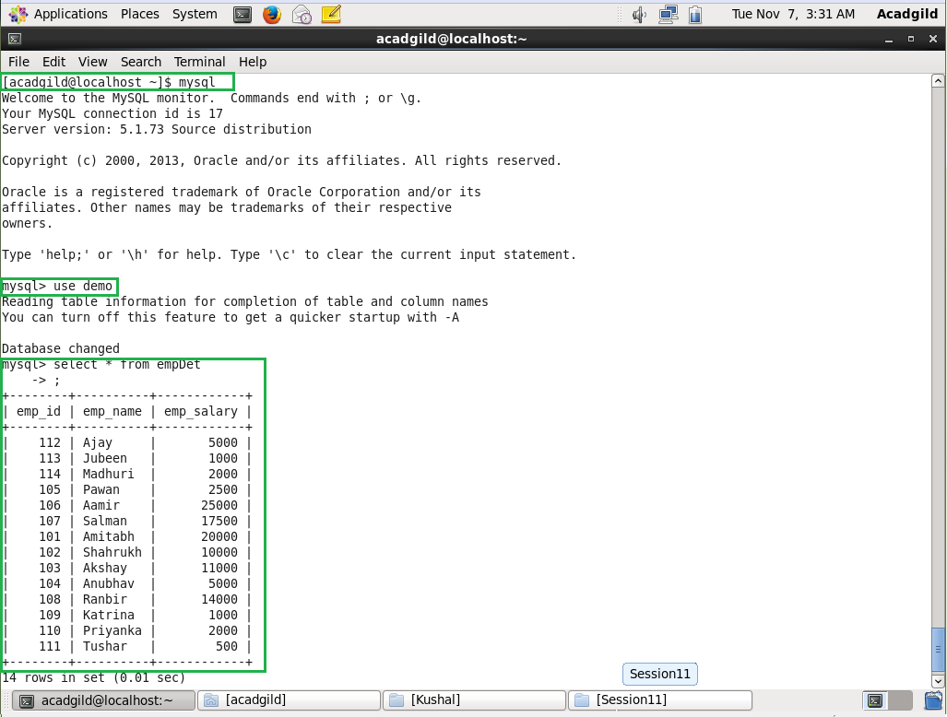

Task 2: Transfer Data between MySQL – Hive

* Select/Create a table which is wanted to be moved from the MySQL to Hive



* Give the below Sqoop command to transfer the data

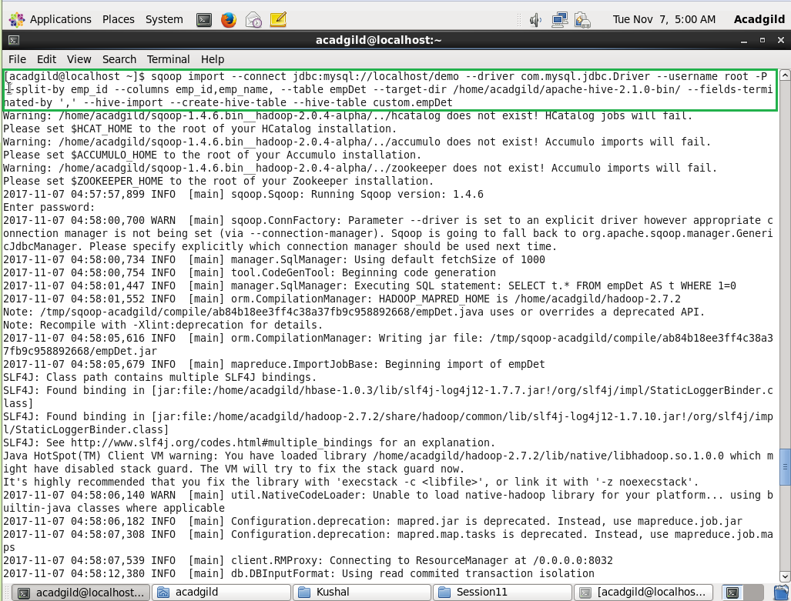

* Log on to Hive to check the selected column data

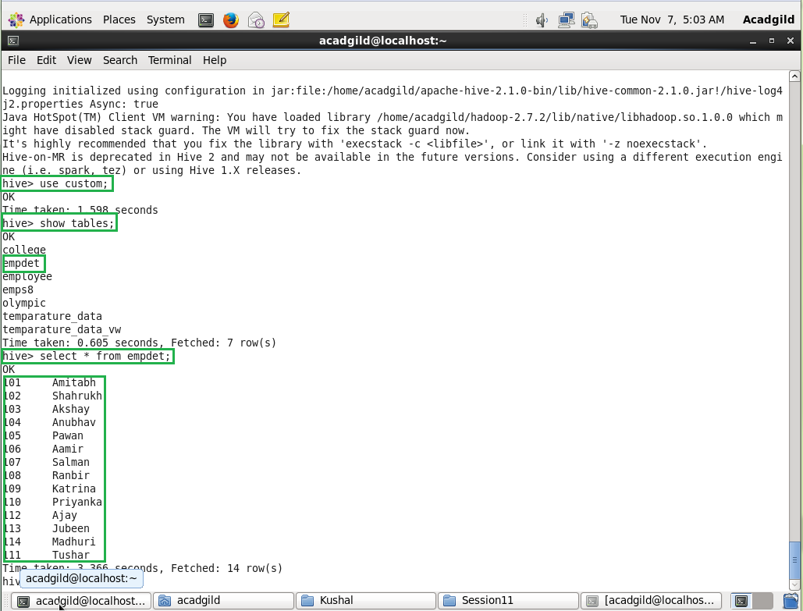

Task 2: Transfer Data between Hive – MySQL

* Create a table in MySQL which suits the data which needs to be transferred.

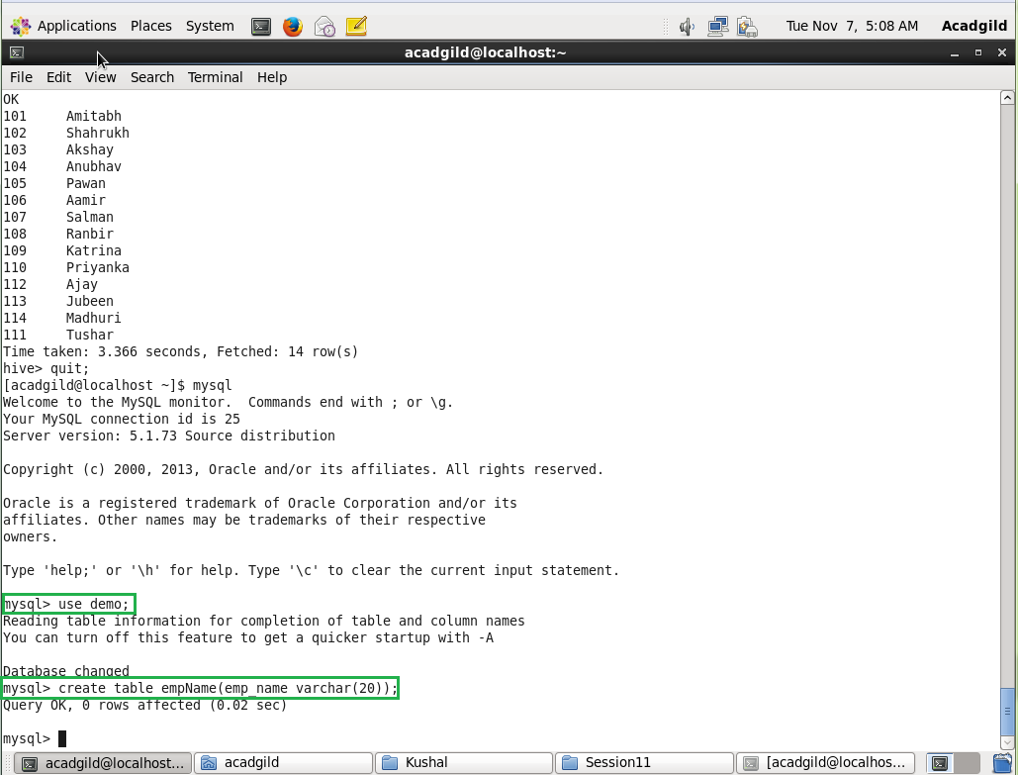

* Give Export command as below

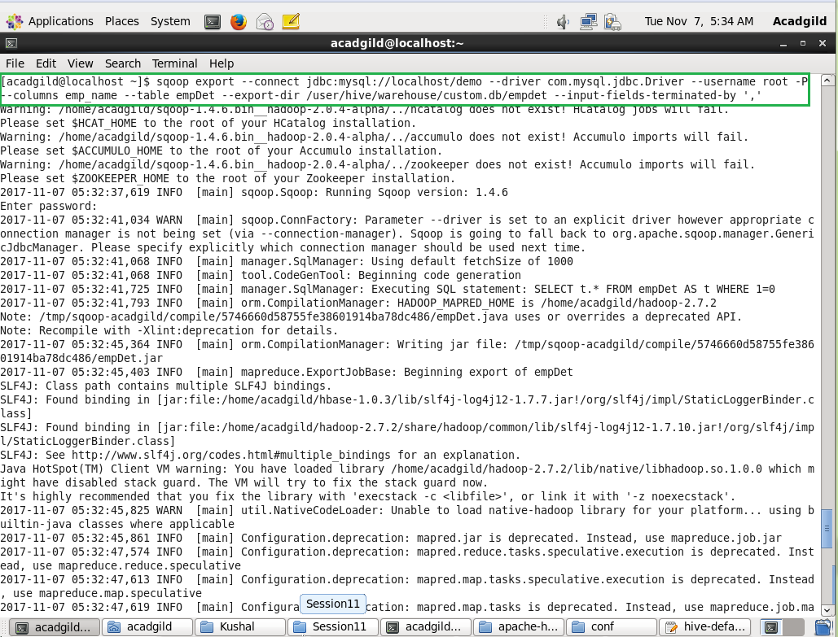

* Log on to hive to check the data

