**Session 11 Assignment 2**

Task 🡪 Read from MySQL Table and load it in Hive table. Create hive table if it does not exist. If it exists, perform the incremental load.

* Create a table and load table in MySQL.

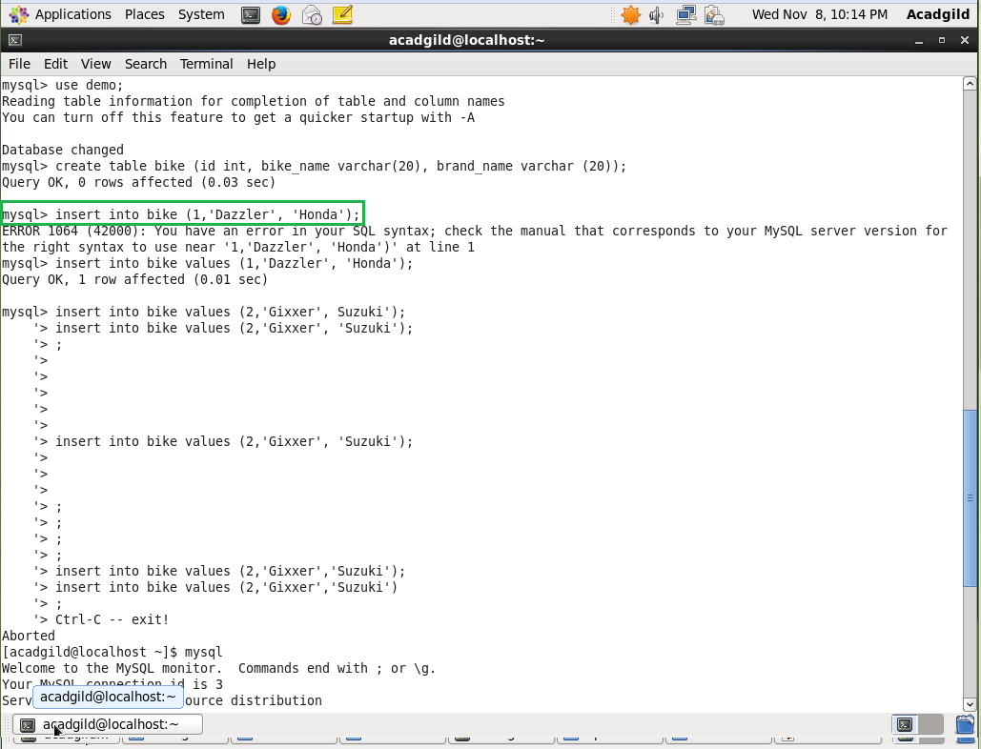

* Give sqoop command to import the data from MySQL to hive

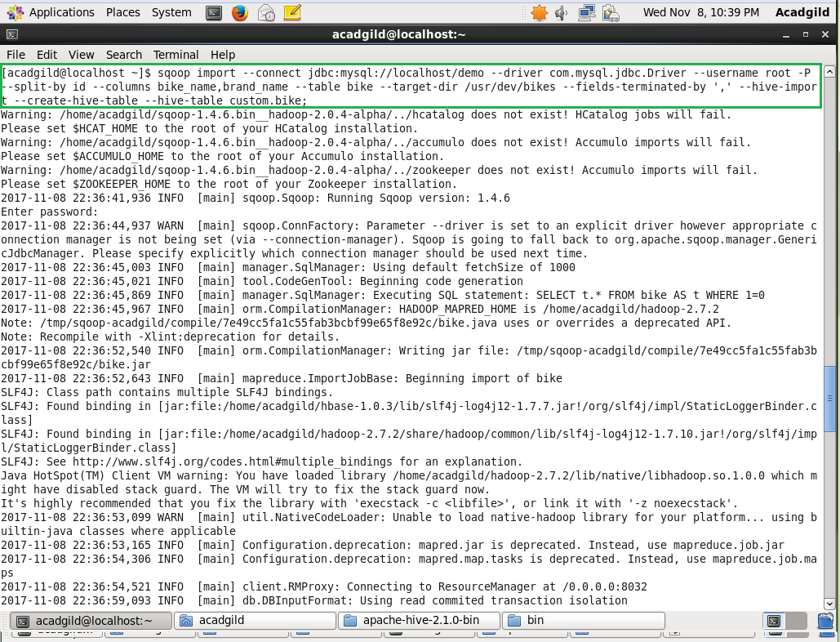

* Log in to hive and check the data

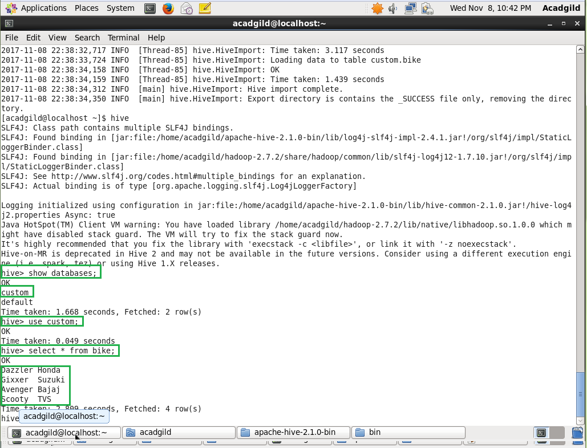

* Hive records

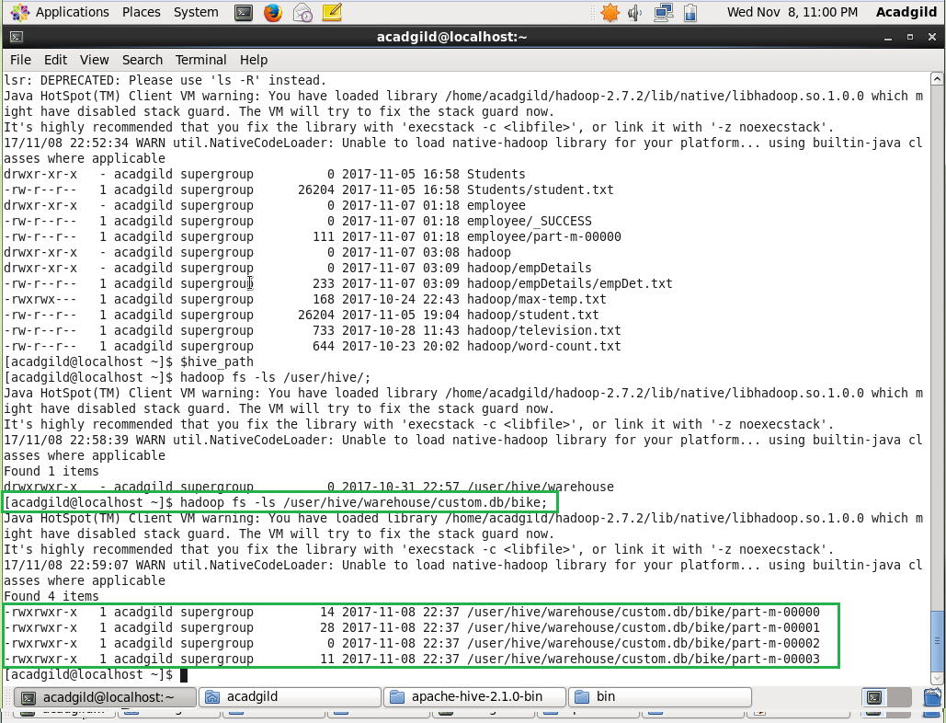

* Add few more records in MySQL

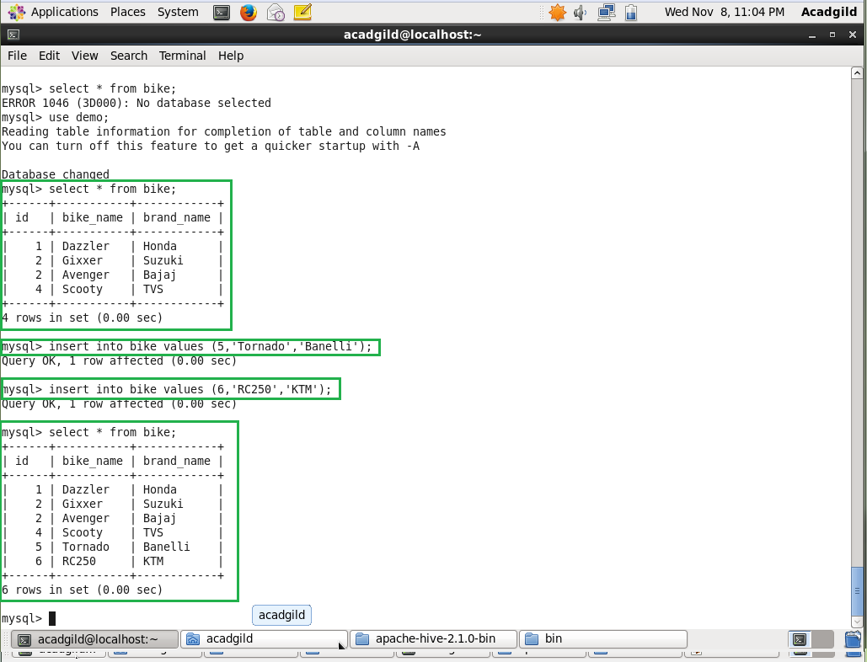

* Execute the Sqoop command to transfer the data from mysql to hive again

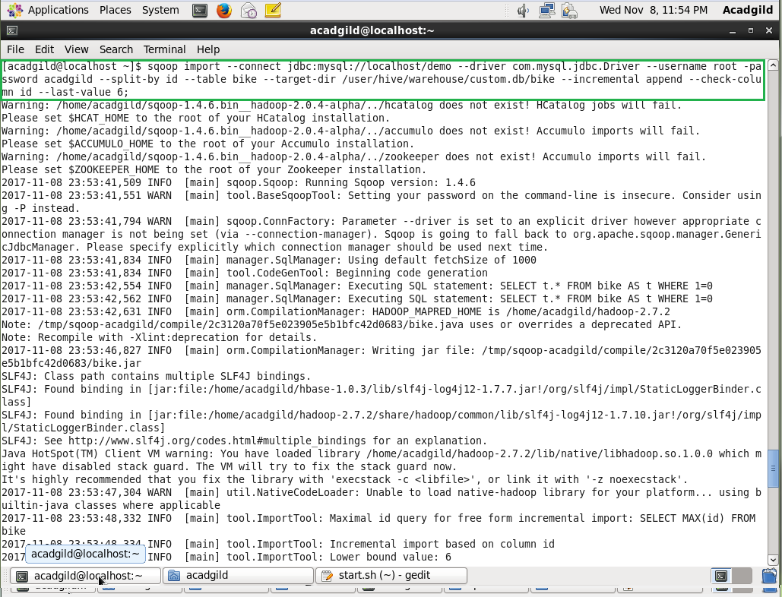

* Log on to hive to check data

