**Session 11 Assignment 3**

Task: Create a flume agent that streams data from Twitter and stores in the HDFS.

* Login to Twitter to create a twitter app and get the access code from the twitter.
* Add the required jars under Flume library

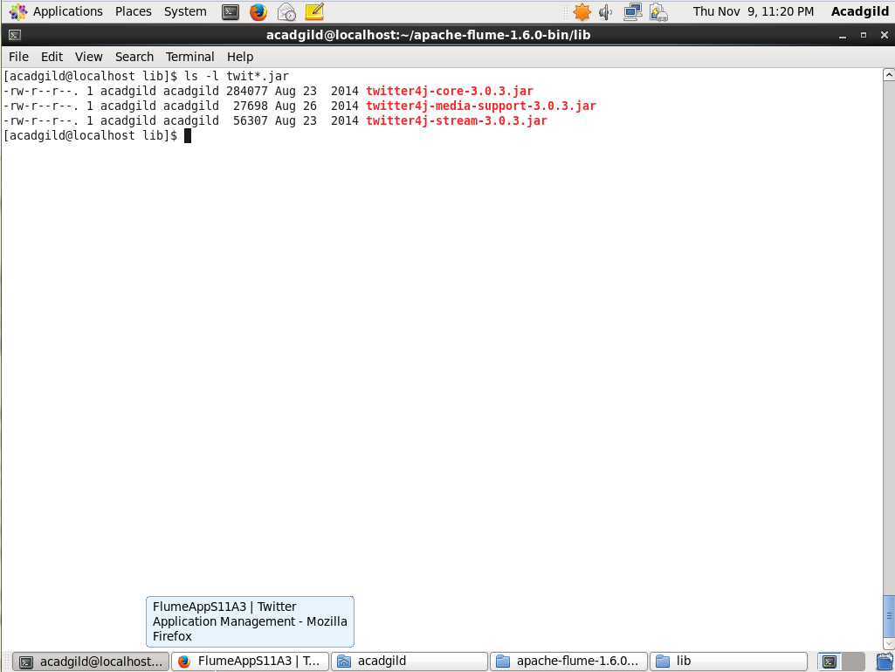

* Create Flume.conf file under conf folder in Flume Directory

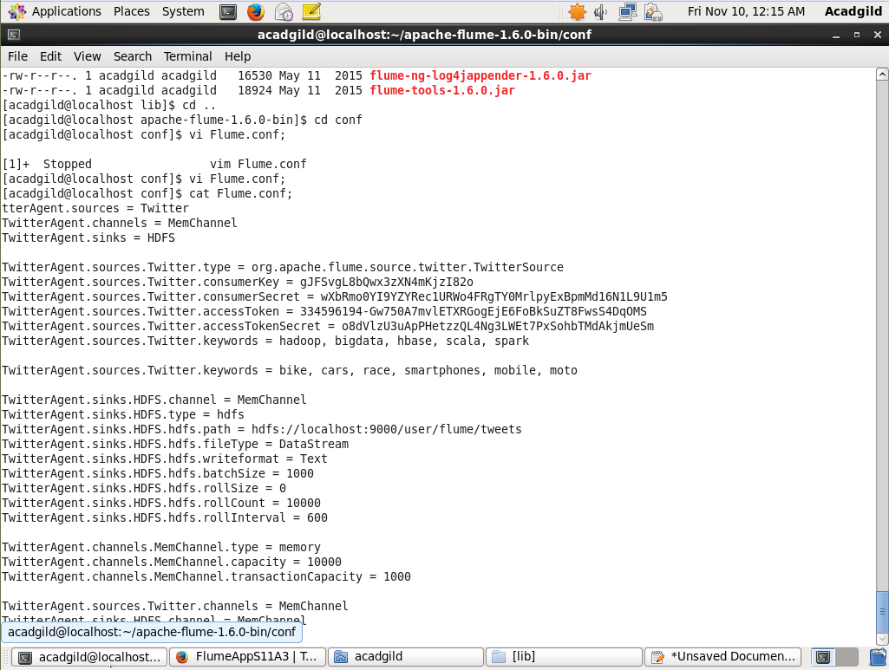

* Create a folder under hdfs as below

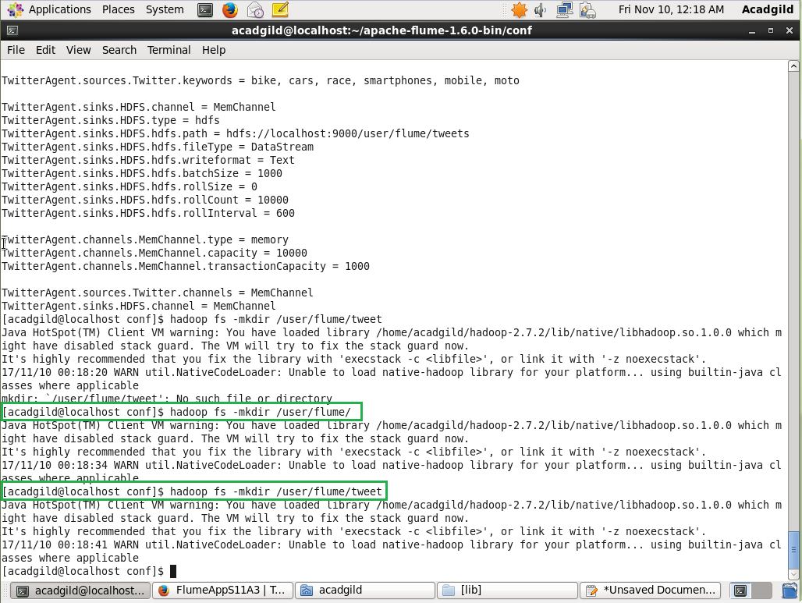

* Invoking the Flume agent

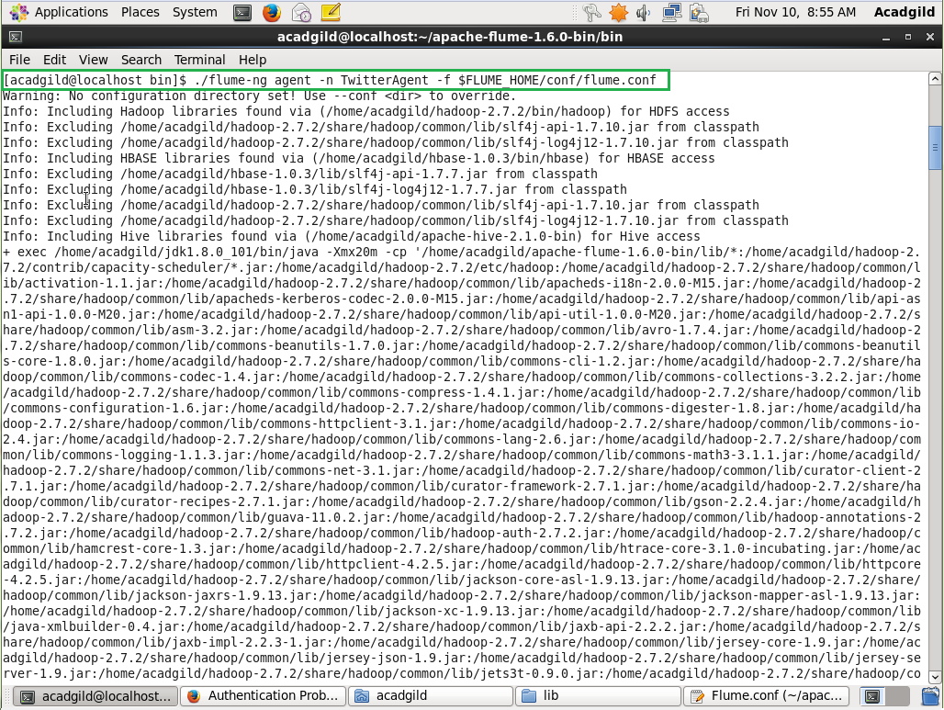

* Getting the Stream data

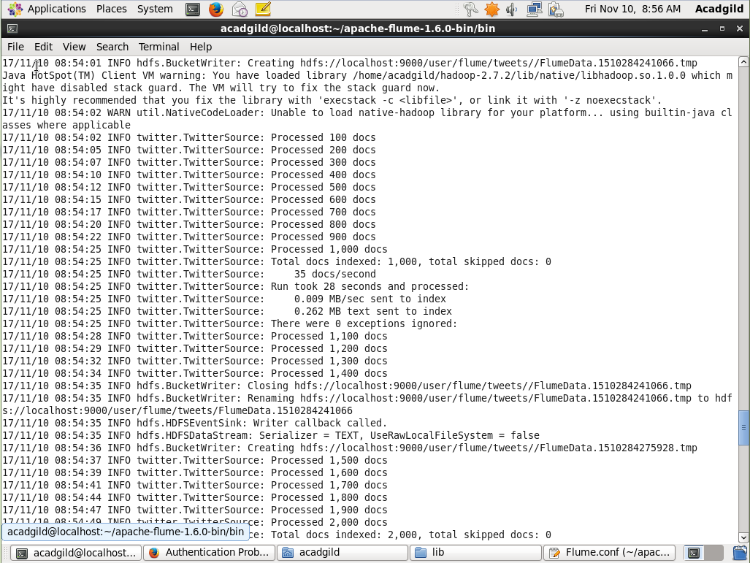

* Check the data received in the Hadoop and in the given path in conf file

