**Session 12 Project 1**

Task 1:

Running Pig file which consists of the commands –

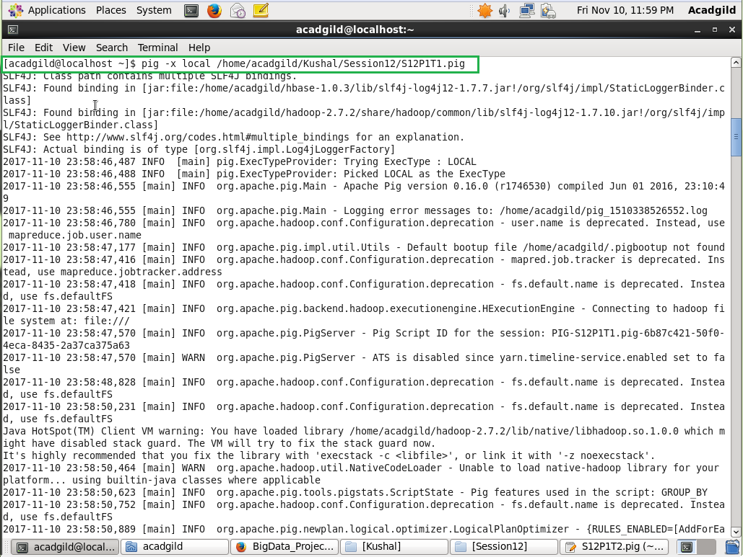

Output of Task1 –

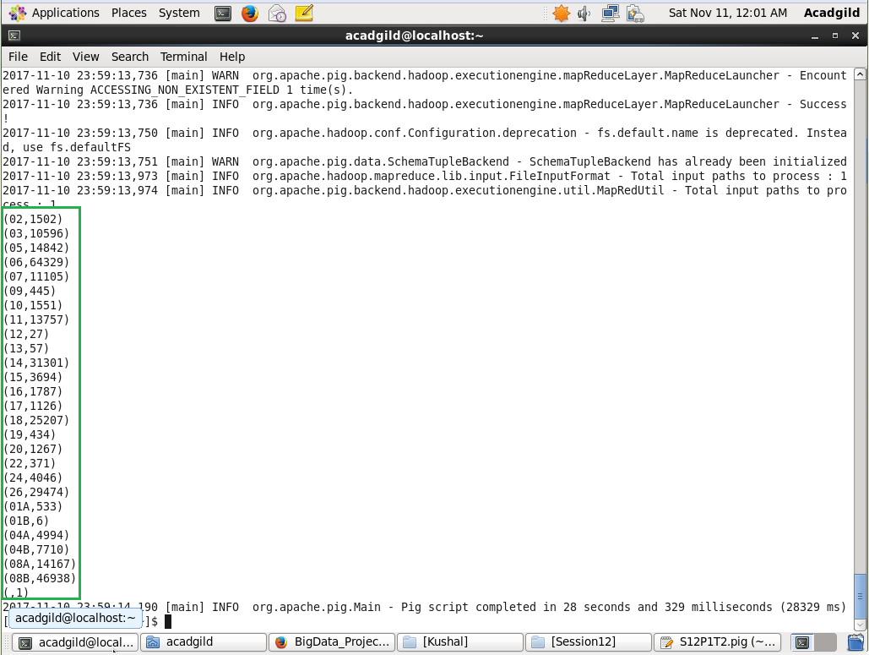

Task 2:

Running Pig file which consists of the commands –

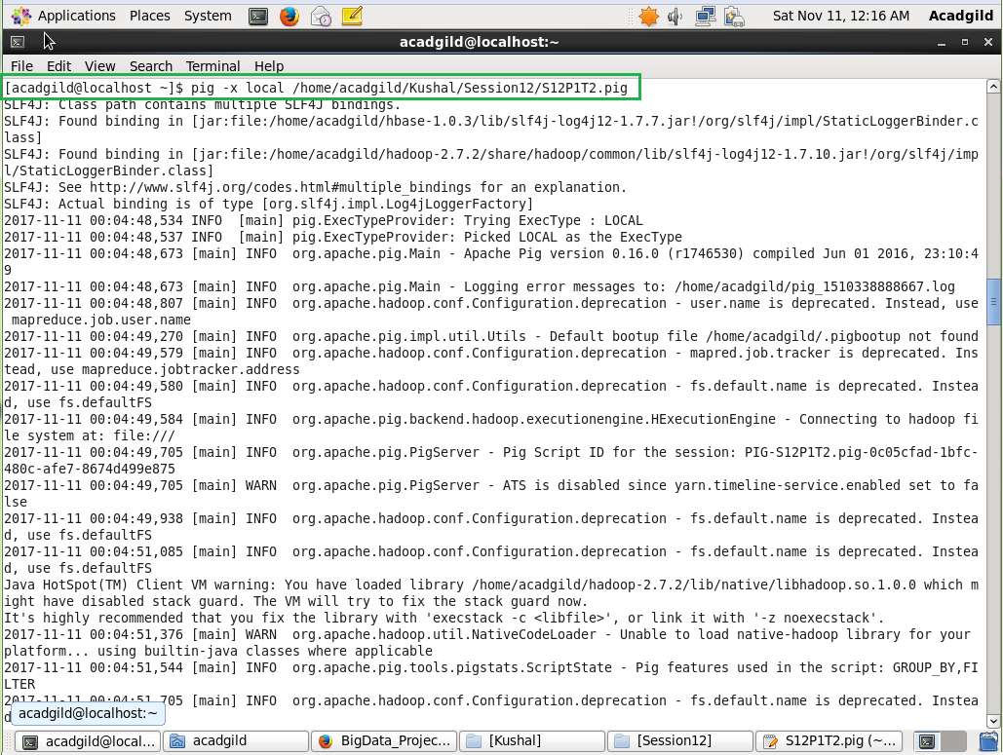

As per question Output of Task 2 – No results are returned.

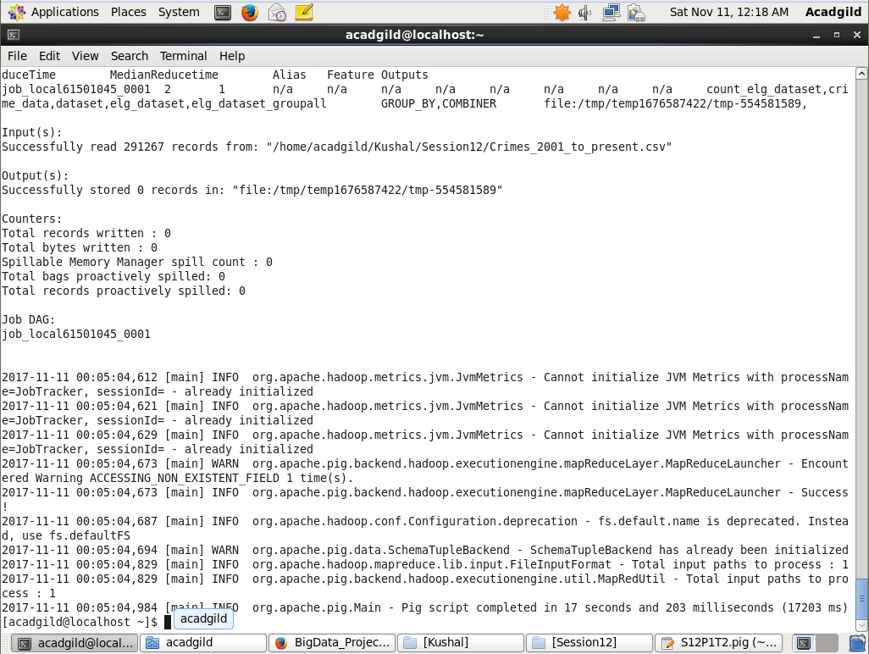

Output if we use other FBI code like 26 –

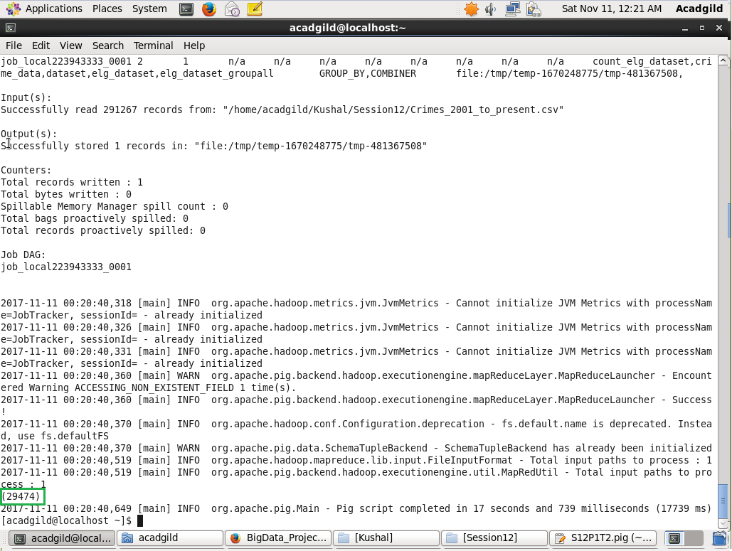

Task 3:

Running Pig file which consists of the commands –

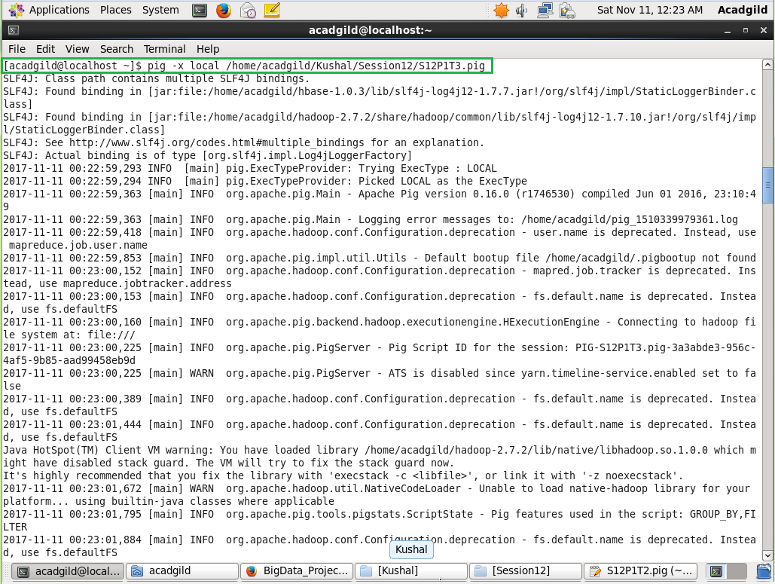

Output of Task3 –

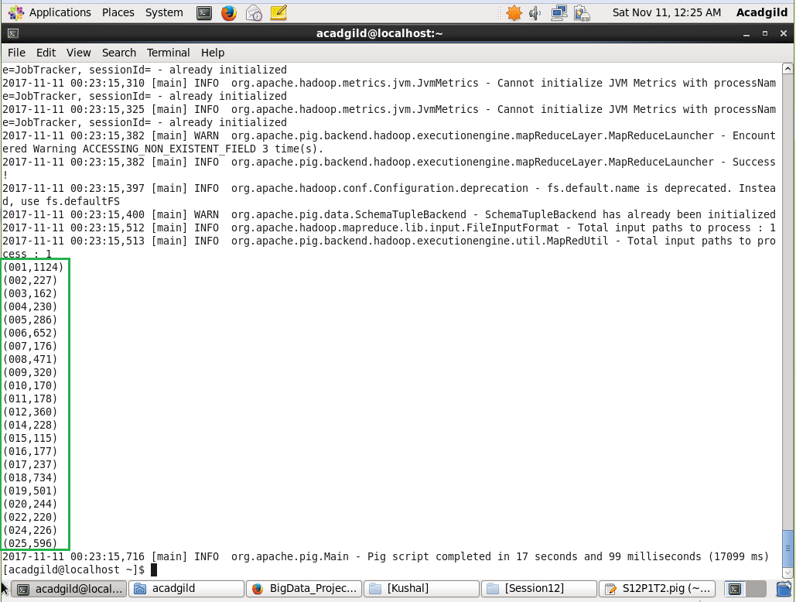

Task 4:

Running Pig file which consists of the commands –

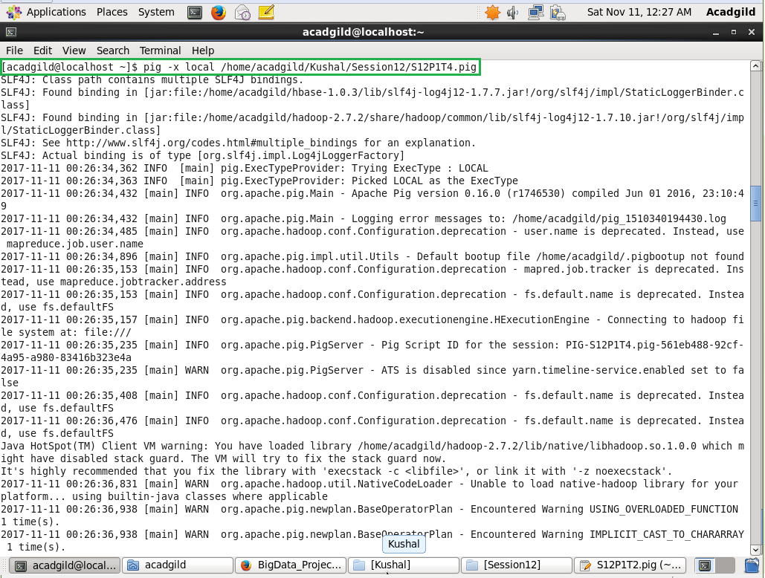

Output of Task4 –

