**Session 17 Assignment 1**

Problem 1: Write a program to read a text file and print the number of rows of data in the document.

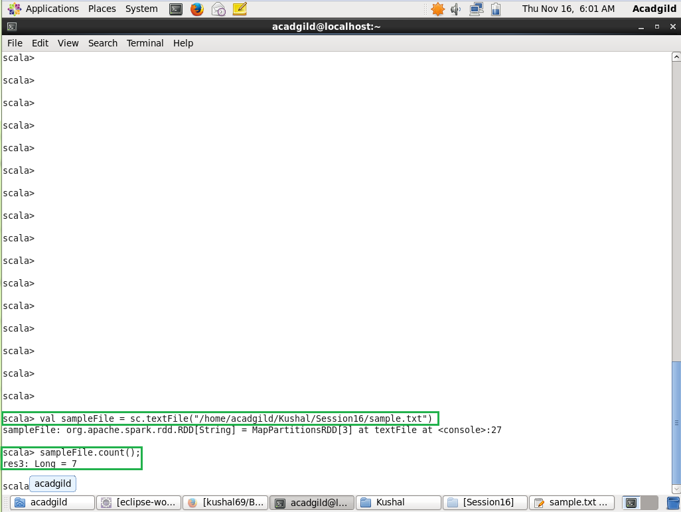

Problem 2: Write a program to read a text file and print the number of words in the document.

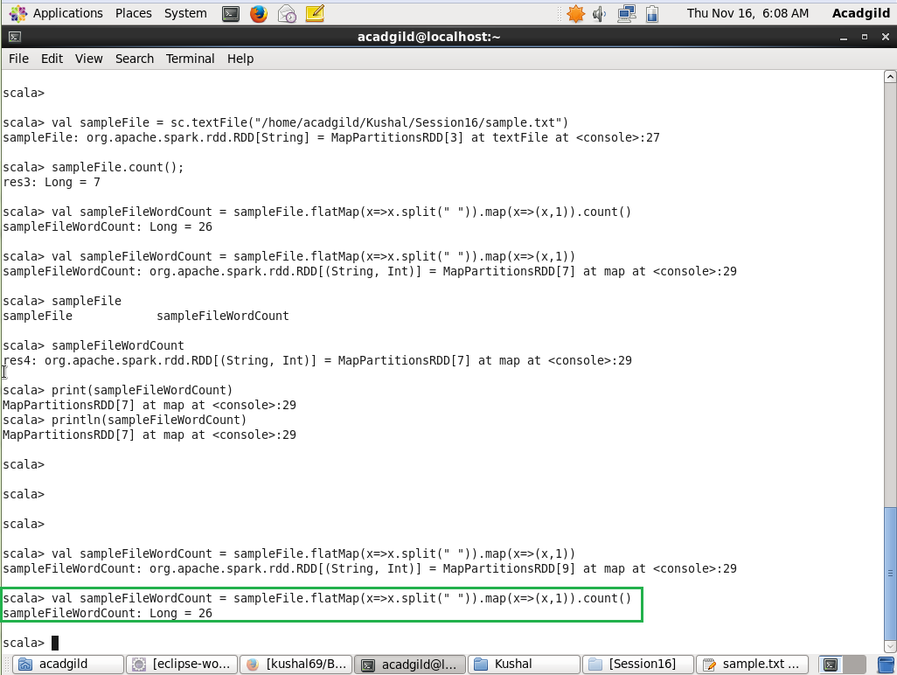

Problem 3: We have a document where the word separator is -, instead of space. Write a spark code, to obtain the count of the total number of words present in the document.

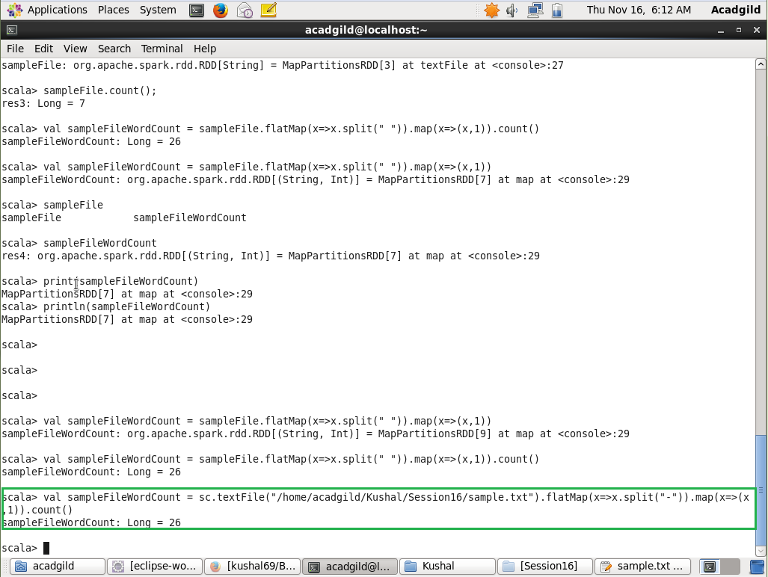

**Sample document:**

This-is-my-first-assignment.

It-will-count-the-number-of-lines-in-this-document.

The-total-number-of-lines-is-3

This is my first assignment.

It will count the number of lines in this document.

The-total-number-of-lines-is-3