**Session 18 Assignment 1**

1. What is the distribution of the total number of air-travellers per year?

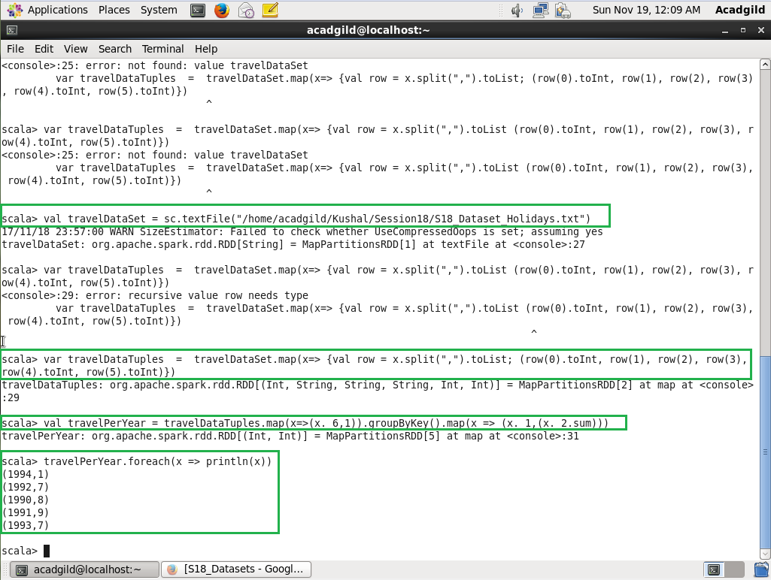

1. What is the total air distance covered by each user per year?

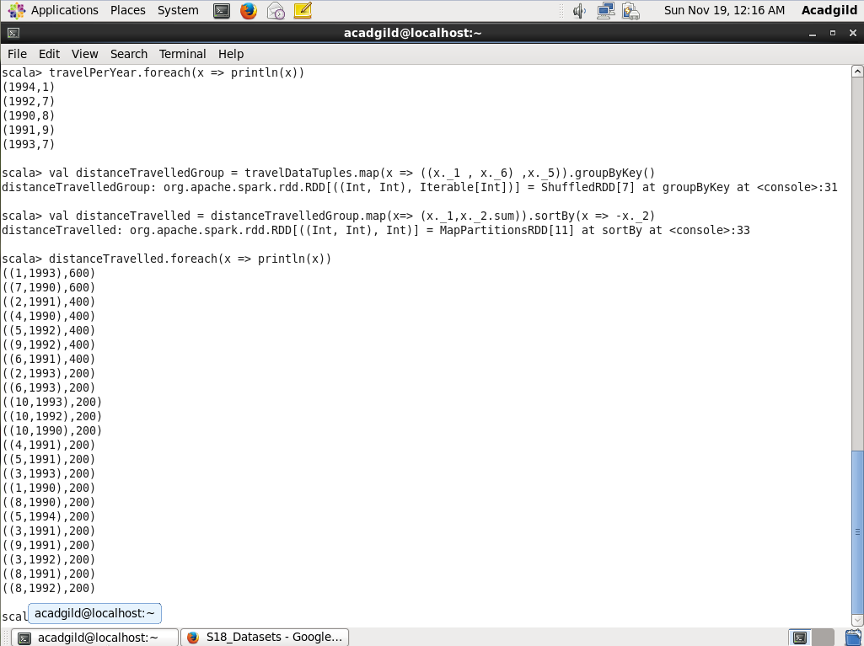

1. Which user has travelled the largest distance till date?

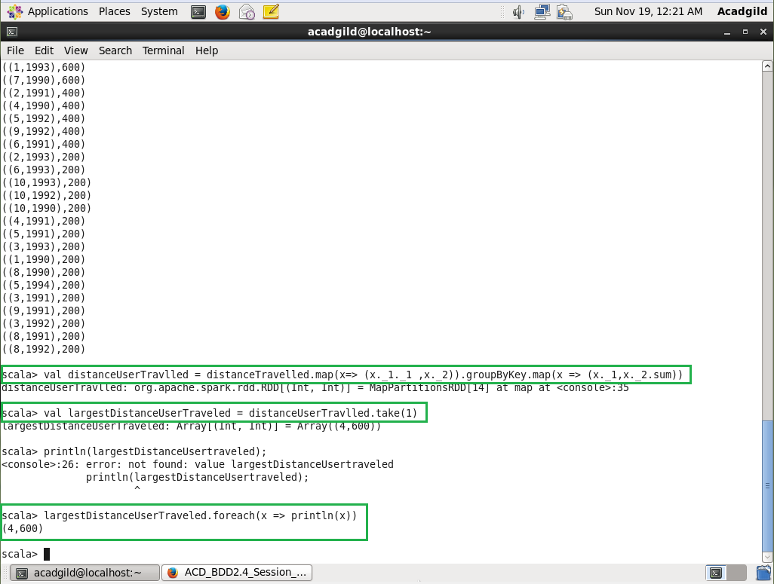

1. What is the most preferred destination for all users?

