**Linux commands**

1. **pwd:** Print the name of the current working directory in which the command is executing.

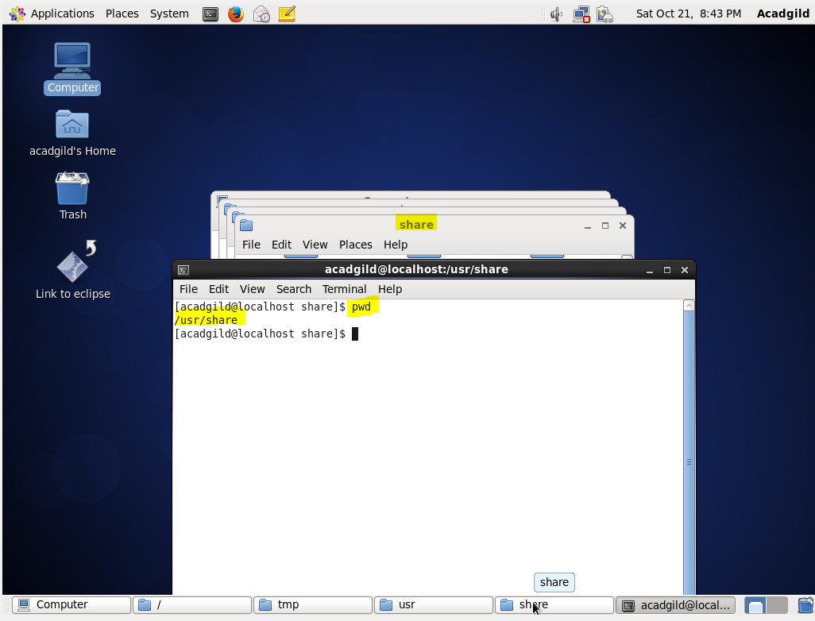

1. **vi:** It is a Text Editor, the terminal acts as interface for the file for which it is opened to edit.

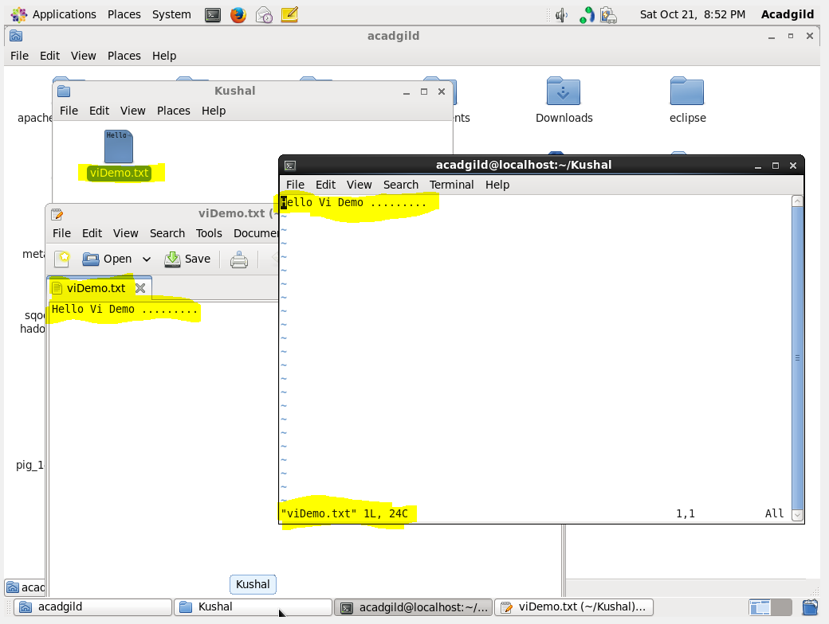

1. **touch:** This command updates the timestamp to the current system time. In the below screen shot viDemo.txt time stamp can be observed.

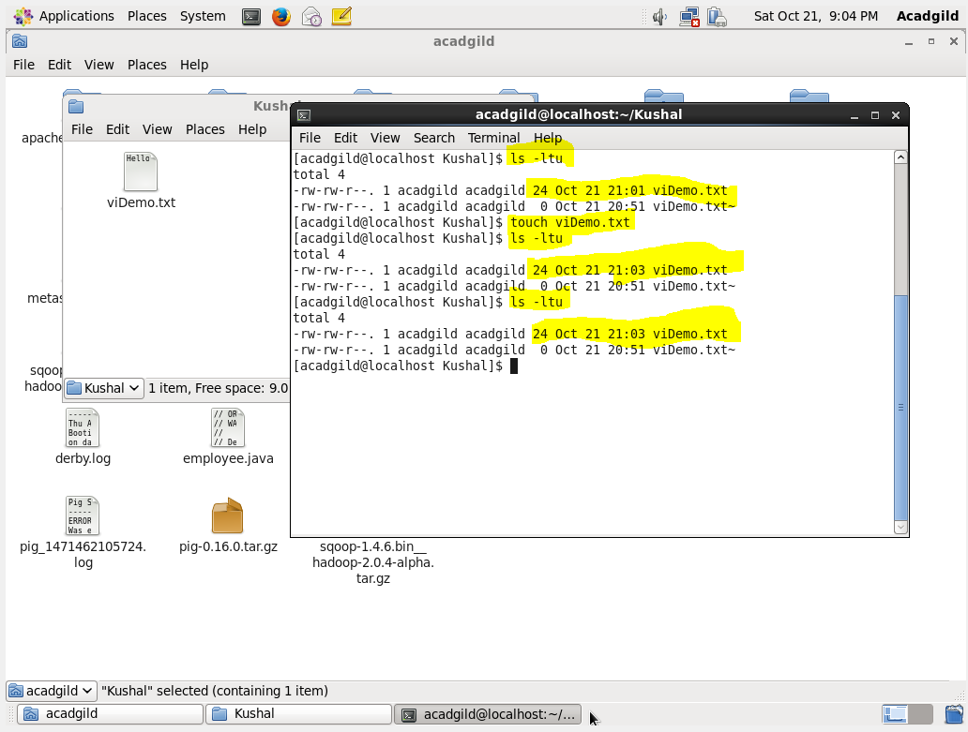

1. **mkdir:** This command is used to make a directory.

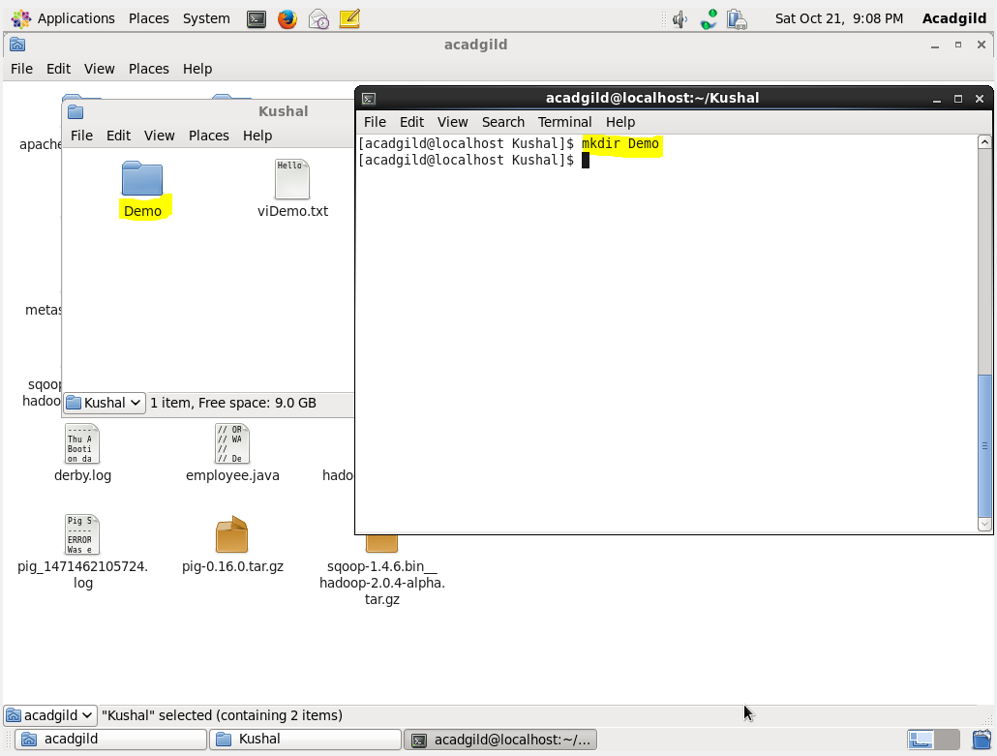

1. **rm:** This Command is used to remove/delete specified file.

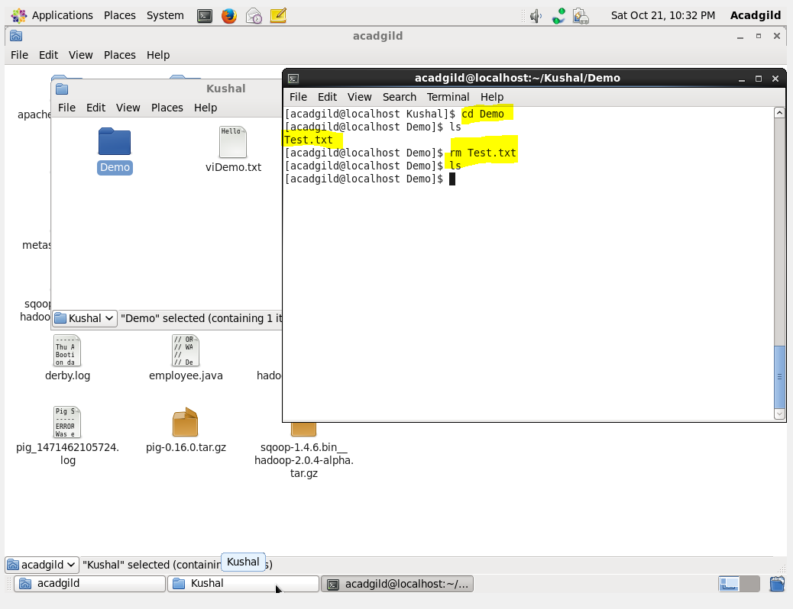

1. **ls:** This Command is used to list the files and directory in the current directory.

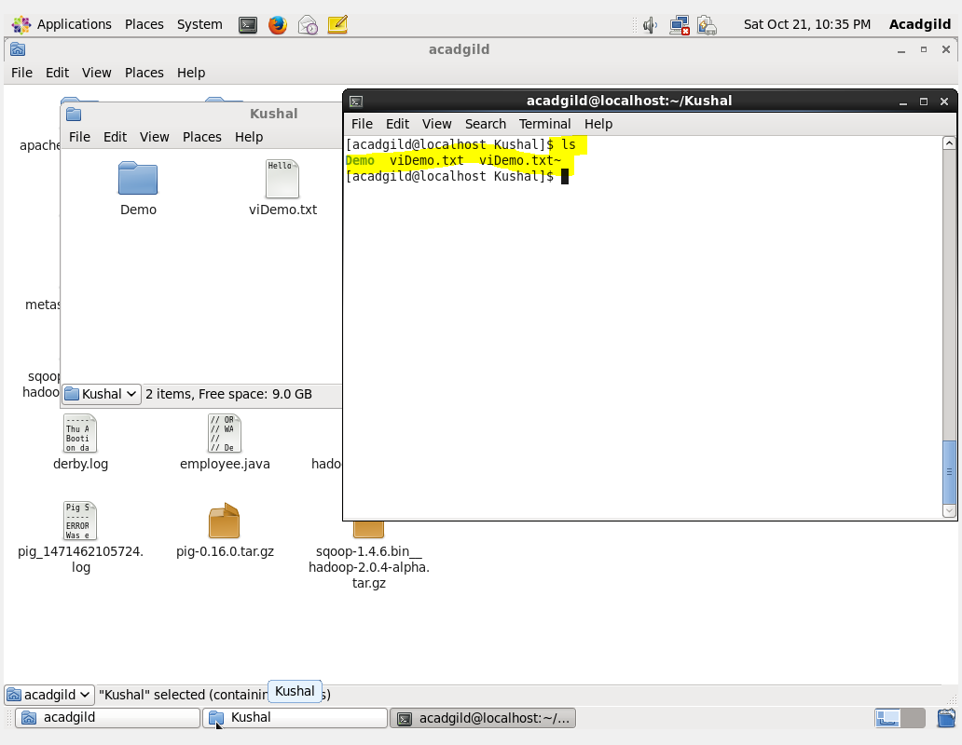

1. **echo:** This command is used to display a line of text/string.

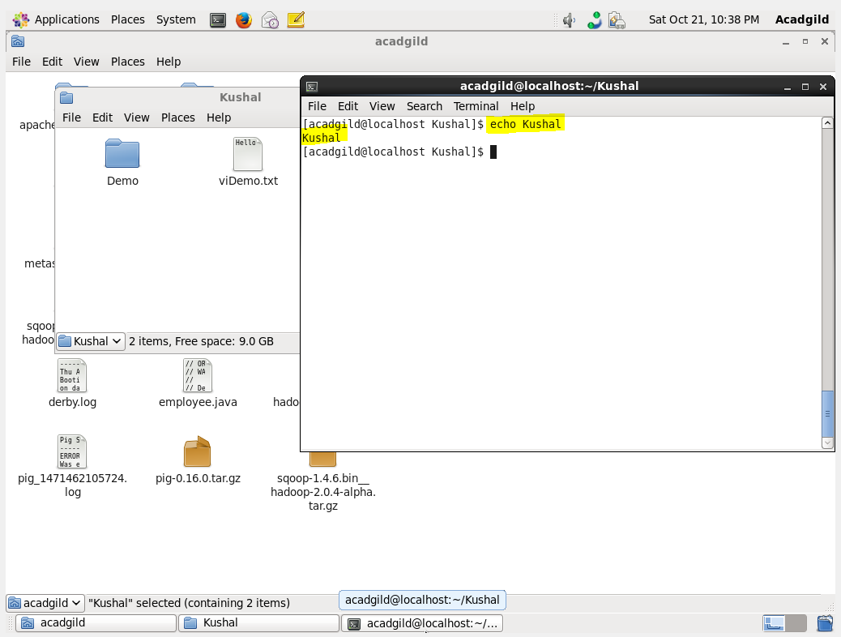

1. **cat:** This command is used to read the file and display the same in the Terminal.

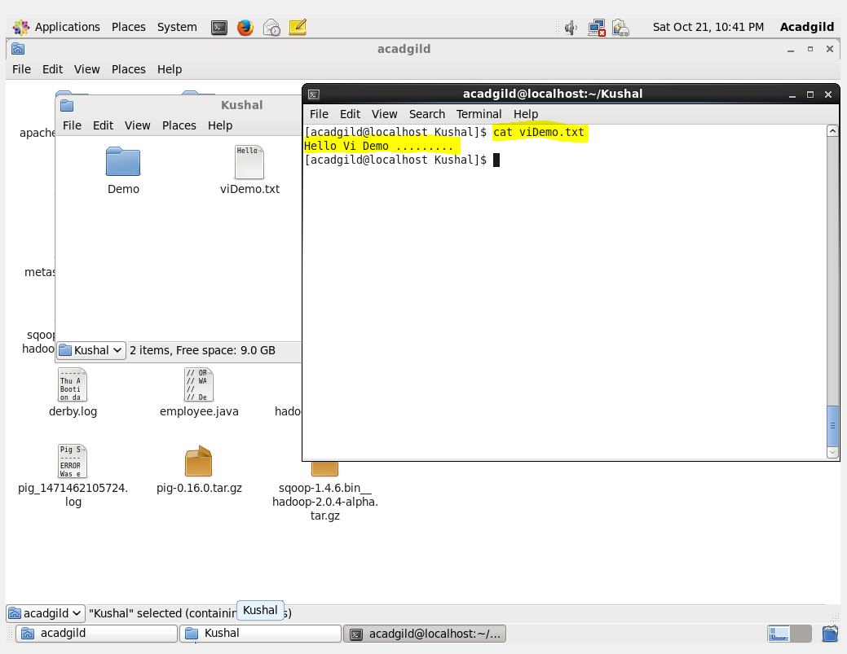

1. **who:** This command is used to print all the information who are all logged in.

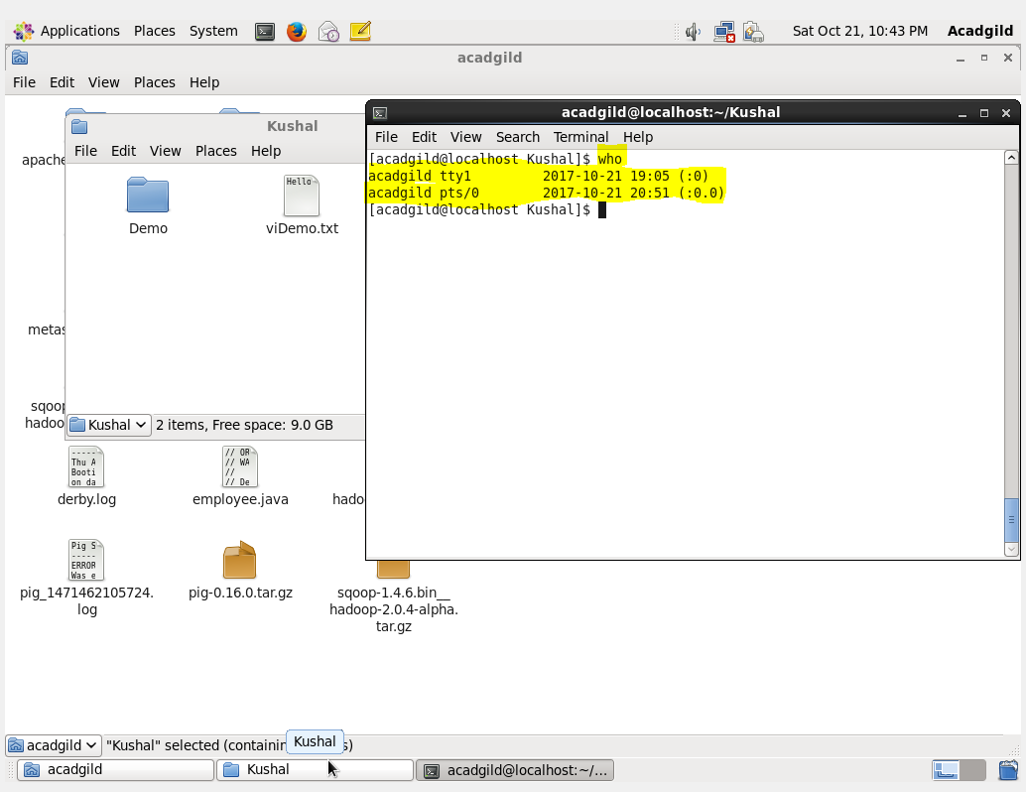

1. **cd:** This command is used to change directory in the terminal.

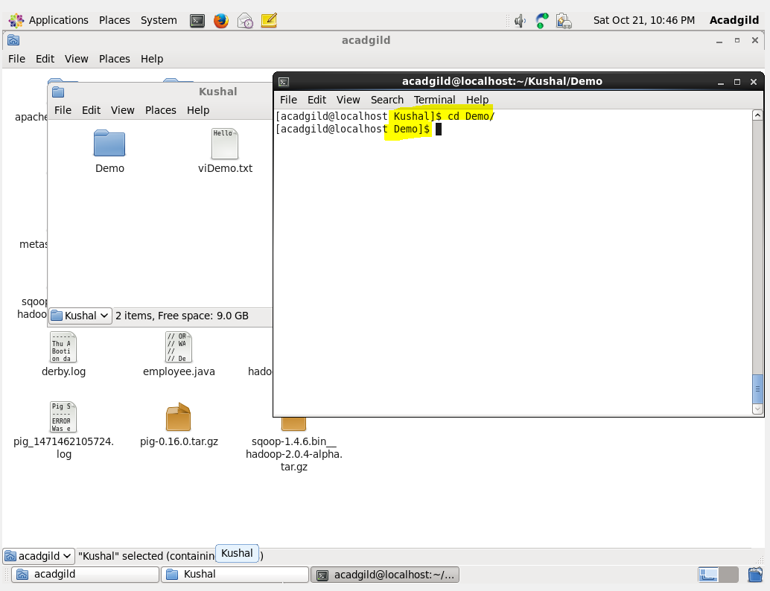

1. **date**: This command is used to print the value of the system time and date.

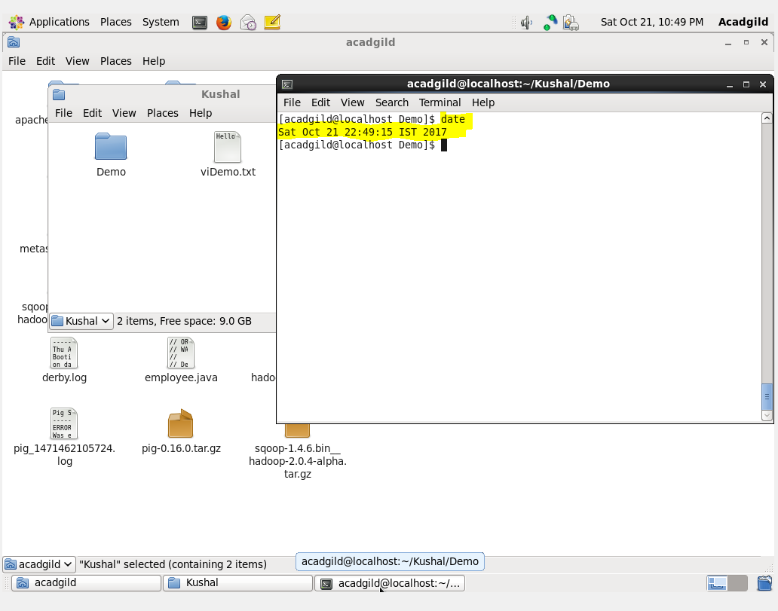

1. **cal:** This command is used to displays the current month at the Terminal.

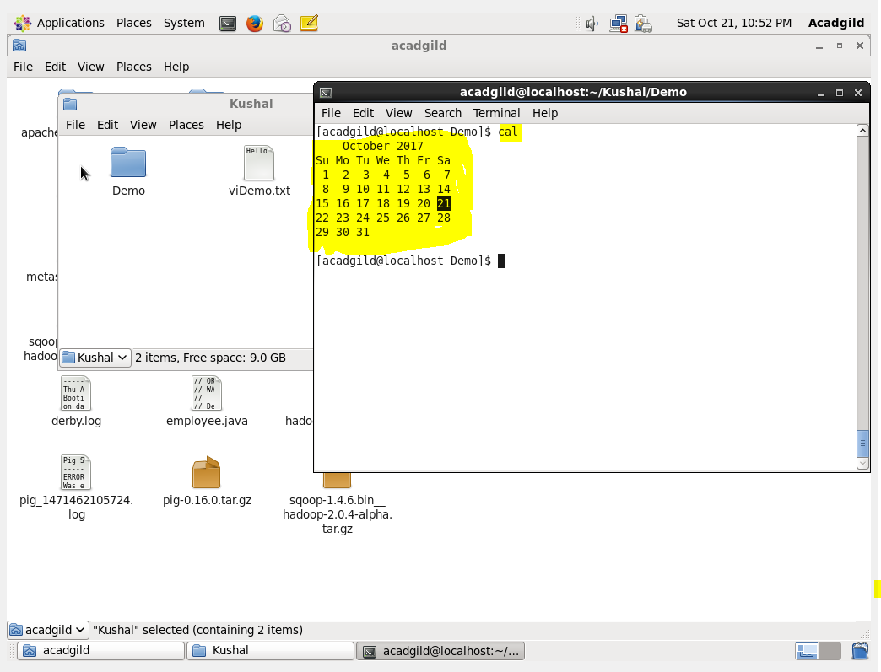

1. **mv:** This command is used to move or rename file at the destination.

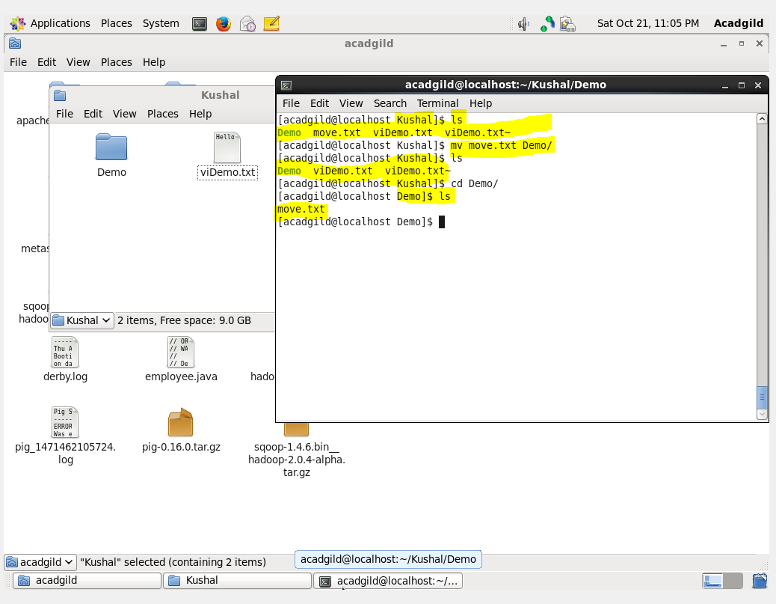

1. **cp:** This command is used to make copies of files and directories.

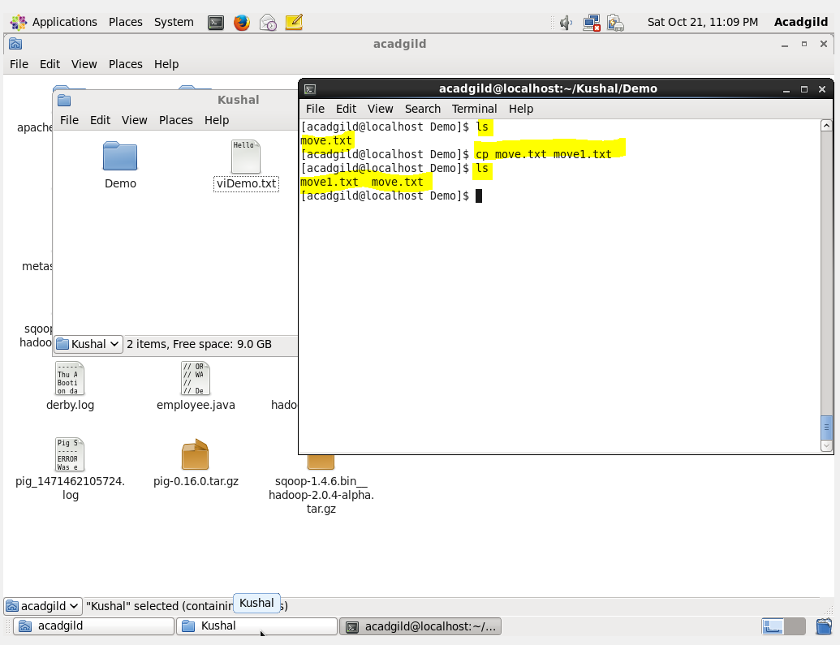

1. **which:** This command is used to locate the file in which path it will be executed.

