**Session 2 Assignment 1 Task 1:**

In the HDFS /user/acadgild/ was present but not the /hadoop folder. Hence created the same as /user/acadgild/hadoop in the hdfs below is the screenshot.

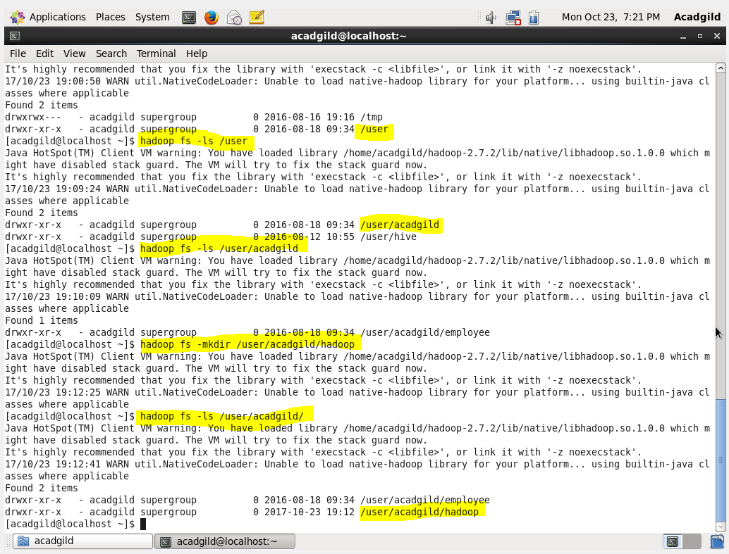

Now creating the file “word-count.txt” using touchz cmd with hadoop in HDFS. And appending the data from the terminal to the file. Below are the cmds which are used,

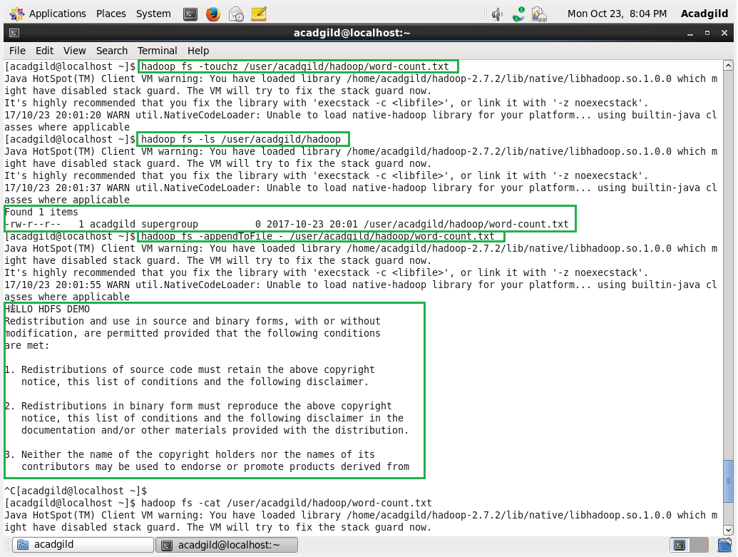

Displaying the entered input from the terminal,

