**Session 2 Assignment 2**

Created a text file in the local file system and displaying it in the terminal. Then moving the same file from the local file system to hdfs with –put cmd. Later checking the file has been moved by –ls cmd.

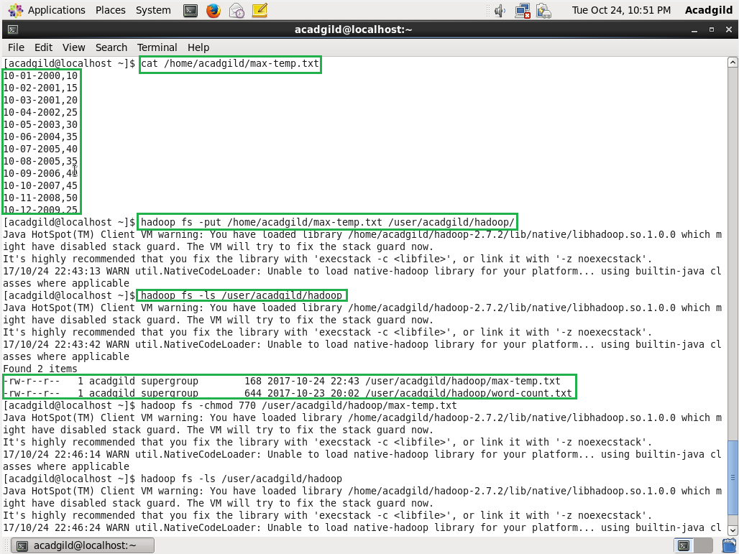

Changing the permissions of the file with chmod and set the permission to 770 as per question.

