Session 5 Assignment 3

**Load Data:**

Load_Data = LOAD ‘/home/acadgild/Kushal/Session5/Assignment3/Pokemon.csv’ USING PigStorage(‘,’) AS(Sno:int,Name:chararray,Type1:chararray,Type2:chararray,Total:int,HP:int,Attack:int,Defense:int,SpAtk:int,SpDef:int,Speed:int);

Screnshots ->

Question 1:

* selected_list = FILTER Load_Data BY Defense>55;

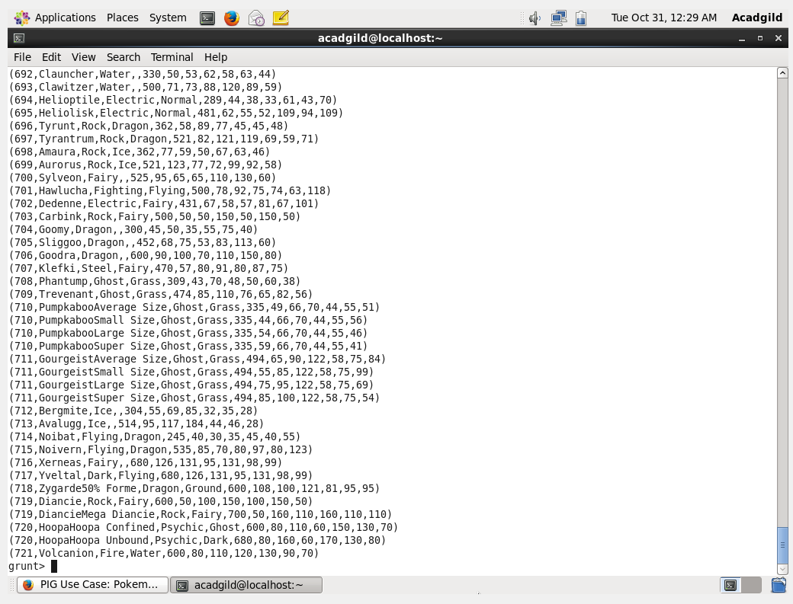

Question 2:

* gourp_selcted_list = Group selected_list All;
* count_selcted_list = foreach gourp_selcted_list GENERATE COUNT(selected_list);

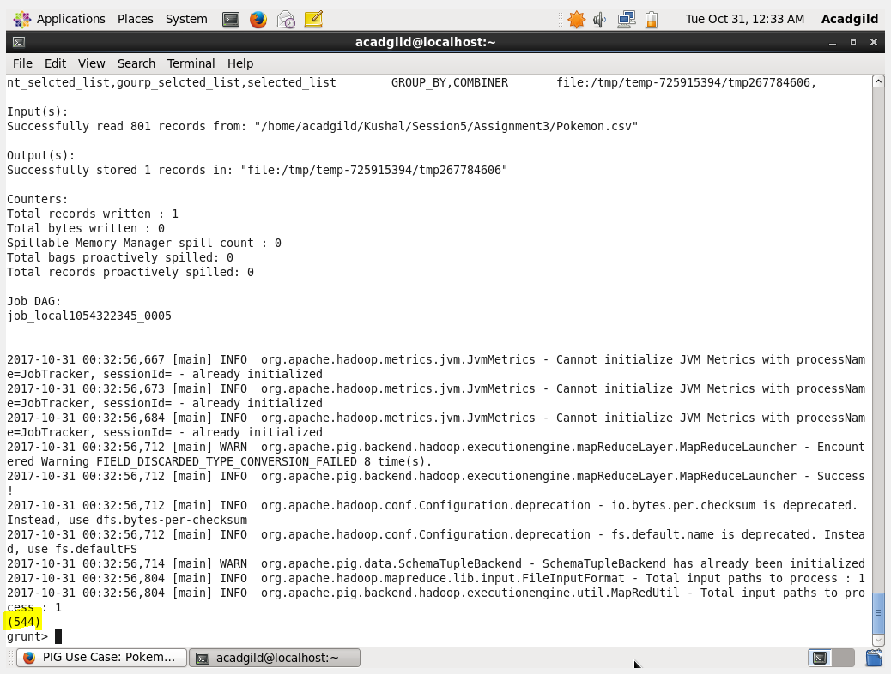

Question 3:

* random_include1 = foreach selected_list GENERATE RANDOM(),Name,Type1,Type2,Total,HP,Attack,Defense,SpAtk,SpDef,Speed;

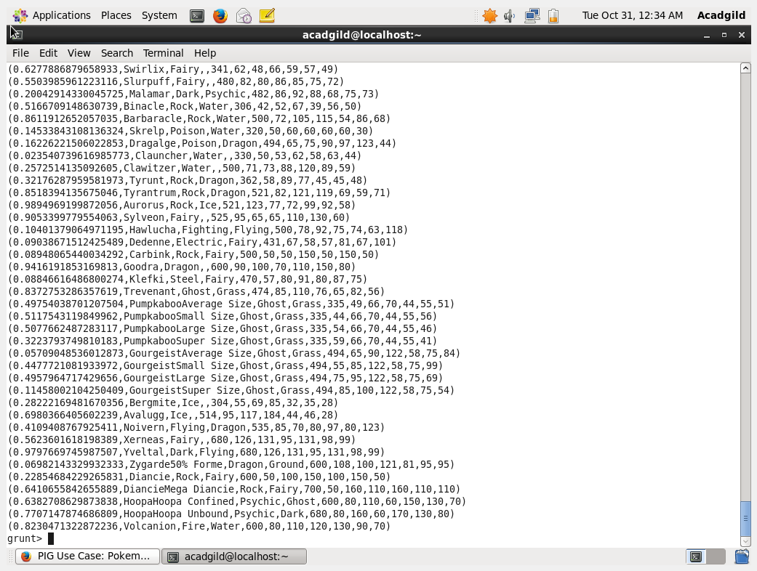

Question 4:

* random1_desending = ORDER random_include1 BY $0 DESC;

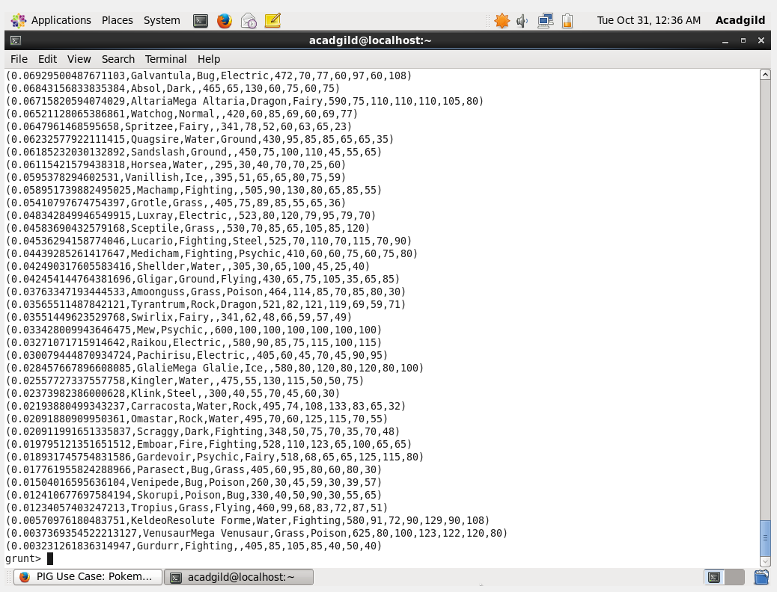

Question 5:

* random_include2 = foreach selected_list GENERATE RANDOM(), Name,Type1,Type2,Total,HP,Attack,Defense,SpAtk,SpDef,Speed;
* random2_desending = ORDER random_include2 BY $0 DESC;

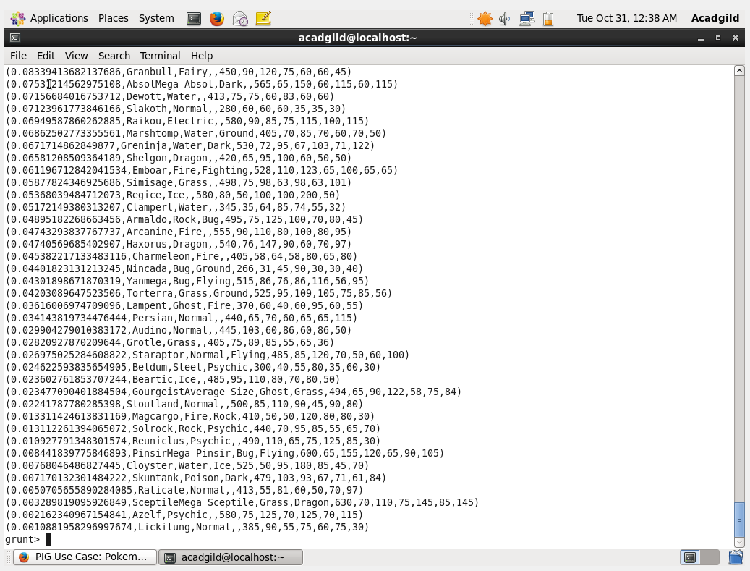

Question 6:

* limit_data_random1_desending = LIMIT random1_desending 5 ;

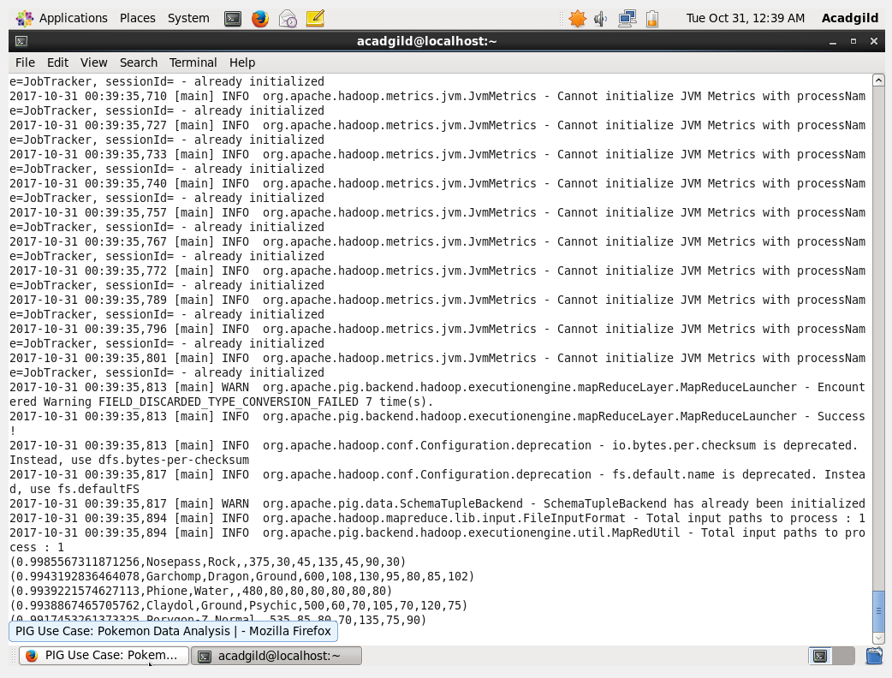

* limit_data_random2_desending = LIMIT random2_desending 5 ;

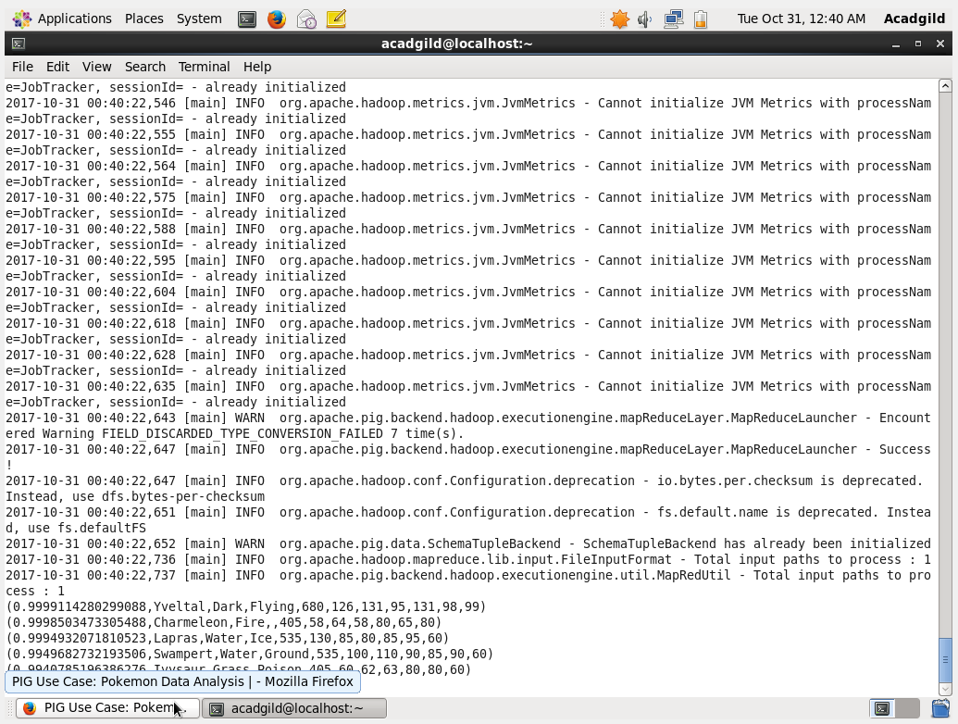

Question 7:

* filter_only_name1 = foreach limit_data_random1_desending Generate ($1,HP);

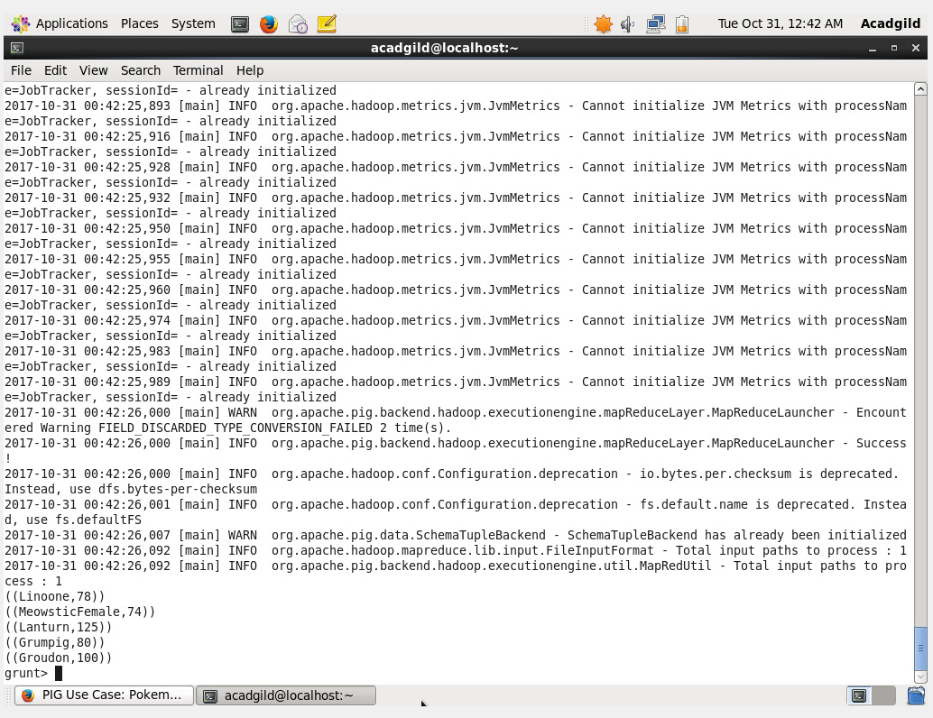

* filter_only_name2 = foreach limit_data_random2_desending Generate ($1,HP);

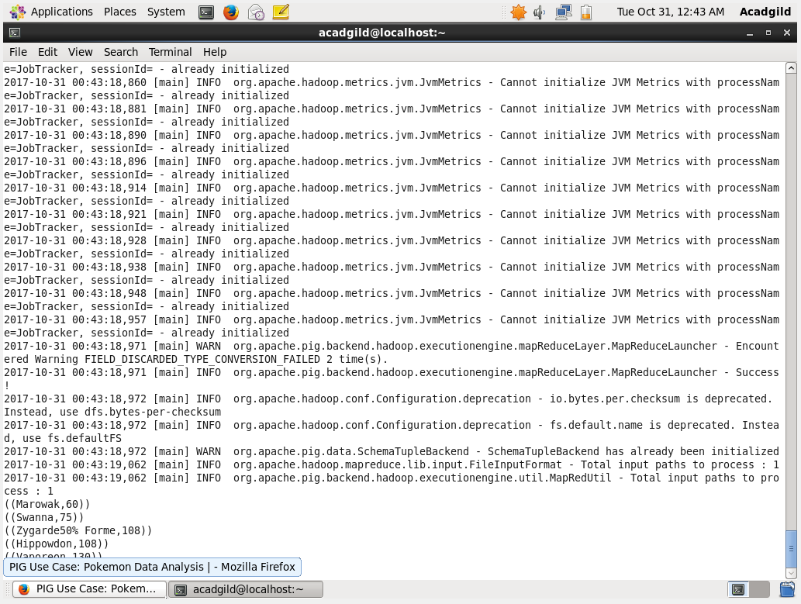

Storing:

* STORE limit_data_random1_desending INTO ‘/home/acadgild/ Kushal/Session5/Assignment3/player1.txt’;
* STORE limit_data_random2_desending INTO ‘/home/acadgild/ Kushal/Session5/Assignment3/player2.txt’;

