Session 6 Assignment 1

Start Local DB -> sudo service msqld start

Start hive shell -> hive

Created the Database ‘custom’

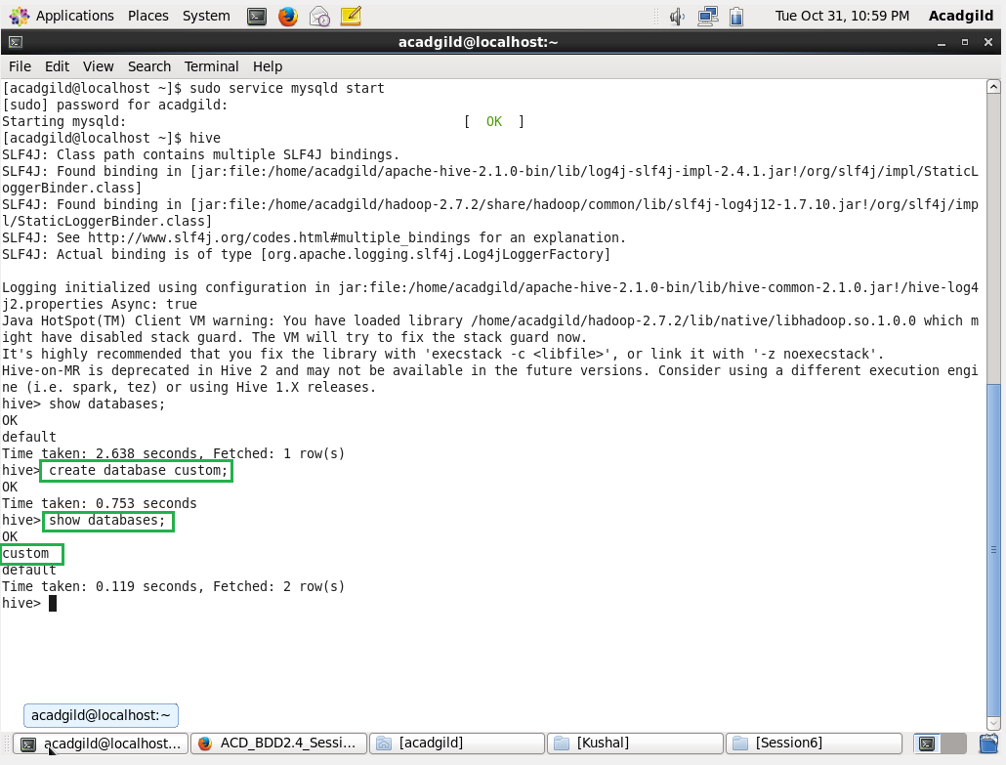

To create a table ->

CREATE TABLE if not exists temperature_data (temp_date STRING, temp_zipcode INT, temp_temparature INT) row format delimited fields terminated by ',';

To LOAD Data ->

LOAD DATA LOCAL INPATH ‘/home/acadgild/Kushal/Session6/dataset_Session14.txt’ INTO TABLE custom.temparature_data;

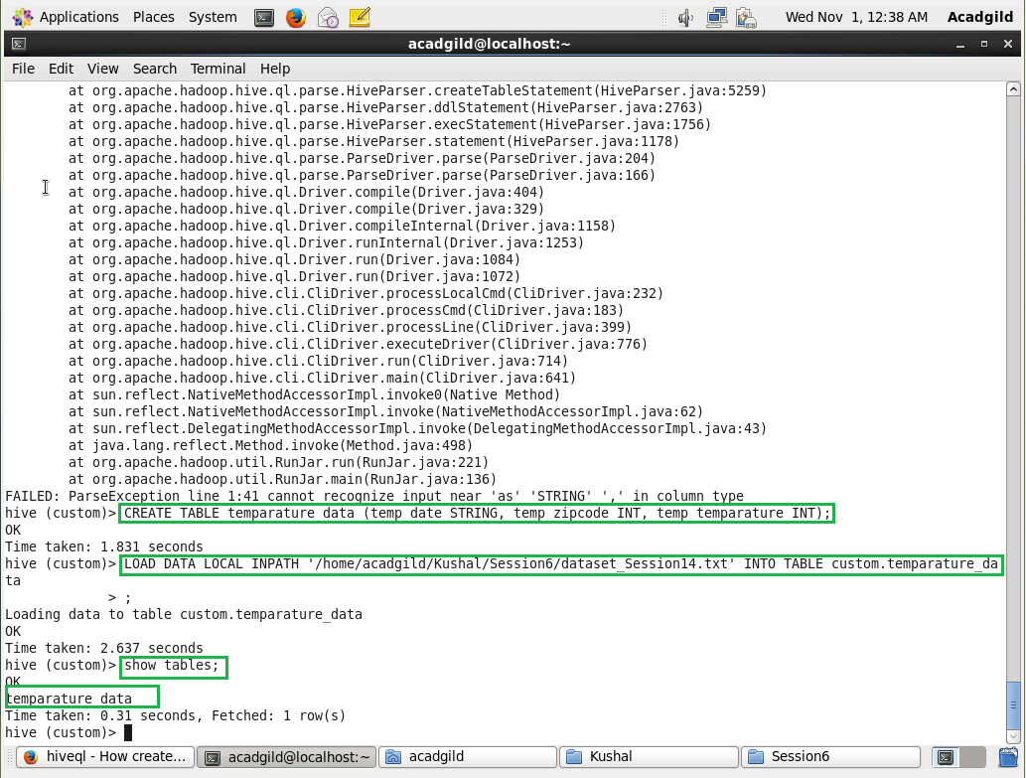

To display the Table Contents ->

Select * from temperature_data;

