Session 6 Assignment 6

* Fetch date and temperature from temperature_data where zip code is greater than

300000 and less than 399999.

* Select temp_date, temp_temparature from temperature_data where temp_zipcode > 300000 and temp_zipcode < 399999;

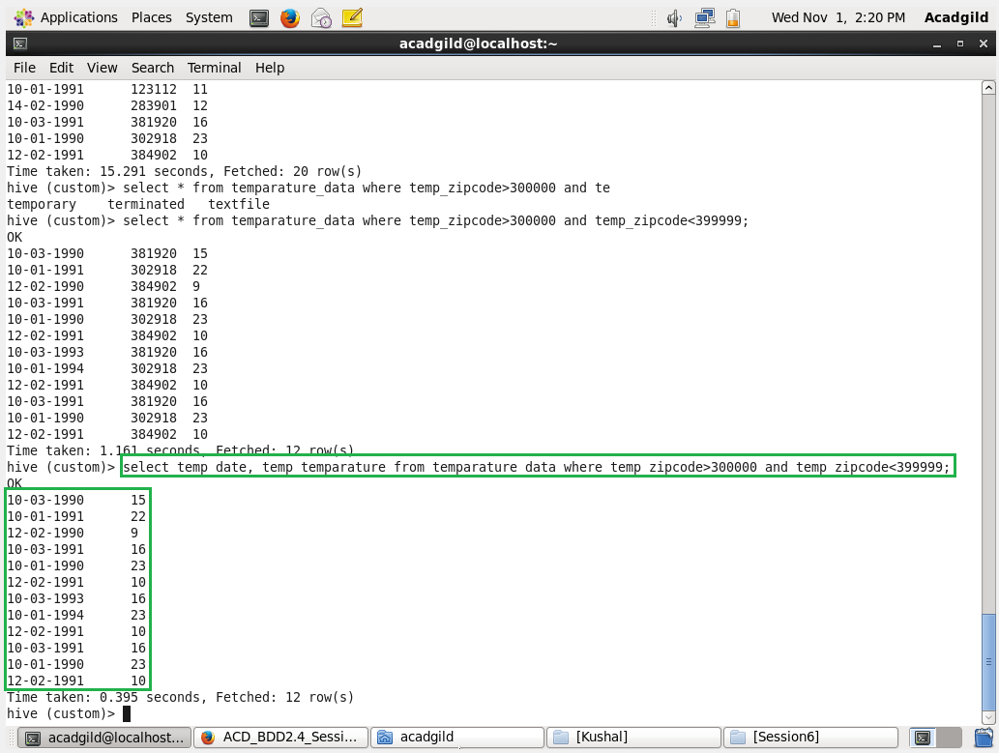

* Calculate maximum temperature corresponding to every year from temperature_data

table.

* Select substring(temp_date,7,10), max(temp_temparature) from temperature_data group by substring(temp_date,7,10);

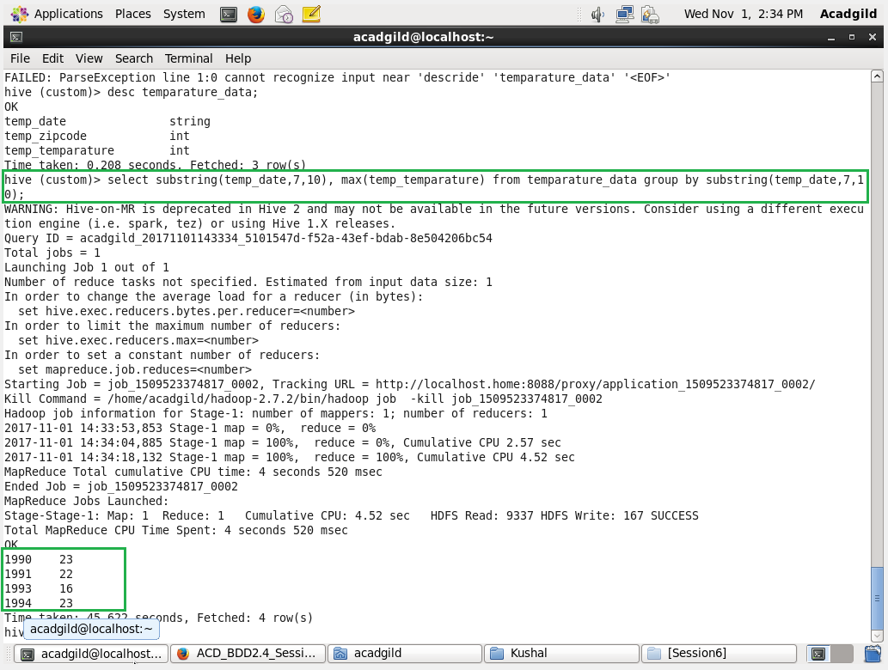

* Calculate maximum temperature from temperature_data table corresponding to those

years which have at least 2 entries in the table.

* Select substring(temp_date,7,10), max(temp_temparature) from temperature_data group by substring(temp_date,7,10) having count(temp_date) > 1;

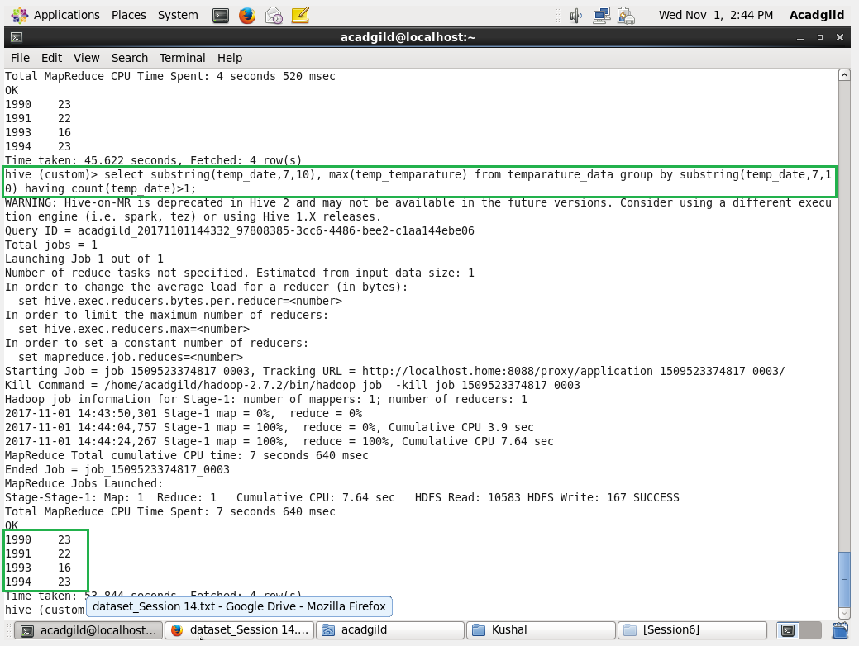

* Create a view on the top of last query, name it temperature_data_vw.
* Create view if not exists temperature_data_vw as Select substring(temp_date,7,10), max(temp_temparature) from temperature_data group by substring(temp_date,7,10) having count(temp_date) > 1;

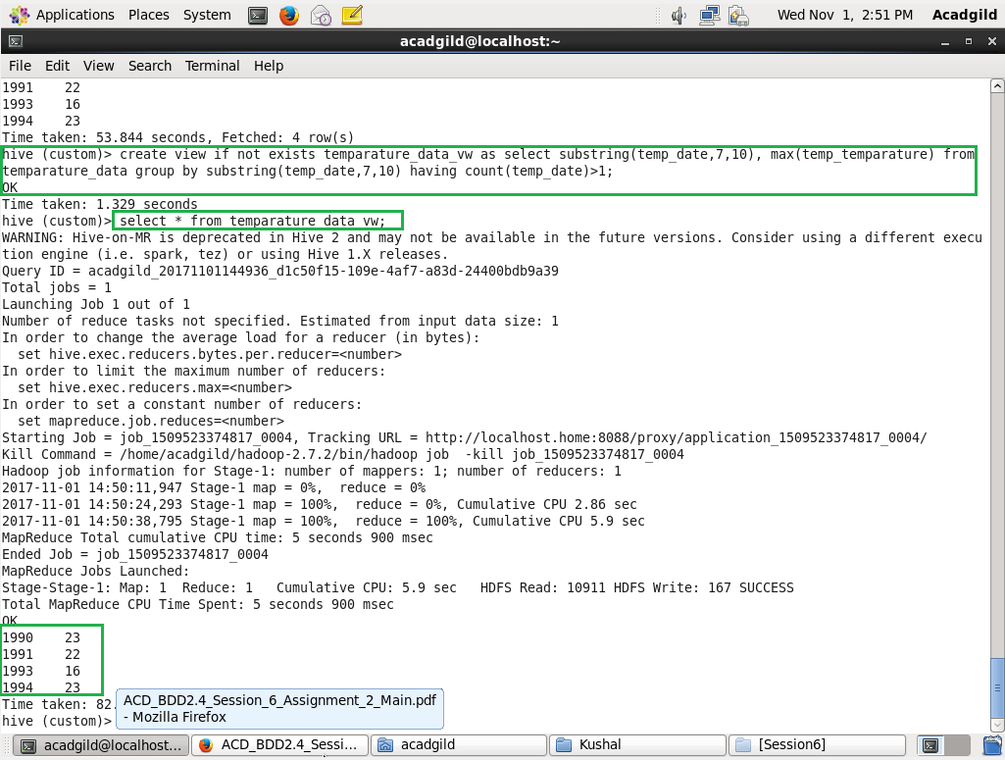

* Export contents from temperature_data_vw to a file in local file system, such that each

file is '|' delimited.

* Insert overwrite local directory ‘/home/acadgild/Kushal/Session6/’ row format delimited fields terminated by ‘|’ select * from temperature_data_vw;

