**Session 7 Assignment 1**

Commands to create the Employee table with given data ->

* CREATE TABLE employee (emp_name string, emp_skill string, emp_level int, emp_city string) ROW FORMAT DELIMITED FIELDS TERMINATED BY ',';
* load data local inpath '/home/acadgild/Kushal/Session7/emp_details.txt' into table employee;

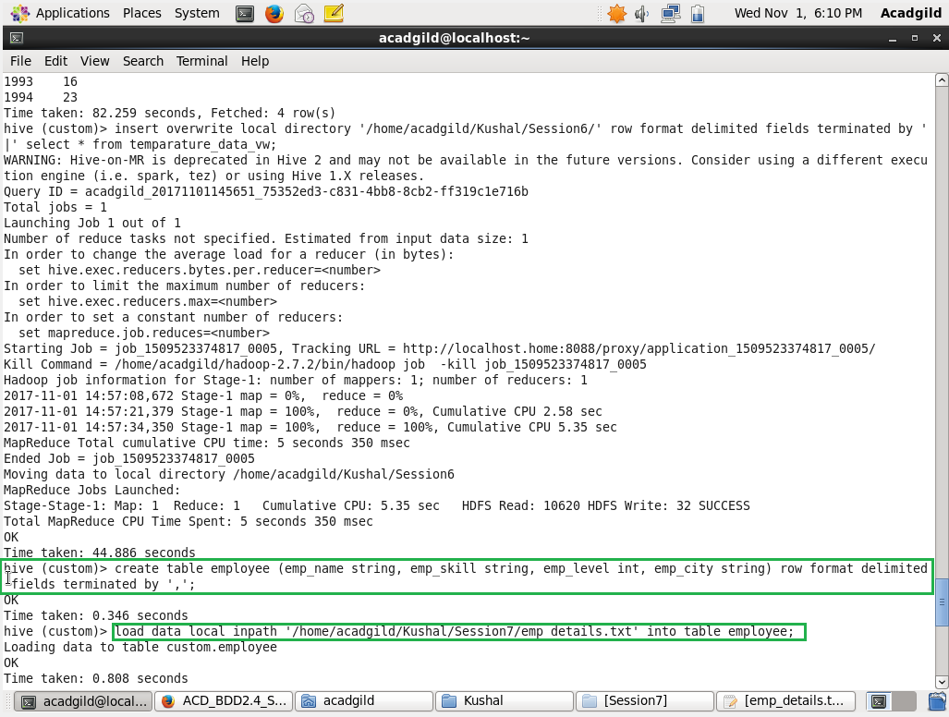

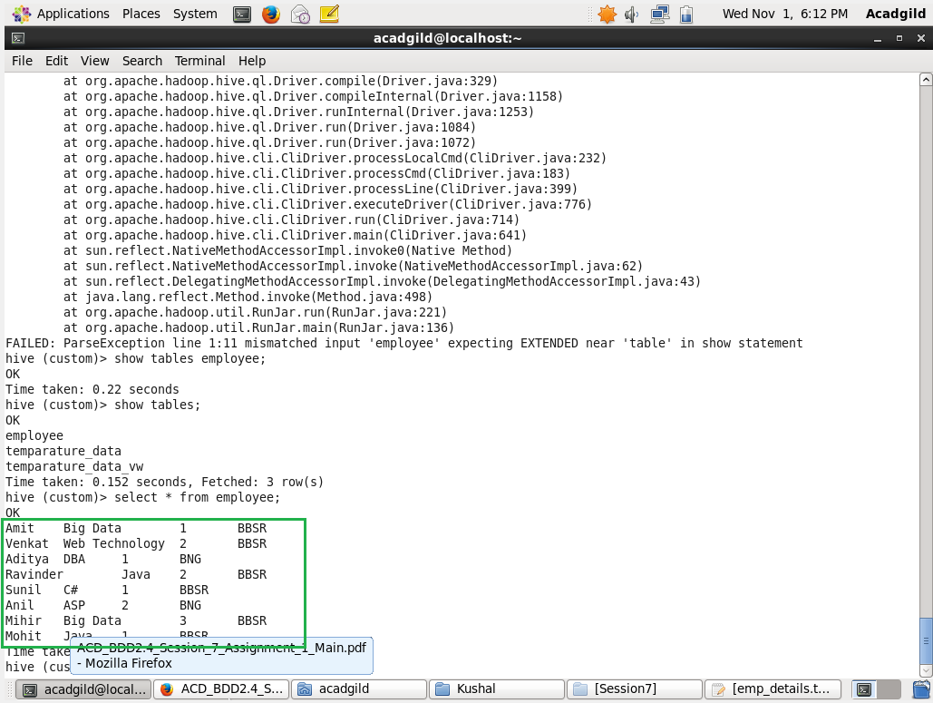

* select emp_skill, count(emp_name) from employee group by emp_skill;

