**Session 7 Assignment 2**

Query to create Olympic Table ->

* create table olympic (athelete string, age int, country string, year int, closing_date string, sport string, gold_medals int, silver_medals int, bronze_medals int, total_medals int) row format delimited fields terminated by ‘\t’;
* load data local inpath ‘/home/acadgild/Kushal/Session7/olympix_data.csv’ into table olympic;

1. **Write a Hive program to find the number of medals won by each country in swimming.**

Query -> select country, sum(total) from olympic where sport = “Swimming” group by country;

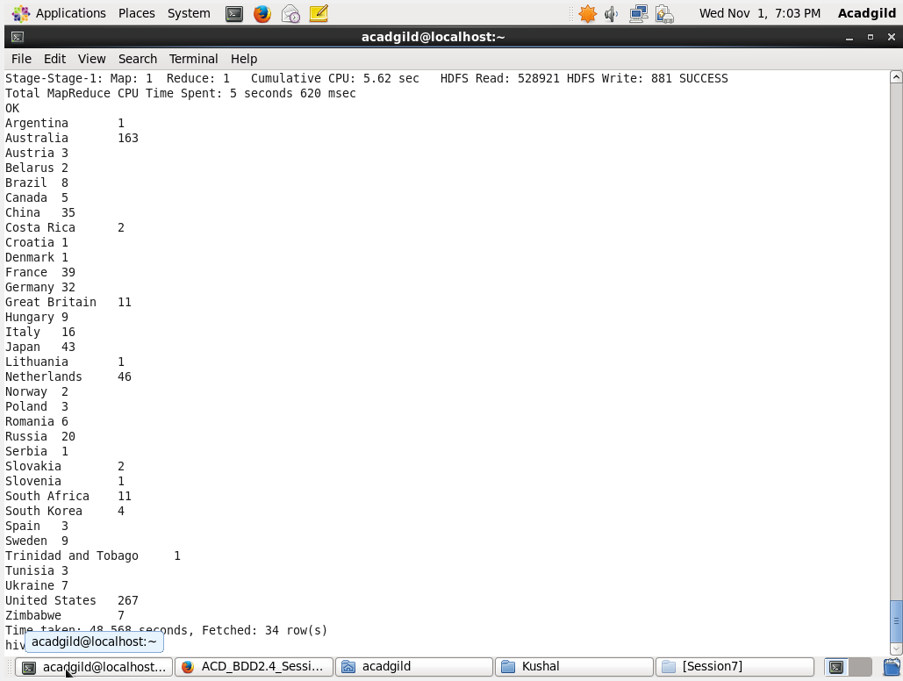

1. **Write a Hive program to find the number of medals that India won year wise.**

Query -> select year, sum(total) from olympic where country = ‘India’ group by year;

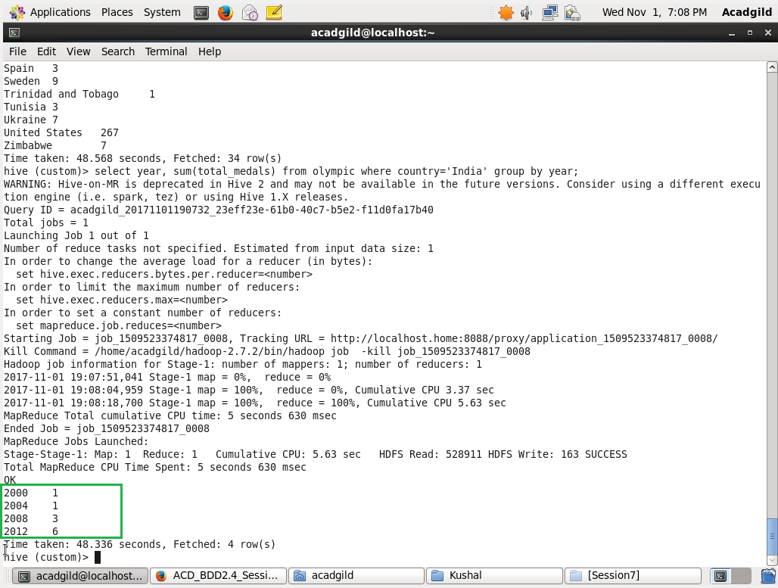

1. **Write a Hive Program to find the total number of medals each country won.**

Query -> select country, sum(total) from olympic group by country;

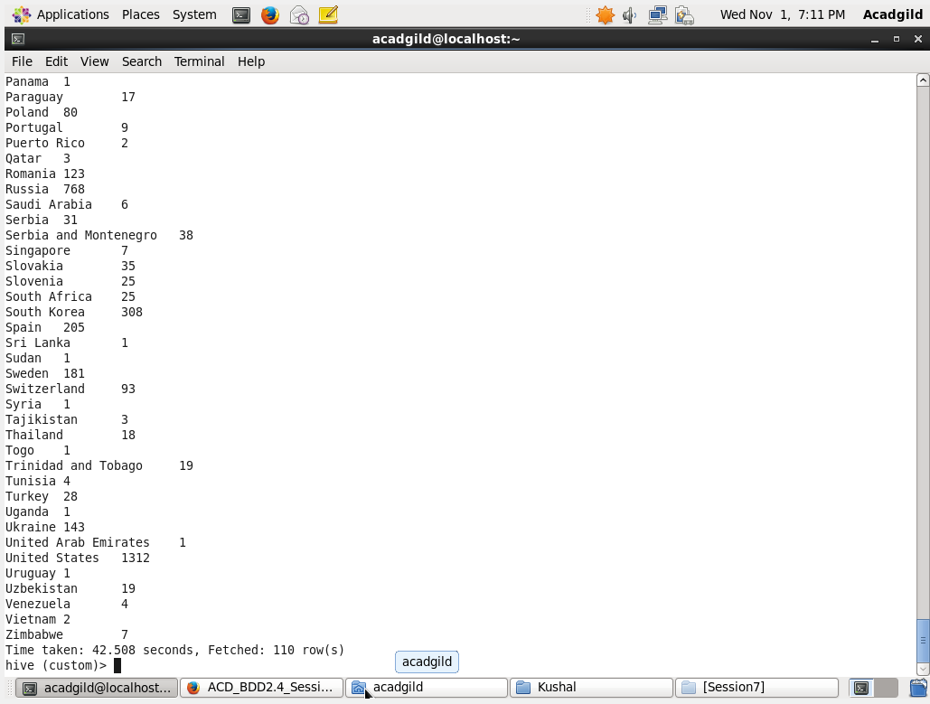

1. **Write a Hive program to find the number of gold medals each country won**

Query -> select country, sum(gold) from olympic group by country;

