**Session 8 Assignment 1**

Loading Data ->

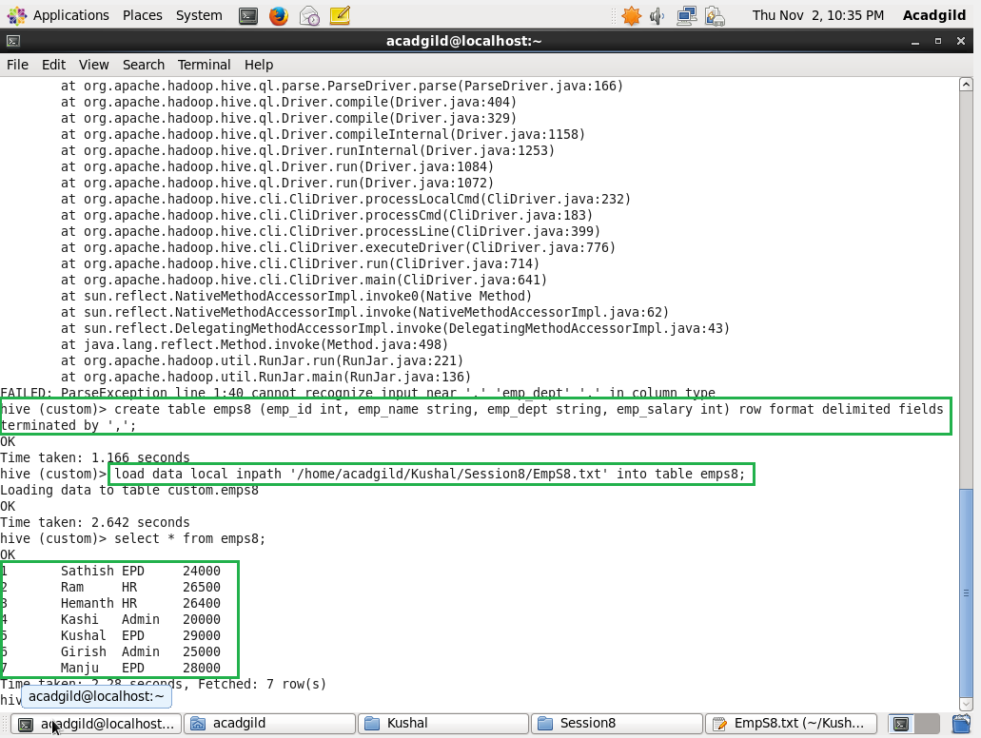

* Get a list of employees who receive a salary less than 100, compared to their immediate employee with higher salary in the same unit

Command –

select e1.emp_id, e1.emp_name, e1.emp_dept, e1.emp_salary from (select emp_id, emp_name, emp_dept, emp_salary from emps8) e1 join (select emp_dept, emp_salary from emps8) e2 on e1.emp_dept=e2.emp_dept where e2.emp_salary>e1.emp_salary and e2.emp_salary-e1.emp_salary=100;

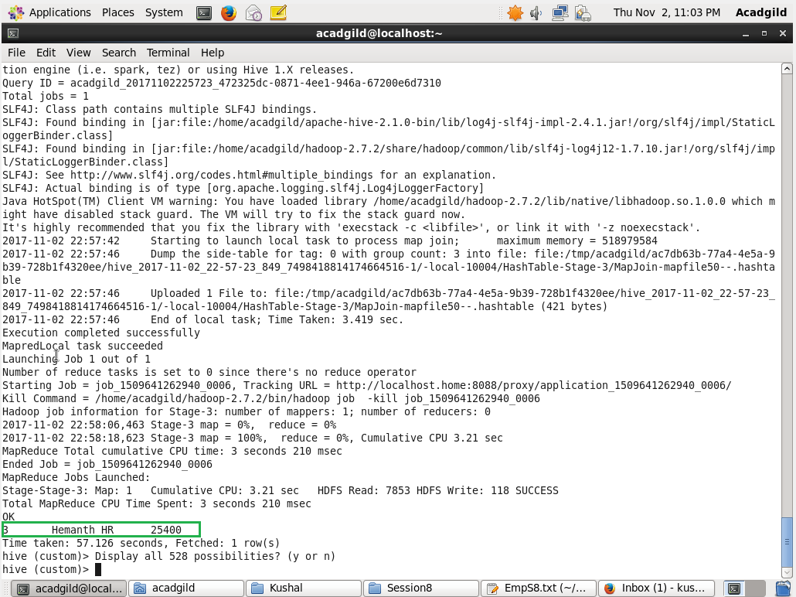

* List of all employees who draw higher salary than the average salary of that department

Command -

select e1.emp_id, e1.emp_name, e1.emp_dept, e1.emp_salary, e2.emp_salary from (select emp_id, emp_name, emp_dept, emp_salary from emps8) e1 join (select emp_dept, avg(emp_salary) emp_salary from emps8 group by emp_dept) e2 on e1.emp_dept=e2.emp_dept where e1.emp_salary>e2.emp_salary;

