**Session 9 Assignment 2**

Started HBase shell and Login to the same.

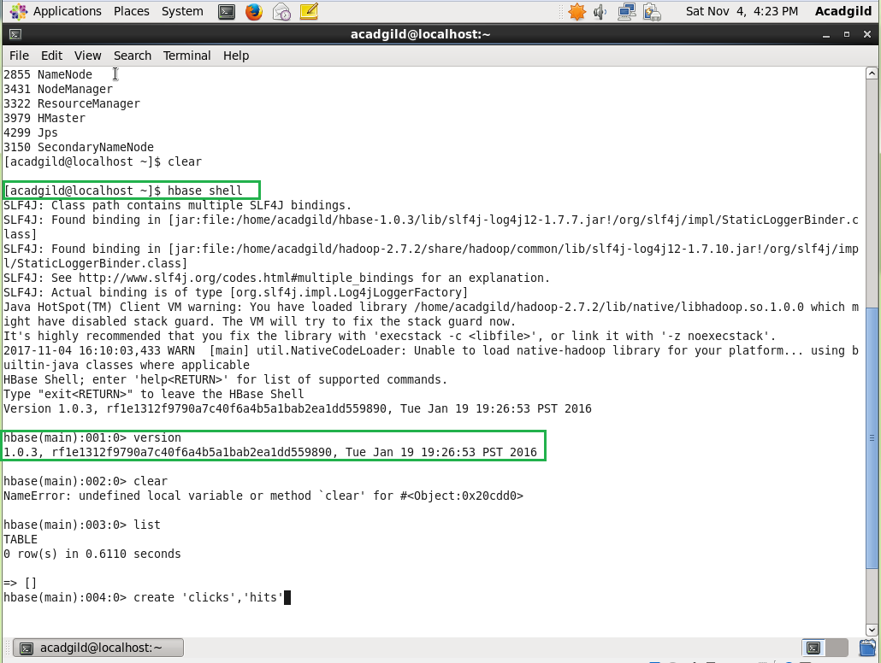

**Problem 1:**

* Create an HBase table named 'clicks' with a column family 'hits' such that it should be able to store last 5 values of qualifiers inside 'hits' column family.

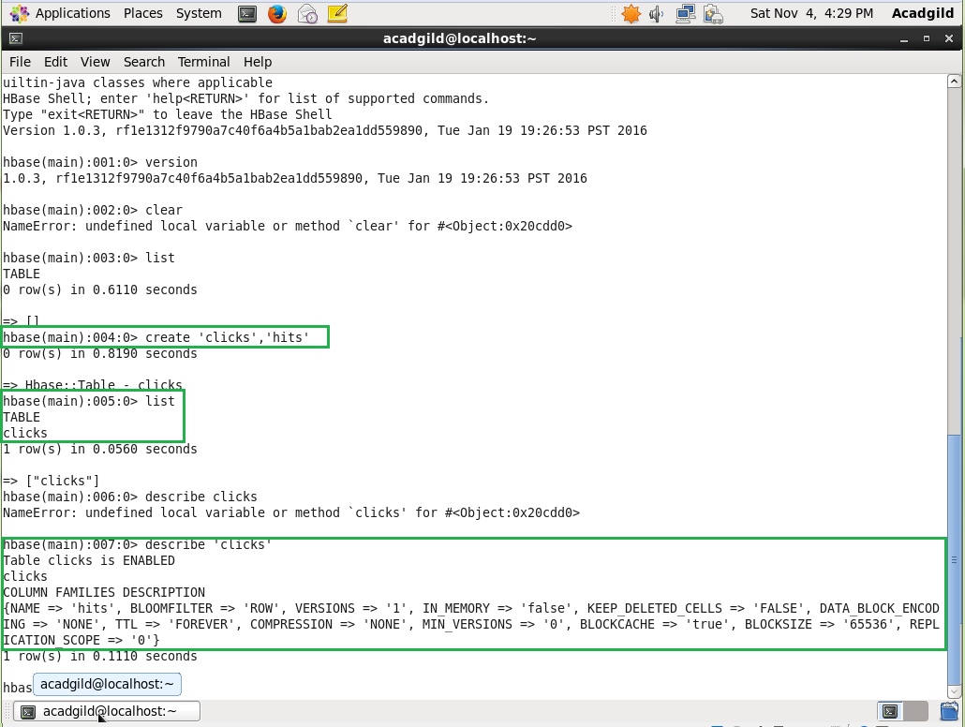

**Problem 2:**

* Add few records in the table and update some of them. Use IP Address as row-key. Scan the table to view if all the previous versions are getting displayed.

Rows Inserted,

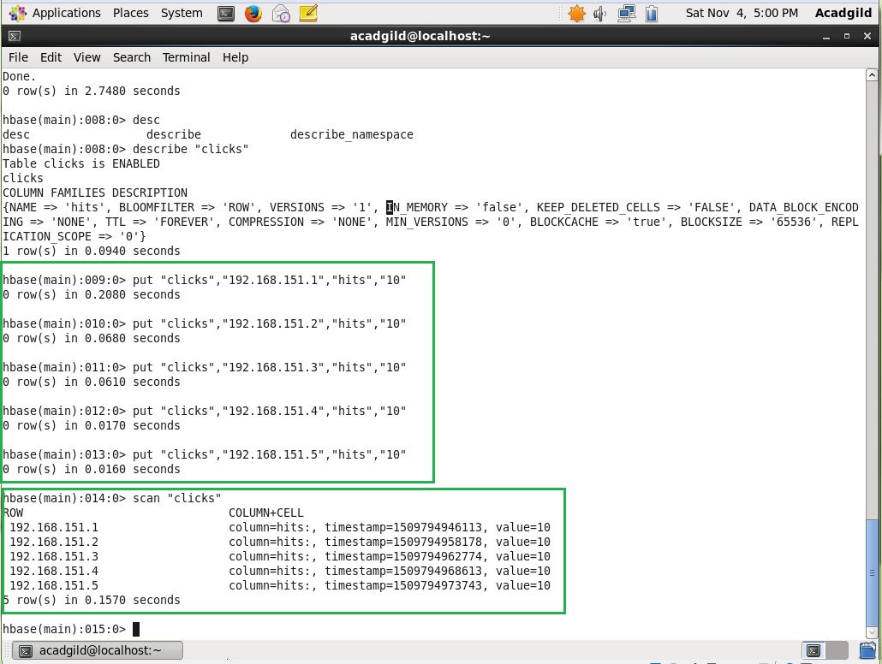

Update the records and scanning the table with version 5

