# ASSIGNMENT-02 COMP3104

# PART-01 JENKINS (SCREENSHOT’S OF ALL DEPOLYMENT)

1. VM SETUP FOR JENKINS 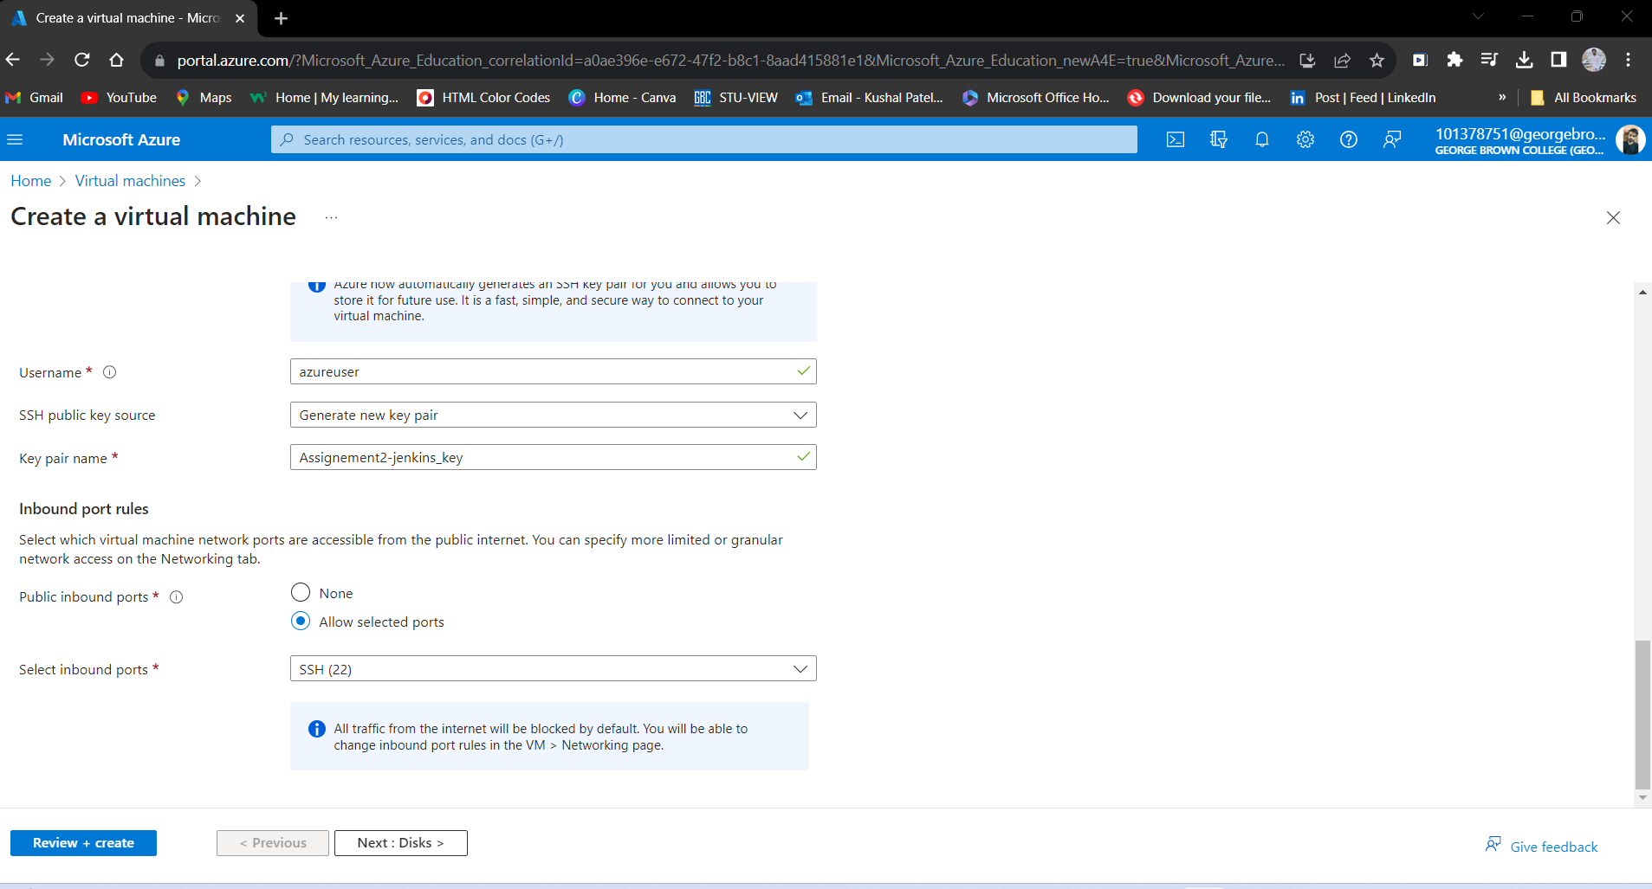

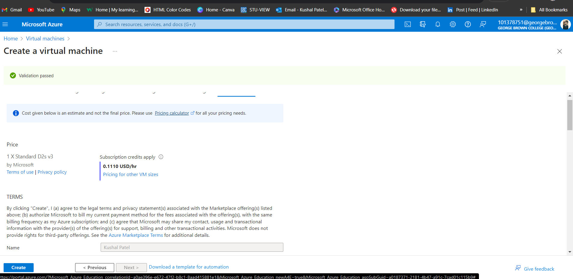

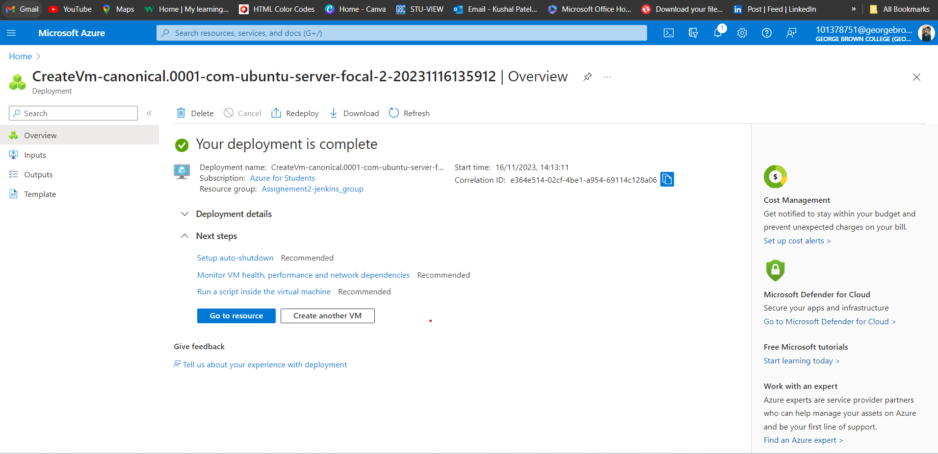

1. JAVA

1. GITHUB

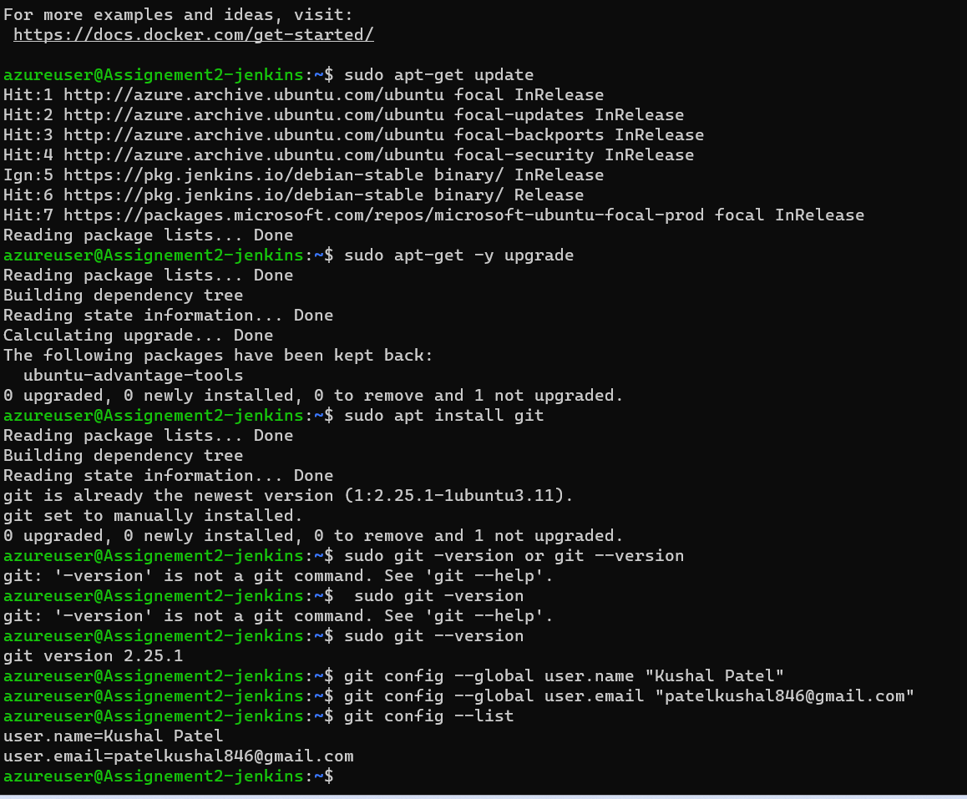

1. JENKINS

Link for Jenkins - <http://localhost:8080/user/kushal/>