In the dataset provided, we know the number of matched rides and double matched rides, but we don’t know what product they were from (POOL vs Express).

The proportion of total trips is split fairly evenly between the 2 min and 5 min wait group. The proportion of total trips from the 2 min wait group was 50.6% and the 5 min wait group was 49.4%. The number of total trips taken by the 2 min wait group was 249,920 compared to the 5 min wait group with total trips at 244,445. The density plot below shows the distribution of total trips by wait time group and both groups follow a similar density.

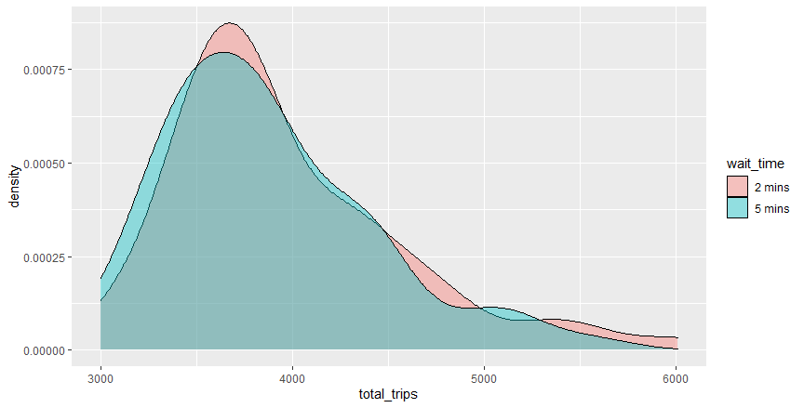

The proportion of trips that were matched between the two wait groups was also similar. The proportion of matched trips for the 2 min wait group was 51.4% and the proportion of matched trips for the 5 min wait group was 48.6%. Changing the wait times did not drastically affect the match rate. The major difference between the groups is the sharp decline in match rate in the 5 min wait time after about 63%, where the 2 min wait group has a more gradual decline.

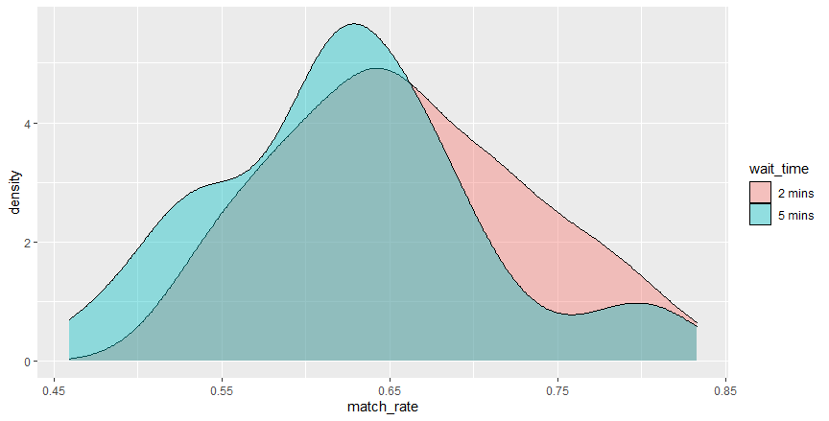

The driver payout per trip is higher for the 2 min wait group compared to the 5 min wait group. The average driver payout for the 2 min wait group was $7.36 and the average driver payout for the 5 min wait group was $6.99. This could be important for Uber as it affects their total cost. It is worth exploring further to see if there is a significant difference.

