Aim : Develop an AI/ML-driven system for topic clustering/modeling to enable auto-categorisation of received grievance reports for sharing of the same with last-mile officers concerned. The proposed solution may include mechanism for sharing received grievance reports with various registered officials as well as monitoring/tracking of reports concerned.

Abstract:
The project introduces an AI/ML-driven system employing agglomerative clustering as a model for automating the categorization of grievance reports, supplemented by UMAP (Uniform Manifold Approximation and Projection) for dimension reduction. Through the utilization of these advanced techniques, incoming grievance reports are efficiently clustered into relevant topics, enabling streamlined dissemination to last-mile officers. Additionally, the integration of monitoring and tracking functionalities enhances transparency and accountability in the grievance resolution process. This innovative approach represents a significant advancement in optimizing grievance handling processes, with potential for scalability and future enhancements to further improve efficiency and user satisfaction.

1. Introduction
Organizations or government agencies often receive a large volume of grievance reports from the public regarding various issues such as infrastructure, public services, social welfare, etc. Traditionally, these reports may be manually reviewed and categorized by personnel before being forwarded to the relevant departments or officers for resolution. Manual processing of grievance reports can be time-consuming, resource-intensive, and prione to errors or biases. The sheer volume of reports may overwhelm human reviewers, leading to delays in response times and potential backlogs in grievance resolution.

There’s a growing need to automate the process of categorizing and prioritizing grievance reports to streamline the handling process and ensure timely resolution. Automation can help improve efficiency, reduce response times, and enhance the overall experience for citizens or users submitting grievances. AI/ML technologies offer promising solutions for automating the categorization of text data, such as grievance reports. By leveraging natural language processing (NLP) techniques and machine learning algorithms, it’s possible to develop systems that can automatically analyze and categorize text data based on its content.

The AI/ML-driven system for topic clustering and auto-categorization of grievance reports needs to integrate seamlessly with existing grievance handling systems of platforms. It should be able to receive incoming reports, categorize them automatically, and facilitate the sharing of categorized reports with relevant officers or departments for resolution.

2. Dataset
Our dataset came from DARPG Hackaton, belong to Government of India. The dataset size is 175784, where split into 2 random sample are 18K as well as 15K due to save memory as well as time consuming. If good, we can more explore as soon.

3. Features and Pre-processing
We take only attribute _id and subject_content_text of our dataset, where _id is unique key or primary key whereas, subject_content_text is user or public request to a government (i.e., complaint, query, and so on) in individually org_code (it is an organization or a department, held by the government). Since how ML can predict on a text, we can convert text to vector in fixed size with the help of embedding (i.e., MiniLM from HuggingFace).

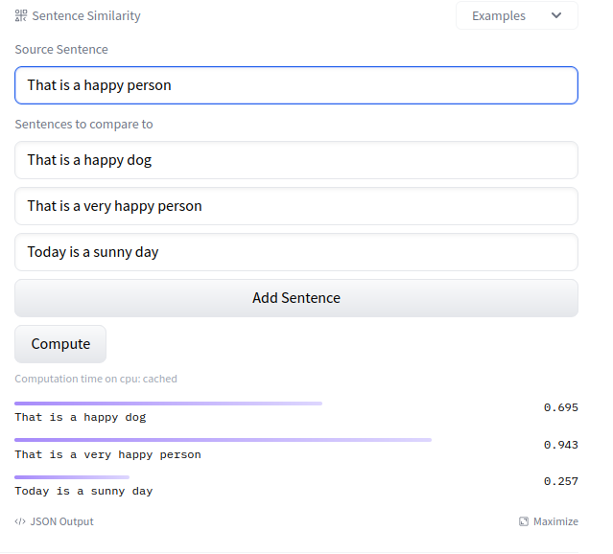
Firstly, we need to pre-processing data such that must be small letter case as well as, remove punctuation. Then, forward to embedding (https://huggingface.co/sentence-transformers/all-MiniLM-L6-v2), and save it in pickle file. Why used MiniLM embedding? Clustering model can processing the numpy array with every same size, and also maps sentences & paragraphs to a 384 dimensional dense vector space. It can be used in Clustering as well as, semantic search. For example, fig 3.1 shows how semantic similarity between texts individually. The Source sentence is “that is a happy person” is comparing with 3 another sentence. One designation sentence got 94.3% matches with the source sentence because the keyword are happy, person, as well as that. It is probably known as pair word in a sentence.

Fig 3.1

4. Models
We used the dataset that’s support Agglomerative Clustering. Agglomerative Clustering is a bottom up method, which iteratively merges similar data points or clusters together to form larger cluster. By iteratively grouping data points or clusters with high similarity, agglomerative clustering enables the formation of hierarchical structures, facilitating the identification of natural groupings within the data. In our dataset, we can predict embedding that’s produces cluster label. The output is given in Google sheet, please refer to https://docs.google.com/spreadsheets/d/16xf0r0qA2UJGa348M8KzfGRdYBtcg1LykduW_WrC0RE/edit#gid=1899414583

5. Metrics & Results
We have two metrics for the model are Silhouette Score as well as Davies Bouldin Score. We are discussing the metrics as below,

Silhouette Score is a metric to evaluate the performance of clustering algorithm. It uses compactness of individual clusters (Intra cluster distance), and separation amongst clusters (Inter cluster distance) to measure an overall representative score of how well our clustering algorithm has performed. Silhouette score function is directly available in sklearn. Let’s quickly look behind the math of it.

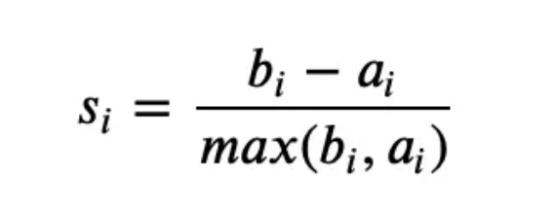

where, bi is the inter cluster distance defined as the average distance to closest cluster of datapoint i except for that it’s a part of

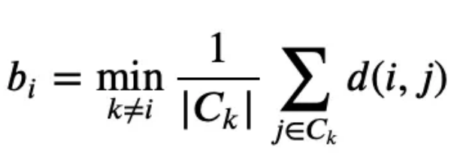

ai is the intra cluster distance defined as the average distance to all other points in the cluster to which it’s a part of

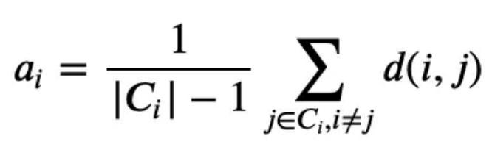

Overall Silhouette score for the complete dataset can be calculated as the mean of silhouette score for all data points in the dataset. As can be seen from the formula silhouette score would always lie between -1 to 1. 1 representing better clustering.

Davies-Bouldin Index is a validation metric that is used to evaluate clustering models. It is calculated as the average similarity measure of each cluster with the cluster most similar to it. In this context, similarity is defined as the ratio between inter-cluster and intra-cluster distances. As such this index ranks well-separated clusters with less dispersion as having a better score. Let’s formula of the math,

where, triangle with Xi is the intra cluster distance within the cluster Xk,
eplison with (Xi, Xj) is the inter cluster distance between the Xi and Xj.

In our result of dataset for the model, a table is given shown as:

 | Silhouette Score | David-Bouldin Index
Dataset size, n_clusters | Silhouette Score | David-Bouldin Index
15K, 4500 | 0.2834 | 1.0492
15K, 8700 | 0.2901 | 0.4618
18K, 6900 | 0.2189 | 0.7589
18K, 8100 | 0.2189 | 0.6875

6. Discussion
As a dimensional reduction (i.e., UMAP), I insight an original category for the dimensional reduction through the embedding as given shown a below,

In dataset size of 15K,

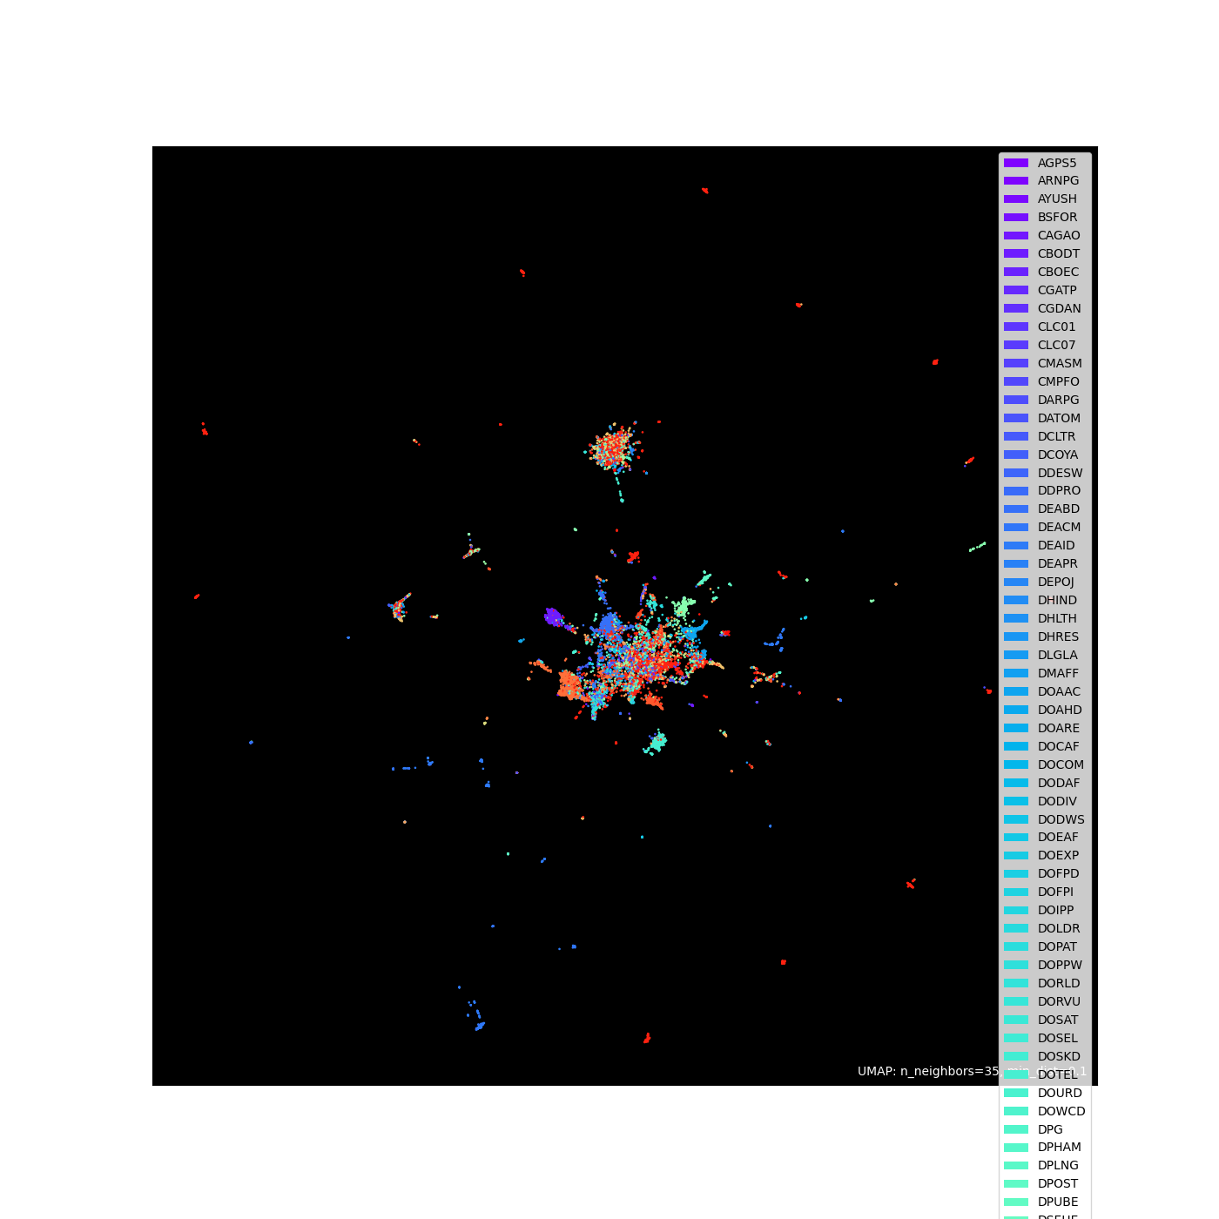
Fig 6.1: UMAP 15K
Fig 6.1: UMAP with org category

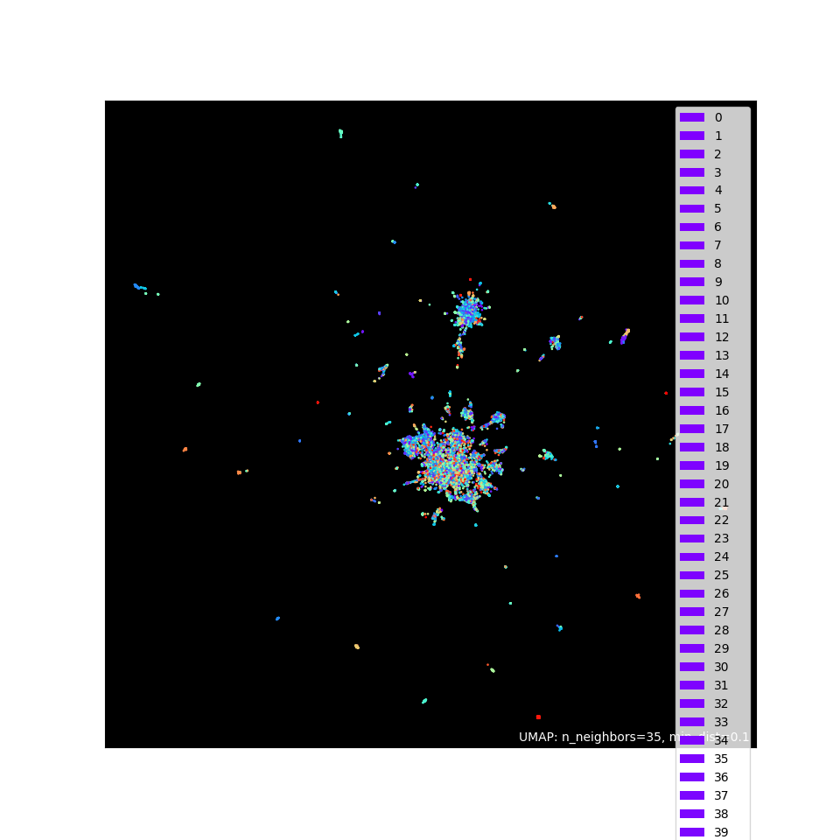
Fig 6.2: UMAP with 4500 n_clusters

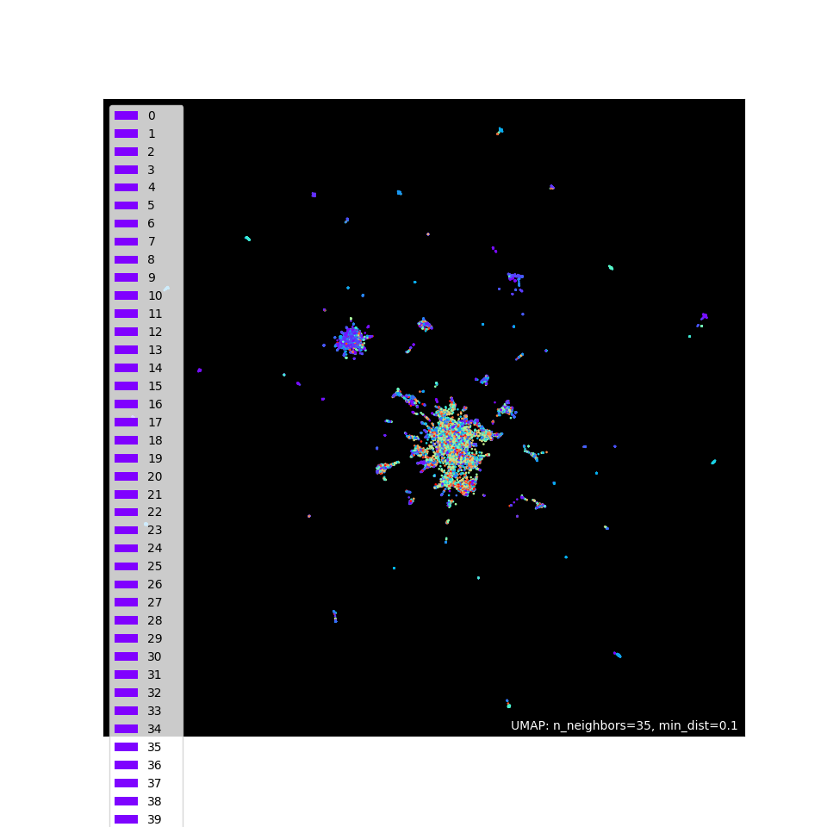
Fig 6.3: UMAP with 8700 n_clusters

Fig 6.1 shows an orginal visualization, and shows overlapping a clustering in a some what. As you seen in the figure, red color and yellowish might not together but overlapping. Imagine if we used 3D plot, it might show different in z-axis. As compared to fig 6.2 and fig 6.3, it shows different. However fig 6.2 and 6.3 are probably same. Therefore, somewhat overfitting as increases clustering but it’s metrics are better. If you want to explore 18k, then please refer as below:
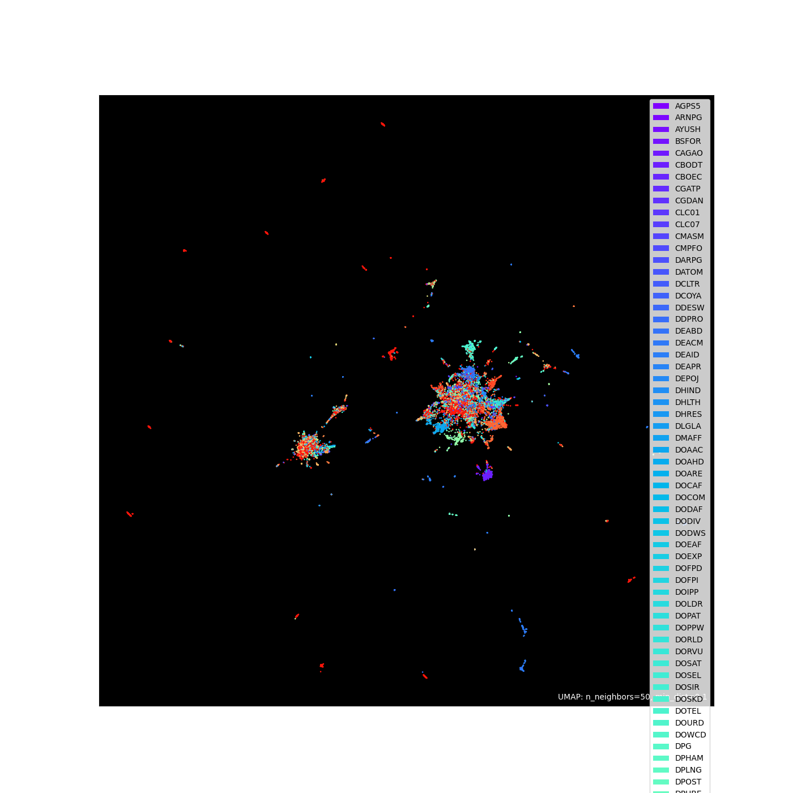
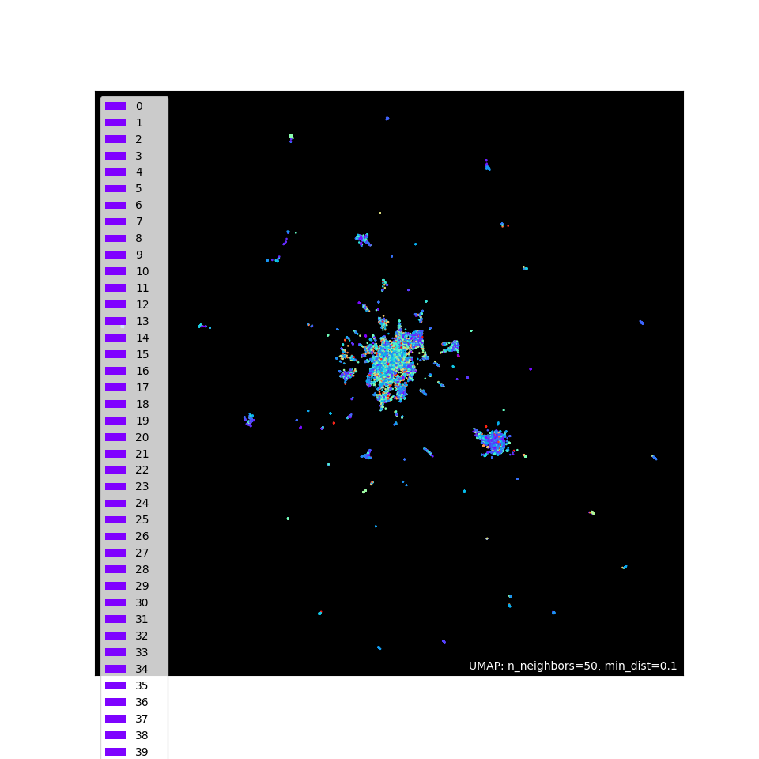
Fig 6.4: Umap with orginal

Fig 6.5: Umap with 6900 n_clusters

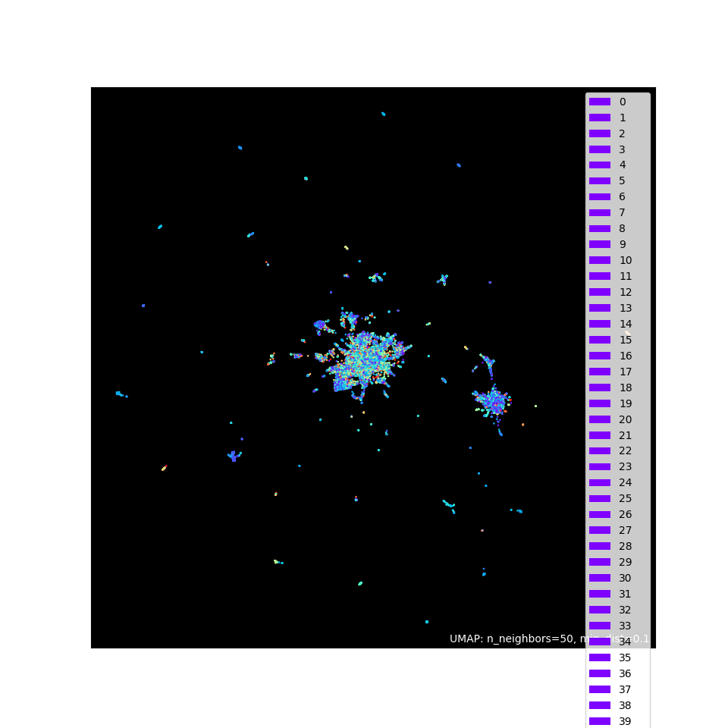
Fig 6.6: Umap with 8100 n_clusters

7. Conclusion and Future work
In conclusion, the development of an AI/ML-driven system for topic clustering and auto-categorization of grievance reports has proven to be a significant step towards streamlining the grievance handling process. Through the utilization of advanced machine learning techniques, we have successfully achieved automatic categorization of incoming grievance reports, thereby reducing the burden on manual reviewers and expediting the dissemination of information to last-mile officers. The integration of monitoring and tracking functionalities has further enhanced the efficiency and transparency of the grievance resolution process, enabling stakeholders to gain valuable insights into trends and performance metrics.

8. References:
- https://scikit-learn.org/stable/modules/generated/sklearn.cluster.AgglomerativeClustering.html
- https://huggingface.co/sentence-transformers/all-MiniLM-L6-v2
- https://scikit-learn.org/stable/modules/generated/sklearn.metrics.davies_bouldin_score.html
- https://scikit-learn.org/stable/modules/generated/sklearn.metrics.silhouette_score.html
- https://umap-learn.readthedocs.io/en/latest/

