SLE-3: Architectural Design (Full C4 Model)
Course: 02AML204 – Introduction to Artificial Intelligence
PRN: 25UAM078
Name: Kushal Kumar Bhavi
Division: A / B
Date: 01 October 2026
GitHub / Portfolio Link (optional): ____________________
1. System Title & Short Description
Maze Route-Finding System. Continuing from SLE-2, this system takes a 2D grid maze with a start cell and a goal cell, and searches for a route between them using BFS and DFS. Alongside the search itself, it profiles its own performance — timing each run, counting nodes expanded, and sampling the call stack to build a flame graph — then reports the route, the metrics, and the comparison charts back to the user. The same search core (get_neighbors(), bfs(), dfs()) from SLE-2 forms the Search Engine container described below.
2. Context Diagram (Level 1)
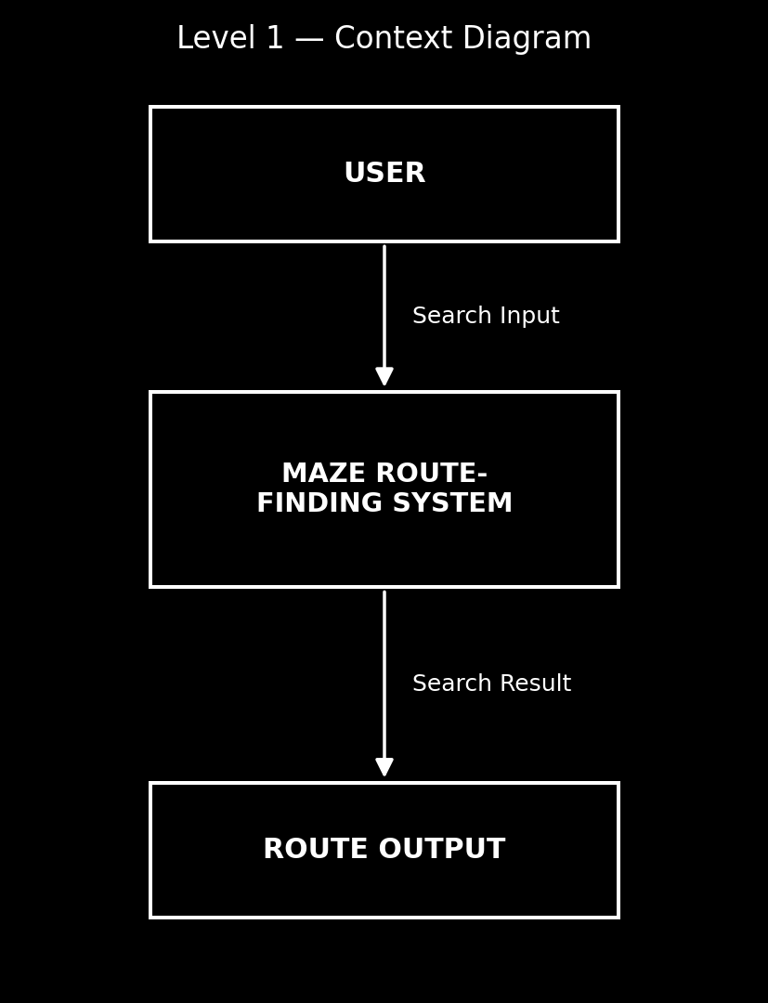
Fig. 1 – Context Diagram: User, the Maze Route-Finding System, and the path/report output
Short explanation:
The User / Operator supplies a maze grid along with the start and goal cells to the Maze Route-Finding System. The system runs its search and profiling internally and returns the found route together with timing, node-count and flame-graph metrics as a path/report output. There is no external service dependency — everything the system needs (the maze, the algorithms, the profiler) runs locally, which is why Level 1 only needs one user actor and one output.
3. Container Diagram (Level 2)
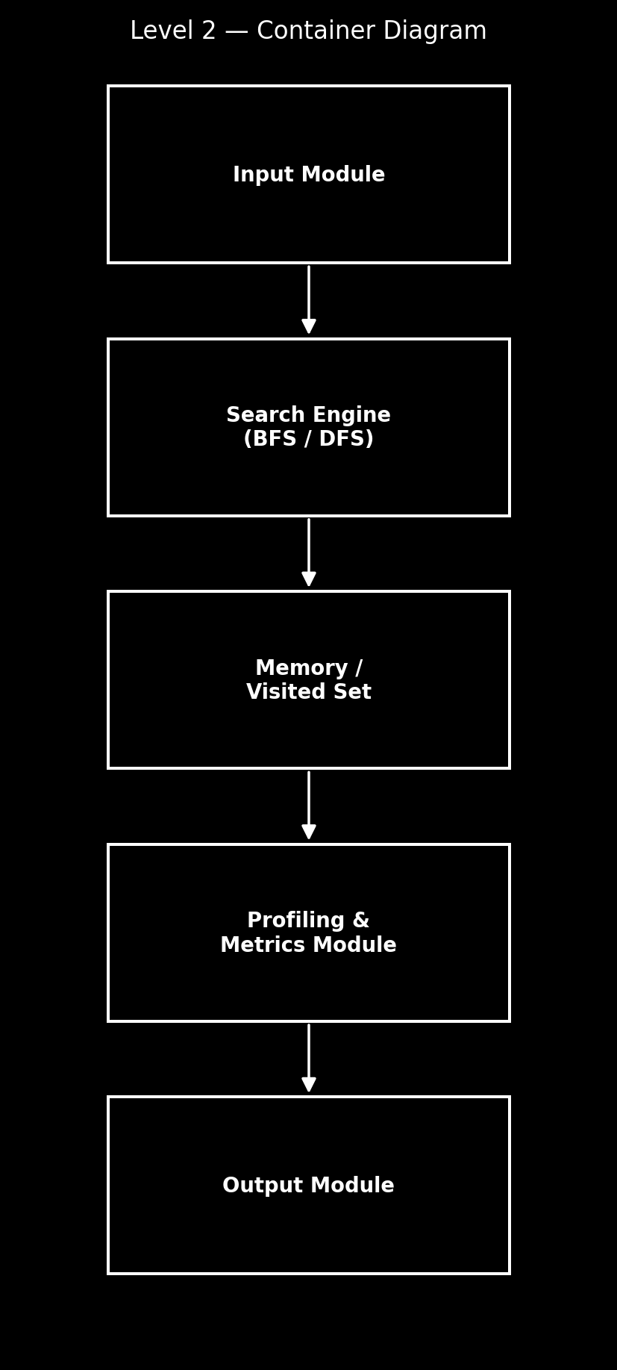
Fig. 2 – Container Diagram: 5 containers inside the Maze Route-Finding System
Explanation of each container:
- Input Module: loads the maze grid and the start/goal cells and hands them to the Search Engine.
- Search Engine: runs the BFS and DFS algorithms over the maze and produces a route.
- Memory / Visited Set: stores the frontier and the visited cells so the search doesn't revisit a cell or loop forever.
- Profiling & Metrics Module: times each run with perf_counter(), counts nodes expanded, and samples the call stack at 100 Hz to build the flame graph.
- Output Module: combines the route, timing table, node counts and flame graph into the final charts and report.
4. Component Diagram (Level 3)
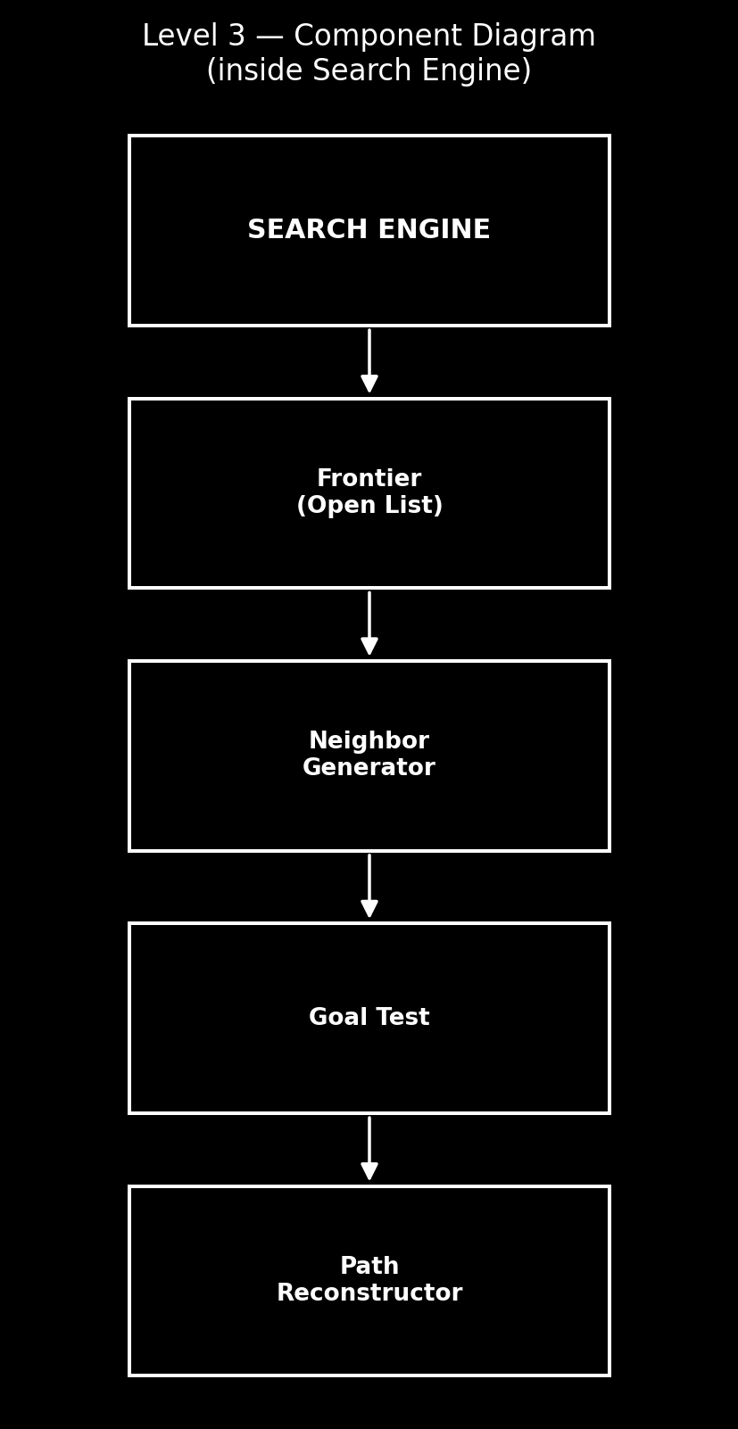
Fig. 3 – Component Diagram: inside the Search Engine container
Short explanation:
The Search Engine container is broken into four components, used in a simple top-to-bottom order. The Frontier (Open List) holds the cells still to be explored (a queue for BFS, a stack for DFS) and feeds one cell at a time to the Neighbor Generator (get_neighbors()), which expands it into its valid moves. Each candidate is passed to Goal Test; once it matches the goal cell, the Path Reconstructor (_reconstruct()) walks the came_from chain back to the start to build the final route. The visited-cell bookkeeping itself lives one level up, in the Memory / Visited Set container, so this component chain stays a simple pipeline. This is the one container the guideline asks to expand — the other four containers are left at the container-level view.
5. Code Level Overview (Level 4)
- def get_neighbors(node, grid): returns the valid, in-bounds, non-wall moves from a cell.
- def bfs(grid, start, goal): breadth-first search; returns (path, nodes_expanded).
- def dfs(grid, start, goal, depth_limit): depth-limited depth-first search; returns (path, nodes_expanded).
- def _reconstruct(came_from, start, goal): rebuilds the route from the came_from chain.
- def time_algorithm(fn, grid, start, goal): times a search function over several runs (driver.py).
- def sampler_loop() / def workload(): background stack sampler and the BFS/DFS workload it samples (flame_sampler.py).
6. Design Decisions
Memory / Visited Set was kept as its own container rather than folded into the Search Engine, so the same visited-set container could later be reused by a different algorithm (e.g. A*) without changing the engine. Profiling & Metrics was also kept separate from the Search Engine on purpose: profiling is an observability concern, not search logic, so the engine stays simple and the profiler can be turned off without touching it. Inside the Search Engine, Goal Test and Neighbor Generator were split into their own components because BFS and DFS share both unchanged — only the Frontier's ordering (queue vs. stack) differs between the two algorithms.
7. AI Contribution Note
- AI tools used: Claude (Anthropic) — helped me design the C4 diagrams (Context, Container, Component), write the diagram-generation script, and lay out this document in the required template format.
- What AI helped with: mapping the existing SLE-2 route_finding.py / driver.py / flame_sampler.py code onto C4 containers and components, drawing the three diagrams, and drafting the explanation text for each level.
- What I did myself: decided how to split the containers (especially keeping Profiling separate from the Search Engine), reviewed the component breakdown against my actual SLE-2 code, and wrote the design-decisions and conclusion based on what I actually built.
8. Conclusion
Building the C4 views on top of my own SLE-2 code made the difference between "code that works" and "a system with a structure" much clearer. At the Context level the system looks like a single black box; by Container level it's obvious that profiling and the core search are two separate concerns that happen to run together; and by Component level, splitting the Search Engine into Frontier, Neighbor Generator, Goal Test and Path Reconstructor showed me that BFS and DFS are really the same engine with only the frontier's ordering changed. Going from Context down to Code made the design decisions behind my own SLE-2 code explicit instead of implicit.

