VNC Weak Password → GUI Access → Credential Access and Persistence Analysis

Ethical Hacking / Post-Exploitation Lab
Target: Metasploitable 2
Attacker/Testing Machine: Kali Linux
Target IP: 192.168.154.130
Target Service: VNC
Port: TCP 5900
Protocol: VNC / RFB
Primary Focus: Credential Access and Persistence Analysis

1. Introduction
This practical lab demonstrates the security risks associated with an exposed VNC service using an intentionally vulnerable Metasploitable 2 virtual machine.
The assessment focuses on:
- VNC service discovery
- VNC authentication
- GUI access
- Local account enumeration
- Credential-access exposure
- SSH persistence indicators
- Authentication-log investigation
- SOC detection
- Security recommendations
The assessment was performed inside an isolated virtual laboratory environment.

2. Lab Environment
Component | Details
Attacker | Kali Linux
Target | Metasploitable 2
Target IP | 192.168.154.130
Service | VNC
Port | 5900/TCP
VNC Server | Xtightvnc
Testing Tool | Nmap / VNC Viewer
Network | Isolated VMware laboratory

Lab Topology
┌─────────────────┐
│ Kali Linux │
│ Attacker VM │
│ │
│ 192.168.154.x │
└────────┬────────┘
│
│ Isolated VMware Network
│
▼
┌──────────────────────┐
│ Metasploitable 2 │
│ Target VM │
│ 192.168.154.130 │
│ │
│ VNC :5900 │
└──────────────────────┘

Screenshot 1 — Lab Environment
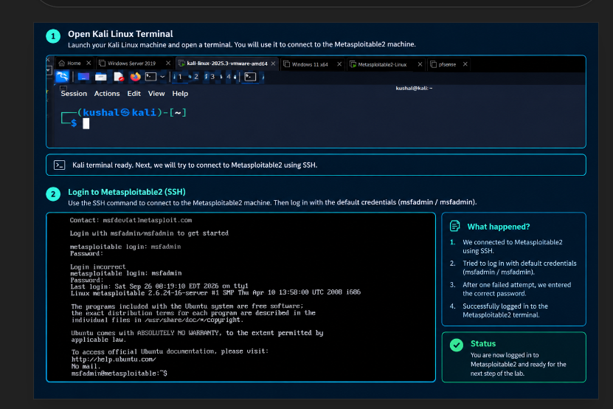
Figure 1: Kali Linux and Metasploitable 2 virtual machines.

3. Objective
The objective of this assessment was to investigate the security impact of an exposed VNC service and determine what information could become accessible after VNC authentication.
The investigation followed this general attack path:
VNC Service Discovery
↓
Port 5900
↓
VNC Authentication
↓
GUI Access
↓
Account Enumeration
↓
Credential Access Analysis
↓
Persistence Analysis
↓
Authentication Log Investigation
↓
Detection and Mitigation

4. VNC Service Discovery
The first stage was identifying the VNC service running on the Metasploitable 2 target.
The target was identified as:
192.168.154.130
VNC uses TCP port:
5900

Evidence
The VNC service was confirmed to be listening on TCP/5900.
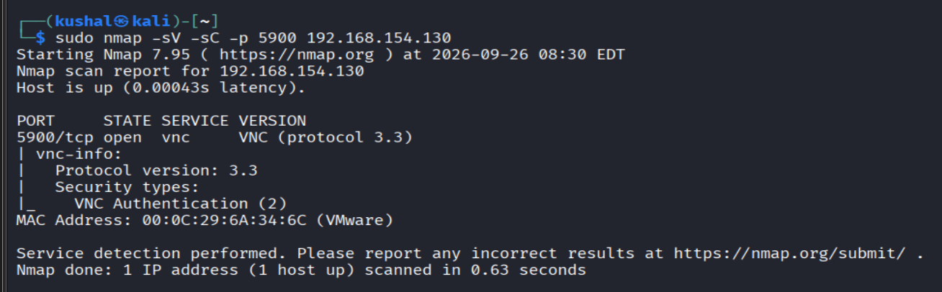
Figure 2: Nmap scan showing TCP port 5900 open.

Finding
TCP/5900 was exposed and accessible from the Kali testing machine.

5. VNC Server Identification
Process enumeration on Metasploitable 2 showed that the VNC server was running using Xtightvnc.
Relevant process information included:
Xtightvnc :0
The VNC desktop was associated with display :0.

Screenshot
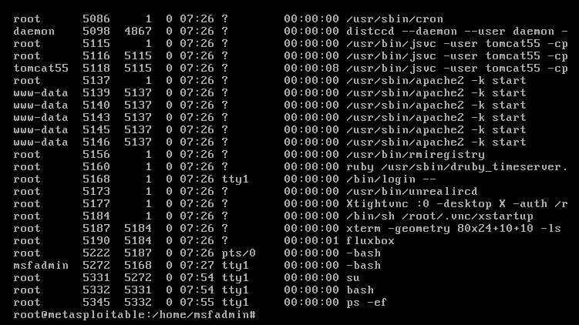
Figure 3: Xtightvnc process running on the target.

6. Confirming Port 5900
The listening network service was also confirmed using network-status information.
The system showed:
0.0.0.0:5900
indicating that the VNC service was listening on TCP port 5900.

Screenshot
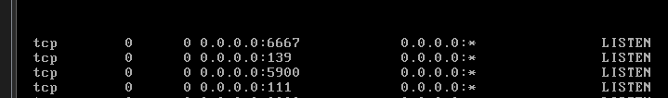
Figure 4: TCP/5900 listening on the Metasploitable 2 system.

7. VNC Authentication
From Kali Linux, the VNC client was launched against the target:
vncviewer 192.168.154.130:5900
The connection produced:
Connected to RFB server, using protocol version 3.3
Performing standard VNC authentication
Password:
This confirmed that the VNC service was reachable and protected by VNC authentication.

Screenshot
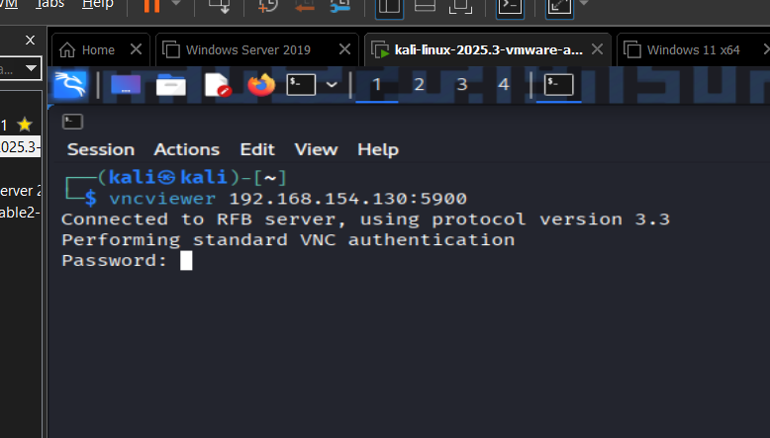
Figure 5: VNC authentication prompt.

8. VNC GUI Access
Successful VNC authentication allowed access to the graphical desktop of Metasploitable 2.
This demonstrated the impact of obtaining valid VNC authentication.

Screenshot
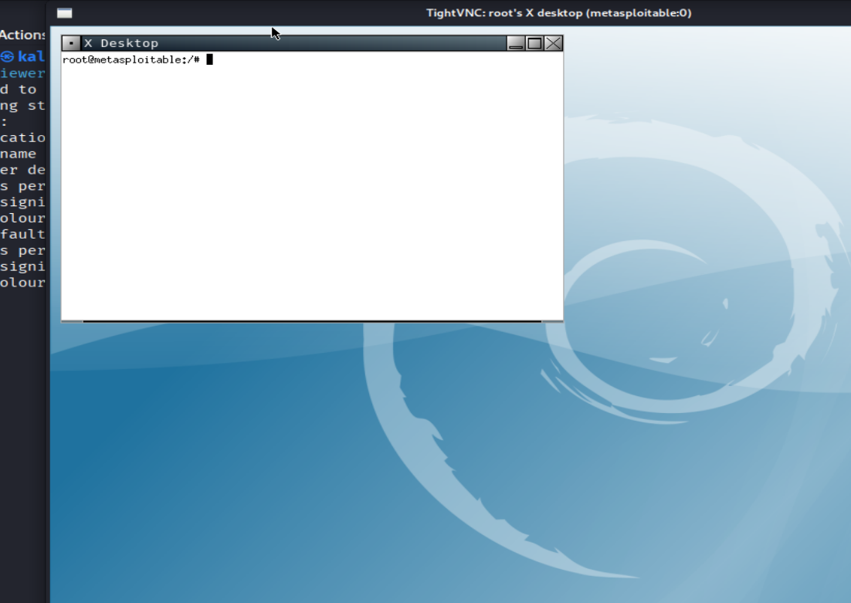
Figure 6: Successful VNC GUI access to Metasploitable 2.

Finding
An attacker with valid VNC authentication could obtain graphical access to the target system.

9. Post-Access System Identification
After obtaining access, basic system information was examined.
Commands used included:
whoami
hostname
id
The hostname was:
metasploitable
The msfadmin account was identified during the assessment.

Screenshot
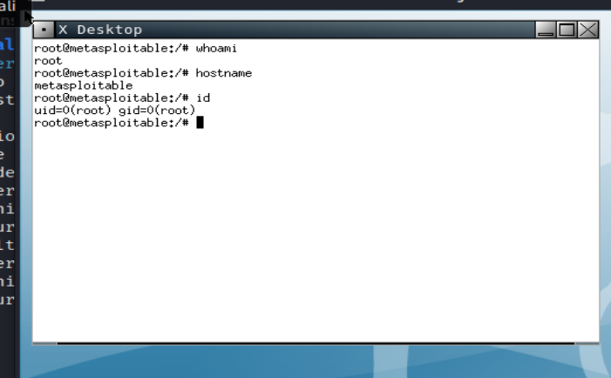
Figure 7: Post-access system identification.

10. Local Home Directory Enumeration
The /home directory was examined:
ls -la /home
The assessment identified several user directories, including:
msfadmin
service
user
ftp

Screenshot
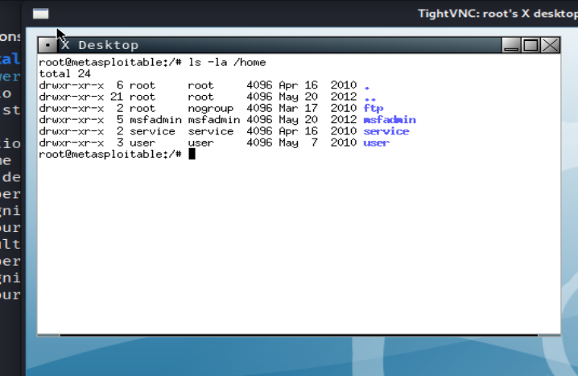
Figure 8: Local user home directories.

Finding
The VNC session provided visibility into local user accounts and their home directories.

11. Local Account Enumeration
The local account database was examined using:
cat /etc/passwd
The system contained numerous service and user accounts.
Examples identified included:
root
msfadmin
postgres
user
service
ftp
www-data
backup

Screenshot
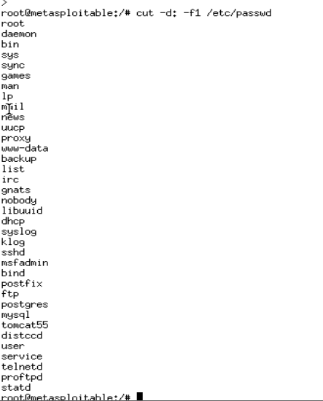
Figure 9: Local account information.

Explanation
The /etc/passwd file provides account information such as:
- Username
- UID
- GID
- Home directory
- Login shell
The x field does not represent the actual password.

12. Interactive Login Account Identification
The following command was used:
awk -F: '$7 ~ /bash|sh$/ {print $1, $7}' /etc/passwd
Accounts with interactive shells included:
msfadmin
postgres
user
service
Other service accounts used shells such as:
/bin/false
/usr/sbin/nologin

Screenshot
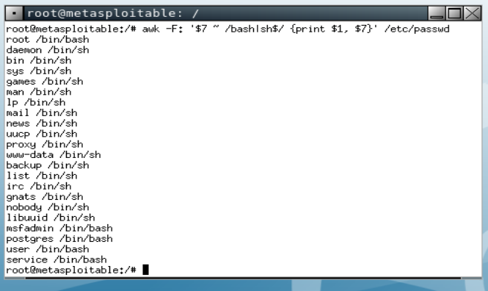
Figure 10: Accounts configured with interactive shells.

13. Credential Access Analysis
The assessment did not extract or crack real passwords.
Instead, credential-access exposure was demonstrated through enumeration of:
- Local usernames
- Interactive accounts
- SSH authentication configuration
- Authentication logs
The assessment showed that obtaining GUI access can provide an attacker with valuable information about the system's authentication environment.

Evidence
/etc/passwd
/home/msfadmin/.ssh/
/var/log/auth.log

Finding
The compromise of an interactive VNC session can expose information useful for further authentication-related investigation.

Screenshot
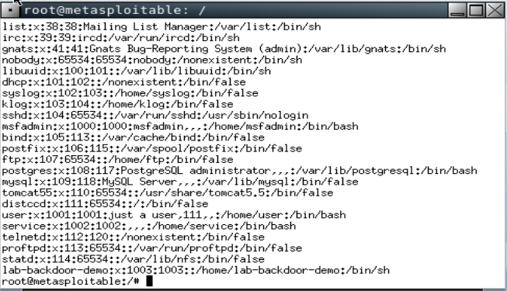
Figure 11: Credential-access related account information.

14. SSH Persistence Indicators
The following directory was examined:
ls -la /home/msfadmin/.ssh
The directory contained:
authorized_keys
id_rsa
id_rsa.pub

Screenshot
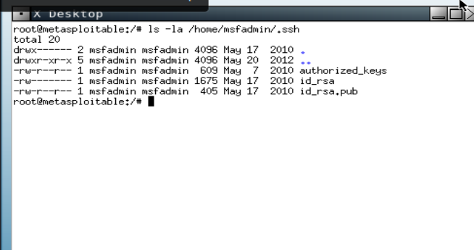
Figure 12: Existing SSH authentication configuration.

Explanation
authorized_keys contains public keys permitted for SSH authentication.
id_rsa is a private SSH key.
id_rsa.pub is a public SSH key.
The private key was not displayed, copied, or used during the assessment.

Finding
The presence of SSH key infrastructure represents a persistence-related area that should be reviewed during an incident investigation.

15. Backdoor / Persistence Analysis
The assessment investigated existing accounts and SSH configuration for potential persistence indicators.
No new malicious account or persistent backdoor was installed.
The following areas were investigated:
/etc/passwd
/home/*/.ssh/
/var/log/auth.log

Persistence Investigation Flow
VNC Access
↓
Local Account Enumeration
↓
SSH Configuration Examination
↓
Authentication Log Review
↓
Persistence Indicators Identified

Finding
Existing SSH authentication configuration should be reviewed during incident response to determine whether unauthorized keys or accounts have been introduced.

Screenshot
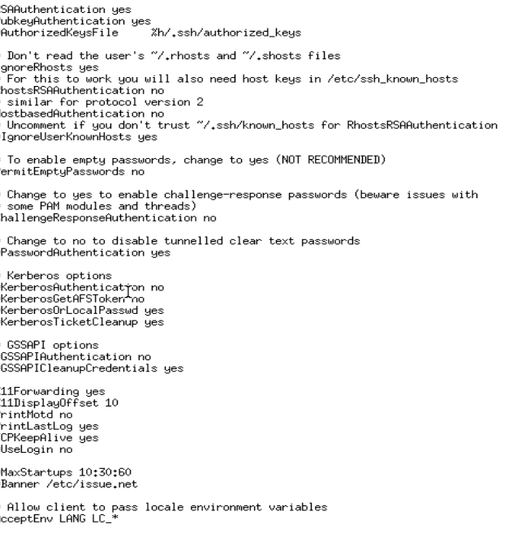
Figure 13: Persistence-related SSH configuration.

16. Authentication Log Investigation
The authentication log was examined:
tail -20 /var/log/auth.log
The logs showed failed attempts by msfadmin to switch to the root account.
Relevant events included:
FAILED su for root by msfadmin
and:
pam_authenticate: Authentication failure

Screenshot
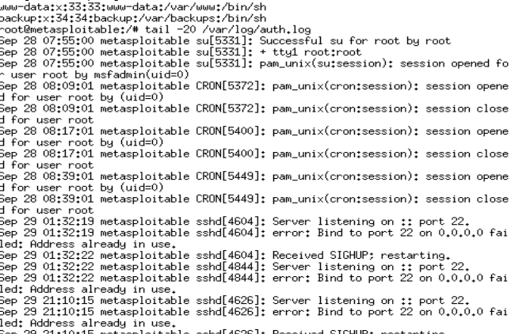
Figure 14: Authentication failures recorded in auth.log.

17. SOC Analysis
From a SOC analyst perspective, the authentication events should be investigated and correlated with other activity.
The following event was notable:
FAILED su for root by msfadmin
Repeated authentication failures can indicate:
- Incorrect credentials
- Unauthorized privilege attempts
- Potential compromise
- Misconfiguration
- User error
The event should therefore be correlated with the user's login history, source, timing, and other system activity.

18. CRON Activity
The authentication log also contained recurring root CRON sessions:
CRON: session opened for user root
CRON: session closed for user root
These events are not automatically malicious because scheduled system tasks commonly execute with root privileges.

Screenshot
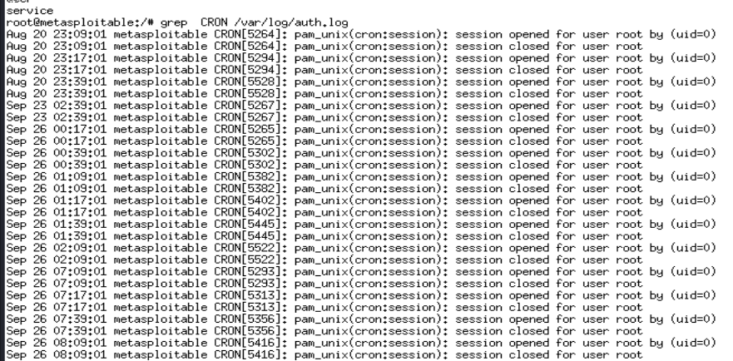

Figure 15: Root CRON activity.

19. Controlled Credential-Harvesting Simulation
Because the purpose of the assessment is to demonstrate credential-access risk, a controlled synthetic credential can be used instead of collecting a real password.
Example:
mkdir -p ~/lab-evidence
printf 'LAB_USER=demo\nLAB_PASSWORD=FakeOnly123!\n' > ~/lab-evidence/credential-demo.txt
The file can be displayed with:
cat ~/lab-evidence/credential-demo.txt

Screenshot
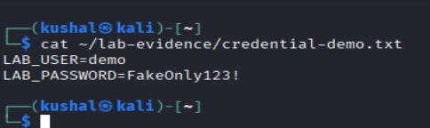
Figure 16: Controlled credential-access simulation using synthetic data.
The test data is not a real credential.
After the demonstration, remove the file:
rm ~/lab-evidence/credential-demo.txt

Report Statement
A controlled credential-access simulation was performed using synthetic credentials. No real user passwords were extracted or cracked.

20. Controlled Backdoor-User Detection Simulation
A controlled temporary test account can be used to demonstrate how an unexpected account could be identified.
If authorized root access is available:
useradd lab-backdoor-demo
Then enumerate local accounts:
cut -d: -f1 /etc/passwd
The test account should appear:
lab-backdoor-demo

Screenshot
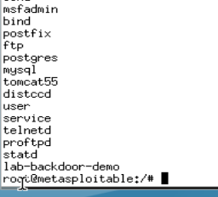
Figure 17: Detection of the temporary test account.
After the demonstration:
userdel lab-backdoor-demo
Then verify that it has been removed:
cut -d: -f1 /etc/passwd

Report Statement
A temporary test account was used in the isolated laboratory to demonstrate detection of an unexpected local account. The account was removed after testing and no persistent backdoor was installed.

21. Attack Chain Summary
VNC SERVICE
│
▼
TCP PORT 5900
│
▼
VNC AUTHENTICATION
│
▼
GUI ACCESS
│
▼
ACCOUNT ENUMERATION
│
▼
CREDENTIAL ACCESS
ANALYSIS/SIMULATION
│
▼
SSH PERSISTENCE
INDICATOR REVIEW
│
▼
AUTHENTICATION LOG
INVESTIGATION
│
▼
SOC DETECTION &
MITIGATION

22. Security Impact
The assessment demonstrated that exposure of a VNC service can provide an attacker with interactive graphical access after successful authentication.
Once access is obtained, the attacker may be able to:
- View system information
- Identify local accounts
- Identify interactive login accounts
- Examine authentication-related configuration
- Investigate SSH configuration
- Access information available to the compromised user
- Generate authentication events that can be investigated by defenders

23. Detection Recommendations
A SOC should monitor for:
- Unexpected VNC connections to TCP/5900
- Repeated VNC authentication failures
- Unusual login times
- Unexpected local account creation
- Changes to authorized_keys
- Unexpected SSH keys
- Repeated failed privilege-authentication attempts
- Suspicious authentication events
- Unexpected processes associated with VNC
- Unusual root activity

24. Mitigation Recommendations
Recommended defensive measures include:
- Disable VNC when it is not required.
- Do not expose VNC directly to untrusted networks.
- Restrict TCP/5900 using firewall rules.
- Use strong, unique authentication credentials.
- Prefer secure remote-access mechanisms.
- Restrict administrative access.
- Monitor authentication logs.
- Regularly review local accounts.
- Regularly review SSH authorized_keys.
- Remove unused accounts and keys.
- Apply security updates to remote-access software.
- Segment management services from normal user networks.

25. Findings Summary
Finding | Evidence | Risk
VNC exposed | TCP/5900 | Unauthorized access opportunity
VNC authentication | VNC password prompt | Authentication boundary
GUI access | Successful VNC session | Interactive system access
Account exposure | /etc/passwd | Account enumeration
Interactive accounts | Login-shell analysis | Authentication reconnaissance
SSH configuration | .ssh directory | Persistence investigation area
Authentication failures | auth.log | Security event requiring investigation
Credential simulation | Synthetic credential | Controlled demonstration
Backdoor detection simulation | Temporary test account | Persistence detection demonstration

26. Conclusion
The assessment demonstrated the security impact of an exposed VNC service on an intentionally vulnerable Metasploitable 2 system.
TCP/5900 was identified as the VNC service, successful VNC access provided GUI access, and subsequent enumeration exposed local account and authentication-related information.
SSH configuration and authentication logs were also examined as part of persistence and incident-response analysis.
The assessment used controlled simulations for credential exposure and backdoor-user detection. No real passwords were harvested, cracked, or disclosed, and no persistent backdoor was installed.
The main defensive lesson is that remote graphical services should be properly secured, restricted to trusted networks, monitored, and protected with strong authentication.

27. Screenshot Checklist
Before submitting, make sure you have these screenshots:
☐ Figure 1 — VMware lab environment
☐ Figure 2 — Nmap showing TCP/5900
☐ Figure 3 — Xtightvnc process
☐ Figure 4 — TCP/5900 listening
☐ Figure 5 — VNC authentication prompt
☐ Figure 6 — Successful VNC GUI
☐ Figure 7 — whoami, hostname, id
☐ Figure 8 — /home enumeration
☐ Figure 9 — /etc/passwd
☐ Figure 10 — Interactive login accounts
☐ Figure 11 — Credential-access evidence
☐ Figure 12 — .ssh directory
☐ Figure 13 — Persistence analysis
☐ Figure 14 — auth.log authentication failures
☐ Figure 15 — CRON activity
☐ Figure 16 — Controlled credential simulation
☐ Figure 17 — Controlled test-account detection

28. Final Attack Summary
Vulnerability/Weakness: Exposed VNC service and weak authentication
Port: TCP 5900
Access Obtained: VNC GUI
Post-Exploitation Focus: Credential Access
Credential Access Demonstrated: Local account and authentication-information enumeration
Persistence Analysis: Existing SSH authentication configuration and local accounts examined
Detection: Authentication logs and account configuration investigated
Credential Harvesting: Controlled synthetic simulation only
Backdoor: Controlled detection simulation only; no persistent backdoor installed
Target: Metasploitable 2
Attacker: Kali Linux

