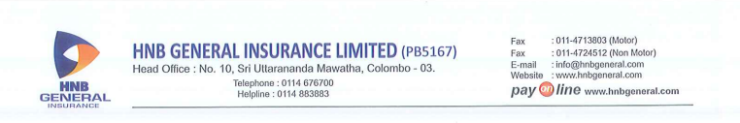

Cover Note No :

Branch :

Date :

Product Type :

|  |  |  |  |
| --- | --- | --- | --- |
| **SCHEDULE** | | **PENDING REQUIREMENTS** | |
|  |  | Inspection of Vehicle |  |
| Make and Model |  | Vehicle Registered Number |  |
| Transfer of Ownership |  |
| Distinctive No. |  | Particulars of Vehicle |  |
| Chassis No. |  | VIC / Copy of Registration |  |
| Engine No. |  | Ins. Sign. / Rubber Stamp |  |
| Cubic Capacity |  | Duly Completed Proposal Form |  |
| Use of Vehicle |  | Document |  |
| Additional Covers |  | Lux./S.Lux./S.Lux./DP Tax |  |
| Previous Cover Note No. |  | Pending Payment |  |
|  |  |  |  |

We hereby certify that the above Cover Note is issued in accordance with the Provisions of Part VI of the

**Motor Traffic Act. No. 14 of 1951**

**\*\*\*\*\*PREMIUM IS SUBJECT TO PREMIUM PAYMENT WARRANTY\*\*\*\*\***

|  |  |  |  |
| --- | --- | --- | --- |
| Issued Date & Time | : |  |  |
| Broker/Channel | : | ***HNB Assurance PLC*** | |
| User Name | : |  | |
| Location | : |
| **Help Line -** | **:** |  |  |
|  |  | *Checked By* | *Authorized Officer* |

|  |  |
| --- | --- |
|  |  |