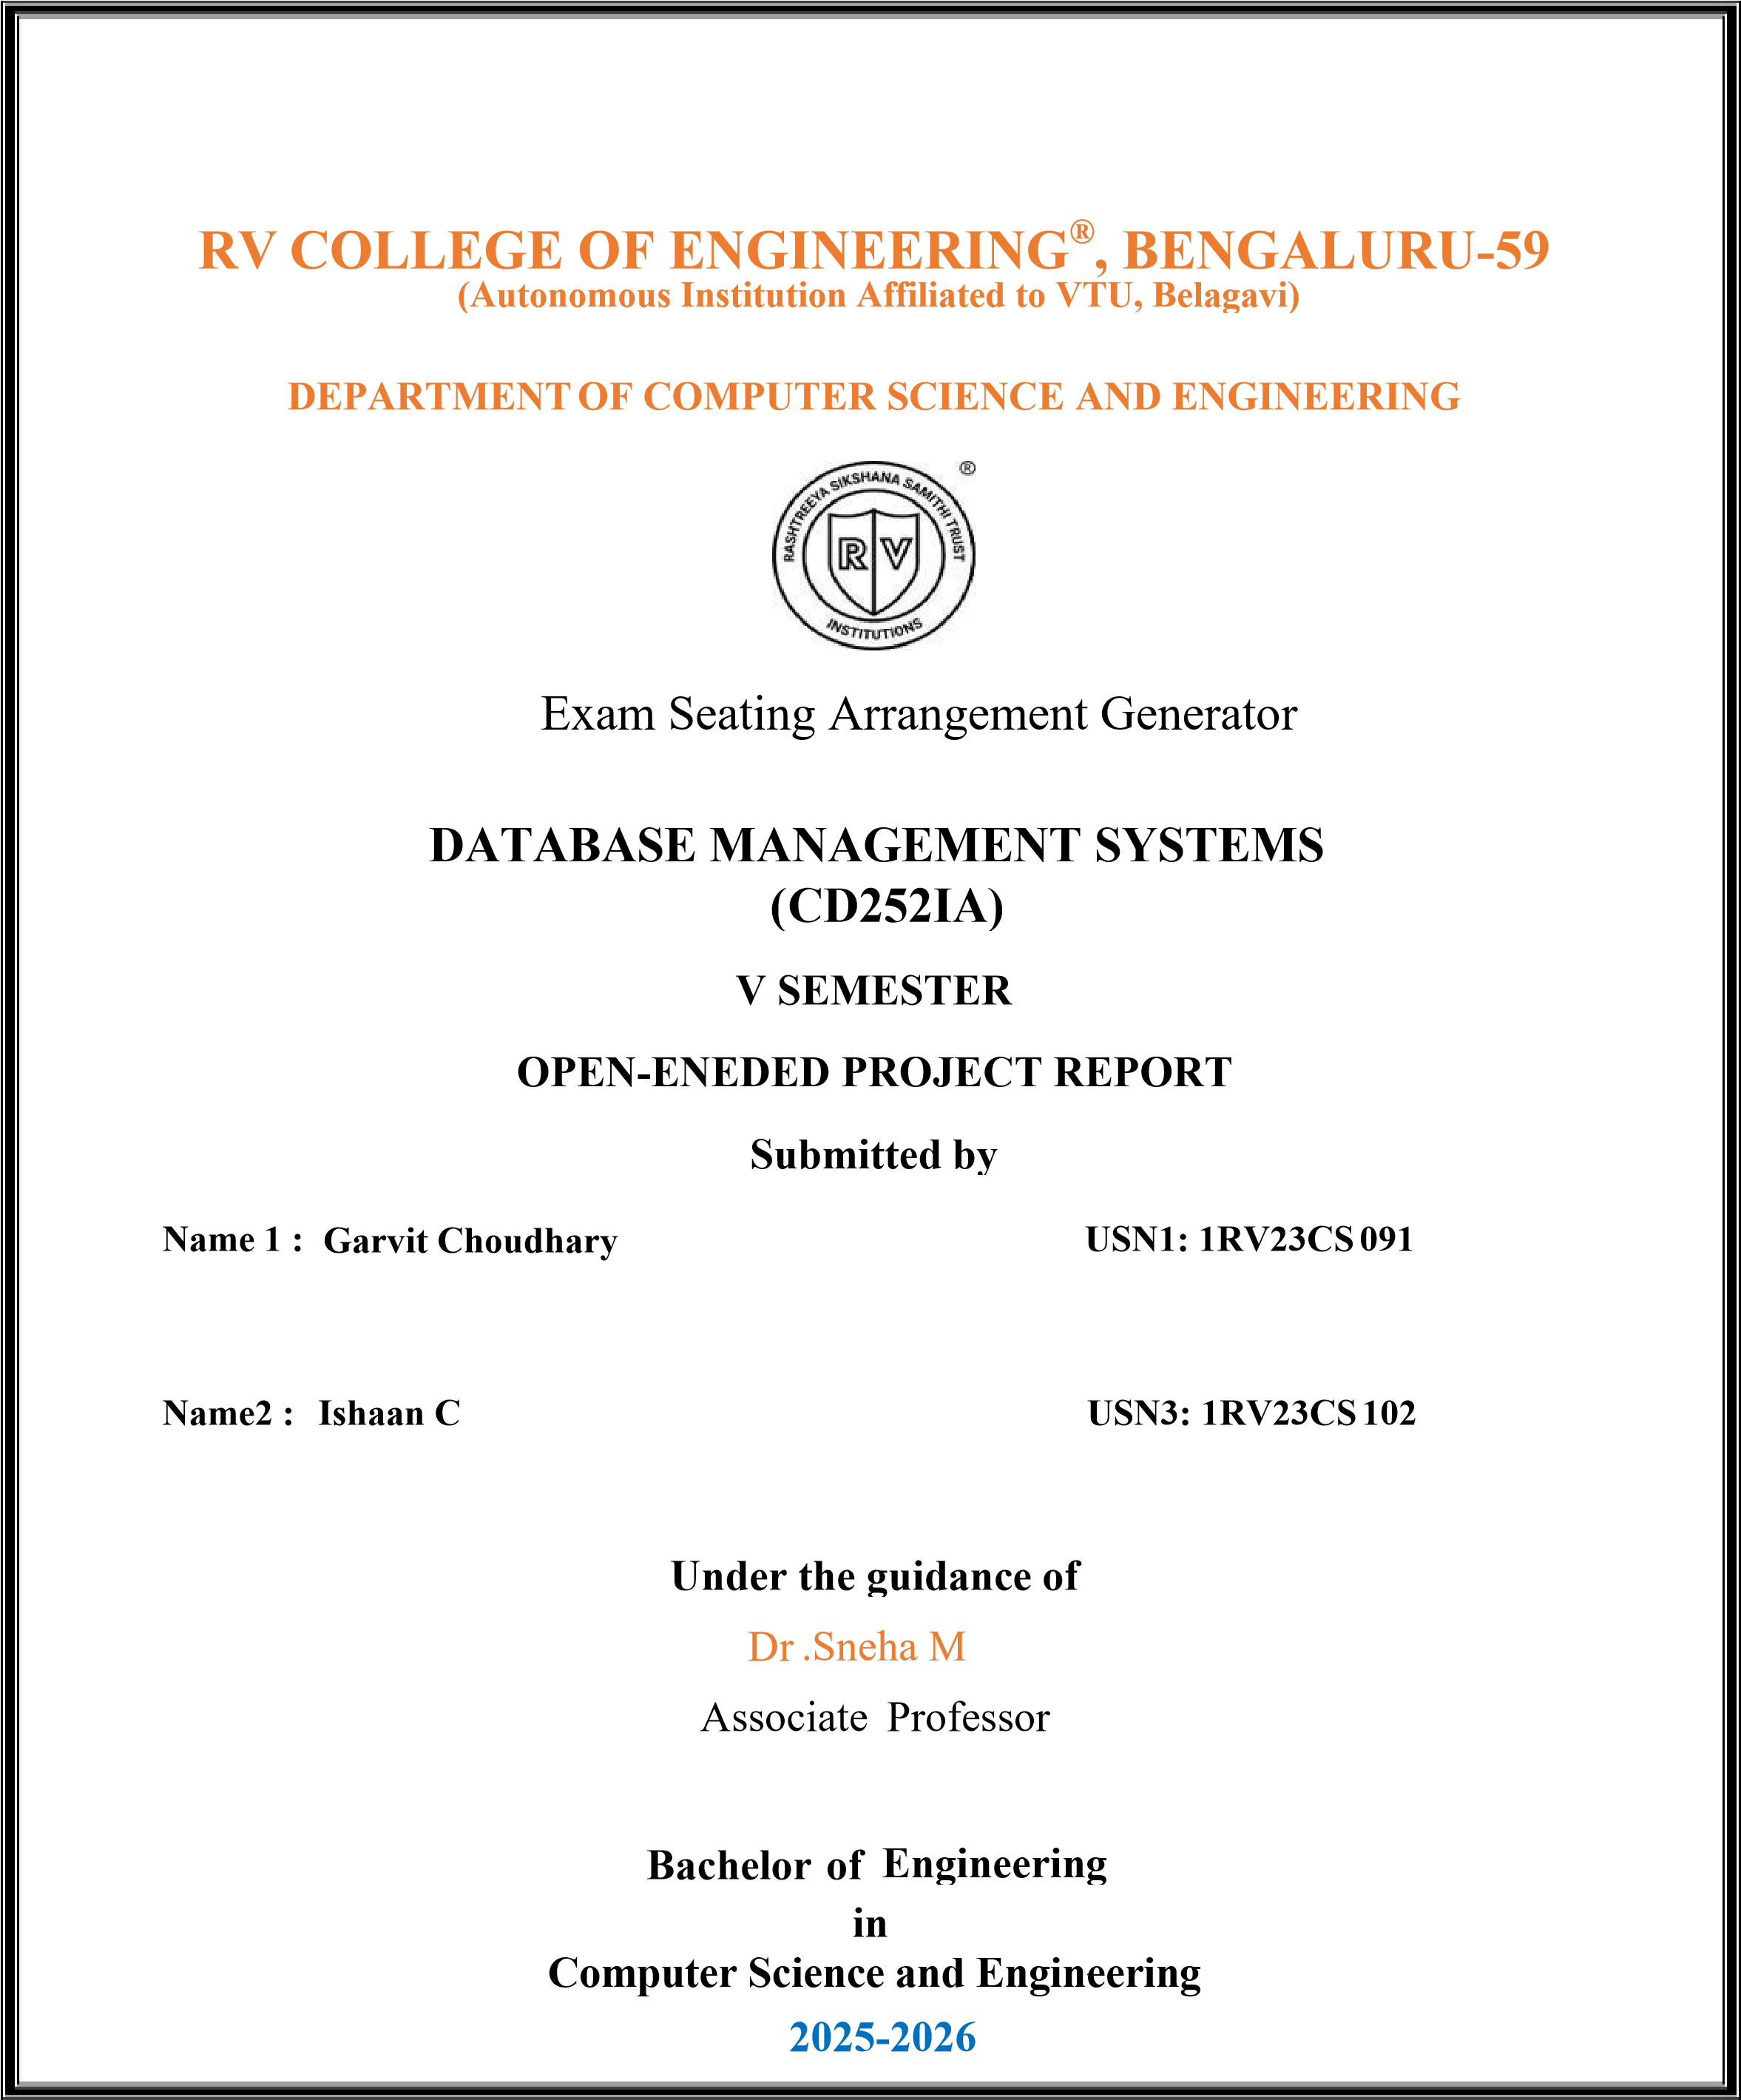

Dr. Sneha M  Faculty Incharge,  Department of CSE,  R.V.C.E., Bengaluru –59 | Dr. Shanta Rangaswamy  Head of Department,  Department of CSE,  R.V.C.E., Bengaluru–59
RV COLLEGE OF ENGINEERING®, BENGALURU-59
(Autonomous Institution Affiliated to VTU, Belagavi)

DEPARTMENT OF COMPUTER SCIENCE AND ENGINEERING



CERTIFICATE

Certified that the project work titled ‘Exam Seating Arrangement Generator’ is carried out by Garvit
Choudhary (1RV23CS091), Ishaan C (1RV23CS102), who are Bonafide students of R. V. College of
Engineering, Bengaluru, in partial fulfillment of the curriculum requirement of 5th Semester Database Management Systems (CD252IA) Laboratory Project during the academic year 2025-2026. It is certified that all corrections/suggestions indicated for the internal Assessment have been incorporated in the report. The report has been approved as it satisfies the academic requirements in all respect laboratory miniproject work prescribed by the institution.

External Viva
Name of Examiners Signature with Date
1
2

ACKNOWLEDGEMENT

We are indebted to our Faculty, Dr. Sneha M, Associate Professor , Dept of CSE, RV College of Engineering for his/her wholehearted support, suggestions and invaluable advice throughout our project work and helped in the preparation of this report.
Our sincere thanks to Dr. Ramakanth Kumar P, Professor and Dean, CSE Cluster, RVCE and Dr. Shanta Rangaswamy Professor and Head, Department of Computer Science and Engineering, RVCE for their support and encouragement.

We express sincere gratitude to our beloved Principal, Dr. K. N. Subramanya for his appreciation towards this project work.

We thank all the teaching staff and technical staff of Computer Science and Engineering department, RVCE for their help.

ABSTRACT

The Exam Seating Arrangement System is a comprehensive web-based application designed to optimize the process of allocating examination seats in educational institutions. Manual seat allocation is time consuming, error-prone, and ineffective in handling constraints such as separating friends, relatives, or students from the same section to prevent malpractice. This project addresses these challenges by applying graph theory and constraint-based algorithms to generate fair, conflict-free, and auditable seating arrangements.
The system uses the DSatur graph coloring algorithm to group students based on conflict relationships, followed by efficient room allocation using First-Fit Decreasing (FFD) and backtracking strategies to satisfy room capacity and institutional constraints. A structured relational database supports secure storage of student data, exams, rooms, relationships, and audit logs, ensuring data integrity and traceability. Rolebased access control, two-factor authentication for administrators, and detailed audit trails enhance system security and accountability.
Developed using a modern full-stack architecture with a Flask-based backend, PostgreSQL database, and interactive web interface, the system provides administrators, teachers, and students with tailored dashboards and visual seating layouts. The project demonstrates the practical application of database design, normalization, graph algorithms, and secure web development, while remaining scalable for future enhancements such as advanced analytics, mobile access, and intelligent cheat detection.

2.1. Software requirements | 4
2.2. Hardware requirements | 5
2.3 Functional requirements  Chapter 3 | 5
Data Flow Diagram | 10
4.1 DFD Level 0 | 10
4.2 DFD Level 1 | 11
4.2 DFD Level 2  Chapter 5 | 12
Relational Schema and Normalization | 14
5.1. Relational Schema | 14
5.2. Normalization  Chapter 6 | 17
Design of Forms, Security and Validation | 20

Table of Contents

Abstract Page No
List of Figures
Chapter 1
Introduction 2
1.1. Objectives 2
1.2. Scope 3

Chapter 2
Software Requirements Specification 4
ER Diagram 8
3.1 Description of the ER Diagram 8
Chapter 4
6.1. Security | 20
6.2. Forms and Validation in Exam Seating Arrangement System  Chapter 7 | 21
References | 24
Appendices | 25

Conclusion 23

FIGURE NO. | TITLE | PAGE NO.
1 | ER Diagram for exam seating arrangement generator | 9
2 | DFD 0 for exam seating arrangement generator | 10
3 | DFD 1 for exam seating arrangement generator | 11
4 | DFD 2 for exam seating arrangement generator | 13
5 | Relational Schema for exam seating arrangement generator | 16
6 | 1NF,2NF | 18
7 | 3NF | 19
8 | Admin Dashboard | 25
9 | Exam management page | 25
10 | Room configuration page | 26
11 | Room layout page | 26
12 | Teacher Dashboard | 27
13 | Student Dashboard | 27
List of Figures

Chapter 1

Introduction
Examinations are a critical component of the academic evaluation process, and proper seating arrangements play a significant role in maintaining fairness, discipline, and academic integrity. In many educational institutions, exam seating is still prepared manually using paper lists or basic spreadsheets. This manual approach becomes inefficient and error-prone as the number of students, subjects, and examination constraints increase. It often leads to issues such as uneven room utilization, accidental seating of friends or classmates together, last-minute changes, and lack of proper documentation.
The Exam Seating Arrangement System is proposed to address these challenges by automating the complete process of exam seat allocation. The system uses structured data and algorithmic techniques to assign seats logically while respecting constraints such as room capacity, exam schedules, student relationships, and departmental distribution. By digitizing the process, the system reduces human effort, minimizes errors, and ensures consistent enforcement of examination rules.
From a database management perspective, the project demonstrates the effective use of relational database concepts such as entity relationships, normalization, constraints, and audit logging. All data related to students, exams, rooms, and seating assignments is stored in a centralized database, enabling fast retrieval, updates, and reporting. The integration of database design with algorithmic logic makes the system reliable, scalable, and suitable for real-world academic environment

1.1 Objectives
The primary objectives of the Exam Seating Arrangement System are as follows:
- To automate the process of generating examination seating arrangements, reducing manual effort and administrative workload.
- To ensure fair and conflict-free seat allocation by separating friends, relatives, or students from the same section where required.
- To optimize room utilization by allocating students based on room capacity and predefined constraints.
- To maintain accurate and structured records of students, exams, rooms, and seating assignments using a relational database.
- To provide role-based access for administrators, teachers, and students, ensuring secure and controlled system usage.
- To maintain audit logs of critical actions for transparency, accountability, and future reference.
- To allow easy modification, regeneration, and retrieval of seating arrangements when exam schedules or constraints change.

1.2 Scope
The scope of the Exam Seating Arrangement System includes the management of student details, examination schedules, room configurations, and automated seat allocation within an educational institution. The system supports multiple user roles such as administrators, teachers, and students, each with clearly defined permissions.
Administrators can manage exams, rooms, and constraints, teachers can view assigned rooms and seating details, and students can access their individual seating information.The system focuses on generating seating arrangements that follow institutional rules and academic integrity requirements while ensuring efficient use of available resources. It is designed as a scalable web-based application that can be deployed in colleges or universities of varying sizes. Although the current scope is limited to examination seating management, the system is future-ready and can be extended to include features such as analytics, mobile access, integration with academic management systems, and advanced cheat-detection mechanisms.

Chapter 2
Software Requirements Specification
The Software Requirement Specification (SRS) defines the functional and non-functional requirements of the Exam Seating Arrangement System. It provides a clear description of the system environment, required software and hardware resources, and the functional capabilities expected from the system. This section serves as a reference for understanding system constraints, implementation feasibility, and deployment requirements.

2.1 Software Requirements
The Exam Seating Arrangement System is designed as a web-based application and requires the following software components:
- Operating System (Server): Windows 10/11, Windows Server, or any modern Linux distribution (such as Ubuntu or Arch Linux) capable of running web servers and database services.
- Operating System (Client): Any operating system that supports a modern web browser such as Google Chrome, Mozilla Firefox, or Microsoft Edge.
- Backend Technologies: Python with Flask framework for handling server-side logic, RESTful APIs, authentication, and business rules.
- Frontend Technologies: HTML, CSS, and JavaScript with templating support for building responsive and user-friendly interfaces for administrators, teachers, and students.
- Database Management System: PostgreSQL as the primary relational database for storing student data, exam schedules, room configurations, relationships, and seating assignments.
- Development Tools: Visual Studio Code or any modern IDE, Git for version control, and tools such as pgAdmin for database management.
- Additional Libraries: SQLAlchemy for ORM, Pandas for data processing, NetworkX for graphbased algorithms, and PyOTP for two-factor authentication.

2.2 Hardware Requirements
The hardware requirements depend on the scale of deployment. A small to medium-sized institution can operate the system with the following configuration:
Client Machines:
- Processor: Intel Core i3 or equivalent and above
- RAM: Minimum 4 GB (8 GB recommended)
- Storage: At least 250 GB HDD or SSD
- Input/Output Devices: Keyboard, mouse, and display10
- Network: Stable internet or local network connection
Server System:
- Processor: Intel Core i5 or equivalent multi-core processor
- RAM: Minimum 8 GB (16 GB recommended for higher user load)
- Storage: 500 GB or more SSD for database storage and backups
- Network: Reliable LAN or internet connectivity

2.3 Functional Requirements
The Exam Seating Arrangement System shall provide the following functional requirements to ensure efficient, secure, and reliable operation:

User Authentication and Authorization
To ensure secure and organized access, the system is designed to allow users to log in exclusively through the use of valid credentials. To manage various user types effectively, it supports role-based access control tailored for administrators, teachers, and students. This structure allows the system to strictly restrict access to specific features and data based on the unique permissions associated with each assigned user role.

Student Management
The system provides comprehensive management of student data by allowing administrators to perform essential operations such as adding, updating, and deleting individual student records. Beyond basic information, the platform securely stores detailed academic attributes, including the student's department, current year, section, and specific examination enrollment data. Furthermore, to ensure the integrity of the seating process, the system maintains a record of personal relationships between students, such as friends or relatives, which is utilized for effective conflict handling during arrangement.

Examination Management
The system provides administrators with full control over the examination timeline by enabling them to create, modify, and delete comprehensive schedules. Each entry securely stores vital examination details, specifically the subject, date, designated time slot, and the participating department. To maintain the integrity of the scheduling process, the system includes built-in validation logic designed to prevent any duplicate entries or conflicting examination assignments.

Room Configuration and Management
The platform enables administrators to configure specific examination rooms by defining their total seating capacity and physical layout details. To ensure compliance with logistical requirements, the system supports various constraints, including the enforcement of maximum capacity limits and the management of allowed student groups within a single space. Additionally, it provides real-time tracking by maintaining the availability status of each room for every scheduled examination, preventing overbooking or logistical overlaps.

Automated Seating Arrangement Generation
The platform features an automated engine that generates optimized seating arrangements through specialized algorithmic techniques. To maintain examination integrity, the system’s logic ensures the physical separation of related or conflicting students based on pre-defined relationship data. Furthermore, it intelligently allocates students to specific rooms while strictly adhering to maximum room capacities and any established logistical constraints.

Visualization and Reporting
The platform provides comprehensive visualization tools by displaying detailed seating layouts and organized student lists for each examination room. To ensure accuracy and oversight, authorized users are granted the ability to view and verify all generated seating arrangements before they are finalized. Additionally, the system ensures practical utility by supporting the exporting or printing of seating details whenever physical documentation is required.

Audit Logging and Traceability
The platform is designed to enhance accountability by recording all critical system actions, including user logins, data modifications, and the execution of the seat generation process. To ensure the integrity of this information, these audit logs are stored securely, providing a reliable trail for future reference, administrative review, and troubleshooting.

System Maintenance and Updates
The platform ensures operational flexibility by allowing administrators to regenerate seating arrangements whenever inputs, such as student counts or specific room constraints, are modified. Throughout these updates and modifications, the system maintains strict data consistency to prevent errors in the database or overlapping assignments.

CHAPTER 3
ER Diagram

The Entity Relationship (ER) Diagram represents the conceptual design of the Exam Seating Arrangement System and illustrates how data entities are structured and related to one another. It provides a clear overview of the system’s database design before physical implementation and helps in identifying entities, attributes, and relationships required to support system functionality. By defining these relationships at the conceptual level, the ER diagram ensures data consistency, reduces redundancy, and supports efficient query processing.
In this system, the ER diagram captures the core components involved in examination management, including students, examinations, rooms, users, and seating assignments. Each entity represents a realworld object, while relationships define how these objects interact within the system. Proper use of primary keys and foreign keys ensures referential integrity across the database.

3.1 Description of the ER Diagram

The Student entity stores information related to students appearing for examinations. It includes attributes such as student ID, name, department, year, section, and other academic details. Each student can be associated with multiple examinations, and relationships between students (such as friends or relatives) are maintained to enforce seating constraints.
The Examination entity represents individual exams conducted by the institution. It includes attributes such as exam ID, subject name, date, time slot, and department. An examination can have multiple students enrolled, and each exam is associated with one or more seating assignments.
The Room entity stores details of examination halls, including room ID, room name, capacity, and layout configuration. Rooms are allocated to examinations based on capacity and predefined constraints. A single room may be used for multiple examinations at different time slots.
The User entity represents system users such as administrators and teachers. It includes attributes like user ID, username, password, and role. Role-based access control is enforced through this entity to restrict system operations based on user permissions.
The Seating Assignment entity acts as a linking entity between students, examinations, and rooms. It records seat numbers and positional information for each student during an examination. This entity ensures that each student is assigned exactly one seat for a given exam and supports visualization and reporting of seating layouts.
Overall, the ER diagram provides a structured foundation for the database design of the Exam Seating Arrangement System. It clearly defines entity boundaries and relationships, supporting normalization, scalability, and efficient management of examination-related data.
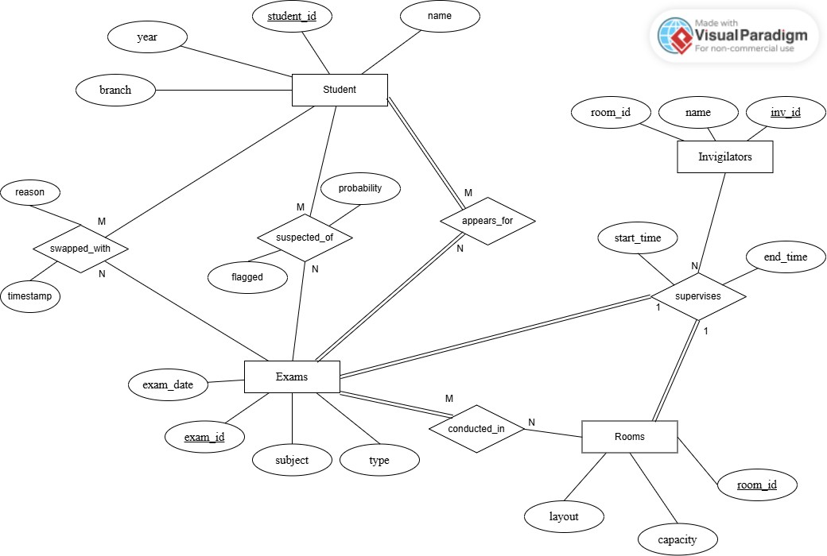
Fig 1. ER Diagram for exam seating arrangement generator
CHAPTER 4 DATA FLOW DIAGRAM

The Data Flow Diagram (DFD) illustrates how data moves through the Exam Seating Arrangement System and how it is processed, stored, and transformed at different stages. The DFD is developed in multiple levels to provide a clear and structured understanding of the system, starting from a highlevel context view and gradually expanding into detailed process-level representations. Thisapproach ensures that both overall system boundaries and internal data processing logic are clearly defined.

4.1 DFD Level 0
The Level 0 Data Flow Diagram represents the entire Exam Seating Arrangement System as a single process labeled Student Exam Seating Arrangement Generator. At this level, the system is shown as a black box, focusing only on interactions with external entities.
The primary external entities are Admin Users, Students, and Invigilators. Admin Users provide configuration inputs such as master data, examination details, and allocation parameters. Students interact with the system by providing student-related information and receiving seating details. Invigilators receive duty rosters and seating maps generated by the system. The context diagram clearly defines the system boundary and the high-level flow of data between the system and its external users.
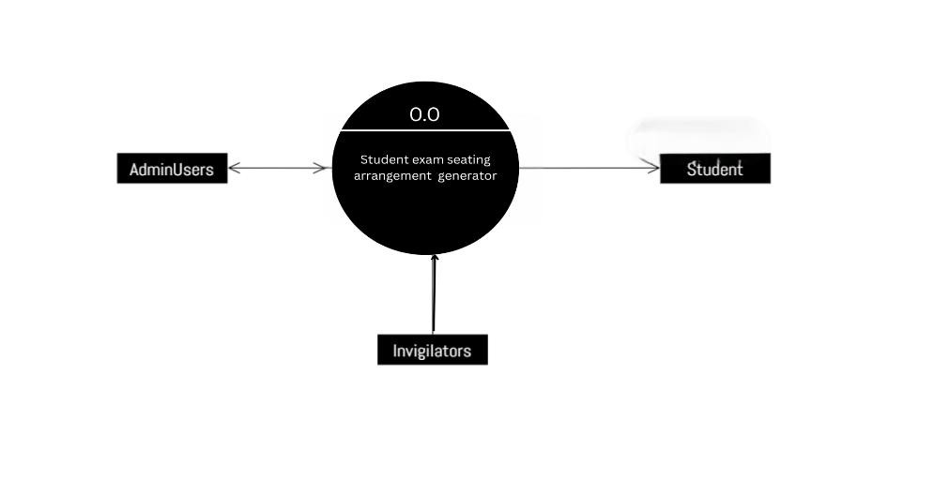
Fig 2. DFD 0 for exam seating arrangement generator

4.2 DFD Level 1
The Level 1 Data Flow Diagram decomposes the system into major functional processes that collectively perform the exam seating arrangement task. These processes include Manage MasterData (1.0), Allocate and Generate Seating (2.0), Assign Invigilation (3.0), and Cheat Detection and Reporting (4.0).
In this level, validated student records and master data related to rooms and examinations are stored in dedicated data stores such as Student Data and Master Data. The seating allocation process uses this validated information to generate final seating assignments, which are stored in the Seating Allocations data store. The system also maintains Admin Audit Logs to record critical events such as allocation generation, invigilation assignment, and cheat detection activities. This level provides a clear view of how core processes interact with data stores and external entities.
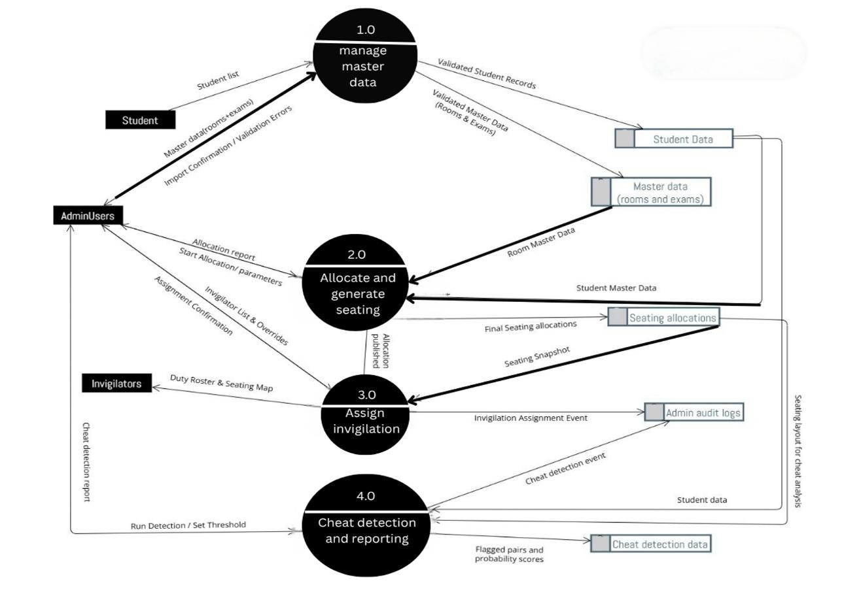
Fig 3. DFD 1 for exam seating arrangement generator

4.3 DFD Level 2
The Level 2 Data Flow Diagram further expands the major processes shown in Level 1 into detailed subprocesses, providing deeper insight into internal data handling and algorithmic logic. The Manage Master Data (1.0) process is decomposed into Receive and Preprocess Uploads (1.1)and Validate and Store Data (1.2), where raw student and exam data is cleaned, validated, and stored in structured data repositories. The seating generation process is refined into Prepare Allocation Dataset (2.1) and Run Allocation and Publish Seating (2.2), which use validated data and constraints to produce final seating layouts.
The invigilation workflow is detailed through Select Invigilator Candidates (3.1) and Assign and Publish Rosters (3.2), ensuring proper duty assignment and dissemination of seating maps. The cheat detection functionality is expanded into Analyze Seating and Score Pairs (4.1) and Flag, Store, and Report (4.2), where seating patterns are analyzed, suspicious cases are identified, and reports are generated and logged.
This detailed decomposition ensures that every data transformation is explicitly represented, supports traceability between processes and data stores, and confirms that the system design is logically consistent and complete.
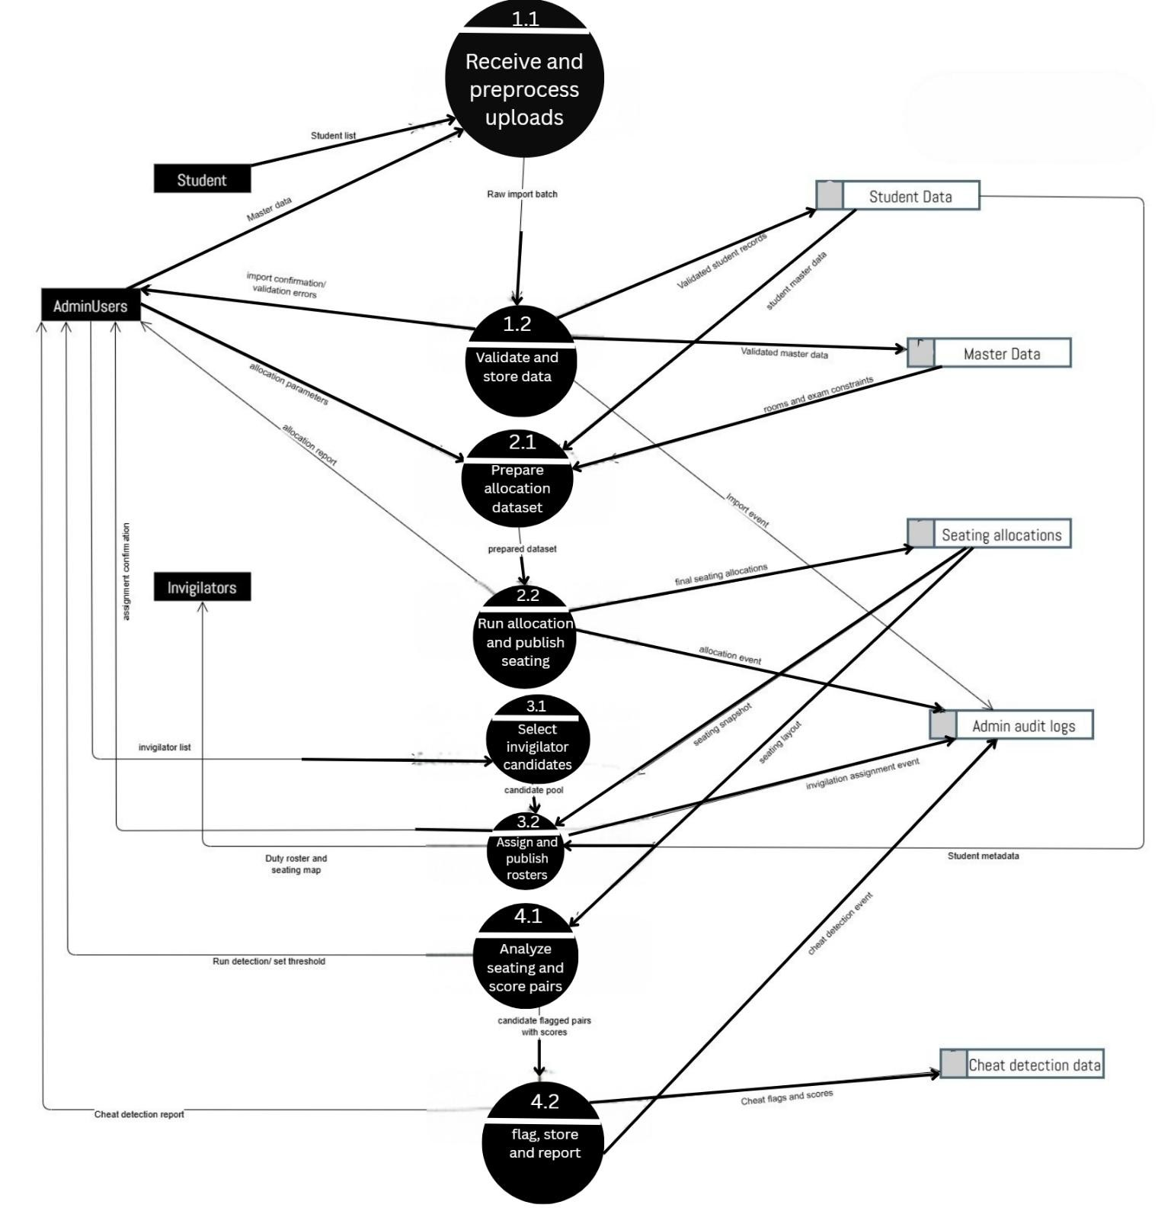
Fig 4. DFD 2 for exam seating arrangement generator
CHAPTER 5 Relational Schema and Normalization

5.1 Relational Schema
The relational schema of the Exam Seating Arrangement System is designed based on the finalized schema diagram and represents the logical organization of data into relations with clearly defined attributes, primary keys, and foreign key constraints. This schema supports examination management, seating allocation, invigilation, and integrity monitoring while maintaining normalization and minimizing redundancy.

STUDENT (student_id, name, branch, year)
The STUDENT relation stores basic academic information of students. The attribute student_iduniquely identifies each student and is referenced by multiple relations related to examinations, seating, and monitoring.

EXAMS (exam_id, subject, type, exam_date)
The EXAMS relation stores details of examinations conducted by the institution. The primary key exam_id uniquely identifies each examination.

ROOMS (room_id, capacity, layout)
The ROOMS relation stores information about examination rooms. The room_id acts as the primary key and is used to associate examinations and invigilation duties with specific rooms.

INVIGILATORS (inv_id, name)
The INVIGILATORS relation stores details of invigilators assigned to supervise examinations. The inv_id uniquely identifies each invigilator.

APPEARS_FOR (student_id, exam_id)
The APPEARS_FOR relation represents a many-to-many relationship between STUDENT and EXAMS.
It records which students are registered to appear for which examinations. The composite primary key (student_id, exam_id) ensures uniqueness.

CONDUCTED_IN (exam_id, room_id)18
The CONDUCTED_IN relation associates examinations with rooms. It specifies where each examination is conducted. The composite primary key (exam_id, room_id) enforces valid exam–room mappings.

SUPERVISES (inv_id, exam_id, room_id, start_time, end_time)
The SUPERVISES relation represents invigilation assignments. It links invigilators to specific examinations and rooms along with supervision time intervals.

SUSPECTED_OF (student_id, exam_id, probability, flagged)
The SUSPECTED_OF relation stores cheating suspicion details generated by the detection module. The attributes probability and flagged indicate the likelihood of malpractice and whether the case has been flagged for review.

SWAPPED_WITH (student_id, exam_id, reason, timestamp)
The SWAPPED_WITH relation records seat swaps performed during or before examinations. It stores the reason for swapping and the time at which the change was made, ensuring traceability.

Overall, the relational schema accurately reflects the schema diagram and provides a robust foundation for implementing the database of the Exam Seating Arrangement System. The use of composite keys and relational mappings ensures consistency, scalability, and efficient enforcement of examination rules.
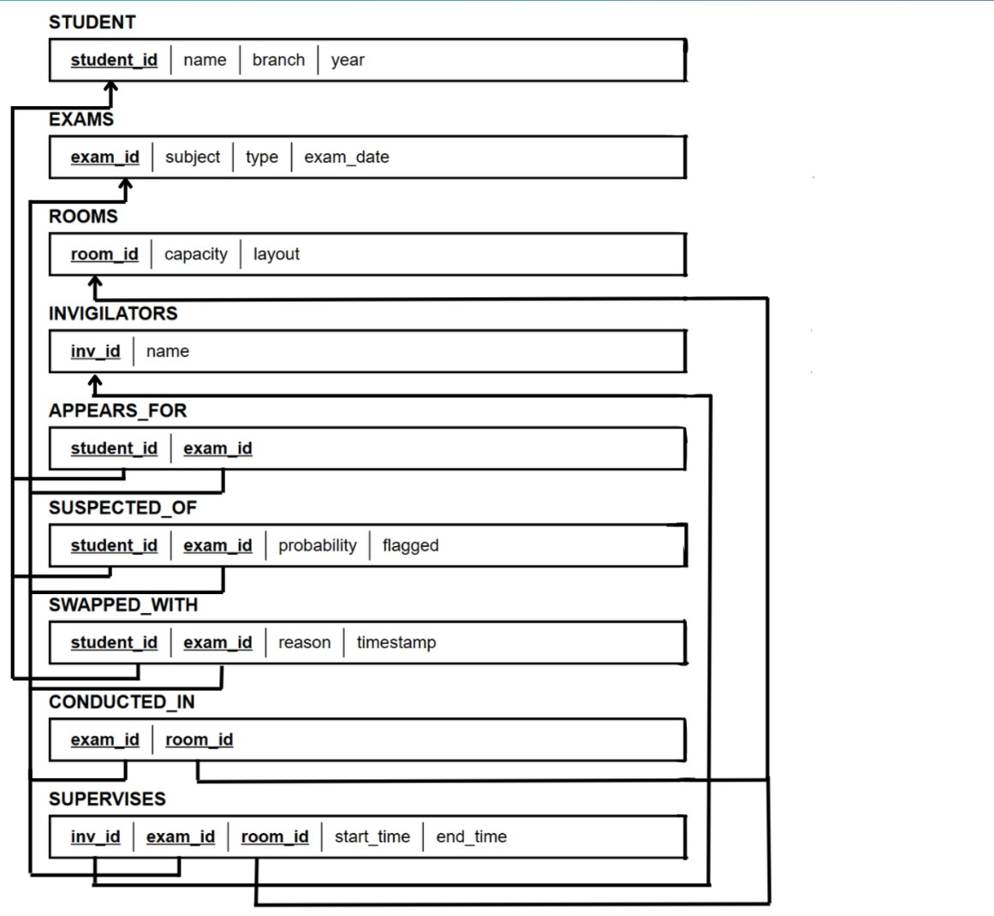
Fig 5. Relational Schema for exam seating arrangement generator

5.2 Normalization
Normalization is the process of organizing data in a database to reduce redundancy and improve data integrity. It involves decomposing relations into smaller, well-structured tables while preserving data dependencies. The Exam Seating Arrangement System follows normalization principles to ensure consistency, avoid anomalies, and support efficient database operations.

5.2.1 First Normal Form(1NF)
A relation is said to be in First Normal Form (1NF) if:
- All attributes contain atomic (indivisible) values
- There are no repeating groups or multi-valued attributes
All relations in the system satisfy 1NF, as each table contains atomic attributes only. For example, in the STUDENT relation, attributes such as name, branch, and year store single values, and there are no repeating fields. Similarly, relationship tables like APPEARS_FOR and SUPERVISES use atomic foreign key values.

5.2.2 Second Normal Form(2NF)
A relation is in Second Normal Form (2NF) if:
- It is in 1NF
- All non-key attributes are fully functionally dependent on the entire primary key
Relations with composite primary keys, such as APPEARS_FOR (student_id, exam_id) and
CONDUCTED_IN (exam_id, room_id), do not contain any non-key attributes that depend on only part of the key. In the SUPERVISES relation, attributes such as start_time and end_time depend on the complete combination of inv_id, exam_id, and room_id. Hence, all relations satisfy 2NF.
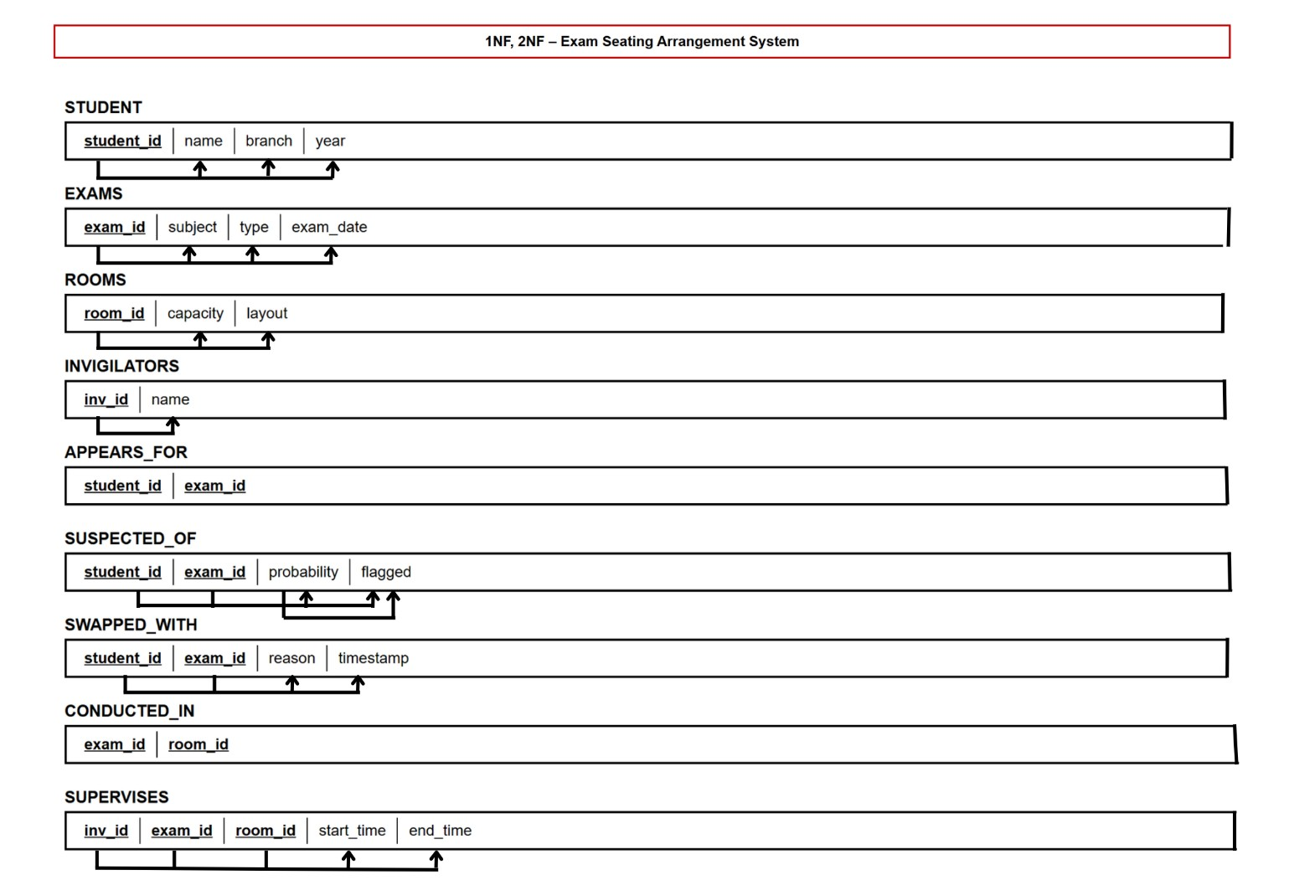
Fig 6. 1NF,2NF

5.2.3 Third Normal Form(3NF)
A relation is in Third Normal Form (3NF) if:
- It is already in 2NF, and
- There are no transitive dependencies, i.e., no non-key attribute is dependent on another non-key attribute.
In the given schema, each non-key attribute in every relation depends only on the primary key and nothing else. For example, in STUDENT, attributes such as name, branch, and year depend solely on student_id. In EXAMS, subject, type, and exam_date depend only on exam_id. Similarly, in relations like SUPERVISES, start_time and end_time depend directly on the full primary key (inv_id, exam_id, room_id) and not on any other non-key attribute.
Since all relations eliminate transitive dependencies and store attributes that are directly dependent on their primary keys, the database schema satisfies 3NF.
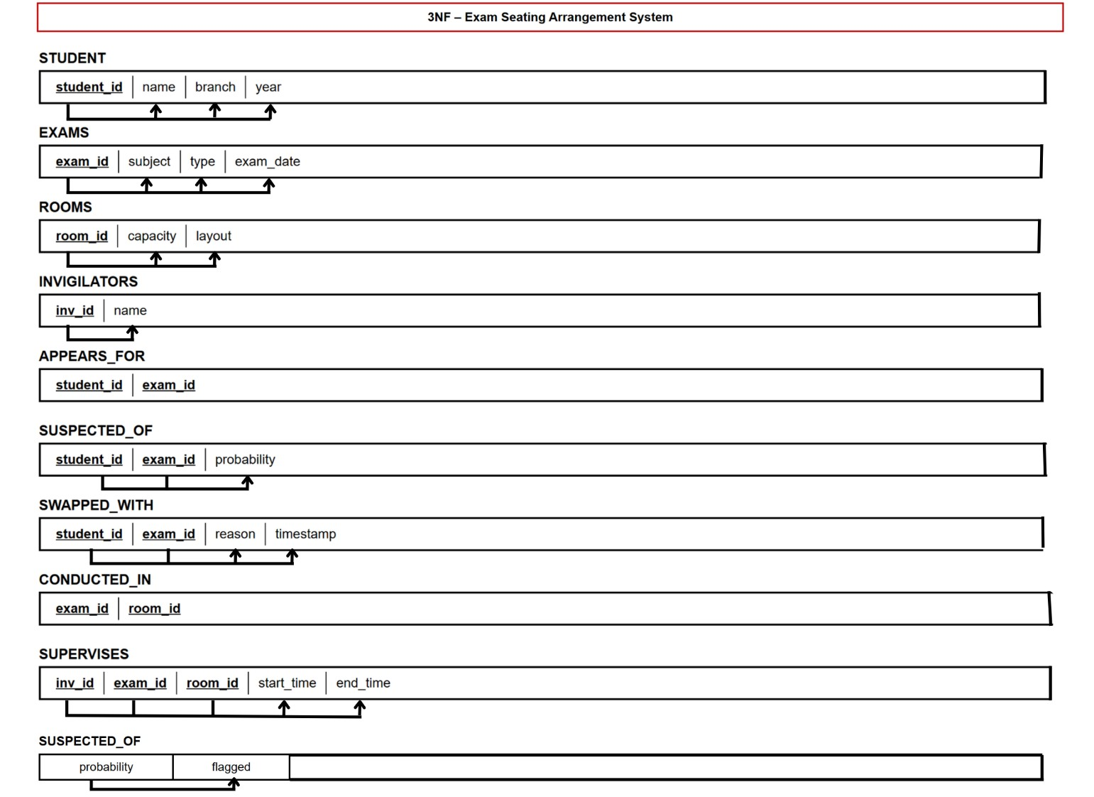
Fig 7. 3NF
CHAPTER 6 Design of Forms, Security and Validation

6.1 Security
The Exam Seating Arrangement Generator is designed with a strong focus on data security, controlled access, and system integrity. Since the platform manages sensitive academic data such as student records, examination schedules, seating arrangements, and invigilation details, robust security mechanisms are essential to prevent unauthorized access and data manipulation. The system enforces secure authentication, role-based authorization, controlled database access, and protected data transmission to ensure confidentiality, integrity, and reliability of all operations.

6.1.1 Role-Based Authentication and Authorization
The system implements a secure authentication mechanism to verify users before allowing access to the application. Users are categorized into roles such as Administrator, Teacher (Invigilator), and Student. Role-based access control ensures that each user can access only the features relevant to their responsibilities. For instance, administrators can manage exams, rooms, and generate seating arrangements; teachers can view assigned rooms and seating layouts; and students can view their individual seating information. This approach restricts unauthorized actions and protects sensitive system data.

6.1.2 Secure Database Access and Integrity Control
Access to the relational database is strictly controlled through authenticated backend services. Only authorized operations are permitted on critical tables such as STUDENT, EXAMS, ROOMS, APPEARS_FOR, SUPERVISES, and SEATING_ALLOCATION. All database transactions related to seat generation, invigilation assignment, and record updates are executed using ACID-compliant transaction mechanisms. This ensures consistency, prevents partial updates, and maintains data integrity even during concurrent access or system failures.

6.1.2 Secure Data Transmission and Audit Logging
All communication between the client interface and the backend server is carried out over secure channels using HTTPS. This ensures that sensitive data such as login credentials, seating details, and examination schedules are encrypted during transmission. Additionally, the system maintains audit logs for critical operations such as seating generation, seat swapping, and invigilation assignment. These logs enhance transparency, accountability, and traceability of system actions.

6.2 Forms and Validation in Exam Seating Arrangement System
The Exam Seating Arrangement Generator uses structured data entry forms to collect and manage information from administrators, teachers, and students. Each form incorporates validation rules to ensure data accuracy, avoid duplication, and maintain consistency within the database.

6.2.1 User Login and Access Form
The login form allows administrators, teachers, and students to access the system using valid credentials. Validation ensures that mandatory fields such as username and password are provided. Incorrect or unauthorized login attempts are restricted, preventing unauthorized access to the system.

6.2.2 Student and Examination Management Form
This form is used by administrators to enter and manage student details and examination schedules. Validation ensures that required attributes such as student ID, exam ID, subject, date, and department are provided in the correct format. Duplicate entries are prevented by enforcing primary key and uniqueness constraints at the database level.

6.2.3 Room Configuration and Seating Allocation Form
The room configuration form allows administrators to define room capacity, layout, and constraints. Validation ensures that room capacity values are positive and match physical seating availability. During seating generation, the system validates that the number of allocated students does not exceed room capacity and that constraint rules such as separation of related students are satisfied.

6.2.4 Seating Adjustment and Swap Validation
The seat swap form enables authorized users to modify seating arrangements when necessary. Validation ensures that swaps are permitted only within the same examination and room constraints. Each swap is recorded with a reason and timestamp to maintain traceability and prevent unauthorized or inconsistent changes.

CHAPTER 7
Conclusion
The Exam Seating Arrangement System successfully addresses the challenges associated with manual exam seat allocation by providing an automated, reliable, and scalable solution. By integrating database management concepts with algorithmic seating logic, the system ensures fair distribution of students, optimal room utilization, and strict enforcement of examination constraints.
The project demonstrates effective application of DBMS principles such as relational schema design, normalization, and data integrity constraints. The use of structured data storage, automatedprocessing, and clear visualization significantly reduces administrative effort and minimizes the possibility of human error. Overall, the system proves to be a practical and efficient solution for realworld academic environments.
Although the system meets current requirements, several enhancements can be incorporated to further improve functionality and scalability:
- Integration of advanced analytics and machine learning techniques for improved cheat detection and pattern analysis.
- Support for real-time monitoring and dynamic seat reallocation during examinations.
- Mobile application support for students and invigilators to access seating and duty details.
- Integration with institutional ERP systems for automatic data synchronization.
- Enhanced reporting features with graphical dashboards and analytics.

These future enhancements can extend the usability of the system and adapt it to evolving academic and technological requirements.
References

- J. Li, X. Zhang, and Y. Wang, “An intelligent examination seating arrangement system based on constraint optimization,” IEEE Access, vol. 8, pp. 214567–214578, 2020.
- P. Nguyen, T. Le, and H. Tran, “A graph-based approach for automated examination room and seat allocation,” in Proc. IEEE Int. Conf. on Advanced Computing and Applications (ACOMP), 2021, pp. 45–52.
- A. Anjum, M. D. Chodey, and M. C. Afzal, “Automation of exam hall allotment and seating arrangement,” Int. J. of Engineering Research & Technology (IJERT), vol. 10, no. 6, pp. 447–452, 2021.
- S. Ayob and A. Malik, “A new model for an examination-room assignment problem,” Int. J. of Computer Science and Network Security, vol. 11, no. 10, pp. 187–190, 2011.
- A. H. N. Kishore, A. Sasireka, and K. Vijay, “Design and development of enhanced exam hall seating arrangement automation system,” IT in Industry, vol. 9, no. 2, pp. 814–820, 2021.
- S. Sadiq, A. Abdulrahman, O. Dada, and A. Olajide, “Automated students examination seat allocation using linear congruential generator algorithm,” Int. J. of Computer Trends and Technology, vol. 69, Jan. 2021.
- J. Deshpande, S. Pagar, W. Sayyad, A. Shukla, and Y. Tupe, “Automatic seating arrangement and supervision system for university examinations,” Int. Research Journal of Engineering and Technology (IRJET), vol. 12, no. 2, 2025.
- K. Aswar, “Final year examination seating arrangement system,” Int. J. of Creative Research Thoughts (IJCRT), vol. 13, no. 6, 2025.
- Z. S. Iro, M. S. Iro, M. Salisu, and V. O. Olalekan, “Automated examination seat allocation and chart generation system,” FUDMA Journal of Sciences, vol. 9, no. 6, 2025.
- IEEE Computer Society, IEEE Standard Glossary of Software Engineering Terminology, IEEE Std. 610.12-2023, 2023.
Appendices
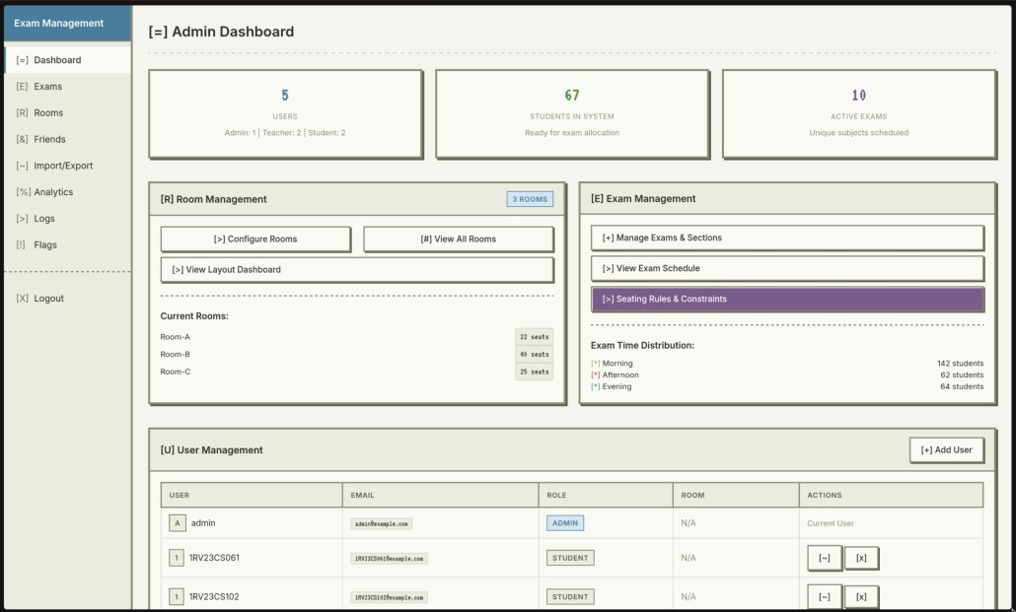
Fig 8:Admin Dashboard
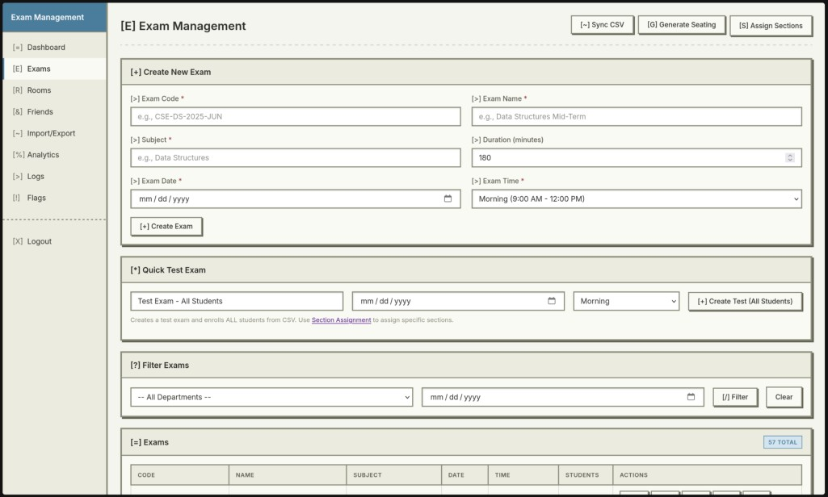
Fig 9:Exam management page
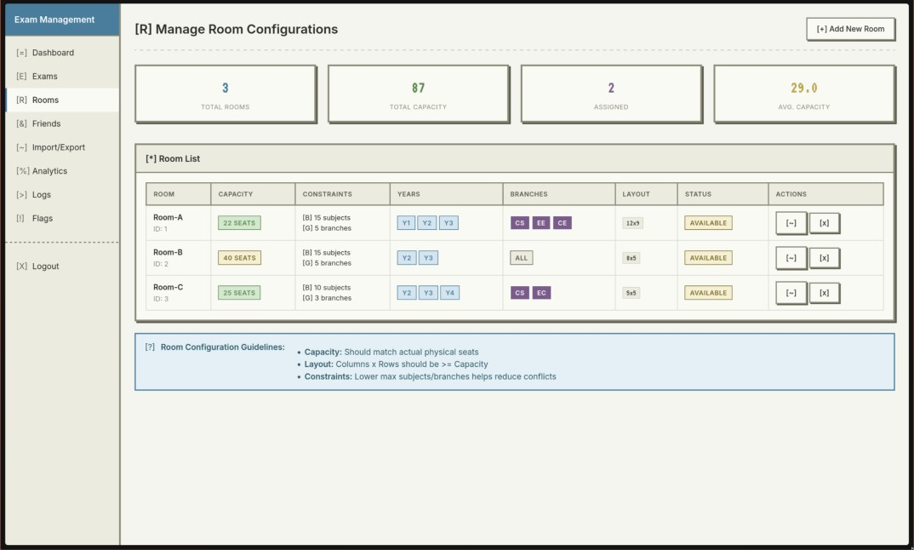
Fig 10: Room configuration page
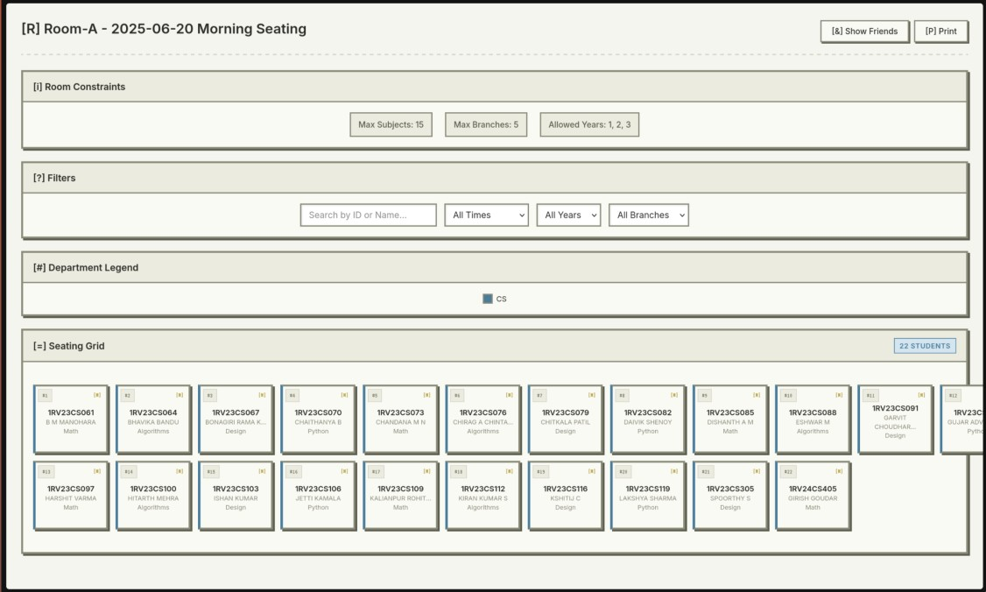
Fig 11: Room layout page
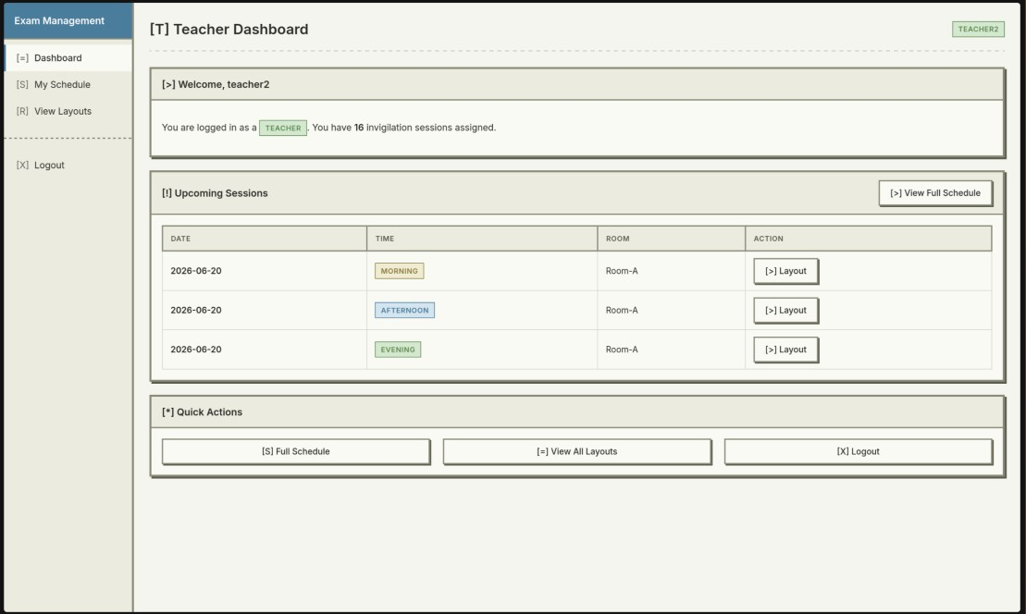
Fig 12: Teacher Dashboard

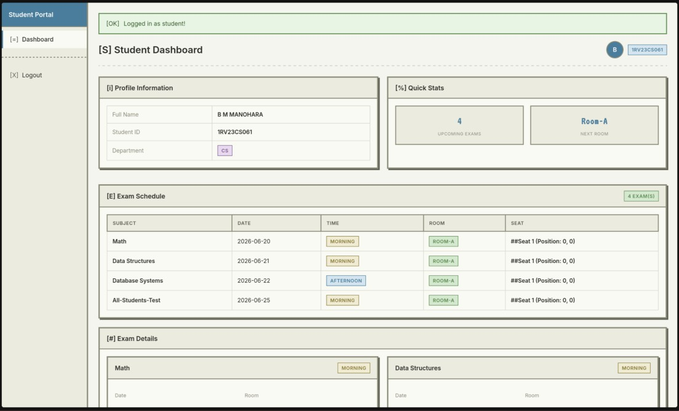
Fig 13: Student Dashboard

