Question 1:

* 1. Create table first in sql 🡪 Country

-- Table: public.Country_data

-- DROP TABLE public."Country_data";

CREATE TABLE IF NOT EXISTS public."Country_data"

(

country character varying COLLATE pg_catalog."default",

images_file character varying COLLATE pg_catalog."default",

image_url character varying COLLATE pg_catalog."default",

alpha_2 character varying COLLATE pg_catalog."default",

alpha_3 character varying COLLATE pg_catalog."default",

country_code integer,

iso_3166_2 character varying COLLATE pg_catalog."default",

region character varying COLLATE pg_catalog."default",

sub_region character varying COLLATE pg_catalog."default",

intermediate_region character varying COLLATE pg_catalog."default",

region_code integer,

sub_region_code integer,

intermediate_region_code integer

)

TABLESPACE pg_default;

ALTER TABLE public."Country_data"

OWNER to postgres;

* 1. Create table structure of Happiness

-- Table: public.Happiness_tbl

-- DROP TABLE public."Happiness_tbl";

CREATE TABLE IF NOT EXISTS public."Happiness_tbl"

(

"Year" character varying COLLATE pg_catalog."default",

"Country_region" character varying COLLATE pg_catalog."default",

"Happiness_Score" character varying COLLATE pg_catalog."default",

"GDP_Per_Capital" character varying COLLATE pg_catalog."default",

"Family" character varying COLLATE pg_catalog."default",

"Social_Support" character varying COLLATE pg_catalog."default",

"Healthy_life_Expectency" character varying COLLATE pg_catalog."default",

"Freedom_to_make_life" character varying COLLATE pg_catalog."default",

"Generosity" character varying COLLATE pg_catalog."default",

"Perception_of_Corruption" character varying COLLATE pg_catalog."default"

)

TABLESPACE pg_default;

ALTER TABLE public."Happiness_tbl"

OWNER to postgres;

2. Question 2

Insert data in table Country:

Class 🡪 AddDataInTableCountry

Each time this class runs, it will truncate the table first then add data to prevent duplicate

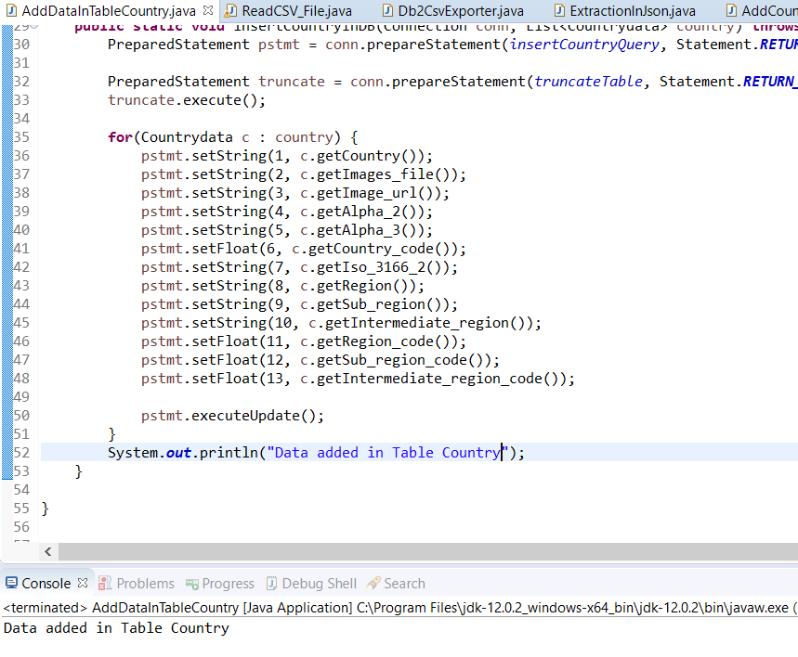

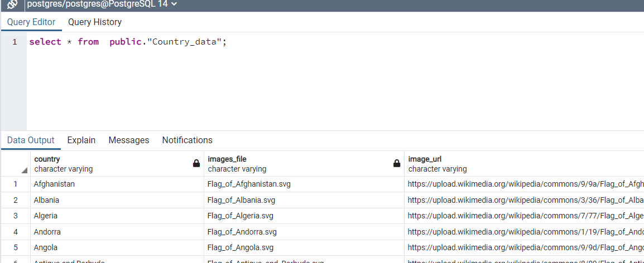

2.2 Adding Happiness Data in table

First data in raw excel need to be formatted in a proper way due to naming convention used.

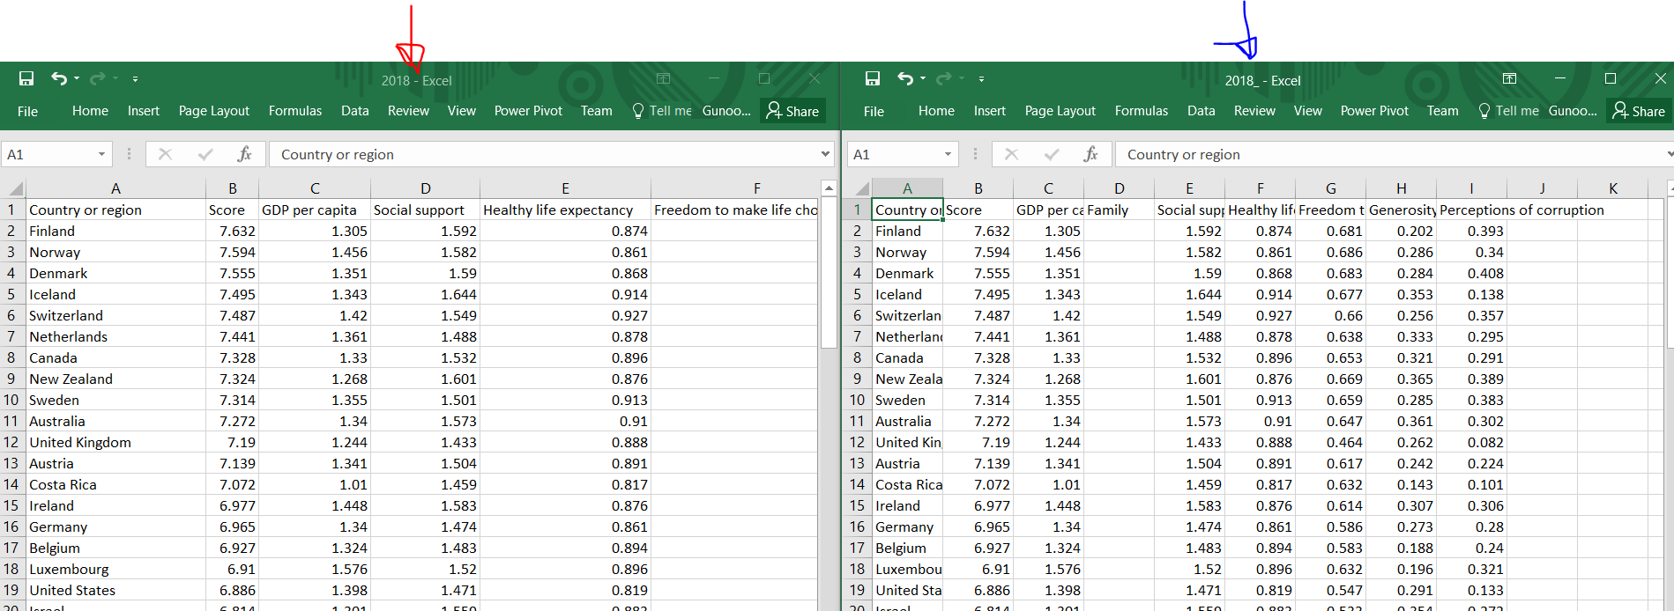

Arrow in red is raw files and arrow in Blue is processed file

Class responsible to load data in Table 🡪 ReadCSV_File

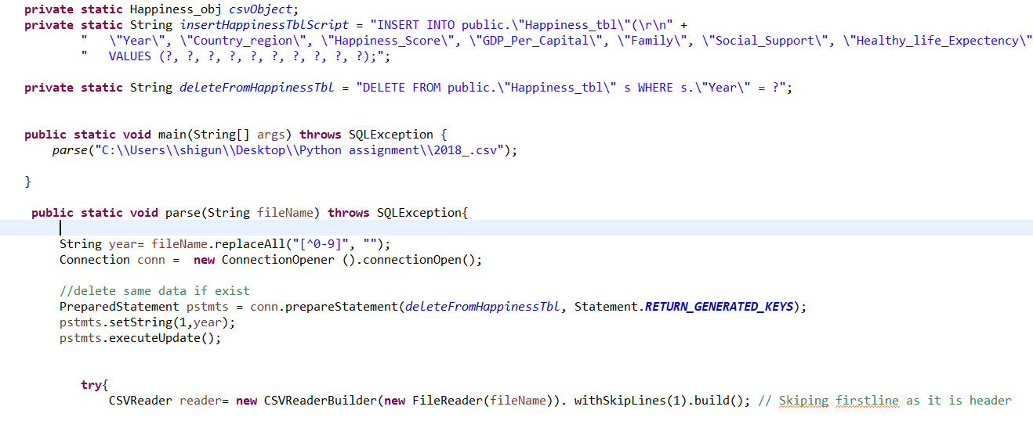

This class is responsible to add data in table Happiness. If data for the year is already present in table first it will delete those data for that particular year then reinsert.

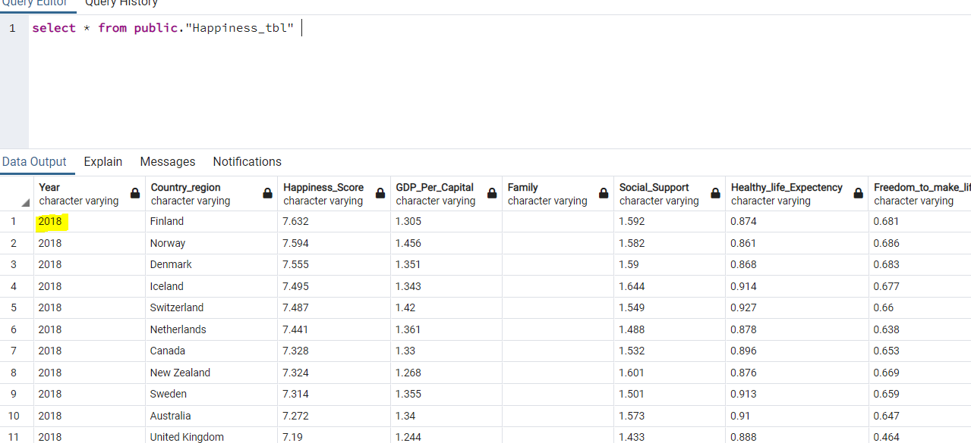

Question 3

3.1 Extraction of data in CSV files

Query 🡪

select

s."Year",

c.country as Country,

c.image_url as Country_Url,

c.region_code as Region_code,

case when c.region ='' then 'Nan'else (upper(c.region)) end as Region,

rank() over(

partition by s."Year" , c.region

order by cast(s."Happiness_Score" as decimal) desc) as Rank_Per_Region,

rank() over(

partition by s."Year"

order by cast(s."Happiness_Score" as decimal) desc) as Overall_rank,

s."Happiness_Score",

case

when cast(s."Happiness_Score" as decimal) > 5.6 then'Green'

when cast(s."Happiness_Score" as decimal) > 2.6 and cast(s."Happiness_Score" as decimal)< 5.6 then 'Amber'

when cast(s."Happiness_Score" as decimal) < 2.6 then 'Red'

end

as "Happiness_Status",

"GDP_Per_Capital",

"Family",

"Social_Support",

"Healthy_life_Expectency",

"Freedom_to_make_life",

"Generosity",

"Perception_of_Corruption"

FROM public."Happiness_tbl" s

left join public."Country_data" c

on c.country = s."Country_region"

where

c.country is not null

order by

"Happiness_Status",

rank() over( order by cast(s."Happiness_Score" as decimal) asc )

Class for extraction of data 🡪 ReadCSV_File.java

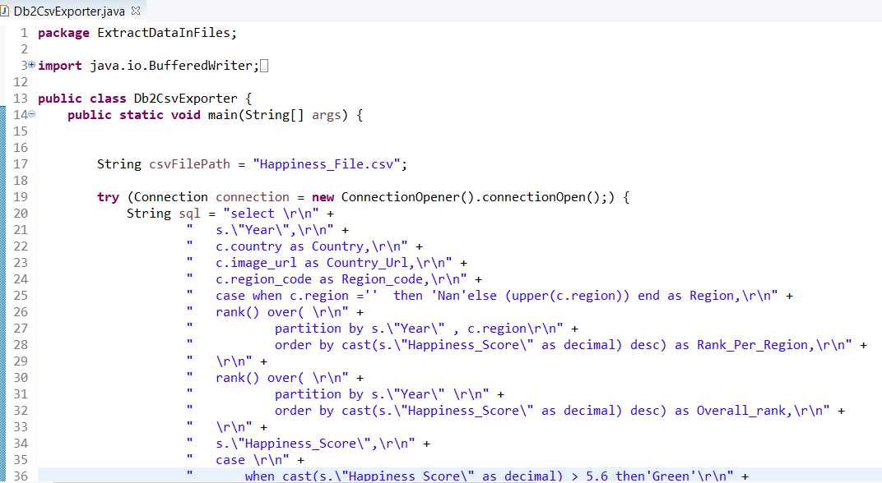

After running the code🡪

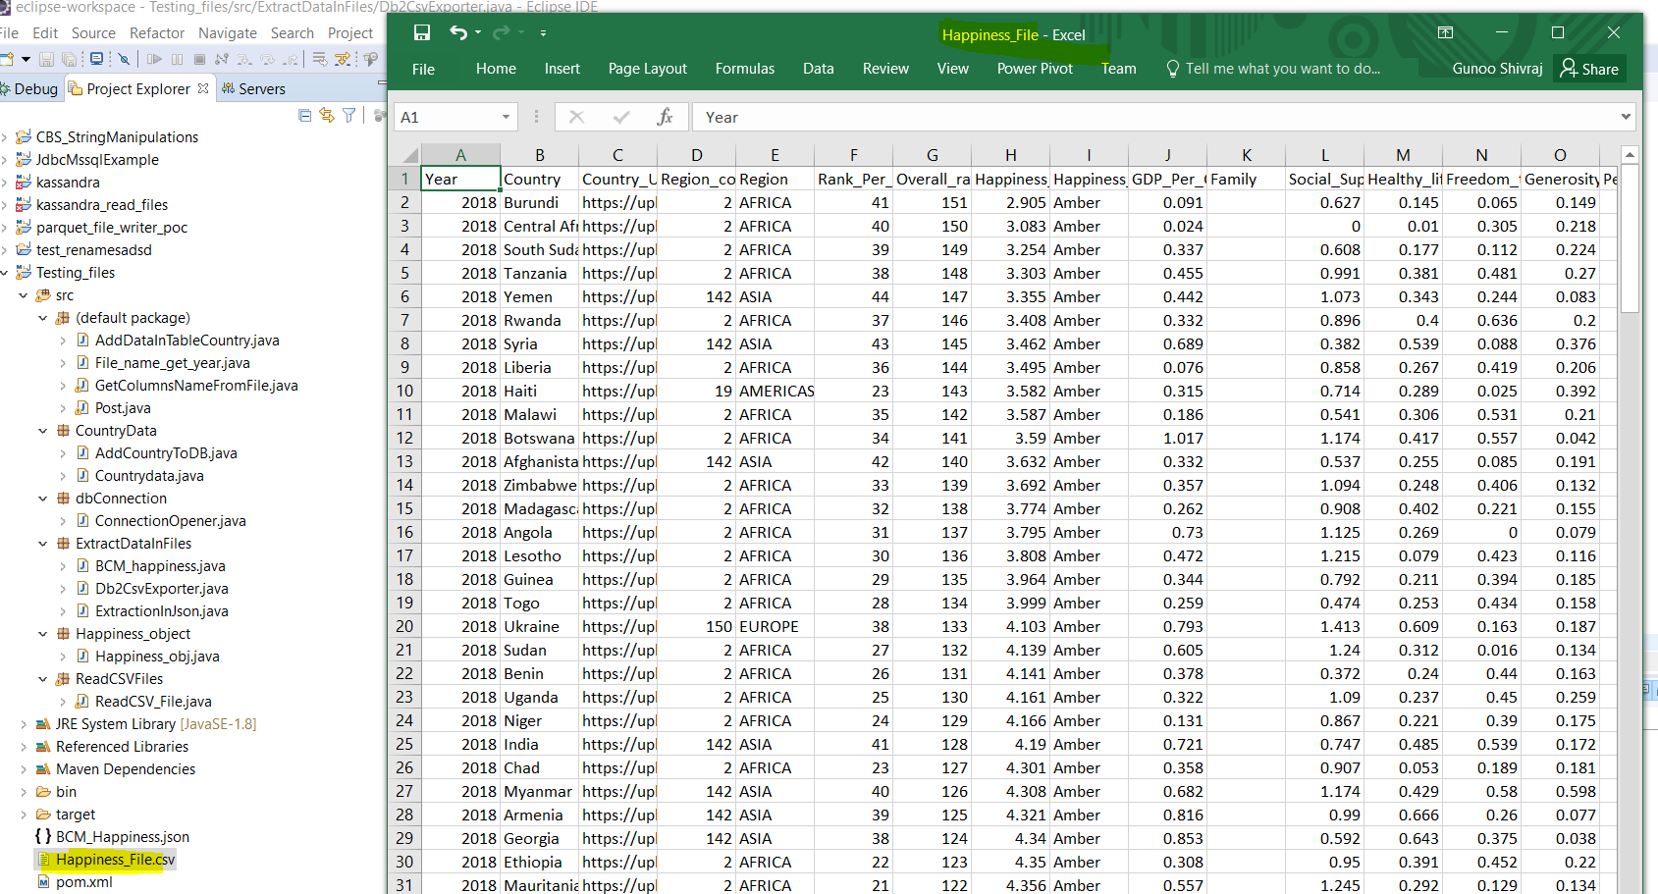

Question 4

4.1 🡪 Query:

with rank_ as (

select

s."Year",

c.country as Country,

c.image_url as Country_Url,

c.region_code as Region_code,

case when c.region ='' then 'Nan'else (upper(c.region)) end as Region,

rank() over(

partition by s."Year" , c.region

order by cast(s."Happiness_Score" as decimal) desc) as Rank_Per_Region,

rank() over(

partition by s."Year"

order by cast(s."Happiness_Score" as decimal) desc) as Overall_rank,

cast(s."Happiness_Score" as decimal) as Happiness_Score,

case

when cast(s."Happiness_Score" as decimal) > 5.6 then'Green'

when cast(s."Happiness_Score" as decimal) > 2.6 and cast(s."Happiness_Score" as decimal)< 5.6 then 'Amber'

when cast(s."Happiness_Score" as decimal) < 2.6 then 'Red'

end

as "Happiness_Status",

"GDP_Per_Capital",

"Family",

"Social_Support",

"Healthy_life_Expectency",

"Freedom_to_make_life",

"Generosity",

"Perception_of_Corruption"

FROM public."Happiness_tbl" s

left join public."Country_data" c

on c.country = s."Country_region"

where

c.country is not null

order by

"Happiness_Status",

rank() over( order by cast(s."Happiness_Score" as decimal) asc )

)

select

r.country,

max(r.Overall_rank) as Highest_Rank,

min(r.Overall_rank) as Lowest_Rank,

max(r.Happiness_Score) as Highest_Happines_score,

min(r.Happiness_Score) as Lowest_Happiness_score

from rank_ r

group by

r.country

Code 🡪 ExtractionInJson.java

